Using LiDAR to quantify, map, and conserve late-successional and old-growth forest in Maine, USA: Comment
Aaron R. Weiskittel
University of Maine, Center for Research on Sustainable Forests, Orono, ME 04469, USA. aaron.weiskittel@maine.edu
Comment on Hagan, J.M., B. Shamgochian, M.M.L. Taylor & J.M. Reed. 2026. Ecosphere 17:e70670.
Positionality: the author conducts forest inventory and biometric modeling in Maine and has a professional interest in how forest-inventory information is used in state policy. The analyses here use the original authors' archived data and public FIA and remote-sensing data, and all code is openly archived.

1. Introduction
Hagan et al. (2026) provide a valuable, transparent, and timely contribution: a field-trained, wall-to-wall classification of late-successional and old-growth (LSOG) forest across approximately 4.2 million hectares of Maine's unorganized townships, derived from publicly available airborne LiDAR. The authors archived their training data and code, the field effort is substantial, and the resulting map has focused overdue attention on older forest in a working landscape. We reproduced their random forest classifier exactly from the archived data, obtaining an out-of-bag accuracy of 94.2% for the Not-LSOG versus LSOG distinction against their reported 94.1%, with the same most-important predictor (canopy cover above 15 m). Nothing in this Comment questions the competence or the openness of the original analysis, both of which we commend.
Our concern is narrower and methodological, and it follows from how the map is now being used. The classification has become the spatial basis for conservation prioritization at scale: Thompson et al. (2026) build directly on it and estimate that protecting the highest-priority half of the mapped LSOG patches would cost on the order of US $200-300 million, in support of Maine's LD 1529. When a single map becomes the substrate for parcel-level acquisition and emerging carbon and conservation markets, the properties that govern its fitness for that purpose are no longer only its training accuracy. They are (i) its accuracy and agreement relative to independent maps and to ground-based inventory of the same target; (ii) the uncertainty of every quantity derived from it; and (iii) the validity of the trend used to motivate action. A map can be both wrong, in the unavoidable sense that LSOG is a continuous and partly subjective condition forced into discrete classes, and useful for some decisions but not others (Box 1976). Our purpose is to show, using analyses built largely on the authors' own archived data and on independent public data over the same area, what a cross-map accuracy assessment and an explicit uncertainty statement add. The difficulty of defining and inventorying older forest is well recognized and has been described as a wicked problem (Spies 2004; Gray et al. 2023); national FIA-based assessments place old growth at about 6.3% of US forest (Barnett et al. 2023) and quantify it on federal lands (Pelz et al. 2023), and spaceborne GEDI lidar has been used to characterize old-growth structure elsewhere (Spracklen and Spracklen 2021). We extend that body of work to a narrower, decision-relevant question: whether a single airborne map should anchor parcel-level conservation finance.
We make four points. First, training accuracy is high for every candidate approach and is therefore not the issue (Section 2). Second, independent operationalizations of LSOG, each with high training accuracy, disagree markedly at the landscape scale, which is the scale at which hectares are prioritized (Section 3). Third, the canopy-structure signal the method relies on is sensitive to large trees and tall canopy but largely insensitive to the dead-wood component that distinguishes old growth, so it maps tall, big-tree forest, which is roughly three times more extensive than ground-defined old forest (Section 4). Fourth, ground-based FIA inventory, the gold standard the LiDAR map approximates, places the amount of older forest with a sampling-error confidence interval the original analysis did not report, and shows the stock to be stable or increasing rather than rapidly declining (Section 5). Section 6 discusses implications.

2. Training accuracy is high for every approach, and is not the issue
The 463 archived training plots carry both the eight LiDAR canopy metrics and a parallel set of ground structural measurements (live and dead basal area, basal area and number of trees >= 40 cm dbh, quadratic mean diameter, coarse woody debris, and diameter variability). Using these, we estimated cross-validated AUC (repeated stratified five-fold cross-validation, 40 repeats; intervals from the repeat distribution) for three predictor sets against three binary targets (Table 1). Hagan's eight LiDAR metrics discriminate the field classes very well in-sample: AUC 0.990 for any-LSOG, 0.988 for LS+OG, and 0.966 for old growth. A canopy-height-only set and a ground-structure set also perform well for the broad classes. The training data are separable and the published classifier is internally sound; we emphasize this because it is the premise that makes the rest of the argument matter. Two features of Table 1 are nonetheless relevant. For old growth specifically, a canopy-height-only model, which approximates the information a spaceborne canopy-height product carries, is the weakest of the three (AUC 0.910), while ground structure is the strongest. And the full LiDAR model's high ranking ability coexists with the operating-point performance the authors report: in their own out-of-bag confusion matrix, only 29.4% of true old-growth plots were classified as old growth. High AUC and low operating accuracy are reconcilable under class imbalance and overlap, but for a map used to select specific hectares, it is operating performance on the rare, high-value class that governs the decision. Discrimination on labelled plots is a necessary property of any usable classifier; because it is achieved here by all three predictor sets, it cannot by itself distinguish among the very different maps those predictors produce when applied across the landscape (Section 3). The pattern is robust to classifier choice: under logistic regression the same ordering holds, with canopy height alone weakest for old growth (AUC 0.91) and ground structure strongest (0.97) (Appendix S1).
Target (prevalence) | Hagan 8 LiDAR | Canopy height only | Ground structure
any-LSOG (0.39) | 0.990 [0.988, 0.992] | 0.984 [0.981, 0.987] | 0.966 [0.962, 0.969]
LS + OG (0.21) | 0.988 [0.984, 0.990] | 0.977 [0.973, 0.982] | 0.970 [0.967, 0.973]
old growth (0.04) | 0.966 [0.954, 0.977] | 0.910 [0.868, 0.933] | 0.974 [0.966, 0.981]
Table 1. Cross-validated AUC (mean [95% interval]) recovering the field-assigned class from three predictor sets, on the 463 archived training plots.

3. High training accuracy does not produce map agreement
The decisive test for policy use is not how well a model separates its own training plots but whether independent, equally defensible operationalizations of LSOG agree on the landscape. We compared three wall-to-wall classifications over the same area on a common 100 m grid: the reproduced Hagan LiDAR classifier; an FIA-field-structure class predicted from Potapov (GEDI-calibrated) canopy height; and the USFS TreeMap imputation of FIA structural class. They disagree substantially. Any-LSOG covers 21.9% of the area under the Hagan classifier, 14.0% under the canopy-height model, and 7.8% under TreeMap, a 2.8-fold range. Spatially, the Hagan and canopy-height maps overlap on only about 21% of the hectares either one flags (Cohen's kappa 0.21); across all three methods, only 21% of the flagged footprint is agreed by all three, and more than half is flagged by a single method (Table 2; Fig. 1). We separately reproduced the privately held Seven Islands classification and found it effectively identical to the published model (pixel-level kappa 0.97 across approximately 290,000 ha), which confirms that the disagreement among methods is genuine rather than an artifact of our reproduction. We stress that none of these products is ground truth, including the two we constructed; the canopy-height map and the TreeMap imputation are themselves proxies, and TreeMap imputation smooths rare classes, so its area (computed at native 30 m resolution) is best read as a lower bound and its pixel-level agreement is weak. The point is not that any one map is correct but that credible operationalizations of the same target disagree by this much, which is the property a single-map prioritization must reckon with.
The consequence for prioritization is direct. If a program protects the highest-priority hectares, the overlap of the protected sets selected by the Hagan map versus the canopy-height map is only 0.16 to 0.30 (Jaccard) for the top 5% to 20% of hectares; that is, 70% to 84% of the prioritized ground differs depending on which equally defensible map is used (Fig. 1). A US $200-300 million acquisition program steered by one map would purchase substantially different forest than the same program steered by another. Each map can have excellent training accuracy and the maps can still disagree on most of the ground, because the disagreement lives in the definitional and methodological choices rather than in the fit to any one training set.
Method | any-LSOG (% area) | kappa vs Hagan | Jaccard vs Hagan
Hagan (airborne LiDAR canopy) | 21.9 | — | —
v5.1-GEDI (FIA class on canopy height) | 14.0 | 0.21 | 0.21
TreeMap (FIA structural imputation) | 7.8 | 0.01 | 0.03
3-way: % of flagged area agreed by all three | 21.0
Table 2. Wall-to-wall any-LSOG area and pairwise agreement across three independent maps over the study area.
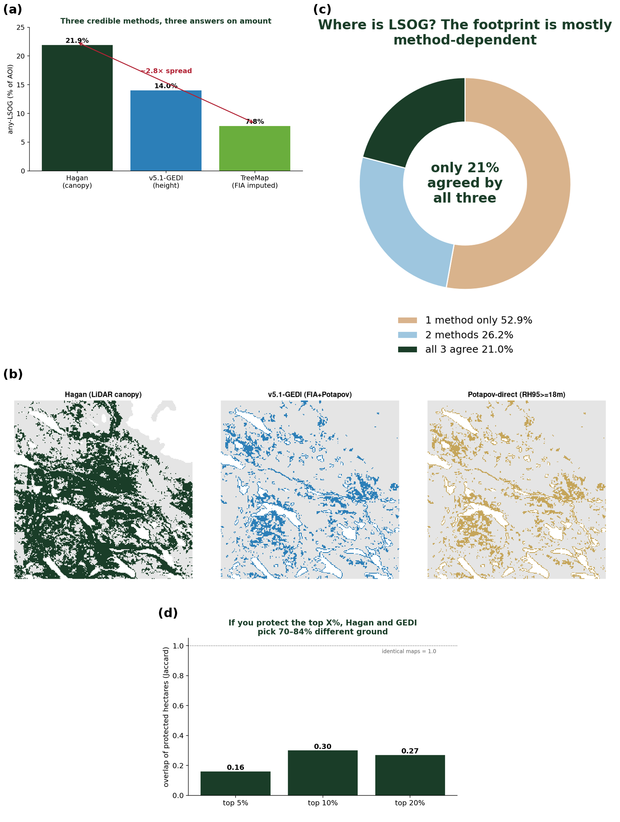
Fig. 1. Cross-map disagreement. (a) any-LSOG area by method (2.8-fold range); (b) the same 24-km window classified by each method; (c) only 21% of the flagged footprint is agreed by all three; (d) overlap of the top-priority protected hectares between maps (Jaccard 0.16-0.30).

4. The canopy signal maps big-tree forest, not old growth
Old growth is defined ecologically by large old trees, structural complexity, and abundant dead wood. Using the archived plots, we asked how well the eight LiDAR canopy metrics predict these defining attributes (cross-validated R-squared). They predict large-tree basal area moderately (R-squared = 0.68) but are largely blind to dead wood: coarse woody debris volume R-squared = 0.20 and standing dead basal area R-squared = 0.24 (Table 3). A classification keyed on canopy height and cover therefore registers tall, continuous canopy whether it is produced by an old, structurally complex stand or by an 80- to 100-year-old fast-growing stand, a failure mode the authors note for Populus. The scale of the resulting ambiguity is illustrated by ground inventory (Section 5): roughly 12.5% of Maine forest carries substantial large-tree basal area, while only about 3.9% meets a stand-age criterion for old forest. These are different criteria and the large-tree threshold is illustrative rather than definitional, but the contrast makes the mechanism concrete: large trees are far more widespread than the full old-growth structural complex, so a canopy- or height-based classifier that keys on the big-tree, tall-canopy signal will tend to over-include relative to a structural or age-based definition, consistent with the among-method spread in Section 3.
Structural attribute | CV R-squared from 8 LiDAR metrics
Live basal area in trees >= 40 cm dbh | 0.68
Number of trees >= 40 cm dbh | 0.59
Diameter variability (CV of dbh) | 0.51
Standing dead basal area (snags) | 0.24
Coarse woody debris volume | 0.20
Table 3. Cross-validated R-squared for predicting ground structural attributes from the eight LiDAR canopy metrics.

5. Ground-based inventory: the estimate, with the interval the map omits
Airborne LiDAR, TreeMap, and spaceborne canopy height are all proxies for the ground-based structural measurements that define LSOG. The USDA Forest Inventory and Analysis (FIA) program provides those measurements under a probability sample, which permits design-based estimates with sampling-error variance. Using rFIA design-based estimation (post-stratified, with FIA estimation-unit areas; Stanke et al. 2020) over all Maine inventory years, the area of older forest by transparent ground criteria is (2024, 95% CI): stand age >= 100 yr, 12.1% [10.9, 13.2] of forestland; stand age >= 120 yr, 3.9% [3.3, 4.6]; stand age >= 150 yr, 0.7% [0.4, 1.0]; and live basal area in trees >= 40 cm dbh exceeding 30 ft-squared/ac, 12.5% [11.4, 13.7] (Table 4). In the northern timberland units that approximate the study area, the stand age >= 120 yr estimate is 4.2% [3.3, 5.1]. FIA stand age is modeled and is less reliable in the uneven-aged Acadian stands common to the region, which is why we report the large-tree basal-area domain alongside it; the two structural and age-based criteria bracket a consistent range. The increasing trend is robust to the large-tree threshold: at 20, 30, and 40 ft-squared/ac the older-forest share is 19.5%, 12.5%, and 8.2% of forestland, each rising over 2003-2024 with confidence intervals excluding zero (Appendix S1). The point estimate for older forest brackets the published LS+OGL figure of 3.9%, which is reassuring, but the original analysis reported that figure without an interval; the ground-based gold standard places it in a range of roughly 3.3 to 4.6%, and that uncertainty is exactly what a $200-300 million prioritization should carry.
The design-based series also addresses the loss premise directly. The map is motivated in part by rapid LSOG loss, reported at 1.37% per year overall and 2.19% per year on commercial timberland. That figure is a gross harvest flux: it counts mapped LSOG hectares that subsequently experienced canopy removal in the Global Forest Watch record, and it does not net out ingrowth, the younger stands that mature into older condition each year. The FIA design-based stock moves the other way. Over 2003-2024, older forest increased by every ground measure, with confidence intervals excluding zero: stand age >= 100 yr at +0.19% of forestland per year [0.15, 0.23], stand age >= 120 yr at +0.065% per year [0.054, 0.075], and large-tree basal area at +0.17% per year [0.15, 0.18], while total forestland area was essentially flat (Fig. 2). The northern units show the same increases; only the oldest class (age >= 150 yr) in the north declines slightly. Both statements can be true at once: LSOG stands are harvested at roughly 2% per year, and the total older-forest stock is not declining, because aging more than replaces the hectares removed, consistent with regional syntheses (Birdsey et al. 2025). Where a rate of loss is invoked to convey urgency, the flux and the stock should be distinguished.
Finally, the publicly available spaceborne canopy-height products covering the study area (Potapov et al. 2021; Lang et al. 2023), although cited in passing in the original introduction, are not used as an independent benchmark. They are coarser than airborne LiDAR but global, repeatable, and free, and they provide the kind of independent cross-check, illustrated in Section 3, that a single airborne map otherwise lacks. Their own accuracy limitations are documented (Moudry et al. 2024), which is precisely the reason to use them as one line of evidence among several rather than to rely on any single map.
Domain (ground criterion) | Statewide % [95% CI] | Northern units % [95% CI] | Trend %/yr [95% CI]
Stand age >= 100 yr | 12.1 [10.9, 13.2] | 12.2 [10.7, 13.7] | +0.19 [0.15, 0.23]
Stand age >= 120 yr | 3.9 [3.3, 4.6] | 4.2 [3.3, 5.1] | +0.065 [0.054, 0.075]
Stand age >= 150 yr | 0.7 [0.4, 1.0] | 0.6 [0.2, 1.0] | +0.000 [-0.005, 0.006]
Large-tree BA >= 30 ft-sq/ac (>=16 in) | 12.5 [11.4, 13.7] | 9.8 [8.4, 11.2] | +0.17 [0.15, 0.18]
Table 4. FIA design-based older-forest area (2024) with 95% CI, statewide and in the northern timberland units, with 2003-2024 trend.
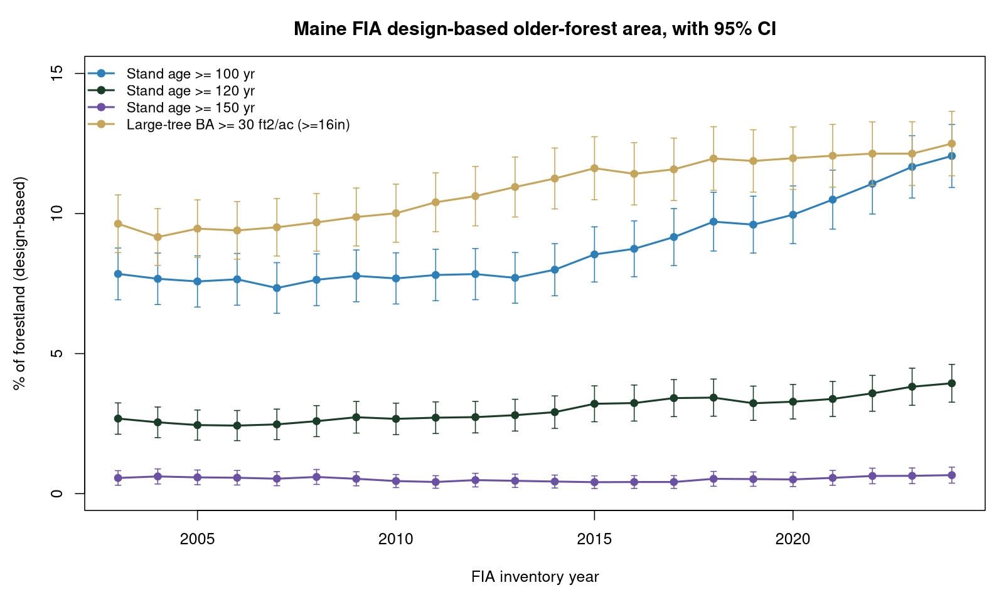
Fig. 2. FIA design-based older-forest area (stand age >= 120 yr) for Maine, 2003-2024, with 95% confidence intervals. The stock rises while total forestland area is flat.

6. Implications
None of the above argues against mapping LSOG with LiDAR, nor against conserving older forest in Maine, which we support. It argues that a single classification, however well trained, is not a sufficient basis for parcel-level expenditures of the magnitude now contemplated, and that three practices should accompany its policy use. First, LSOG extent should be reported as a range across methods and with the design-based sampling interval, rather than as a single number; the ground-based estimate of older forest, 3.9% [3.3, 4.6], is an example. Second, before hectares are prioritized for acquisition or enrolled in markets, the map should be checked against at least one independent product and field-verified at the parcel scale, as the authors themselves recommend for management decisions. Third, where a rate of loss is invoked, the harvest flux and the net stock should be distinguished, because they point in opposite directions here. These practices matter most where a map underwrites cost estimates and prioritization at the scale of the recent statewide assessment (Thompson et al. 2026), whose $200-300 million estimate is computed parcel by parcel from the mapped patches and therefore inherits the map's accuracy and uncertainty directly. The Hagan et al. map is a useful and reproducible product; our point is that its usefulness for high-stakes allocation depends on the cross-map accuracy assessment and uncertainty characterization that should now accompany it.

Data and code availability
All analyses, code, and derived products supporting this Comment are archived at Zenodo (concept DOI 10.5281/zenodo.20614496). Hagan et al.'s training data and code are at Zenodo 10.5281/zenodo.19696494. FIA data are from the USDA FIA DataMart, accessed June 2026.

References
Barnett, K., G. H. Aplet, and R. T. Belote. 2023. Classifying, inventorying, and mapping mature and old-growth forests in the United States. Frontiers in Forests and Global Change 5:1070372. https://doi.org/10.3389/ffgc.2022.1070372
Box, G. E. P. 1976. Science and statistics. Journal of the American Statistical Association 71:791-799.
Gray, A. N., K. Pelz, G. D. Hayward, T. Schuler, W. Salverson, M. Palmer, C. Schumacher, and C. W. Woodall. 2023. Perspectives: the wicked problem of defining and inventorying mature and old-growth forests. Forest Ecology and Management 546:121350. https://doi.org/10.1016/j.foreco.2023.121350
Hagan, J. M., B. Shamgochian, M. M. L. Taylor, and J. M. Reed. 2026. Using LiDAR to quantify, map, and conserve late-successional and old-growth forest in Maine, USA. Ecosphere 17:e70670.
Lang, N., W. Jetz, K. Schindler, and J. D. Wegner. 2023. A high-resolution canopy height model of the Earth. Nature Ecology & Evolution 7:1778-1789. https://doi.org/10.1038/s41559-023-02206-6
Moudry, V., et al. 2024. Comparison of three global canopy height maps and their applicability to biodiversity modeling: accuracy issues revealed. Ecosphere 15:e70026.
Pelz, K., G. Hayward, A. Gray, E. Berryman, C. Woodall, A. Nathanson, and N. Morgan. 2023. Quantifying old-growth forest of United States Forest Service public lands. Forest Ecology and Management 549:121437. https://doi.org/10.1016/j.foreco.2023.121437
Potapov, P., et al. 2021. Mapping global forest canopy height through the fusion of GEDI and Landsat data. Remote Sensing of Environment 253:112165.
Shamgochian, B., J. Hagan, M. Taylor, and M. Reed. 2025. LSOG Rapid Assessment Protocol (RAP) for Maine (v1.0). Our Climate Common Report, Georgetown, Maine.
Spies, T. A. 2004. Ecological concepts and diversity of old-growth forests. Journal of Forestry 102(3):14-20.
Spracklen, B., and D. V. Spracklen. 2021. Determination of structural characteristics of old-growth forest in Ukraine using spaceborne LiDAR. Remote Sensing 13(7):1233. https://doi.org/10.3390/rs13071233
Stanke, H., A. O. Finley, A. S. Weed, B. F. Walters, and G. M. Domke. 2020. rFIA: an R package for estimation of forest attributes with the FIA database. Environmental Modelling & Software 127:104664.
Thompson, J. R., A. Daigneault, J. Plisinski, I. Moon, and J. Norton. 2026. Pathways for protecting Maine's remaining late-successional and old-growth forests. Property and Environment Research Center.

