Reproducing and Stress-Testing the Hagan et al. (2026) LSOG Map
A full unorganized-townships cross-validation of the FIA-based v5.1 classifier
Northeast LSOG Project | Center for Research on Sustainable Forests, University of Maine | June 9, 2026

Executive summary
The publication of Hagan, Shamgochian, Taylor and Reed (2026) in Ecosphere, together with its Zenodo deposit, supplied the three pieces our project had been missing: the 463-plot LiDAR training data, the exact random forest recipe, and the per-hectare canopy metrics for all 4.2 million hectares of Maine's unorganized townships. With these we reproduced the published classification, validated our FIA-based v5.1 classifier against it across the full territory, stress-tested every step, and confirmed that the privately shared Seven Islands raster (SILC) is the same product as the published model.
- The published model reproduces faithfully: 94.2% binary accuracy (published 94.1%), same top predictor (canopy cover above 15 m), and wall-to-wall LS+OGL of 180,000 ha versus the published 161,881 ha.
- The full-UT cross-validation now rests on 1,760 FIA plots, roughly fourteen times the earlier Pingree-only sample of 125.
- FIA proxy and LiDAR agree on the landscape total but not plot by plot: v5.1 any-LSOG 12.0% versus Hagan 21.1%, Cohen kappa 0.12. The two methods measure related but distinct stand properties.
- The result is robust: a 20-seed ensemble, a coordinate-fuzz test, and a 2,000-sample bootstrap all confirm the reproduction and the weak plot-level agreement.
- SILC and Hagan's published model agree almost perfectly (pixel kappa 0.97 across 289,703 hectares), retroactively validating the Phase 9 cross-validation.

1. Background and data
Our v5.1 classifier scores FIA plots on six structural dimensions (large-tree basal area, maturity, structural diversity, canopy stocking, deadwood, and Potapov canopy height) to assign Not LSOG, Transitioning LS, LS, or old-growth. Hagan et al. instead classify every hectare from eight airborne-LiDAR canopy metrics with a random forest. Until now we could only compare the two indirectly. The Zenodo deposit (10.5281/zenodo.19696494) removed that barrier.

2. Reproduction of the published model
Refitting the random forest on the 463 training hectares reproduced the published performance closely. The out-of-bag binary accuracy for the Not-LSOG versus LSOG distinction was 94.2% against the published 94.1%, and the fraction of canopy above 15 m was the most important predictor in both.
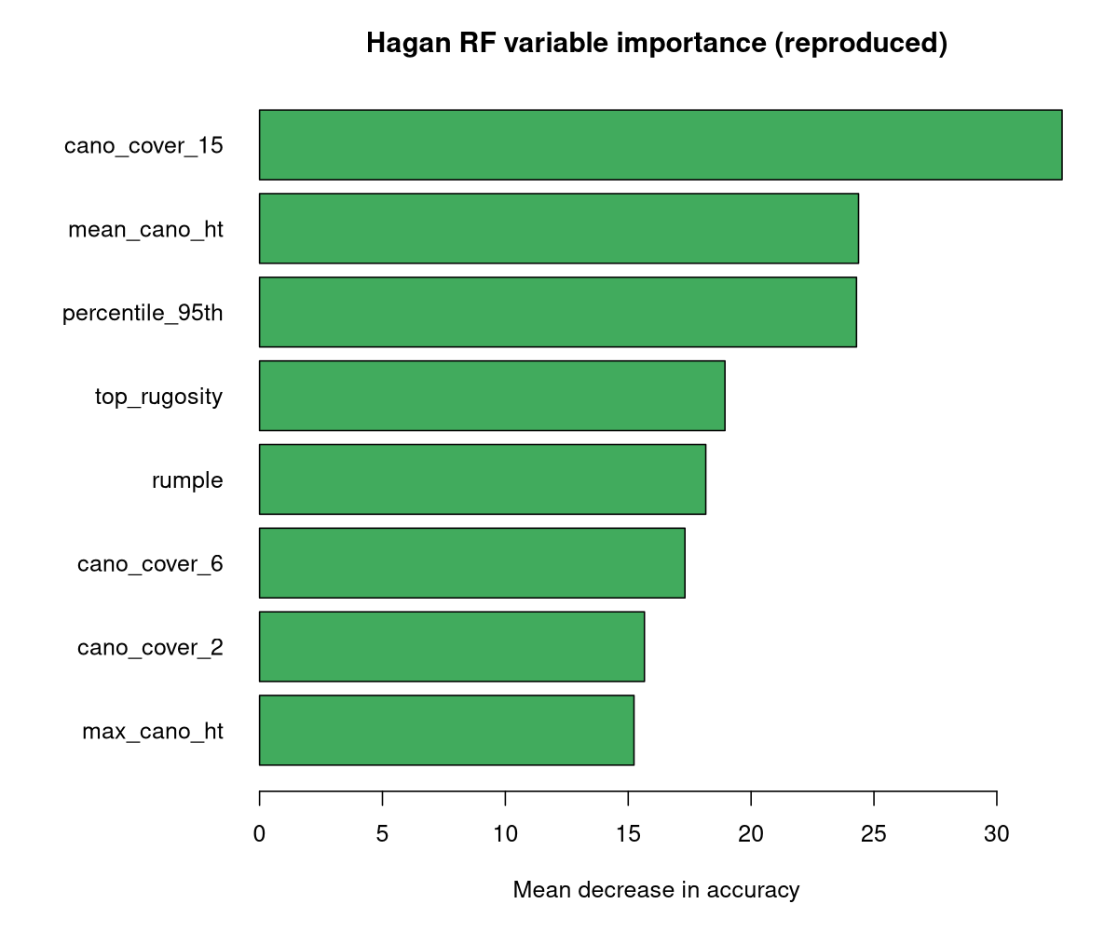
Figure 1. Reproduced random forest variable importance. Canopy cover above 15 m dominates, matching the published model.

3. Wall-to-wall area comparison
Applying the reproduced model to all 4.28 million hectares returned per-class areas closely matching the published Table 7. The old-growth-like class reproduced almost exactly.
Class | Reproduced % | Published % | Reproduced ha | Published ha
Not LSOG | 78.1 | 80.3 | 3,343,087 | 3,361,292
Transitioning LS | 17.7 | 15.8 | 758,788 | 662,696
LS | 3.32 | 3.0 | 142,118 | 124,821
OGL | 0.88 | 0.9 | 37,773 | 37,060
LS + OGL | 4.20 | 3.9 | 179,891 | 161,881
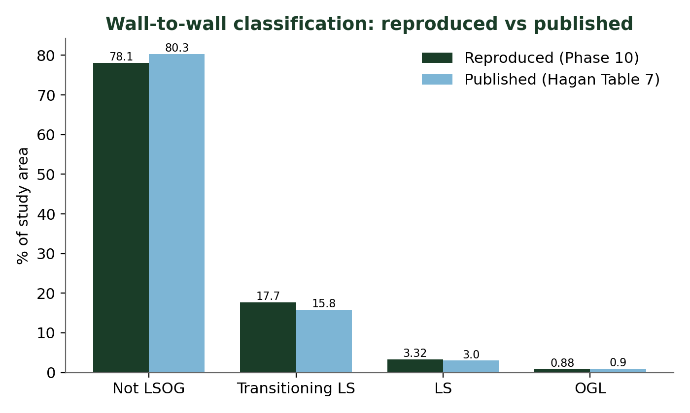
Figure 2. Reproduced versus published wall-to-wall class percentages.
Note. The reproduced LS+OGL share (4.2%) sits slightly above the published 3.9% because the archived grid carries about 96,000 more edge hectares than the published 4,185,869-ha study-area total, and because of random forest stochasticity (Section 5).

4. Full unorganized-townships cross-validation
Sampling the reproduced Hagan classification at every Maine FIA plot placed 3,527 plots inside the unorganized townships (1,760 in the 2019-2023 panel). Hagan's any-LSOG rate at the plot locations (21.1%) matched the landscape wall-to-wall rate (19.7%), confirming the FIA sample is spatially representative. The two products diverge plot by plot, however.
Share (2019-2023, n=1,760) | v5.1 (FIA) | Hagan (LiDAR)
any-LSOG | 12.0% [10.5, 13.5] | 21.1% [19.2, 23.0]
LS + OG | 1.19% [0.68, 1.71] | 3.86% [3.01, 4.77]
OG only | 0.06% | 0.85%
Cohen kappa (any-LSOG) | 0.12 | —
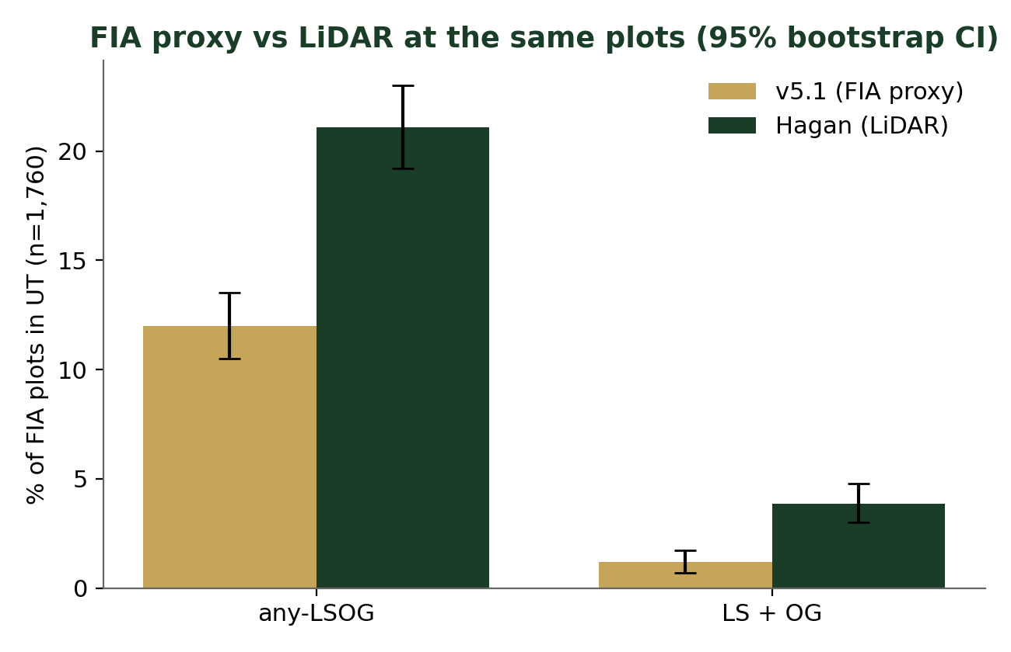
Figure 3. FIA proxy versus LiDAR at the same 1,760 plots, with 95% bootstrap confidence intervals.
The divergence is structural. Hagan's LiDAR reads canopy disturbance from skid trails and selective harvest that FIA tree records miss, while v5.1 weights tree-level attributes that change after partial harvest even where the residual canopy stays tall. Only the combined LS+OG category should be treated as policy-stable across methods.

5. Stress test
Three robustness checks confirm the findings are not artifacts of model randomness, coordinate fuzzing, or sampling.
Check | Result
20-seed RF ensemble | LS+OGL 4.23% (SD 0.06, range 4.12 to 4.34); kappa_any 0.128 (SD 0.004). Published 3.9% lies just below the seed range, so the gap is the denominator, not noise.
FIA coordinate-fuzz (1 km modal) | kappa_any rises from 0.123 to 0.207 but remains fair-to-weak; fuzzing explains part but not most of the disagreement.
Bootstrap (B = 2,000) | v5.1 and Hagan any-LSOG shares fall in non-overlapping intervals; kappa_any 0.122 [0.071, 0.175].

6. SILC update: the privately shared raster equals the published model
Because the published model is now reproducible, we tested the Seven Islands LSOG raster (SILC, M2V2b) against it on the Pingree ownership. The two Hagan-lineage products agree almost perfectly, while v5.1 diverges from both equally.
Comparison | n | Cohen kappa
SILC vs reproduced Hagan, any-LSOG (pixel) | 289,703 | 0.966
SILC vs reproduced Hagan, LS+OG (plot) | 124 | 1.000
v5.1 vs reproduced Hagan, any-LSOG (plot) | 124 | 0.050
v5.1 vs SILC, any-LSOG (plot) | 125 | 0.065
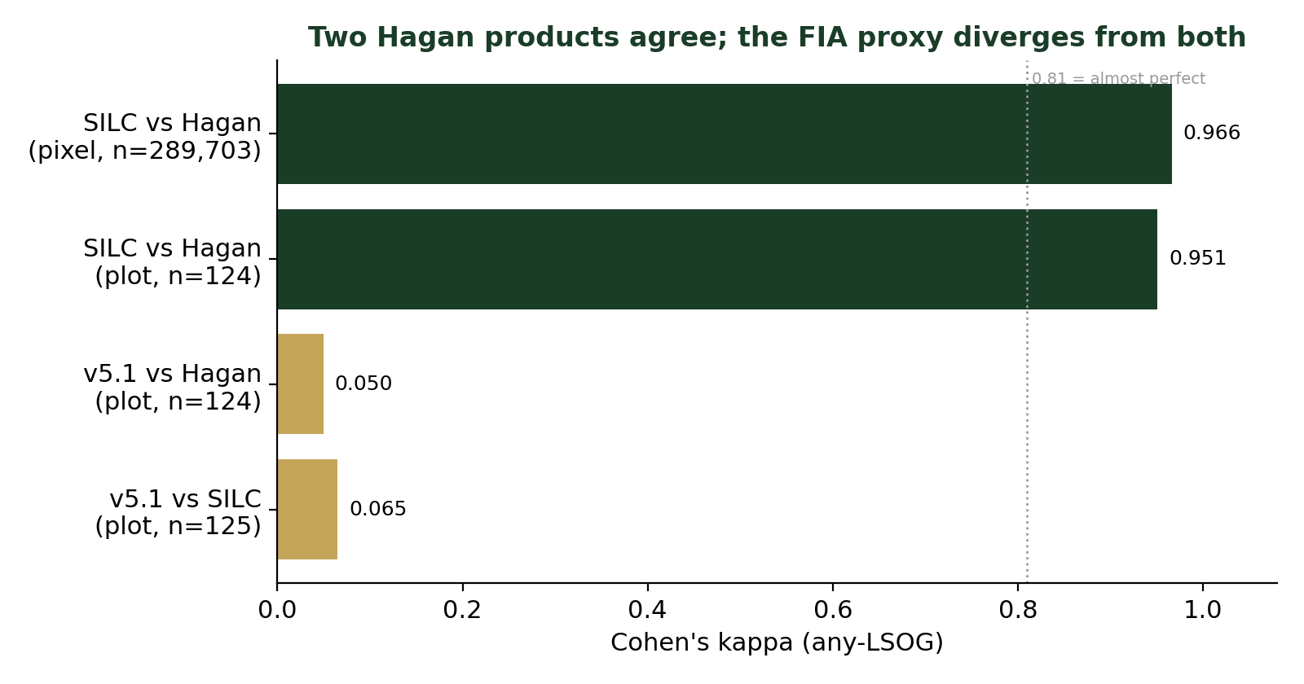
Figure 4. The two Hagan-lineage products agree (kappa near 1); the FIA proxy diverges from both.

7. Implications and next steps
- The published Hagan numbers are reproducible from the public deposit and can be cited as the authoritative LiDAR benchmark for Maine's unorganized townships.
- Area estimates of LSOG forest should always state the classification method; FIA-proxy and LiDAR products are not interchangeable at the plot level.
- The manuscript's cross-validation and Limitations sections can now cite the full-UT result (n=1,760) and the SILC equivalence, replacing the Phase 9 single-ownership text.
- The reproduced classification is saved as a 100 m raster (output_phase10/C_hagan_class_100m.tif) for any further ownership or size-class analysis.

Sources
Hagan, J.M., Shamgochian, B., Taylor, M.M.L. & Reed, J.M. (2026). Using LiDAR to quantify, map, and conserve late-successional and old-growth forest in Maine, USA. Ecosphere 17:e70670. doi.org/10.1002/ecs2.70670
Hagan et al. (2026). Supplemental data deposit. Zenodo. doi.org/10.5281/zenodo.19696494

