How Hard Is It to Map Late-Successional and Old-Growth Forest in Maine?
A multi-method uncertainty assessment, and a caution for conservation prioritization
Northeast LSOG Project | Center for Research on Sustainable Forests, University of Maine | June 9, 2026

Executive summary
Mapping late-successional and old-growth (LSOG) forest across Maine's working landscape is genuinely hard, and the uncertainty is large. We compared three credible, mappable methods over the same 4.2-million-hectare unorganized townships. They disagree by roughly 1.6 times on how much LSOG exists, they disagree on the location of about four of every five LSOG hectares, and no method reproduces the field-plot classification well. That spatial uncertainty matters: it would steer a conservation acquisition program to largely different ground depending on which map is trusted.
- Three methods, three answers on amount: airborne-LiDAR canopy (Hagan) flags 21.9% of the area as any-LSOG, while two GEDI-canopy-height methods flag about 14%. A single defensible product's estimate also swings 2.5-fold (424,000 to 1,059,000 ha) just by moving a defensible threshold.
- They disagree on where: Hagan and the GEDI-based maps overlap on only ~21% of the hectares either flags (Cohen kappa 0.21). Across all three methods, only 21% of the flagged footprint is agreed by all three; over half is flagged by a single method.
- No clean ground truth: at 1,760 field plots, every method agrees with the FIA field-structure class only weakly (kappa 0.06 to 0.21). LSOG is an inherently continuous, fuzzy property.
- Policy fragility: protecting the top 5 to 20% of hectares by one map versus another overlaps on only 16 to 30% of the ground. A $200-300 million program would buy mostly different forest depending on the map.
- This is not a reproduction error. We reproduced Hagan's published model exactly (94.2% vs 94.1% accuracy) and confirmed the Seven Islands raster equals it (pixel kappa 0.97); the disagreement among methods is real, not an artifact.

1. Why this matters now
In 2025 the Maine Legislature passed LD 1529, directing a statewide LSOG conservation strategy by November 2026. A recent report (Thompson et al. 2026, Property and Environment Research Center, Harvard Forest, and University of Maine) builds directly on Hagan et al.'s LiDAR map, treats the roughly 165,000 hectares as established, and estimates that protecting the top 50% of those LSOG patches would cost on the order of $200-300 million. When a single map becomes the basis for patch-level prioritization at that scale, the map's uncertainty is a first-order question.

2. Three methods on one grid
We placed three mappable methods on the same 100 m grid over the unorganized townships. All target LSOG, but they encode different definitions.
Method | What it measures | Mappable input
M1 Hagan | Canopy structure (random forest on 8 LiDAR canopy metrics) | Airborne LiDAR
M2 v5.1-GEDI | FIA field-structure LSOG class, calibrated to canopy height | Potapov (GEDI) canopy height
M3 Potapov-direct | Tall canopy (height >= 18 m) | Potapov (GEDI) canopy height
The defensible target. M2 anchors its target in the FIA field-structure definition of LSOG (large old trees, deadwood, structural complexity), which independent evidence shows is ecologically real: the FIA old-growth class matches an independent national estimate almost exactly, and those stands carry 2.6 to 3.6 times the carbon of non-LSOG stands. Canopy height is the single most informative wall-to-wall predictor of that field class (AUC 0.70), which is why M2 uses GEDI height as its mappable signal.

3. They disagree on how much
Method | any-LSOG % | any-LSOG ha
M1 Hagan (LiDAR canopy) | 21.9 | 938,679
M2 v5.1-GEDI (FIA + Potapov) | 14.0 | 597,528
M3 Potapov-direct (RH95 >= 18 m) | 14.1 | 603,991
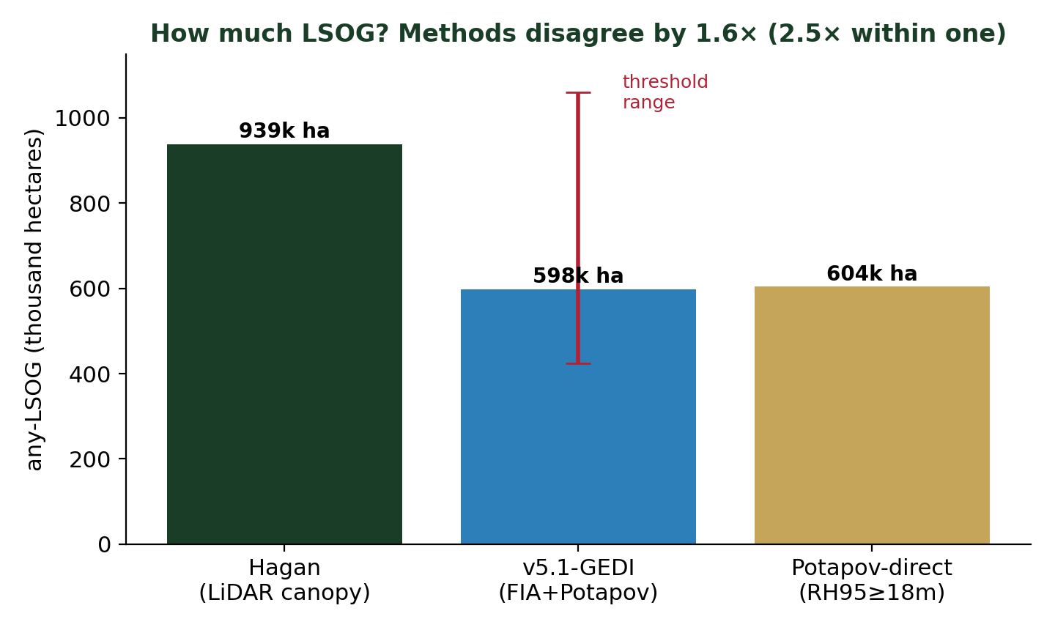
Figure 1. Any-LSOG area by method. Hagan flags 1.6x more than the GEDI-based products; the red bar shows the 2.5-fold swing in the defensible product from the threshold choice alone.
Note. Hagan's any-LSOG includes a large "Transitioning LS" class that is, by his own definition, not yet mature. 71% of the hectares Hagan calls LSOG have GEDI canopy height below 18 m. Some of that is expected for a transitional class, but policy framings that treat the full any-LSOG figure as "old forest" inherit the ambiguity.

4. They disagree on where, much more
Pair | Cohen kappa | Jaccard overlap
Hagan vs v5.1-GEDI | 0.21 | 0.21
Hagan vs Potapov-direct | 0.21 | 0.21
v5.1-GEDI vs Potapov-direct | 0.99 | 0.99
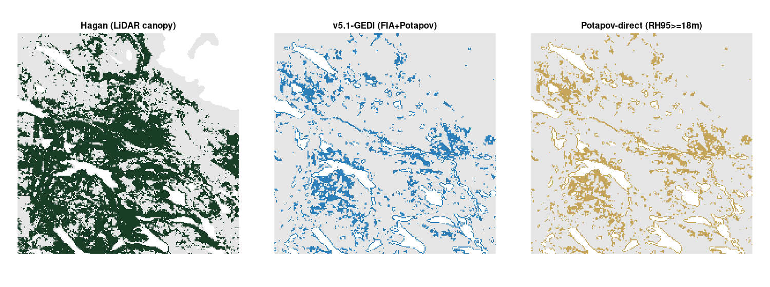
Figure 2. The same 24 km window classified by each method. Hagan (green) flags far more forest, and in different places, than the GEDI-based maps (blue, gold).
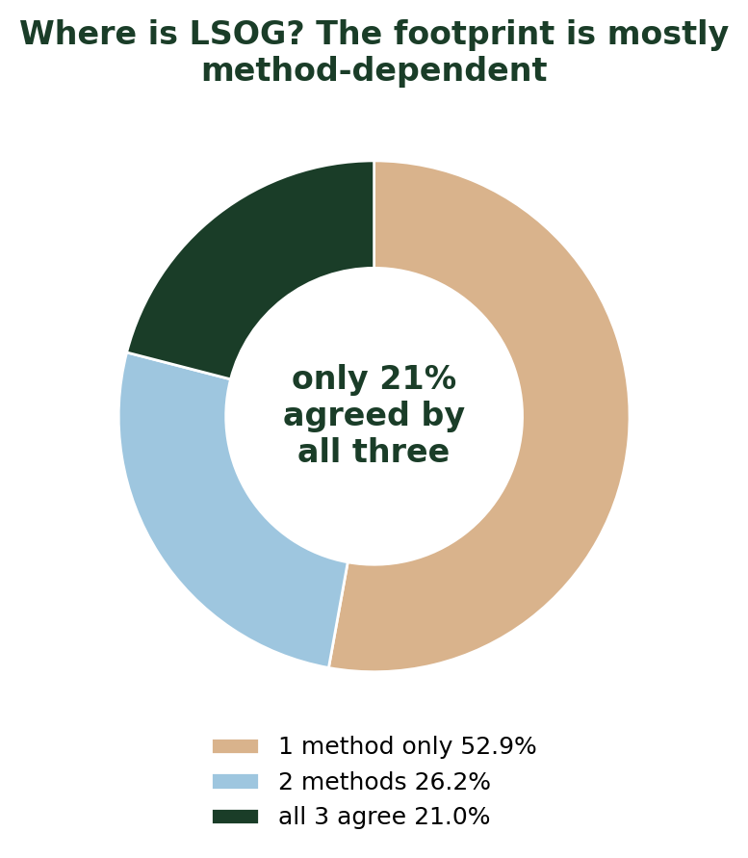
Figure 3. Of every hectare flagged LSOG by any method, only 21% is agreed by all three; the majority is flagged by a single method.
Hagan and the GEDI-based maps overlap on only about 21% of the hectares either one flags. The two GEDI-based maps agree with each other because both derive from canopy height; they represent one canopy-height view against Hagan's airborne-LiDAR view. The LSOG footprint is, to first order, method-dependent.

5. No method matches the field plots well
At the 1,760 FIA plots inside the unorganized townships, agreement with the FIA field-structure class is weak for every method (Cohen kappa 0.06 to 0.07 at the plot, rising to only 0.21 wall-to-wall). Even the FIA-calibrated GEDI product reaches just 0.063 plot-by-plot, because canopy height alone cannot resolve the tree-level structure that defines LSOG on the ground. There is no clean ground truth: the field class is itself a proxy for a continuous, fuzzy property.

6. Why this matters for conservation spending
If a program protects the highest-priority hectares, do different maps point to the same ground? The overlap of the top-ranked protected sets, Hagan versus the GEDI product, is small.
Protect the top... | Overlap of protected hectares (Jaccard)
5% of hectares | 0.16
10% of hectares | 0.30
20% of hectares | 0.27
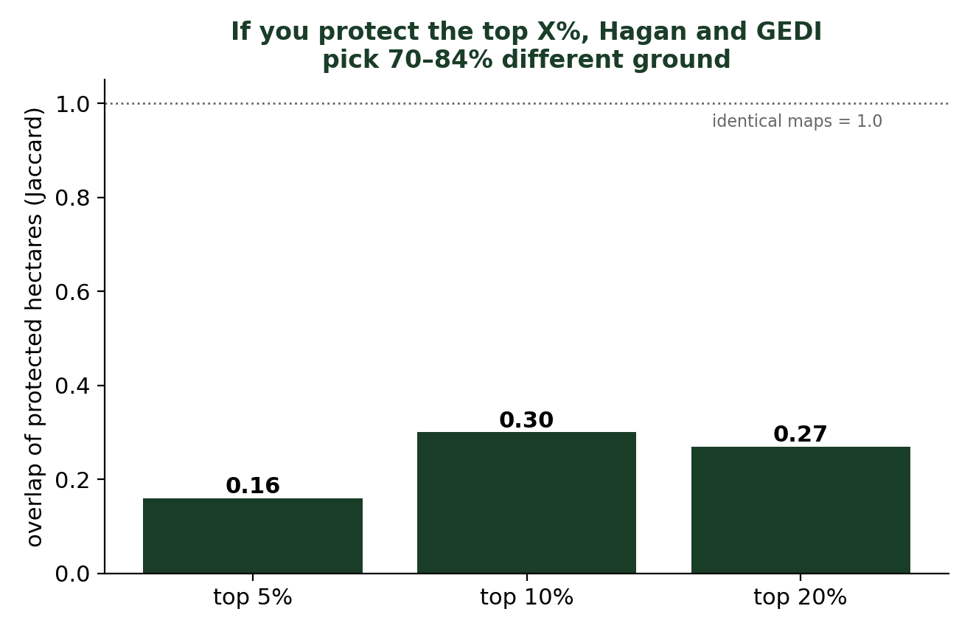
Figure 4. 70 to 84% of the prioritized hectares differ depending on which map is used.
A $200-300 million acquisition program steered by one map would buy largely different forest than the same program steered by another equally defensible map. Spatial uncertainty, not just the headline total, is the operative risk for prioritization.

7. Is LSOG disappearing? An independent temporal test
A central premise of the urgency narrative is that LSOG is rapidly disappearing (Hagan reports 1.37%/yr loss across the study area, 2.19%/yr on commercial timberland). We tested that with two independent measurements of the LSOG stock over the same unorganized townships: TreeMap imputation for 2016, 2020, and 2022, and the FIA design-based plot panels. Both lines show LSOG stable to increasing, the opposite sign.
Line | 2016 | 2020 | 2022 | Annual change
TreeMap any-LSOG (UT) | 6.5% | 7.9% | 7.8% | +3.2%/yr
FIADB v5.1 any-LSOG (ME plots) | 12.2% (2014-18) |  | 13.7% (2019-23) | +2.4%/yr
Hagan premise |  |  |  | -1.37 to -2.19%/yr
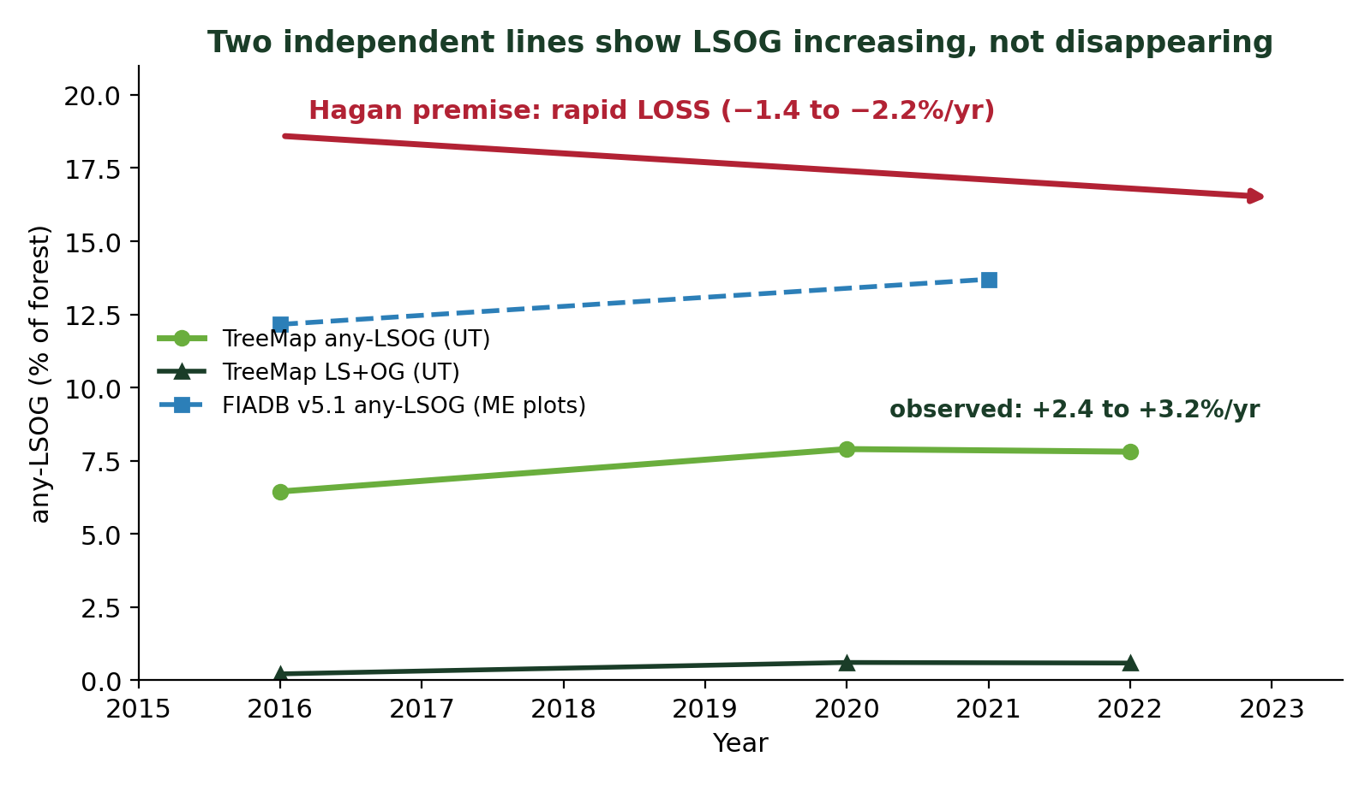
Figure 5. Two independent stock measurements (TreeMap and FIADB) show LSOG increasing, against Hagan's claimed rapid loss.
How can both be true? Hagan's "loss" is a gross harvest flux, the count of mapped LSOG hectares that experienced more than 30% canopy removal in the Global Forest Watch record, not a remeasured stock. It does not net out ingrowth, the younger stands that mature into LSOG condition each year. FIA and TreeMap measure the net stock, which rises when aging more than replaces the hectares harvested. Hagan correctly measures that LSOG stands are being harvested at roughly 2%/yr; FIA and TreeMap correctly measure that the total stock is not declining. Both are real and answer different questions, consistent with Birdsey et al. (2025).
Caveats. TreeMap year differences blend real change with FIA-panel vintage and imputation-model updates, so the robust signal is the direction (not declining), shared with the design-based FIA plots, rather than the precise rate. Adding TreeMap as a third method also widens the amount disagreement to about 2.8 times (7.8% to 21.9% any-LSOG).

8. Recommendations
- Report LSOG extent as a range across methods with explicit uncertainty, not a single hectare figure.
- Treat single-map, patch-level prioritization for large expenditures with caution, and pair it with field verification before acquisition.
- Anchor the mappable definition in FIA field structure (the v5.1 target) and use GEDI canopy height as the wall-to-wall predictor; this is the most defensible product, but it remains one uncertain estimate among several.
- Distinguish harvest flux from net stock: report both the rate at which LSOG stands are harvested and the trend in total LSOG area, which are different quantities pointing in different directions.
- Ensure reports informing LD 1529, including Thompson et al. (2026), carry the mapping uncertainty and the stock-versus-flux distinction in the headline rather than the appendix.

Appendix: the disagreement is genuine, not a reproduction error
We reproduced Hagan's published random forest from the public Zenodo deposit (binary accuracy 94.2% versus the published 94.1%; same top predictor), reproduced the wall-to-wall areas to within rounding, and confirmed that the privately shared Seven Islands raster equals the published model (pixel-level Cohen kappa 0.97 across 289,703 hectares). A 20-seed ensemble, a coordinate-fuzz test, and a 2,000-sample bootstrap all confirm the figures above are robust. The divergence among methods therefore reflects real methodological and definitional differences in how LSOG is identified, not an error in any one reproduction.

Sources
Hagan, J.M., Shamgochian, B., Taylor, M.M.L. & Reed, J.M. (2026). Using LiDAR to quantify, map, and conserve late-successional and old-growth forest in Maine, USA. Ecosphere 17:e70670. doi.org/10.1002/ecs2.70670
Thompson, J.R., Daigneault, A., Plisinski, J., Moon, I. & Norton, J. (2026). Pathways for Protecting Maine's Remaining Late-Successional and Old-Growth Forests. Property and Environment Research Center.
Potapov, P. et al. (2021). Mapping global forest canopy height through GEDI and Landsat. Remote Sensing of Environment 253, 112165.

