# Site-to-Site VPN configuration-Windows Server 2019

Setup:

-Windows-Debian subnet: 10.10.10.0/24

-First GRE subnet: 10.20.20.0/24

-Second GRE subnet: 10.30.30.0/24

-Install Remote Access -> DirectAccess and VPN (RAS)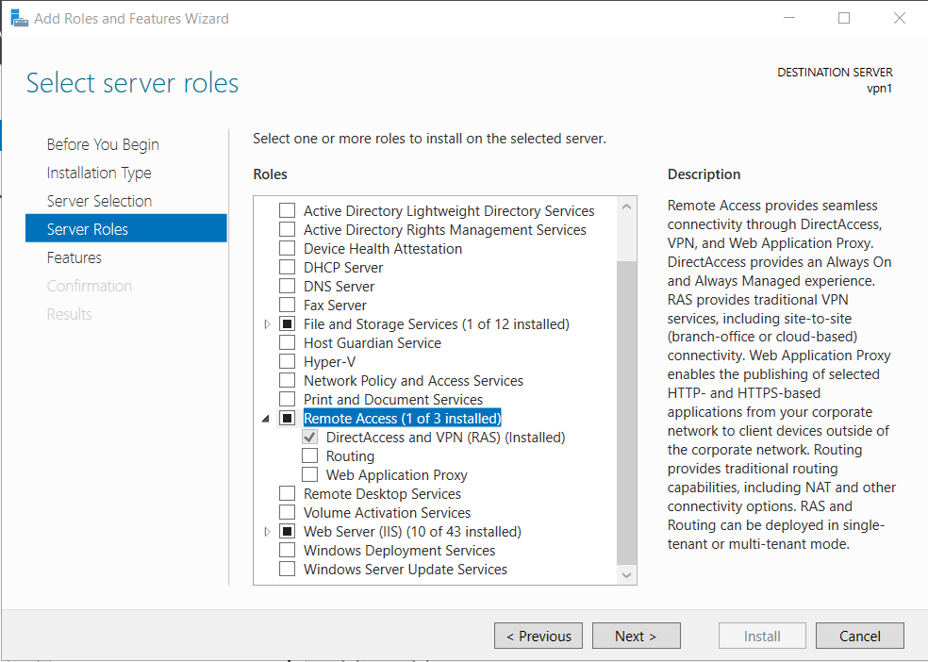

-In Routing and Remote Access -> New Demand-dial Interface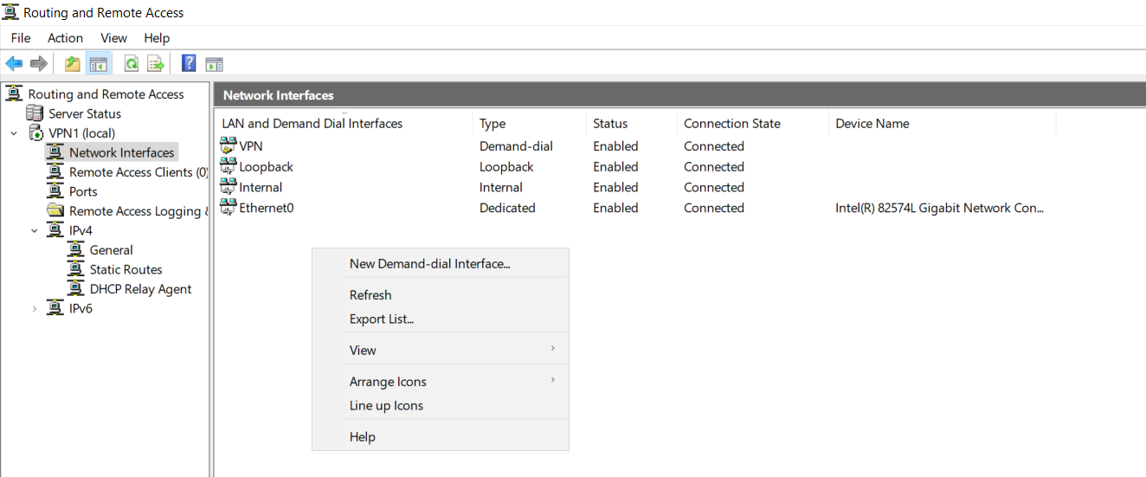

-Give the interface a name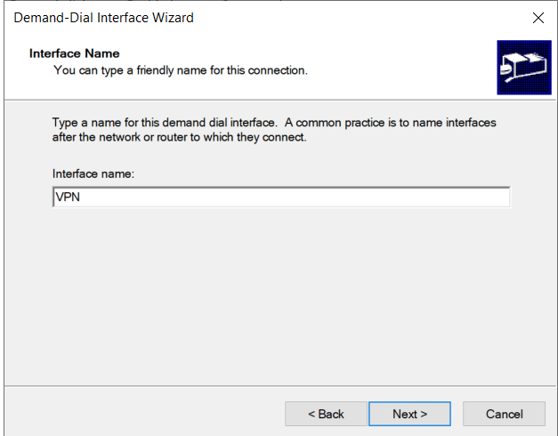

-Connect using VPN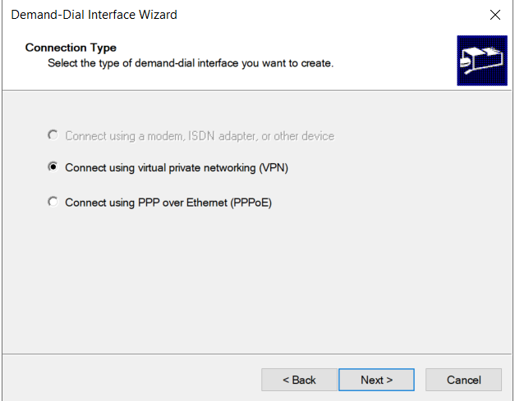

-Select Ikev2 as VPN type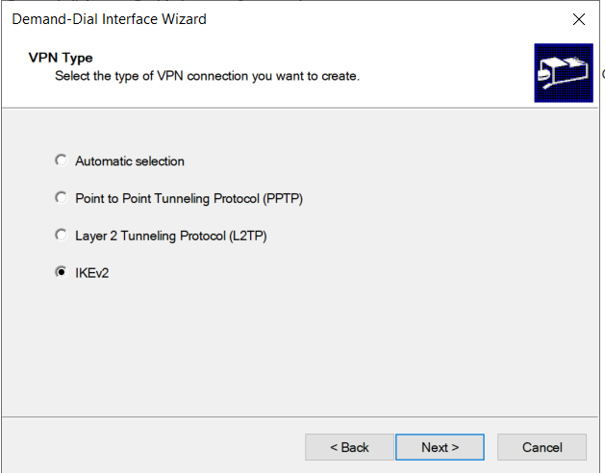

-Destination address: Other VPN server to connect to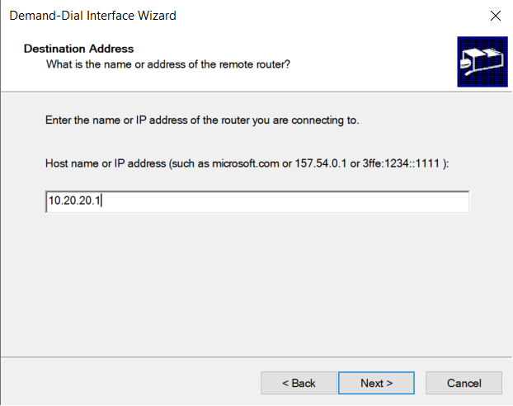

-Tick only: Route IP packets on this interface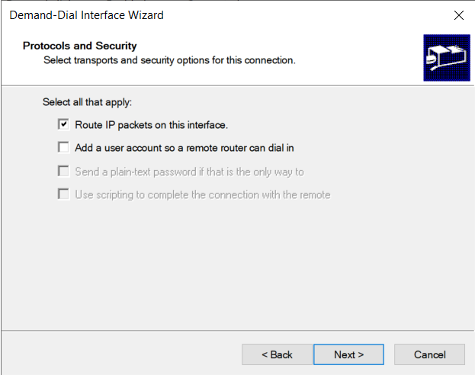

-Don’t need to add static route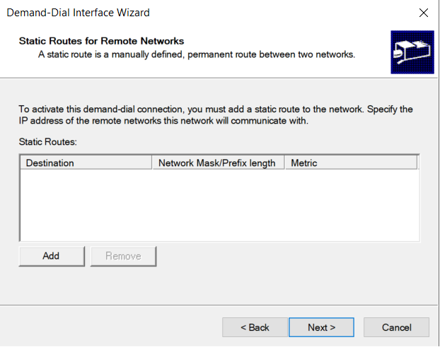

-Set the username to tun0, after this click finish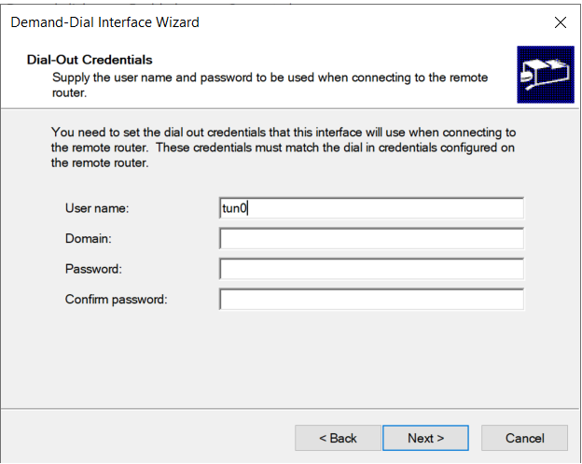

-Right click on the new interface and go to Properties -> Security;

-Set data encryption to: Optional encryption then select: Use preshared key for authentication, then add a preshared key

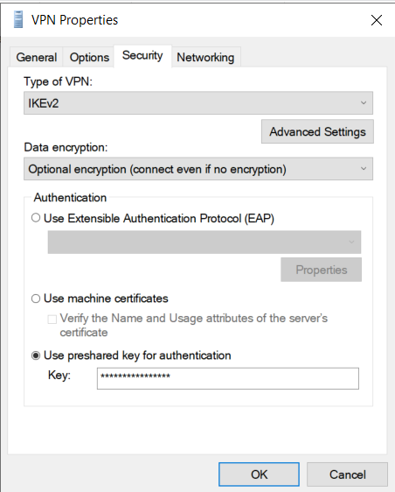

-Right click on the interface again and click on connect to connect to the other VPN server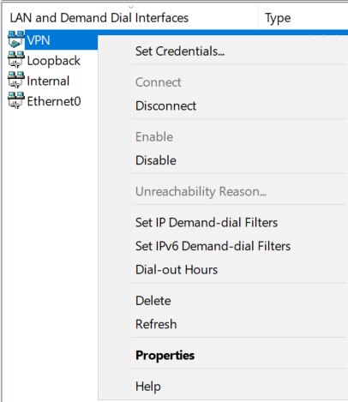

-Open Powershell and create 2 GRE tunnels with the following commands, just fill out with the appropriate values

Add-VpnS2SInterface -Name GRE -Destination 10.10.10.1 -IPv4Subnet 10.20.20.0/24:100 -PassThru -SourceIpAddress 10.10.10.2 -GreTunnel -IPv4Address 10.20.20.2

Add-VpnS2SInterface -Name GRE2 -Destination 10.20.20.1 -IPv4Subnet 10.30.30.0/24:100 -PassThru -SourceIpAddress 10.20.20.2 -GreTunnel -IPv4Address 10.30.30.2

-You can check the interfaces with: Get-VpnS2SInterface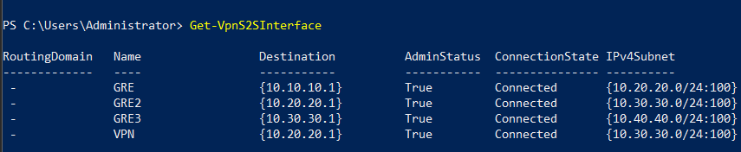

-Open Windows Firewall and go to Connection Security Rules -> Right click and click on New rule…

-On Rule type click on Tunnel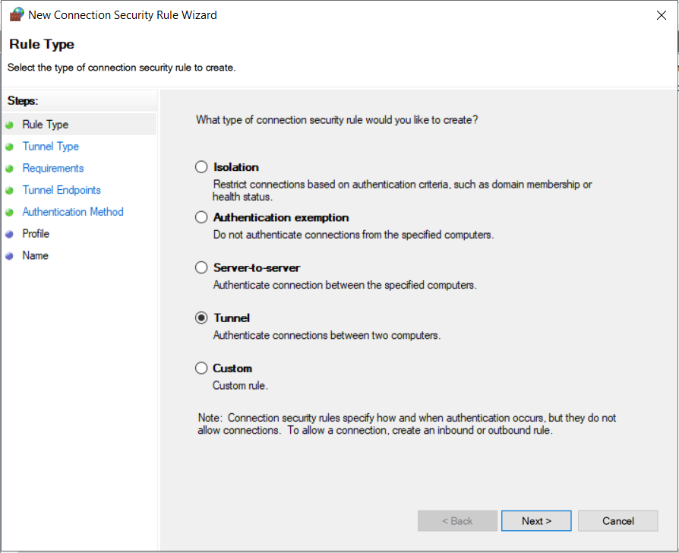

-On Tunnel type, select Custom configuration on top and select No at the bottom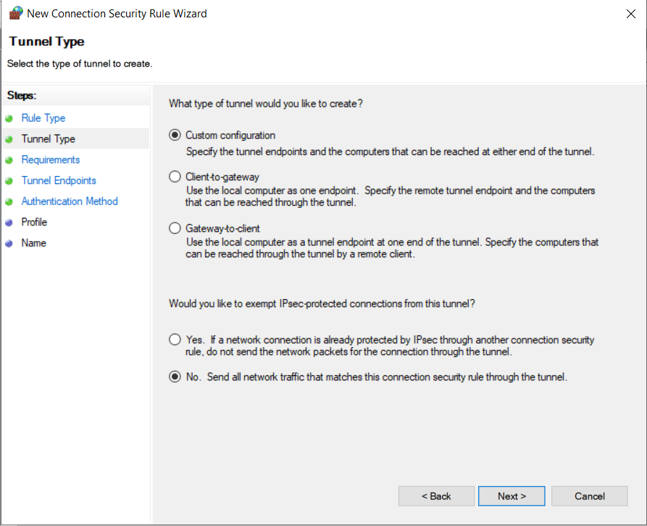

-On Requirements click on Do not authenticate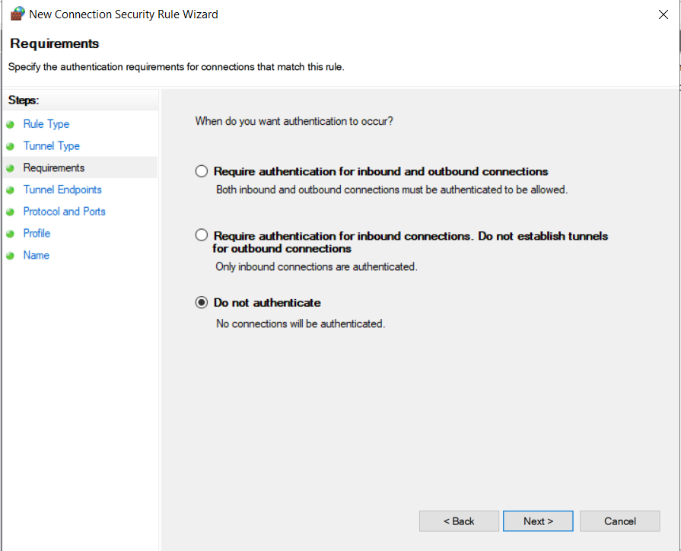

-On Tunnel Endpoints click on Add and add a subnet that contains every subnet that the VPN uses. In this setup: 10.0.0.0/8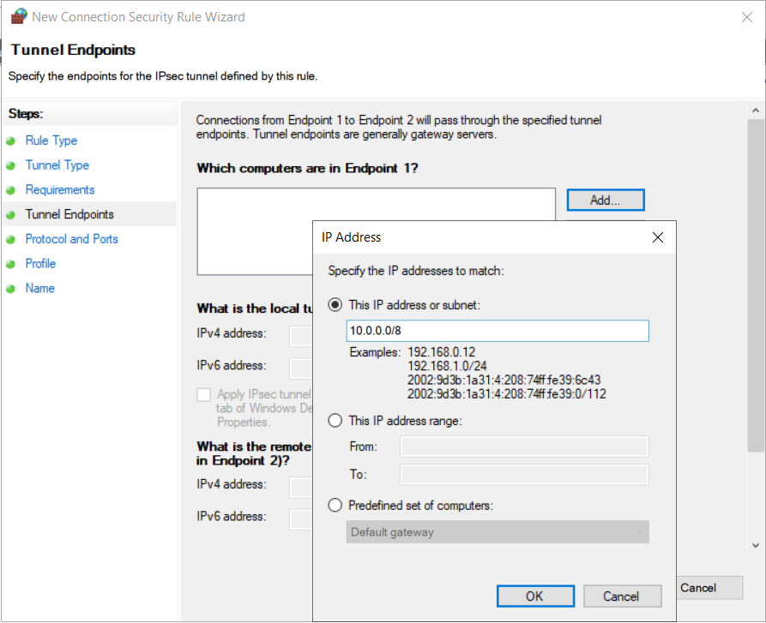

-On Protocols and Ports select Any as protocol type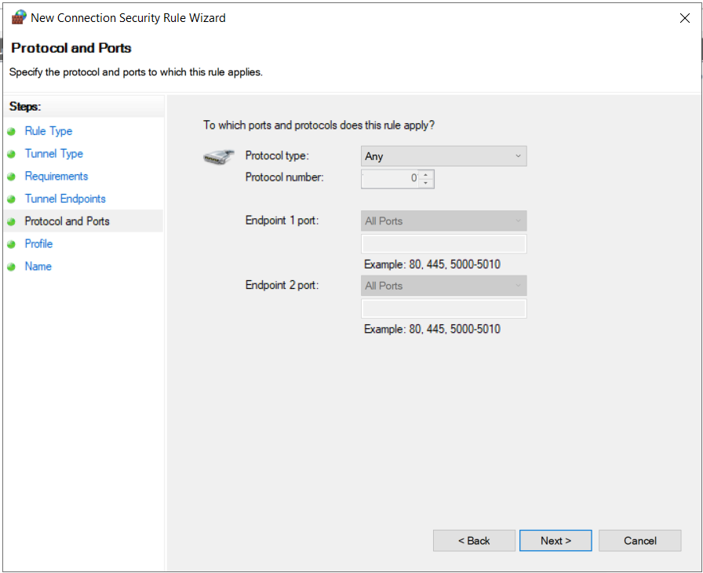

-On Profile, tick everything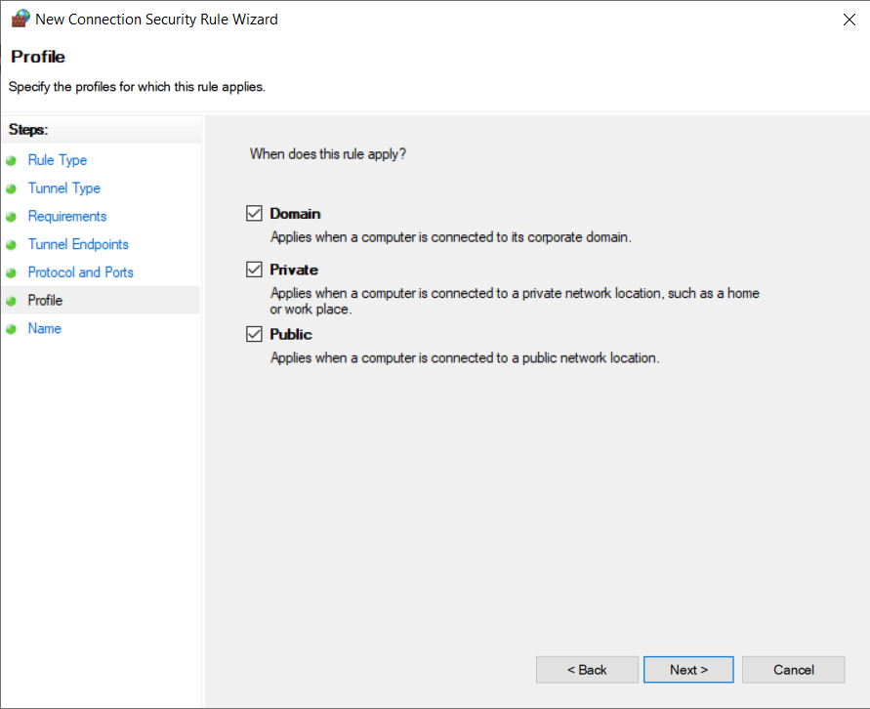

-On Name give the rule a name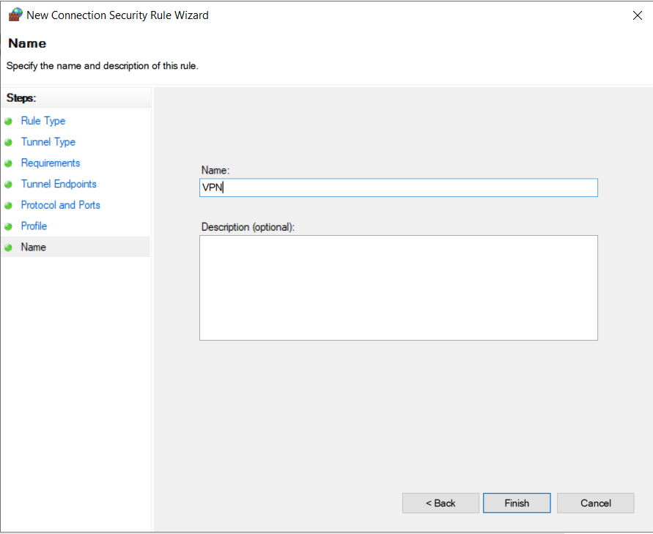

-Enable pinging to test the connection and encryption:

-Go to Inbound rules and click on New rule… -> On Rule type click on Custom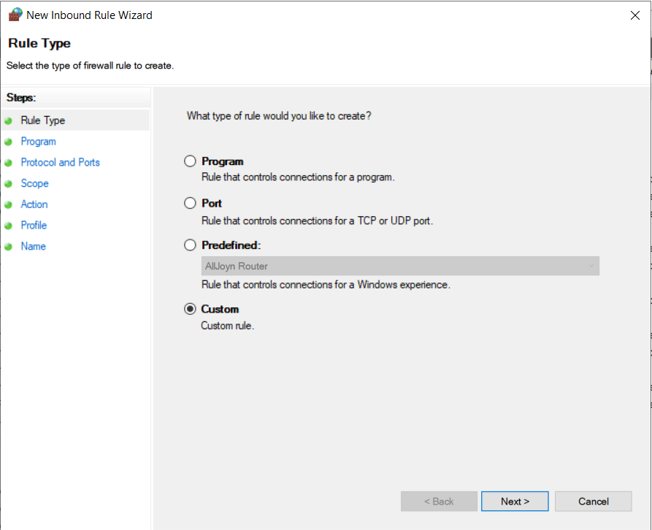

-On Program select All programs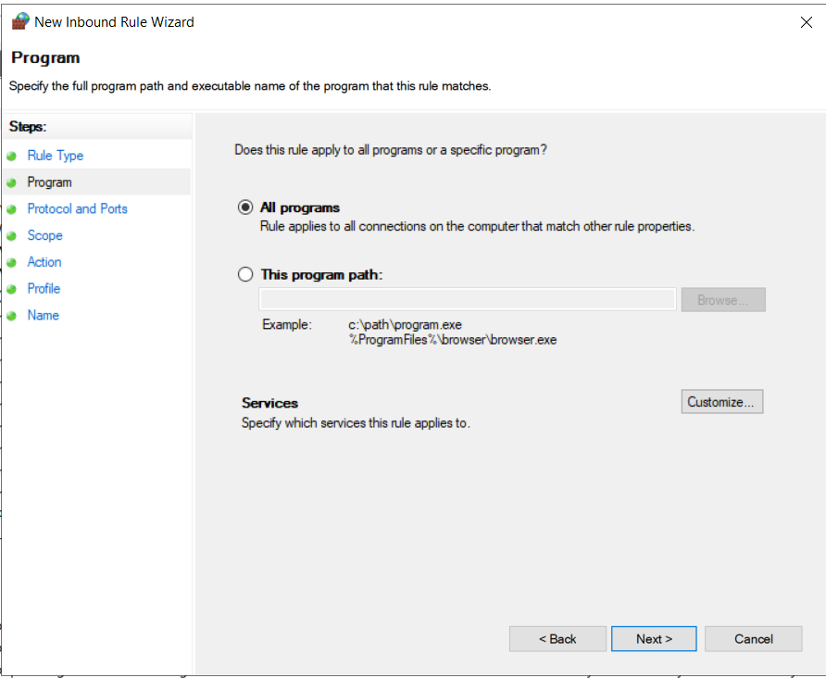

-On Protocols and Ports select ICMPv4 as protocol type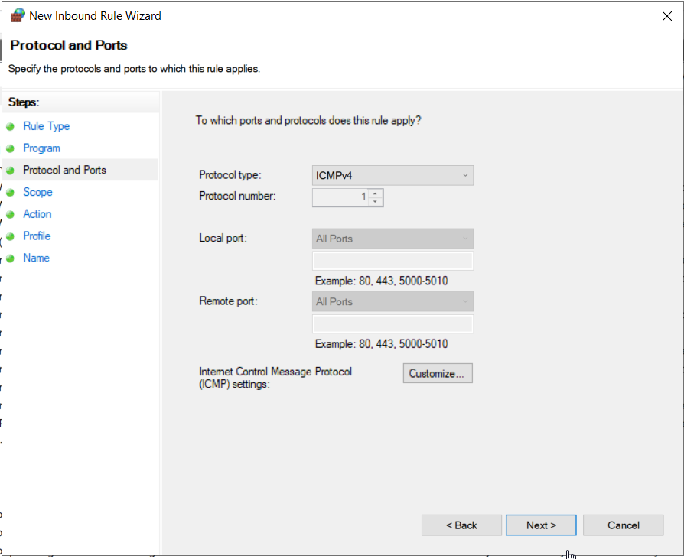

-On scope leave any address on both local and remote IP addresses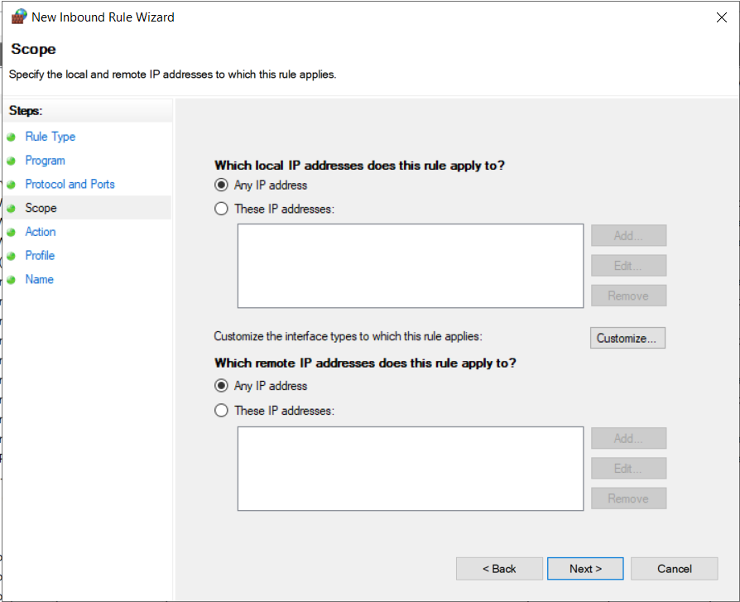

-On Action select Allow the connection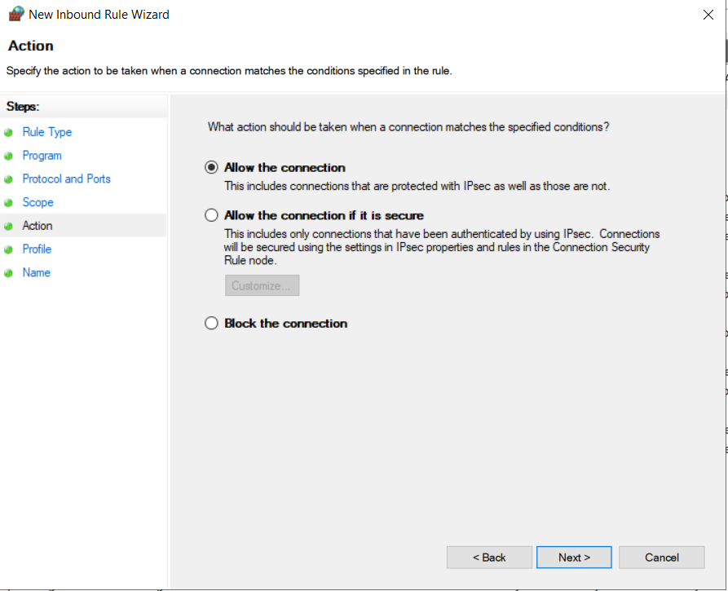

-On profile, tick everything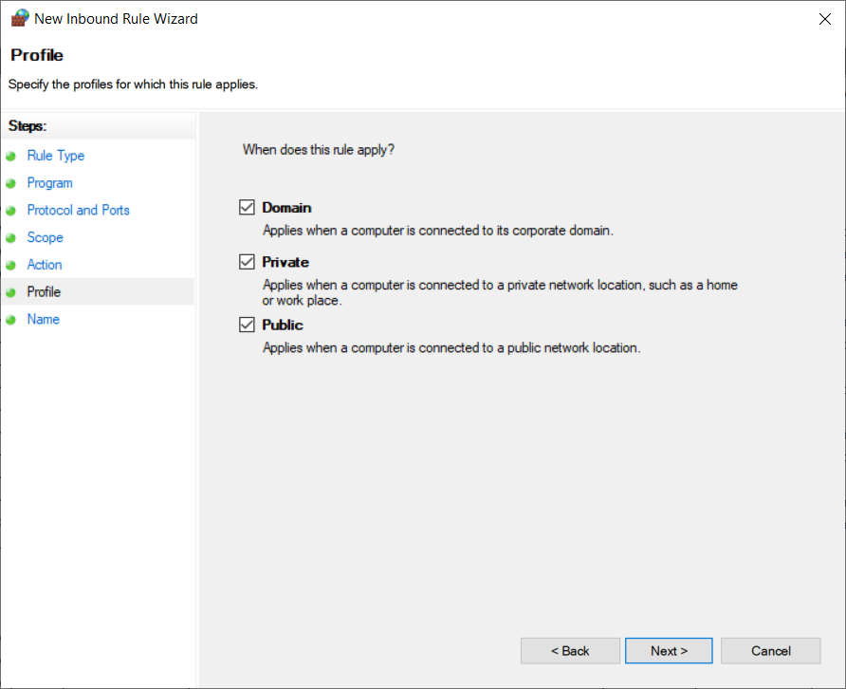

-On name, give the rule a name then finish