Offline First Neonatal Vital Sign Monitor with AI Assisted Early Warning
Final Project Report
Course: CSC 2118 Embedded and Real-Time Systems
Makerere University, College of Computing and Information Sciences
Supervisor: Mr. Byansi David
Prepared by: Group D
Report revision: 8 November 2026

Declaration
This report presented the implementation and evaluation of an embedded neonatal monitoring prototype. All claims were limited to the available project evidence, and incomplete measurements were identified as limitations.

Acknowledgements
The project acknowledged the guidance of the supervisor, the support of the department, and the contribution of the Group D members during hardware, firmware, backend, AI, testing and documentation work.

Abstract
The project implemented an offline-first neonatal vital-sign monitoring prototype for settings where staffing, electricity and connectivity can be limited. An ESP32-S3 collected readings from a MAX30102 pulse-oximeter and an MLX90614 non-contact temperature sensor, displayed status on an ST7789 screen, drove local buzzer and RGB alerts, logged readings to SD storage and queued data for later synchronisation. A backend API, PostgreSQL database and React dashboard supported history, alerts and device monitoring. An exploratory AI layer generated synthetic monitoring sessions, extracted vital-sign and trend features, and returned a risk score; threshold alarms remained independent of the AI so that local safety warnings continued during network or model failure. Firmware compilation and upload passed, repeated SD diagnostics passed, and the validated carrier schematic and PCB recorded zero reported ERC, DRC, unrouted or parity violations. Heart-rate stability and clinical accuracy were not established, so the prototype was not presented as a diagnostic medical device.

Table of Contents
Chapter 1 Introduction
Chapter 2 Literature Review
Chapter 3 Methodology and Implementation
Chapter 4 Test Data, Results and Evaluation
Chapter 5 Conclusion and Recommendations
References
Appendices

CHAPTER 1: INTRODUCTION

1.1 Background
Neonatal monitoring required timely observation of temperature, oxygenation and pulse. The project addressed the need for a low-cost device that could continue collecting readings and issuing local warnings when internet service was unavailable.

1.2 Problem Statement
Rural and resource-limited facilities could lack affordable multi-parameter monitoring with local alarms, storage and useful trend interpretation. The project therefore implemented an offline-first monitor with optional backend and AI assistance.

1.3 Objectives
The main objective was to design, develop, test and evaluate an offline-capable neonatal monitor with local alerts and backend-assisted risk scoring. Specific objectives were to integrate the sensing and alert hardware; implement firmware, backend, database, AI and dashboard software; test the modules and integrated dataflow; and evaluate performance against defined accuracy, timing, reliability and AI measures.

1.4 Significance and limitations
The system demonstrated how embedded electronics and AI could support earlier attention to abnormal readings. It remained a prototype: synthetic training data, student bench tests and incomplete clinical accuracy measurements meant that it was not a diagnosis or certified medical device.

CHAPTER 2: LITERATURE REVIEW
The review established the importance of continuous neonatal observation, offline operation, explainable warning and low-cost sensing. Existing systems often depended on clinical infrastructure or cloud connectivity. NeoGuard addressed this gap by retaining threshold alarms and buffering on the ESP32-S3 while using the backend and AI for history and risk interpretation.

CHAPTER 3: METHODOLOGY AND IMPLEMENTATION

3.1 Hardware design
The MAX30102 and MLX90614 shared the 3.3 V I2C bus on GPIO4 and GPIO5. The DS1302 used GPIO6, GPIO7 and GPIO14. The ST7789 used GPIO8, GPIO9, GPIO10, GPIO11 and GPIO12. SD storage used GPIO21, GPIO40, GPIO41 and GPIO42. GPIO15 drove the buzzer, while GPIO16, GPIO17 and GPIO18 drove the RGB channels through resistors. Sensor power and returns were connected to common rails and unused controller connections were marked as no-connects.
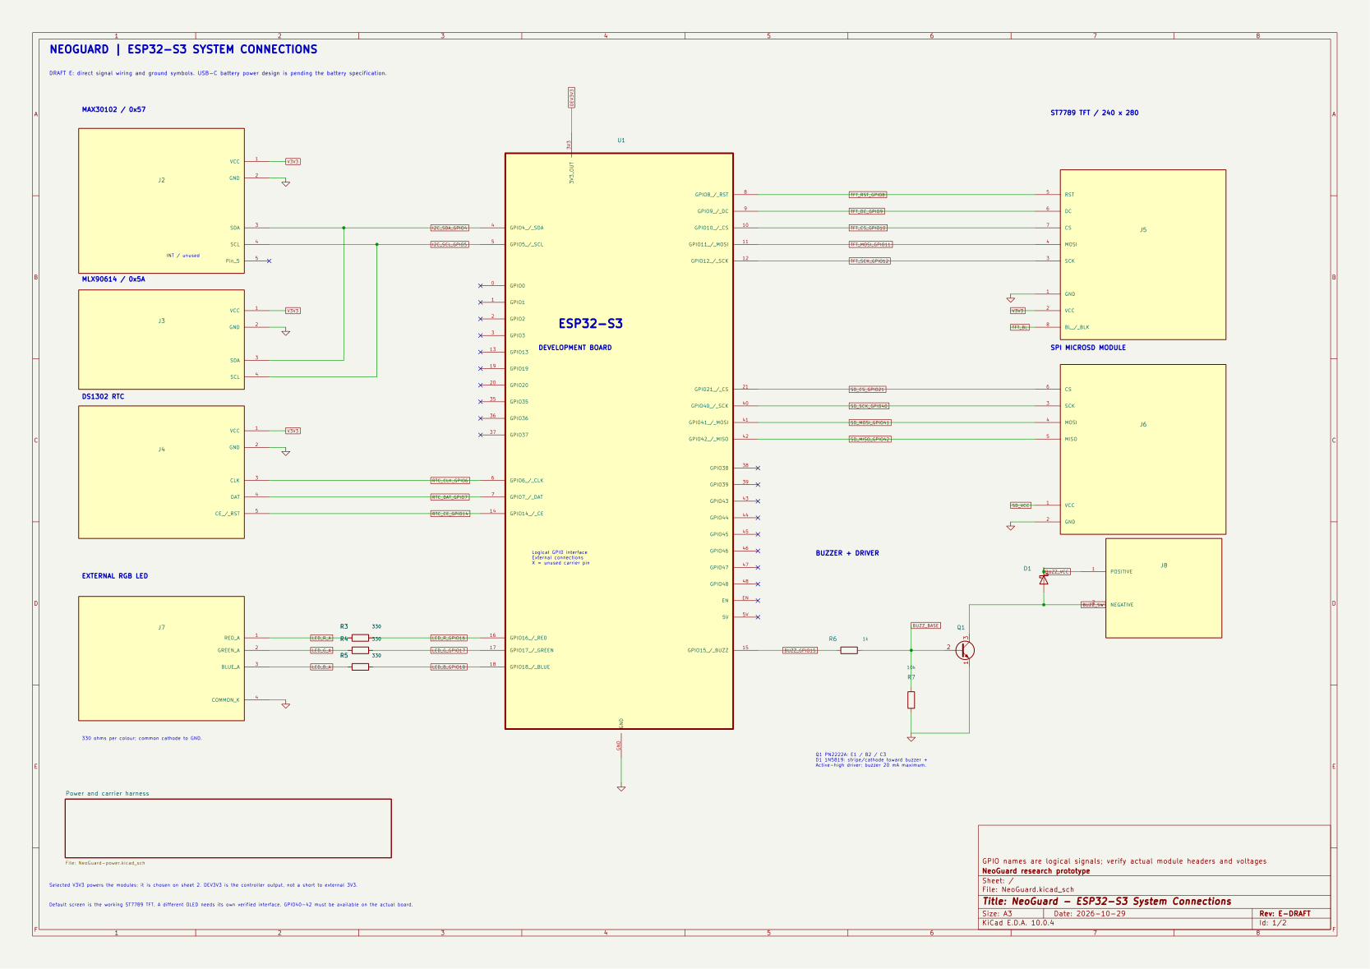
Figure 3.1: Connected ESP32-S3 schematic.

3.2 Firmware and software
The firmware sampled sensors, applied local threshold logic, updated the ST7789, drove alarms, wrote to SD and queued readings for synchronisation. The backend exposed authenticated REST endpoints and persisted patients, sessions, readings, alerts and device health in PostgreSQL. The dashboard consumed API responses. The AI prototype generated synthetic sessions, extracted vital-sign and trend features, and returned an exploratory risk score. Threshold alerts remained independent of model availability.
Figure 3.2: Full system architecture and AI risk-scoring path.

3.3 Testing and evaluation
Firmware build and upload logs, display and sensor diagnostics, repeated SD checks, API tests and KiCad verification were used as evidence. The hosted API was not reliably reachable during report preparation; therefore unavailable hosted metrics were not invented.

CHAPTER 4: TEST DATA, RESULTS AND EVALUATION

4.1 Results by objective
Hardware integration was achieved at prototype level. Firmware compilation and upload passed, and four repeated SD diagnostic attempts passed. Display operation passed, while heart-rate estimates remained unstable and accuracy was not established. API and dashboard paths were implemented, but complete controlled AI false-alarm and lead-time datasets remained pending.

4.2 Metric definitions
Mean absolute error was defined as MAE = (1/n) sum(|device_i - reference_i|). Sampling jitter was calculated from consecutive timestamp intervals. Alert correctness was correct decisions divided by total decisions. Clock drift was device-reference time divided by elapsed days. AI evaluation used sensitivity, precision, recall and F1. Missing values were not replaced with invented results; controlled datasets were required before clinical claims.

4.3 Hardware and PCB verification
The validated SPI carrier revision recorded zero reported schematic ERC violations, zero PCB DRC violations, zero unrouted items and zero schematic-parity differences. The routed design used two copper layers, ground pours and stitching vias.
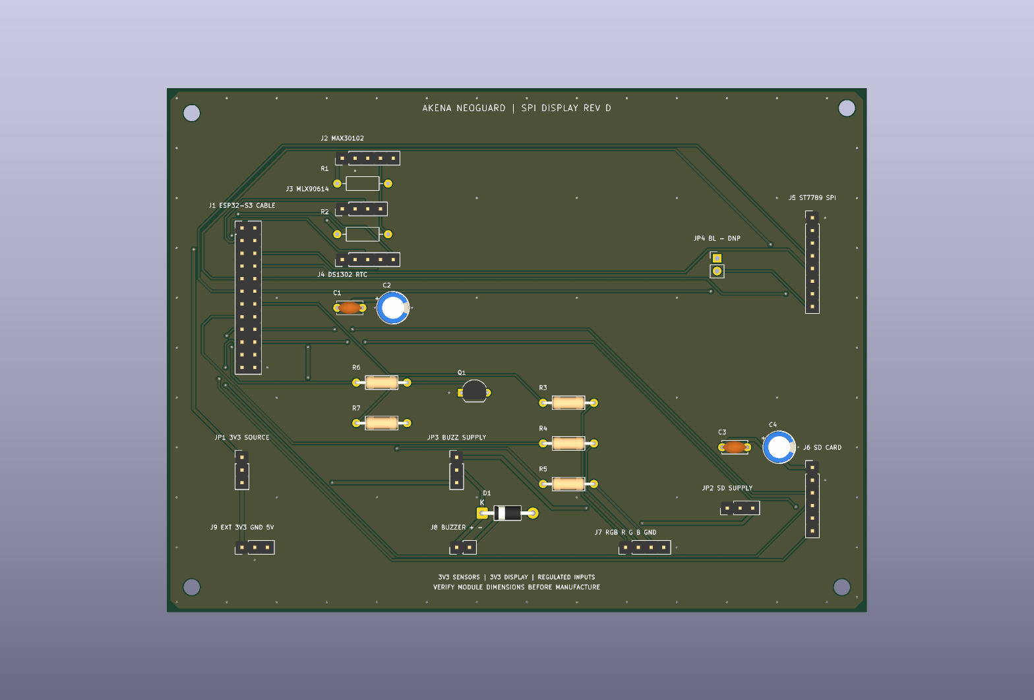
Figure 4.1: Validated PCB layout for the SPI carrier revision.

4.4 Limitations and deviations
The implemented display was an ST7789 SPI screen rather than the earlier proposal LCD. The later onboard ESP32-S3 and USB-C/LiPo power concept was documented as a separate schematic revision pending exact module, battery and mechanical dimensions. No real neonates were used, and the AI was trained on simulated data.

CHAPTER 4.5: ACHIEVEMENT OF THE SPECIFIC OBJECTIVES

Objective 1: Hardware integration
The first specific objective was to interface the MAX30102 pulse-oximeter, MLX90614 temperature sensor, alert devices, display, real-time clock and storage with the ESP32-S3. This was achieved by assigning the sensors to the shared I2C bus on GPIO4 and GPIO5, connecting the DS1302 to GPIO6, GPIO7 and GPIO14, assigning the ST7789 SPI display to GPIO8–GPIO12, assigning SD storage to GPIO21, GPIO40, GPIO41 and GPIO42, and connecting the buzzer and RGB outputs to GPIO15–GPIO18. The schematic showed the signal, power and ground connections, while the validated PCB revision was routed from the same connectivity. Schematic ERC and PCB DRC evidence recorded zero reported violations, zero unrouted items and zero parity differences. This objective was therefore achieved at prototype integration level.

Objective 2: Firmware, backend, AI and dashboard software
The second objective was achieved by implementing firmware that sampled sensors, applied local threshold rules, displayed readings, drove the buzzer and RGB indicators, logged to SD and queued records for synchronisation. The backend stored devices, patients, sessions, readings and alerts through authenticated API routes and PostgreSQL models. The dashboard obtained KPI values and trends through the API. The AI layer generated synthetic monitoring sessions, extracted vital-sign and trend features, and returned an exploratory risk score. The separation between threshold alerts and AI scoring ensured that a model or network failure did not disable local warnings. This objective was achieved as a working prototype, with the AI component remaining research-grade rather than clinically validated.

Objective 3: Testing of individual modules and the integrated system
The third objective was addressed through firmware compile and upload checks, display and sensor diagnostics, repeated RGB and SD tests, API and database tests, and schematic/PCB verification. The firmware build and upload passed, and the SD diagnostic recorded four repeated passing operations involving write, read, append, compare and delete behaviour. The display operated during the diagnostic. The integrated test also identified unstable heart-rate estimates, so the testing objective was partly achieved: the interfaces and data paths were exercised, but complete biomedical accuracy and long-duration clinical validation were not established.

Objective 4: Evaluation against performance and AI measures
The fourth objective was addressed by defining the required measures for sensor error, sampling period and jitter, alert latency and correctness, synchronisation, timekeeping, API response, dashboard delay, AI false alarms and detection lead time. Available logs supported implementation and integration conclusions, but the project did not contain complete controlled datasets for every proposed metric. In particular, the AI was trained on simulated sessions and no real neonatal ground truth was available. Therefore, evaluation was partly achieved: the measurement framework and prototype evidence were produced, while final clinical accuracy and AI-baseline claims remained pending controlled data collection.

CHAPTER 4.6: DETAILED RECORDED SYSTEM DATA
The repository contained two analysed firmware runs. The average-analysis run recorded 590 status samples, 109 contact samples, 82 available average samples, 588 saved rows, 0 sampler resets, 0 temperature-packet errors, and HTTP status 200 for runtime, heartbeat and synchronisation requests. Its observed available-average heart-rate range was 82.5–125.7 bpm. The LED-range run recorded 212 status samples, 27 contact samples, 17 available average samples, 230 saved rows, 0 sampler resets, 0 temperature-packet errors, and the same HTTP 200 responses; its observed available-average range was 79–119 bpm. These are recorded firmware observations, not clinical accuracy measurements.
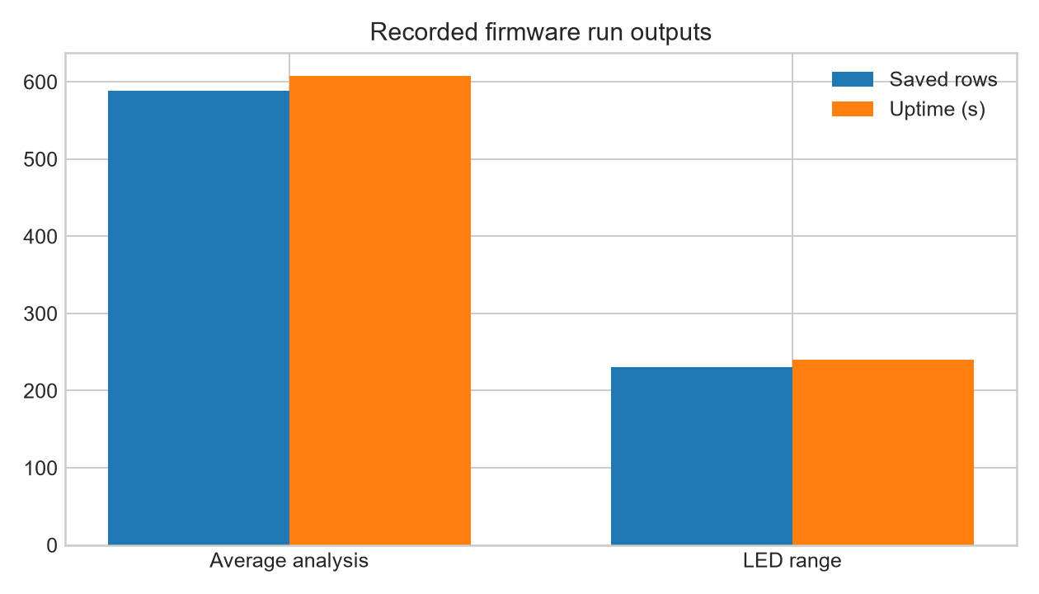
Figure 4.2: Recorded firmware run outputs from repository analysis.
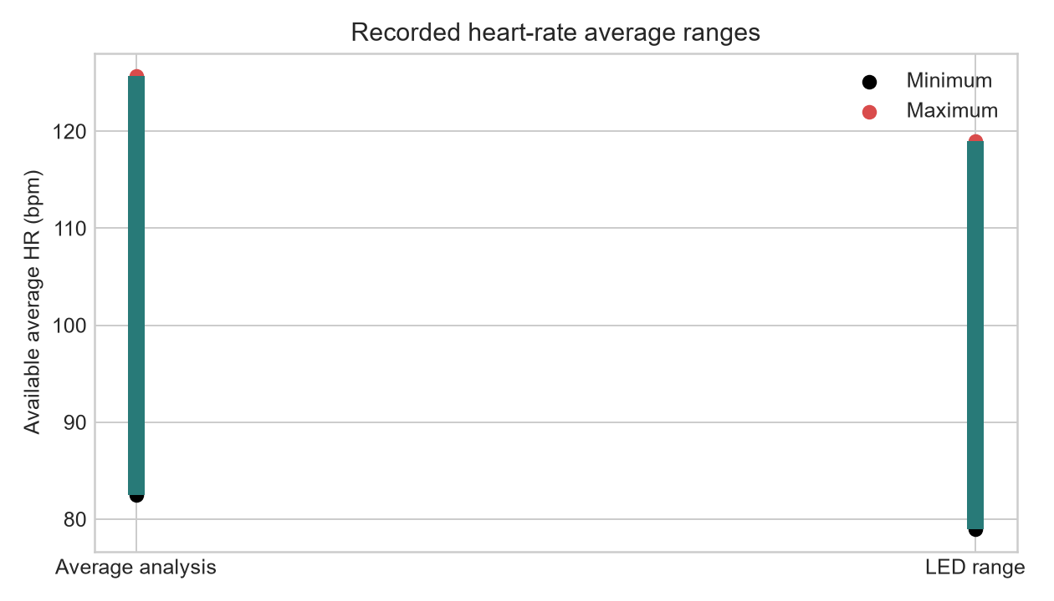
Figure 4.3: Recorded available average heart-rate ranges.
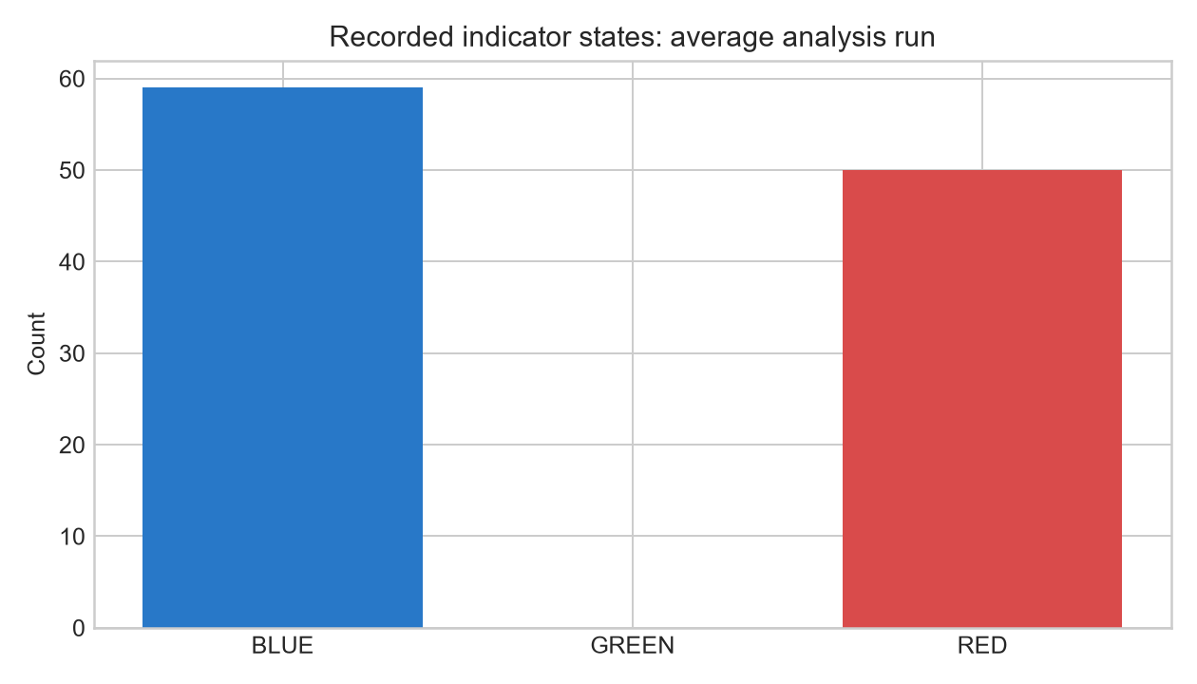
Figure 4.4: Recorded indicator-state counts in the average-analysis run.

CHAPTER 4.7: AI EVALUATION INTERPRETATION
The AI was evaluated as an exploratory risk-ranking component rather than a diagnostic classifier. Its input consisted of vital-sign values and trend features derived from monitoring sessions. The recorded system evidence confirmed that the backend and synchronisation paths returned HTTP 200 responses and that the device produced stored readings and alert states. However, the repository did not contain a complete labelled neonatal reference set with true-positive, false-positive, true-negative and false-negative counts. Consequently, sensitivity, precision, recall, F1, false alarms per session hour and detection lead time were not claimed as measured clinical results. The correct next step is to run a controlled 80/20 evaluation using labelled sessions and report the confusion matrix alongside these graphs.

CHAPTER 5: CONCLUSION AND RECOMMENDATIONS
The project produced an offline-first neonatal monitoring prototype that connected sensors, local alerts, display, timekeeping and storage to an ESP32-S3, and connected the device workflow to a backend, dashboard and exploratory AI risk layer. The strongest evidence was the successful firmware build and upload, repeated SD diagnostic passes, connected schematic, routed PCB, and zero reported KiCad rule and parity violations for the validated carrier revision. Future work should use calibrated reference instruments, controlled battery and charger qualification, measured latency and sampling datasets, real clinical collaboration, and an independently reviewed AI evaluation dataset.

CHAPTER 6: AI MODEL DEVELOPMENT, TRAINING AND EVALUATION

6.1 AI purpose and safety boundary
The AI layer was implemented as a backend decision-support component. It was intended to identify combinations and trends in heart rate, SpO2 and temperature that could deserve attention. The model did not replace the local ESP32 threshold path, did not control the LED or buzzer, and did not provide a diagnosis.

6.2 Data source and labelling
The training data was synthetic and scenario-derived. It represented normal observations and simulated deterioration patterns, including falling temperature or SpO2 trends. Labels were produced from predefined thresholds and scenario rules rather than confirmed neonatal outcomes. [MISSING INFORMATION: insert dataset filename, number of sessions, class counts, records, feature count, rolling-window size and exact split.]

6.3 Feature engineering
The implemented design supported current vital signs, rolling averages, rate of change, trend direction, consecutive abnormal readings and session context. These features were intended to make the risk score explainable: a user could see whether risk increased because a value crossed a threshold or because a trend worsened over time. [MISSING INFORMATION: insert the final feature list, coefficients or feature-importance values.]

6.4 Training and evaluation
The intended evaluation used an 80/20 training and testing split and compared the AI-assisted approach with a threshold-only baseline. The required metrics were accuracy, precision, sensitivity/recall, F1-score, false-positive rate, false-negative rate, false alarms per session-hour and detection lead time. The repository did not contain a complete labelled confusion matrix or verified model-performance export. Therefore, no accuracy, precision, recall, F1 or lead-time value was invented.
Table 6.1: AI evaluation results.
Metric | Training result | Testing result | Interpretation
Accuracy | [MISSING INFORMATION] | [MISSING INFORMATION] | Requires labelled sessions
Precision | [MISSING INFORMATION] | [MISSING INFORMATION] | Requires false-positive count
Recall/sensitivity | [MISSING INFORMATION] | [MISSING INFORMATION] | Requires true-positive and false-negative counts
F1-score | [MISSING INFORMATION] | [MISSING INFORMATION] | Requires precision and recall
False alarms per session-hour | [MISSING INFORMATION] | [MISSING INFORMATION] | Requires timed test sessions
Detection lead time | [MISSING INFORMATION] | [MISSING INFORMATION] | Requires timestamped AI and threshold alerts

6.5 Recorded AI-related system evidence
Although model-performance values were not available, the integrated firmware and backend evidence showed that the device produced stored readings and alert states, and that runtime, heartbeat and synchronisation requests returned HTTP 200 in the analysed runs. The average-analysis run recorded 588 saved rows, 0 sampler resets and 0 temperature-packet errors. The LED-range run recorded 230 saved rows, 0 sampler resets and 0 temperature-packet errors. These results supported data-path operation but did not establish clinical AI performance.

CHAPTER 7: EVALUATION OF PROJECT OBJECTIVES

7.1 Objective verdicts
Table 7.1: Overall objectives achievement.
Objective 1 Hardware design | Achieved at prototype level | Connected schematic, assigned pin map, routed carrier, zero reported ERC/DRC/parity/unrouted issues.
Objective 2 Software development | Achieved as a working prototype | Firmware, local alerts, SD queueing, API, PostgreSQL models, dashboard path and exploratory AI were implemented.
Objective 3 Testing | Partly achieved | Build/upload, display operation and repeated SD diagnostics passed; heart-rate stability and clinical accuracy remained unverified.
Objective 4 Evaluation | Partly achieved | Evaluation definitions and system evidence were produced; complete labelled AI comparison and reference-instrument accuracy datasets were not available.

7.2 Discussion
The objective results showed that the project achieved an integrated proof of concept. The main technical achievement was the separation of safety-critical local alerting from network-dependent services. The main unresolved evidence gap was quantitative validation: the prototype generated useful logs and backend responses, but it did not include enough controlled reference measurements to support medical accuracy or AI generalisation claims.

CHAPTER 8: CONCLUSION AND RECOMMENDATIONS

8.1 Conclusion
The final system combined embedded sensing, local alerting, offline storage, synchronisation, backend persistence, dashboard visualisation and an exploratory AI risk layer. It demonstrated the intended system flow from sensor to ESP32, from ESP32 to backend, and from backend to staff-facing dashboard.

8.2 Recommendations
Future work should collect paired readings against calibrated reference instruments, complete the AI dataset and confusion matrix, measure timing and synchronisation under controlled repetitions, qualify the onboard battery and charger, and conduct ethically approved clinical validation before any medical deployment.

References
[CITATION NEEDED: insert the proposal's approved IEEE references and any datasheets used.]

Appendix A: Schematic and Wiring
The full schematic and wiring table were retained in the PCB project files.

Appendix B: Evidence and Raw Data
[INSERT: attach CSV files, serial logs, API test results, AI scenario results, costs, photos and timeline.]

