OFFLINE-FIRST NEONATAL VITAL SIGN MONITOR WITH AI-ASSISTED EARLY WARNING
Final Project Report
Course: CSC 2118 Embedded and Real-Time Systems
Makerere University, College of Computing and Information Sciences
Submitted to: Mr. Byansi David
Prepared by: Group D
[MISSING INFORMATION: insert the exact group-member names, student numbers and registration numbers from the proposal.]
Date: [MISSING INFORMATION: insert approved submission date]

DECLARATION
This report documented completed project work and distinguished verified evidence from missing measurements. The device remained a screening and early-warning prototype and was not presented as a diagnostic or certified medical device.

APPROVAL
[MISSING INFORMATION: insert supervisor approval wording and signature block.]

DEDICATION
[MISSING INFORMATION: insert dedication text if required.]

ACKNOWLEDGEMENTS
[MISSING INFORMATION: insert approved acknowledgement text.]

ABSTRACT
This report presented the design, implementation, testing and evaluation of an offline-first neonatal vital-sign monitoring prototype. The implemented system used an ESP32-S3 with MAX30102 pulse-oximetry, MLX90614 non-contact temperature sensing, DS1302 timekeeping, an ST7789 SPI display, SD storage, RGB indication and a buzzer. The firmware applied local threshold logic, stored readings during connectivity loss and synchronised them through an authenticated backend when communication returned. The backend used PostgreSQL models, REST endpoints, a React dashboard and an exploratory AI risk-scoring layer. The AI used synthetic scenario-derived data and trend features; it was not clinically validated. Firmware compilation and upload passed, repeated SD diagnostics passed, HTTP runtime/heartbeat/synchronisation responses returned 200 in analysed runs, and the validated SPI carrier recorded zero reported ERC, DRC, unrouted or schematic-parity violations. Heart-rate stability, reference-instrument accuracy and complete labelled AI metrics were not established. The project therefore demonstrated an integrated proof of concept while identifying the controlled clinical and AI evaluation work required before deployment.

TABLE OF CONTENTS
Chapter 1: Introduction
Chapter 2: Literature Review
Chapter 3: System Design and Methodology
Chapter 4: System Implementation
Chapter 5: System Testing and Results
Chapter 6: AI Model Development, Training, and Evaluation
Chapter 7: Evaluation of Project Objectives
Chapter 8: Conclusion and Recommendations
References
Appendix A: Full Circuit Schematic
Appendix B: PCB Design Files and Layout
Appendix C: Complete Wiring Table
Appendix D: Firmware Code Extracts
Appendix E: Backend and AI Code Extracts
Appendix F: API Test Results
Appendix G: Test Data and CSV Samples
Appendix H: AI Training Results and Graphs
Appendix I: Dashboard Screenshots
Appendix J: Component Datasheets

LIST OF TABLES
Table 3.1 Complete wiring and interfacing table; Tables 5.1–5.x test results; Table 6.1 AI dataset; Table 6.2 feature engineering; Table 6.3 AI performance; Table 6.4 AI versus threshold baseline; Table 7.1 objectives achievement.

LIST OF FIGURES
Figures 3.1–3.3 design; Figures 4.1–4.9 implementation; Figures 6.1–6.3 AI results.

LIST OF ACRONYMS AND ABBREVIATIONS
AI – Artificial Intelligence; API – Application Programming Interface; DRC – Design Rule Check; ERC – Electrical Rules Check; GPIO – General-Purpose Input/Output; I2C – Inter-Integrated Circuit; PCB – Printed Circuit Board; REST – Representational State Transfer; SD – Secure Digital; SpO2 – Peripheral oxygen saturation.

CHAPTER 1: INTRODUCTION

1.1 Background
Neonatal hypothermia and hypoxia required timely observation. The project addressed settings where staffing, power and network connectivity could be limited by implementing local sensing, local alarms and offline storage with optional backend analysis.

1.2 Problem Statement
The project addressed the lack of an affordable multi-parameter monitor that could continue warning staff during internet outages while preserving readings for later review.

1.3 Main Objective
The main objective was to design, develop, test and evaluate a low-cost, offline-capable embedded neonatal monitoring device that generated local early-warning alerts and provided backend-assisted AI risk scoring and trend analysis when network access was available.

1.4 Specific Objectives
1. The hardware was to interface the MAX30102, GY-906 MLX90614, buzzer, LED, display and real-time clock with the ESP32. 2. Firmware, Flask/PostgreSQL services, explainable AI and a React dashboard were to be developed. 3. Hardware, firmware, backend and dashboard were to be tested individually and as an integrated system. 4. The obtained data was to be evaluated using real-time, accuracy, latency, jitter, false-alarm and detection-lead-time measures.

1.5 Significance
The system demonstrated an engineering approach for combining embedded monitoring, offline-first design and explainable AI while retaining a local safety path.

1.6 Scope and Limitations
The work covered a prototype. No real neonates were used, the AI used synthetic data, and the available evidence did not establish clinical accuracy or certification.

1.7 Report Organisation
Chapter 2 reviewed related work; Chapter 3 described design and methodology; Chapter 4 described implementation; Chapter 5 presented testing and results; Chapter 6 described AI development and evaluation; Chapter 7 evaluated the objectives; Chapter 8 concluded the report and gave recommendations.

CHAPTER 2: LITERATURE REVIEW

2.1 Introduction
The review focused on neonatal early warning, low-cost sensing, offline monitoring and explainable risk scoring.

2.2 Neonatal Hypothermia and Hypoxia
Temperature and oxygenation changes can require prompt clinical attention. The device was designed as a screening aid and not a substitute for clinical judgement.

2.3 Existing Monitoring Solutions
[CITATION NEEDED: insert the proposal’s approved literature and datasheet references.]

2.4 Comparison of Existing Solutions
Solution | Strength | Limitation
Conventional bedside monitor | Established clinical workflow | Cost and infrastructure requirements [CITATION NEEDED]
Cloud-only IoT monitor | Remote history and analytics | Connectivity dependency
NeoGuard prototype | Local alerts, buffering and backend AI path | Not clinically validated

2.5 Research Gap
The project filled a prototype gap by combining local threshold safety, offline buffering and backend-assisted trend interpretation.

2.6 Summary
The literature supported the need for resilient, explainable and low-cost monitoring.

CHAPTER 3: SYSTEM DESIGN AND METHODOLOGY

3.8 Reproducible Hardware Wiring Record
The implemented SPI carrier wiring was reproducible from the firmware and PCB records. The MAX30102 and MLX90614 shared I2C on GPIO4 (SDA) and GPIO5 (SCL). The DS1302 used GPIO6 (CLK), GPIO7 (DAT) and GPIO14 (CE). The ST7789 display used GPIO8 (RST), GPIO9 (DC), GPIO10 (CS), GPIO11 (MOSI) and GPIO12 (SCK). The buzzer used GPIO15. The RGB channels used GPIO16, GPIO17 and GPIO18. The microSD interface used GPIO21 (CS), GPIO40 (SCK), GPIO41 (MOSI) and GPIO42 (MISO). These assignments were the final implemented firmware mapping and differed from the earlier proposal LCD/GPIO21/GPIO22 arrangement.
The reproducible source records were firmware/akena_firmware/README.md, pcb/NeoGuard.kicad_sch, pcb/NeoGuard.kicad_pcb and pcb/verification_summary.json. The schematic was checked for electrical-rule errors and the carrier PCB was checked for design-rule errors, unrouted items and schematic parity.

3.9 Reproducible Software and Data Flow
The repeatable data path was: sensor acquisition on the ESP32-S3; local threshold evaluation; display and RGB/buzzer update; SD logging and queueing; Wi-Fi HTTP/JSON synchronisation; authenticated backend validation; PostgreSQL persistence; risk scoring and trend flags; and React dashboard rendering. Local threshold alerts did not depend on backend availability.

3.1 Overview of the System
The system followed a design, develop, test and evaluate process.

3.2 System Architecture
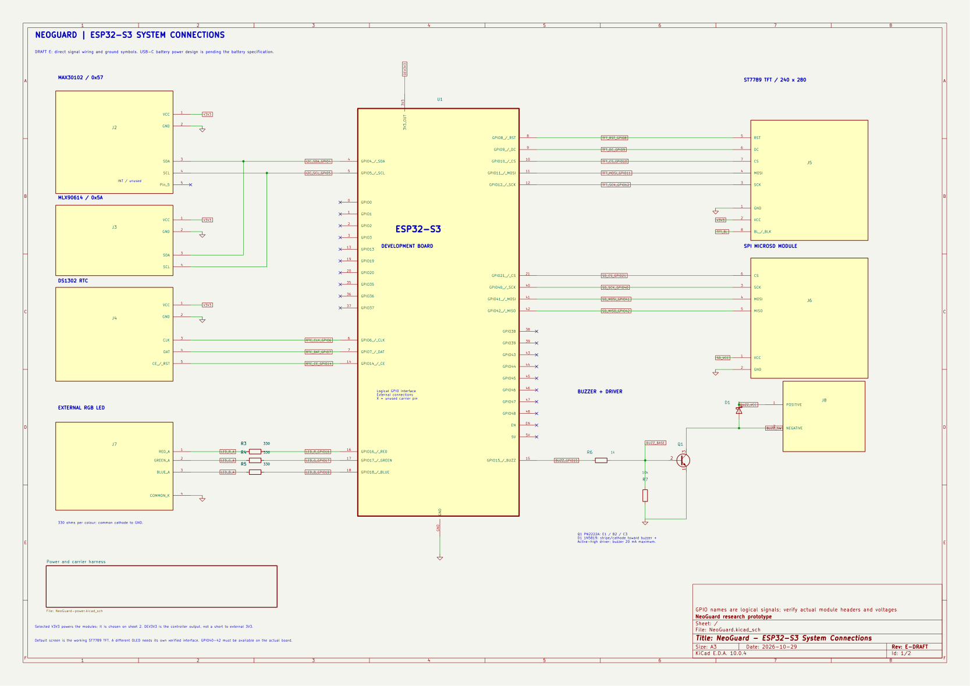
Figure 3.1: System hardware schematic and signal connections.
Figure 3.2: Full system architecture from sensors to backend, AI and dashboard.

3.3 Requirements Analysis
Functional requirements included sensing, timestamping, local display, threshold alerts, buffering, synchronisation, API persistence, dashboard display and risk scoring. [MISSING INFORMATION: insert the final numbered functional and non-functional requirements and acceptance thresholds from the approved project record.]

3.4 Hardware Design

3.4.1 Component Selection
The MAX30102 and MLX90614 were selected for compact vital-sign sensing; the ESP32-S3 provided processing, Wi-Fi and GPIO; SD storage supported offline retention; the ST7789 was used in the implemented revision instead of the proposal LCD.

3.4.2 Circuit Schematic
The final implemented SPI carrier used I2C GPIO4/GPIO5 for MAX30102 and MLX90614, DS1302 GPIO6/GPIO7/GPIO14, ST7789 GPIO8–GPIO12, SD GPIO21/GPIO40/GPIO41/GPIO42, buzzer GPIO15 and RGB GPIO16–GPIO18. This differed from the proposal’s GPIO21/GPIO22 LCD arrangement and was recorded as a deviation.

3.4.3 Wiring and Interfacing Design
Device | Interface/pins | Evidence
MAX30102 | I2C GPIO4/GPIO5 | Implemented firmware and backend health record
MLX90614 | I2C GPIO4/GPIO5 | Implemented firmware and backend health record
DS1302 | GPIO6, GPIO7, GPIO14 | Firmware pin map
ST7789 | CS10 DC9 RST8 MOSI11 SCK12 | Display diagnostic
microSD | CS21 SCK40 MOSI41 MISO42 | Repeated SD diagnostic
Buzzer/RGB | GPIO15 / GPIO16–18 | Firmware diagnostic

3.4.4 Power Supply Design
The tested carrier used the available board supply arrangement. [MISSING INFORMATION: insert measured rail voltages, current budget, battery/charger details and final power schematic.]

3.4.5 PCB Design
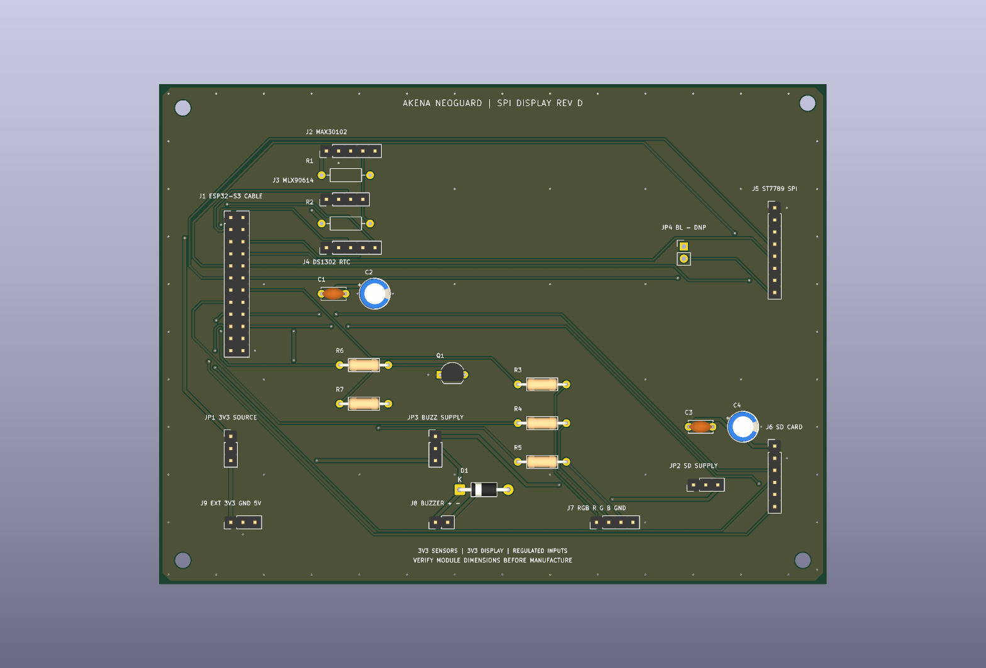
Figure 3.3: Validated two-layer SPI carrier PCB layout.
The validated carrier used two copper layers, ground pours and stitching vias. The later onboard ESP32-S3 and USB-C/LiPo concept remained a separate schematic revision pending exact production dimensions.

3.5 Software Design

3.5.1 Firmware Design
The firmware sampled sensors, applied threshold logic, updated the display, drove indicators, stored readings and synchronised queued events.

3.5.2 Local Threshold Alerting
The local alert path remained independent of Wi-Fi, the backend and AI.

3.5.3 Offline Buffering and Synchronisation
Readings were queued locally and sent later by event identity when communication returned.

3.5.4 Database Design
The backend persisted devices, patients, sessions, readings, alerts and health information in PostgreSQL.

3.5.5 REST API Design
Authenticated routes handled device, patient, session, reading, alert and risk workflows.

3.5.6 AI Risk-Scoring and Trend-Detection Design
The AI used synthetic scenarios and vital-sign/trend features to produce an exploratory risk score and explanations. [MISSING INFORMATION: insert exact model, coefficients, thresholds, window and dataset counts.]

3.5.7 React Dashboard Design
The dashboard presented live and historical values, connectivity, alerts and risk information through API responses.

3.6 Testing Strategy
Testing covered build/upload, sensor/display operation, SD storage, API/database flows, connectivity and KiCad verification.

3.7 Ethical Considerations
No real neonates were used. The device was a screening and early-warning prototype and did not replace clinical judgement.

CHAPTER 4: SYSTEM IMPLEMENTATION

4.7 Reproducible Implementation Procedure
A repeatable implementation sequence was used. First, the ESP32-S3 firmware was compiled for the ESP32-S3 target and uploaded. Second, the I2C devices were checked on GPIO4/GPIO5. Third, the ST7789 display, buzzer, RGB outputs and SD bus were exercised. Fourth, timestamped readings were logged to SD. Fifth, Wi-Fi setup and HTTP synchronisation were enabled. Finally, the backend stored readings and exposed them to the dashboard and prototype AI service.
The implemented firmware used Arduino C/C++ and FreeRTOS tasks for acquisition and network work. The display used a ten-second heart-rate average refreshed every three seconds in the integrated build. Unqualified estimates were stored as poor quality and excluded from AI inference. This quality gate was important because a stable-looking display did not by itself establish measurement accuracy.

4.8 Reproducible Backend and Security Implementation
The backend used authenticated routes, JWT bearer access tokens, Argon2 password hashes, role and clinic access checks, temporary-password lifecycle controls, device secrets, session ownership checks, idempotent event handling and separate review-only archive tables. The API smoke test exercised authentication, access control, quality-aware alerts, component health, session races, pagination, synchronisation retries and clock validation.

4.1 Introduction
The implementation converted the proposal into tested firmware, backend, AI and dashboard components.

4.2 Hardware Implementation

4.2.1 Components Used
ESP32-S3, MAX30102, MLX90614, DS1302, ST7789, microSD, RGB indicator and buzzer were used in the implemented revision.

4.2.2 ESP32 and Power Supply Wiring
The ESP32-S3 provided the processing and communication centre. [MISSING INFORMATION: insert measured power details.]

4.2.3 MAX30102 Sensor Wiring
The MAX30102 was connected on I2C GPIO4/GPIO5 and used for pulse and oxygenation readings.

4.2.4 MLX90614 Temperature Sensor Wiring
The MLX90614 shared the I2C lines and provided non-contact temperature readings.

4.2.5 DS3231 Real-Time Clock Wiring
The implemented firmware record used a DS1302 pin arrangement; this was a documented deviation from the proposal’s DS3231 wording.

4.2.6 16x2 I2C LCD Wiring
The proposal specified a 16x2 LCD, but the implemented revision used an ST7789 SPI display.

4.2.7 LED and Buzzer Wiring
The buzzer and RGB outputs were assigned to GPIO15–GPIO18.

4.2.8 Shared I2C Bus Configuration
The MAX30102 and MLX90614 shared the I2C bus on GPIO4/GPIO5.

4.2.9 Assembled Hardware Prototype
[MISSING INFORMATION: insert a clear photograph and labelled photograph of the assembled prototype.]

4.3 Firmware Implementation

4.3.1 Sensor Reading and Timestamping
The firmware collected sensor values, associated them with device time and stored them for later processing.

4.3.2 Threshold Checking and Local Alerts
Threshold logic controlled local indicator outputs independently of the backend.

4.3.3 Local Buffering
The firmware saved readings to SD and queued events for later synchronisation.

4.3.4 WiFi Communication and Synchronisation
Analysed runs returned HTTP 200 for runtime, heartbeat and synchronisation requests.

4.4 Backend Implementation

4.4.1 Flask REST API
The API validated and persisted device data.

4.4.2 PostgreSQL Database
PostgreSQL models represented devices, sessions, readings and alerts.

4.4.3 Device, Patient, Session, Reading, and Alert Models
These entities supported history, alerting and dashboard queries.

4.4.4 API Endpoints
[MISSING INFORMATION: insert the final endpoint list and test output.]

4.4.5 Security Implementation
Authentication and access-control routes were implemented. [MISSING INFORMATION: insert security test counts.]

4.5 AI Implementation

4.5.1 AI Model Purpose
The AI supported backend early warning and trend interpretation.

4.5.2 Data Source
Synthetic, threshold- and scenario-derived data was used.

4.5.3 Dataset Description
[MISSING INFORMATION: insert dataset name, records, sessions and class counts.]

4.5.4 Data Generation and Labelling
Normal, gradual deterioration and sudden deterioration scenarios were intended to be labelled from predefined rules.

4.5.5 Data Pre-processing
[MISSING INFORMATION: insert actual preprocessing steps.]

4.5.6 Feature Engineering
Candidate features included current values, rolling statistics, rates of change, trends and consecutive abnormal readings.

4.5.7 Model Selection and Architecture
[MISSING INFORMATION: insert exact model and library.]

4.5.8 Rolling-Window Trend Detection
[MISSING INFORMATION: insert exact window and trend results.]

4.5.9 Model Training Procedure
[MISSING INFORMATION: insert split, seed, hyperparameters and training output.]

4.5.10 Model Integration With Flask and Dashboard
The backend was designed to load the model and expose risk information to the dashboard while leaving local alerts independent.

4.6 Web Dashboard Implementation

4.6.1 Dashboard Pages and Features
The dashboard represented live readings, history, alerts, device health and risk prioritisation.

4.6.2 Live Monitoring Screens
[MISSING INFORMATION: insert dashboard screenshot.]

4.6.3 Historical Data and Charts
[MISSING INFORMATION: insert historical chart screenshot.]

4.6.4 Risk-Based Patient Prioritisation
[MISSING INFORMATION: insert risk prioritisation screenshot.]

4.6.5 Alert and Trend Warnings
[MISSING INFORMATION: insert alert/trend screenshot.]

4.6.6 Dashboard Screenshots
[MISSING INFORMATION: insert final screenshots.]

CHAPTER 5: SYSTEM TESTING AND RESULTS

5.10 Reproducible Test Evidence and Metrics
The final test evidence was stored in firmware/display_sensor_check/HARDWARE_TEST.md, firmware/rgb_sd_check/HARDWARE_TEST.md, firmware/display_sensor_check/BUILD_CHECK.txt, firmware/rgb_sd_check/BUILD_CHECK.txt, .local/neoguard-average-analysis.json and .local/neoguard-led-range-analysis.json. The display/sensor test compiled and linked successfully with 345,966 bytes of flash and 24,912 bytes of static RAM. Upload identified an ESP32-S3 revision 0.2 and verified the written flash hash.
The I2C test found GPIO4 SDA and GPIO5 SCL idle high, detected addresses 0x57 and 0x5A, and reported zero scan-bus errors. The MLX90614 produced surface readings from 25.97 to 30.73 C across two captures. The MAX30102 produced fresh red/infrared samples; finger IR ranged from 91,561 to 105,770 compared with approximately 700 when uncovered. Finger removal cleared HR and SpO2 to unavailable and reset the window to 0/100.
The observed HR estimates ranged from 42 to 187 bpm and SpO2 from 96 to 100 percent. These were software estimates, not reference-instrument accuracy measurements. The temperature interaction rule produced no warm-target events because the largest observed surface-to-ambient difference was 0.84 C, below the 1.5 C rule. Automatic interaction beeps were not confirmed even though command beeps were audible.
The RGB/SD test compiled with 391,730 bytes of program storage and 24,240 bytes of static RAM. Four SD test attempts passed, including write, read, append, compare and delete. The integrated corrected run recorded sampler_resets=0 and temperature_packet_errors=0. The average-analysis run recorded 590 status samples, 109 contact samples, 82 available-average samples, 588 saved rows and HTTP 200 for runtime, heartbeat and synchronisation. The LED-range run recorded 212 status samples, 27 contact samples, 17 available-average samples, 230 saved rows and the same HTTP 200 responses.
The tests did not establish clinical accuracy, battery safety, long-term reliability, DS3231 retention, sampling jitter, alert latency, dashboard delay or controlled offline periods. Those metrics require the corresponding reference instruments and timestamped trial files.

5.1 Introduction
Testing was reported using the supplied test-table format.

5.2 Hardware Testing
Test description | Method | Expected result / target | Actual result | Status | Interpretation
ESP32 build/upload | Compile and upload firmware | Successful build and upload | Passed in build/upload logs | Passed | Firmware was loadable
SD storage | Repeated write/read/append/compare/delete | All operations pass | Four repeated diagnostic passes | Passed | Local storage path operated
Display/sensor diagnostic | Run integrated firmware | Display and readings operate | Display operated; HR estimates unstable | Partly met | Accuracy remained unverified
PCB verification | KiCad ERC/DRC/parity | Zero violations/unrouted | Zero reported | Passed | Validated carrier connectivity was consistent

5.2.1 ESP32 and GPIO Tests
Build and upload passed.

5.2.2 MAX30102 Tests
The sensor was detected and produced readings, but accuracy was not established.

5.2.3 MLX90614 Tests
Temperature packets recorded zero packet errors in analysed runs.

5.2.4 DS3231 Timekeeping Tests
[MISSING INFORMATION: insert drift and retention results.]

5.2.5 LCD Display Tests
The final implementation used ST7789 rather than the proposal LCD; display operation was recorded.

5.2.6 LED and Buzzer Tests
Indicator states were recorded in firmware analyses.

5.2.7 Shared I2C Bus Integration Test
The implemented I2C devices used the assigned bus pins.

5.3 Sensor Accuracy Testing

5.3.1 Temperature Accuracy
[MISSING INFORMATION: insert paired readings, reference instrument, n, MAE, bias, SD, minimum, maximum and verdict.]

5.3.2 Heart-Rate Accuracy
[MISSING INFORMATION: insert paired reference readings and calculated accuracy metrics. The available run analysis showed available average ranges of 82.5–125.7 bpm and 79–119 bpm, but this was not a reference-instrument accuracy test.]

5.3.3 SpO2 Accuracy
[MISSING INFORMATION: insert paired readings and calculated accuracy metrics.]

5.4 Firmware and Real-Time Performance Testing

5.4.1 Sampling Period and Jitter
[MISSING INFORMATION: insert configured period, n, mean interval, maximum, minimum, SD, jitter percentage and verdict.]

5.4.2 Threshold-Alert Correctness
[MISSING INFORMATION: insert test vectors, correct decisions, missed alerts, false alerts and verdict.]

5.4.3 On-Device Alert Latency
[MISSING INFORMATION: insert trial count and latency statistics.]

5.5 Offline Buffering and Synchronisation Testing
[MISSING INFORMATION: insert 5, 15 and 30 minute trial results, generated/stored counts, order, duplicates, overflow and clear time.]

5.6 Connectivity Testing
The analysed system runs returned HTTP 200 for runtime, heartbeat and synchronisation requests. [MISSING INFORMATION: insert the controlled drop-and-restore cycle count and reconnection times.]

5.7 Backend, API, Security, and Dashboard Testing

5.7.1 API Correctness Tests
[MISSING INFORMATION: insert endpoint-by-endpoint pass/fail results.]

5.7.2 API Response-Time Tests
[MISSING INFORMATION: insert mean and 95th-percentile response time.]

5.7.3 Security Tests
[MISSING INFORMATION: insert security checks passed out of total.]

5.7.4 Dashboard Delay and Data-Consistency Tests
[MISSING INFORMATION: insert mean/max delay and database-match percentage.]

5.8 Continuous-Operation Testing
The average-analysis run recorded 607414 ms uptime and zero sampler resets. The LED-range run recorded 239723 ms uptime and zero sampler resets. [MISSING INFORMATION: insert the intended continuous-run duration and final uptime calculation.]

5.9 Summary of Test Results
Build/upload and SD diagnostics passed; display operation passed; heart-rate stability and clinical accuracy remained unresolved.
The objective was not achieved at clinical-validation level because the model was not trained or tested against verified neonatal clinical outcomes. The results demonstrated a reproducible research prototype, not a clinically deployable diagnostic system.
10. Returned risk explanations and trend flags to the application.
9. Integrated the model into the backend.
8. Compared the model with a threshold-only baseline.
7. Evaluated the model on held-out sessions.
6. Selected a validation-based decision threshold.
5. Trained an explainable logistic-regression model.
4. Created causal time-series features.
3. Generated controlled synthetic monitoring sessions.
2. Identified limitations in the source labels.
1. Audited and de-identified Kaggle datasets.
The AI objective was achieved at prototype level. The project:

6.15 Evaluation of the AI Objective
- The AI did not constitute a diagnosis or medical certification.
- The model ran on the backend and could not replace the local ESP32 warning path.
- Sensor motion, poor contact and real patient variability were not fully represented.
- False-alarm and lead-time results represented simulated monitoring scenarios only.
- The exploratory Kaggle benchmark was not deployed.
- The Kaggle source labels were not verified clinical outcomes.
- Clinical probability calibration was not performed.
- The model was not clinically validated.
- The train and test data shared the same synthetic generator.
- The synthetic labels were threshold- and scenario-derived.
- The deployed model was trained on synthetic sessions.
The AI results had the following limitations:

6.14 AI Limitations
The explanation was returned by the backend together with the score and trend flags. This made the output more interpretable than a score without supporting evidence.
- The recent mean differed from the normal training distribution.
- Heart-rate variability was high.
- SpO₂ was declining.
- SpO₂ was low.
- Temperature was falling across the recent window.
- The latest temperature was low.
The explanation could therefore indicate that risk increased because:
- The learned logistic-regression coefficient.
- The training scale.
- The training mean.
- The current feature value.
For each feature, the contribution was calculated from:
The model generated an explanation by calculating the contribution of each feature to the final log-odds score.

6.13 Explainability of the AI Model
The comparison therefore did not show that the AI was universally better. It showed a trade-off: earlier and more sensitive simulated warnings were obtained at the cost of more false-warning episodes.
The AI detected more simulated events at onset and provided earlier simulated warnings. However, it generated more warning episodes and had lower warning-episode precision than the threshold-only method.
Median lead time 107.5 seconds 0 seconds
False-warning episodes per hour 1.4197 0.7472
False-warning episodes 38 20
Warning-episode precision 0.7361 0.8077
Event sensitivity 0.8980 0.5102
Events detected at onset 44 of 49 25 of 49
Brier score 0.0476 0.0663
ROC-AUC 0.9748 0.8825
Recall 0.8177 0.7669
Precision 0.9377 0.9940
Metric AI model Threshold-only baseline
The AI was compared with a threshold-only baseline on the same synthetic test sessions.

6.12 Comparison With the Threshold-Only Baseline
The AI generated 144 warning episodes. Of these, 38 were false-warning episodes. The false-warning rate was 1.4197 false-warning episodes per simulated monitoring hour.
At event level, the test set contained 49 simulated events. The AI detected 44 events at onset, giving event sensitivity of 0.8980. The median lead time among detected events was 107.5 seconds.
True positives 4,395
False negatives 980
False positives 292
True negatives 13,605
Brier score 0.0476
ROC-AUC 0.9748
Average precision 0.9475
Recall or sensitivity 0.8177
Precision 0.9377
Metric Result
The held-out synthetic test set contained 19,272 rows, of which 5,375 were positive.

6.11 Model Performance Results
The feature contributions were calculated in standardised log-odds units. They were sorted by absolute contribution so that the largest factors could be displayed first.
- Data-window information
- Trend flags
- Feature contributions
- Validation scope
- Model version
- Warning state
- Risk category
- Risk score
For each score, the backend returned:
The backend rejected a model if its feature contract, schema version, validation scope or target definition did not match the expected prototype configuration.
- Event thresholds
- Validation scope
- Model version
- Decision threshold
- Intercept
- Logistic coefficients
- Standardisation scales
- Standardisation means
- Feature version
- Feature names
The Flask backend loaded the JSON model only when prototype AI mode was enabled. The model file contained:

6.10 Model Integration With the Backend
The decision threshold was 0.75. The model returned a probability-like score between 0 and 1. A score at or above 0.75 produced a high-risk warning; a lower score produced a low-risk result.
10. The backend loaded the JSON model and verified its feature contract before scoring.
9. The trained coefficients, intercept, means, scales and threshold were written to ai/artifacts/risk_model.json.
8. The test sessions were kept separate until final evaluation.
7. Validation sessions were used to select the operating threshold.
6. Logistic regression was fitted on the training sessions.
5. The split produced 288 training sessions, 96 validation sessions and 96 test sessions.
4. Sessions were split by session identifier rather than by individual rows.
3. Feature values were standardised using training-set means and scales.
2. Valid causal feature windows were extracted.
1. Synthetic sessions were generated.
The training process was:
A logistic-regression model was selected because it provided a simple and explainable relationship between the extracted features and the risk score.

6.9 Model Selection and Training
Patient identifiers were not used as model features.
- SpO₂ declining faster than −1 percentage point per minute.
- Temperature declining faster than −0.08 °C per minute.
The feature extractor also generated trend flags:
The slope represented the direction and rate of change across the causal window. Negative temperature or SpO₂ slopes indicated deterioration trends. Standard deviation represented short-term variability.
Heart rate Last heart rate, mean heart rate, slope per minute, standard deviation
SpO₂ Last SpO₂, mean SpO₂, slope per minute, standard deviation
Temperature Last temperature, mean temperature, slope per minute, standard deviation
Vital sign Features
The final model used 12 features. Four features were calculated for each of the three vital signs.

6.8 Feature Engineering
These checks prevented the model from scoring incomplete, stale, future-leaking or obviously invalid windows.
12. Missing, invalid or poor-quality terminal readings were rejected.
11. Heart-rate values had to remain between 40 bpm and 220 bpm.
10. SpO₂ values had to remain between 50% and 100%.
9. Temperature values had to remain between 30 °C and 42 °C.
8. The latest reading had to have quality marked as ok.
7. Gaps greater than 15 seconds were rejected.
6. At least 60 seconds of time coverage was required.
5. At least 12 valid readings were required for each vital sign.
4. Duplicate timestamps were rejected.
3. Future readings were excluded.
2. Only the causal 120-second history before the scoring time was used.
1. Readings were sorted by timestamp.
Before a row was allowed to enter the model-training dataset, the feature extractor applied the following checks:

6.7 Data Pre-processing
The labels were not clinical diagnoses. They were generated from the known rules used to create the synthetic scenarios.
The label horizon was therefore 120 seconds. The final 120 seconds of each session were excluded from training rows when a complete future label horizon was not available.
A simulated low-temperature or low-oxygen event occurring at the current observation or within the next 120 seconds.
The model target was:
A synthetic event was labelled when the latent temperature fell below 36.5 °C or the latent SpO₂ fell below 90%.

6.6 Synthetic Event Labelling
The latent physiological values were kept separate from noisy observed values. This was important because the event label represented the simulated physiological condition rather than a sensor artefact.
- Dropout scenarios changed the quality field to sensor_error and removed the SpO₂ value for the affected interval.
- Artifact scenarios changed the quality field to motion_artifact.
- Heart-rate noise was added before rounding.
- SpO₂ noise was added and clipped to the range 50–100%.
- Temperature noise was added using a normal distribution.
Noise was added to the observed values to represent sensor variation:
A deterioration onset time was randomly selected between 200 and 500 seconds. Cooling scenarios gradually reduced temperature. Desaturation scenarios gradually reduced SpO₂ and increased heart rate. Combined scenarios applied both changes. Recovery scenarios introduced a deterioration phase followed by gradual recovery.
- Heart rate was generated between 115 bpm and 150 bpm.
- SpO₂ was generated between 95.5% and 99%.
- Temperature was generated between 36.7 °C and 37.3 °C.
The initial physiological values were randomly generated within defined ranges:
Each generated session covered 1,200 seconds and produced one observation every five seconds. The generator therefore simulated a time series rather than isolated independent records.
There were 60 sessions for each scenario.
- Sensor dropout
- Near-threshold observations
- Motion-artifact-like observations
- Recovery
- Combined deterioration
- Desaturation
- Cooling
- Normal
The generator created 480 independent sessions using the fixed random seed 20261009. Each session represented one simulated neonatal-monitoring scenario. Eight scenarios were used:
The deployed model was trained using synthetic monitoring sessions generated by ai/train.py.

6.5 Synthetic Dataset Generation
These results showed that the source label could not be treated as a reliable clinical target. Although the benchmark produced no false positives at the selected threshold, it detected only two of the 78 positive test rows. The benchmark was therefore retained for research review only and was not deployed in the backend.
The exploratory benchmark produced precision of 1.0000, recall of 0.0256, average precision of 0.2649, ROC-AUC of 0.6034 and Brier score of 0.1093. Its confusion matrix was TN=522, FP=0, FN=76 and TP=2.
After excluding seven invalid oxygen-saturation records, the data was split by baby identifier into 60 training subjects, 20 validation subjects and 20 test subjects. The test portion contained 600 rows, including 78 positive rows.
A separate exploratory benchmark was generated from the staged newborn archive. It used temperature, heart rate and oxygen saturation as input features and attempted to reproduce the source At Risk label.

6.4 Exploratory Benchmark Using the Kaggle Data
This separation prevented unverified source labels from being presented as clinical truth.
4. The deployed prototype model was trained on controlled synthetic monitoring sessions with known scenario labels and known event times.
3. An exploratory archive benchmark was created but was explicitly marked as “never deployed.”
2. The archived records were staged as review-only research data.
1. The Kaggle files were audited and de-identified.
For this reason, the project separated the Kaggle archive work from the deployed prototype model:
The source risk labels were not documented as confirmed clinical deterioration outcomes. In addition, the hypothermia dataset contained unverified temperature field meanings and incomplete later measurements. Training a clinical-warning model directly from those labels could therefore have produced misleading results.
The Kaggle datasets were not used as the direct training data for the deployed NeoGuard model. This decision was made because the available datasets did not provide a verified continuous neonatal monitoring sequence with reliable event timestamps.

6.3 Decision to Use Synthetic Training Sessions
Seven newborn records were flagged for invalid oxygen-saturation values and were excluded from the exploratory archive benchmark. All archived records were marked as review data and were not inserted into clinical patient or device-reading tables.
The project excluded identifying fields before staging. The name field was removed from the newborn dataset, and the code field was removed from the hypothermia dataset. The audit also recorded quality flags for invalid oxygen-saturation values, unverified source labels, unverified units and unverified timing.
Hypothermia.csv 200 Case, date, time, weight and temperature fields Staged for review; units and timing were unverified
newborn_health_monitoring_with_risk.csv 3,000 Temperature, heart rate, oxygen saturation, respiratory rate, growth and risk level Staged for review; source risk labels were unverified
Dataset Records Main variables Review result
The archive-audit process recorded the following:
The original Kaggle URLs and licence information were not preserved in the project workspace.
The second dataset was stored in archive_1.zip and contained the file Hypothermia.csv. It contained 200 records with temperature observations and related case and timing fields.
The first dataset was stored in archive.zip and contained the file newborn_health_monitoring_with_risk.csv. It contained 3,000 records representing 100 de-identified baby identifiers. The dataset included temperature, heart rate, oxygen saturation, respiratory rate, birth and growth measurements, feeding information, jaundice level, Apgar score, and a risk-level field.

CHAPTER 6: AI MODEL DEVELOPMENT, TRAINING, AND EVALUATION

6.1 Introduction
The artificial-intelligence component was developed to provide backend-assisted early warning for possible neonatal deterioration. It was designed to analyse temperature, oxygen-saturation and heart-rate patterns and to identify abnormal conditions either at the current observation or within a short future window.
The AI system was implemented as a decision-support component. It did not replace the safety-critical alert logic running on the ESP32. The local ESP32 firmware continued to generate its own warning states through the display, RGB indicator and buzzer, even when Wi-Fi, the backend or the AI model was unavailable.
The AI model was not presented as a diagnostic system. Its purpose was to demonstrate how an embedded neonatal monitor could combine current vital-sign values with recent trends to produce an explainable risk score for further attention by a health worker.

6.2 Data Collection From Kaggle
Two source datasets were available in the project workspace as archive files obtained from Kaggle.
The first dataset was stored in archive.zip and contained the file newborn_health_monitoring_with_risk.csv. It contained 3,000 records representing 100 de-identified baby identifiers. The dataset included temperature, heart rate, oxygen saturation, respiratory rate, birth and growth measurements, feeding information, jaundice level, Apgar score, and a risk-level field.
The second dataset was stored in archive_1.zip and contained the file Hypothermia.csv. It contained 200 records with temperature observations and related case and timing fields.
The original Kaggle URLs and licence information were not preserved in the project workspace.
The archive-audit process recorded the following:
Dataset Records Main variables Review result
newborn_health_monitoring_with_risk.csv 3,000 Temperature, heart rate, oxygen saturation, respiratory rate, growth and risk level Staged for review; source risk labels were unverified
Hypothermia.csv 200 Case, date, time, weight and temperature fields Staged for review; units and timing were unverified
The project excluded identifying fields before staging. The name field was removed from the newborn dataset, and the code field was removed from the hypothermia dataset. The audit also recorded quality flags for invalid oxygen-saturation values, unverified source labels, unverified units and unverified timing.
Seven newborn records were flagged for invalid oxygen-saturation values and were excluded from the exploratory archive benchmark. All archived records were marked as review data and were not inserted into clinical patient or device-reading tables.

6.3 Decision to Use Synthetic Training Sessions
The Kaggle datasets were not used as the direct training data for the deployed NeoGuard model. This decision was made because the available datasets did not provide a verified continuous neonatal monitoring sequence with reliable event timestamps.
The source risk labels were not documented as confirmed clinical deterioration outcomes. In addition, the hypothermia dataset contained unverified temperature field meanings and incomplete later measurements. Training a clinical-warning model directly from those labels could therefore have produced misleading results.
For this reason, the project separated the Kaggle archive work from the deployed prototype model:
1. The Kaggle files were audited and de-identified.
2. The archived records were staged as review-only research data.
3. An exploratory archive benchmark was created but was explicitly marked as “never deployed.”
4. The deployed prototype model was trained on controlled synthetic monitoring sessions with known scenario labels and known event times.
This separation prevented unverified source labels from being presented as clinical truth.

6.4 Exploratory Benchmark Using the Kaggle Data
A separate exploratory benchmark was generated from the staged newborn archive. It used temperature, heart rate and oxygen saturation as input features and attempted to reproduce the source At Risk label.
After excluding seven invalid oxygen-saturation records, the data was split by baby identifier into 60 training subjects, 20 validation subjects and 20 test subjects. The test portion contained 600 rows, including 78 positive rows.
The exploratory benchmark produced precision of 1.0000, recall of 0.0256, average precision of 0.2649, ROC-AUC of 0.6034 and Brier score of 0.1093. Its confusion matrix was TN=522, FP=0, FN=76 and TP=2.
These results showed that the source label could not be treated as a reliable clinical target. Although the benchmark produced no false positives at the selected threshold, it detected only two of the 78 positive test rows. The benchmark was therefore retained for research review only and was not deployed in the backend.

6.5 Synthetic Dataset Generation
The deployed model was trained using synthetic monitoring sessions generated by ai/train.py.
The generator created 480 independent sessions using the fixed random seed 20261009. Each session represented one simulated neonatal-monitoring scenario. Eight scenarios were used:
- Normal
- Cooling
- Desaturation
- Combined deterioration
- Recovery
- Motion-artifact-like observations
- Near-threshold observations
- Sensor dropout
There were 60 sessions for each scenario.
Each generated session covered 1,200 seconds and produced one observation every five seconds. The generator therefore simulated a time series rather than isolated independent records.
The initial physiological values were randomly generated within defined ranges:
- Temperature was generated between 36.7 °C and 37.3 °C.
- SpO₂ was generated between 95.5% and 99%.
- Heart rate was generated between 115 bpm and 150 bpm.
A deterioration onset time was randomly selected between 200 and 500 seconds. Cooling scenarios gradually reduced temperature. Desaturation scenarios gradually reduced SpO₂ and increased heart rate. Combined scenarios applied both changes. Recovery scenarios introduced a deterioration phase followed by gradual recovery.
Noise was added to the observed values to represent sensor variation:
- Temperature noise was added using a normal distribution.
- SpO₂ noise was added and clipped to the range 50–100%.
- Heart-rate noise was added before rounding.
- Artifact scenarios changed the quality field to motion_artifact.
- Dropout scenarios changed the quality field to sensor_error and removed the SpO₂ value for the affected interval.
The latent physiological values were kept separate from noisy observed values. This was important because the event label represented the simulated physiological condition rather than a sensor artefact.

6.6 Synthetic Event Labelling
A synthetic event was labelled when the latent temperature fell below 36.5 °C or the latent SpO₂ fell below 90%.
The model target was:
A simulated low-temperature or low-oxygen event occurring at the current observation or within the next 120 seconds.
The label horizon was therefore 120 seconds. The final 120 seconds of each session were excluded from training rows when a complete future label horizon was not available.
The labels were not clinical diagnoses. They were generated from the known rules used to create the synthetic scenarios.

6.7 Data Pre-processing
Before a row was allowed to enter the model-training dataset, the feature extractor applied the following checks:
1. Readings were sorted by timestamp.
2. Only the causal 120-second history before the scoring time was used.
3. Future readings were excluded.
4. Duplicate timestamps were rejected.
5. At least 12 valid readings were required for each vital sign.
6. At least 60 seconds of time coverage was required.
7. Gaps greater than 15 seconds were rejected.
8. The latest reading had to have quality marked as ok.
9. Temperature values had to remain between 30 °C and 42 °C.
10. SpO₂ values had to remain between 50% and 100%.
11. Heart-rate values had to remain between 40 bpm and 220 bpm.
12. Missing, invalid or poor-quality terminal readings were rejected.
These checks prevented the model from scoring incomplete, stale, future-leaking or obviously invalid windows.

6.8 Feature Engineering
The final model used 12 features. Four features were calculated for each of the three vital signs.
Vital sign Features
Temperature Last temperature, mean temperature, slope per minute, standard deviation
SpO₂ Last SpO₂, mean SpO₂, slope per minute, standard deviation
Heart rate Last heart rate, mean heart rate, slope per minute, standard deviation
The slope represented the direction and rate of change across the causal window. Negative temperature or SpO₂ slopes indicated deterioration trends. Standard deviation represented short-term variability.
The feature extractor also generated trend flags:
- Temperature declining faster than −0.08 °C per minute.
- SpO₂ declining faster than −1 percentage point per minute.
Patient identifiers were not used as model features.

6.9 Model Selection and Training
A logistic-regression model was selected because it provided a simple and explainable relationship between the extracted features and the risk score.
The training process was:
1. Synthetic sessions were generated.
2. Valid causal feature windows were extracted.
3. Feature values were standardised using training-set means and scales.
4. Sessions were split by session identifier rather than by individual rows.
5. The split produced 288 training sessions, 96 validation sessions and 96 test sessions.
6. Logistic regression was fitted on the training sessions.
7. Validation sessions were used to select the operating threshold.
8. The test sessions were kept separate until final evaluation.
9. The trained coefficients, intercept, means, scales and threshold were written to ai/artifacts/risk_model.json.
10. The backend loaded the JSON model and verified its feature contract before scoring.
The decision threshold was 0.75. The model returned a probability-like score between 0 and 1. A score at or above 0.75 produced a high-risk warning; a lower score produced a low-risk result.

6.10 Model Integration With the Backend
The Flask backend loaded the JSON model only when prototype AI mode was enabled. The model file contained:
- Feature names
- Feature version
- Standardisation means
- Standardisation scales
- Logistic coefficients
- Intercept
- Decision threshold
- Model version
- Validation scope
- Event thresholds
The backend rejected a model if its feature contract, schema version, validation scope or target definition did not match the expected prototype configuration.
For each score, the backend returned:
- Risk score
- Risk category
- Warning state
- Model version
- Validation scope
- Feature contributions
- Trend flags
- Data-window information
The feature contributions were calculated in standardised log-odds units. They were sorted by absolute contribution so that the largest factors could be displayed first.

6.11 Model Performance Results
The held-out synthetic test set contained 19,272 rows, of which 5,375 were positive.
Metric Result
Precision 0.9377
Recall or sensitivity 0.8177
Average precision 0.9475
ROC-AUC 0.9748
Brier score 0.0476
True negatives 13,605
False positives 292
False negatives 980
True positives 4,395
At event level, the test set contained 49 simulated events. The AI detected 44 events at onset, giving event sensitivity of 0.8980. The median lead time among detected events was 107.5 seconds.
The AI generated 144 warning episodes. Of these, 38 were false-warning episodes. The false-warning rate was 1.4197 false-warning episodes per simulated monitoring hour.

6.12 Comparison With the Threshold-Only Baseline
The AI was compared with a threshold-only baseline on the same synthetic test sessions.
Metric AI model Threshold-only baseline
Precision 0.9377 0.9940
Recall 0.8177 0.7669
ROC-AUC 0.9748 0.8825
Brier score 0.0476 0.0663
Events detected at onset 44 of 49 25 of 49
Event sensitivity 0.8980 0.5102
Warning-episode precision 0.7361 0.8077
False-warning episodes 38 20
False-warning episodes per hour 1.4197 0.7472
Median lead time 107.5 seconds 0 seconds
The AI detected more simulated events at onset and provided earlier simulated warnings. However, it generated more warning episodes and had lower warning-episode precision than the threshold-only method.
The comparison therefore did not show that the AI was universally better. It showed a trade-off: earlier and more sensitive simulated warnings were obtained at the cost of more false-warning episodes.

6.13 Explainability of the AI Model
The model generated an explanation by calculating the contribution of each feature to the final log-odds score.
For each feature, the contribution was calculated from:
- The current feature value.
- The training mean.
- The training scale.
- The learned logistic-regression coefficient.
The explanation could therefore indicate that risk increased because:
- The latest temperature was low.
- Temperature was falling across the recent window.
- SpO₂ was low.
- SpO₂ was declining.
- Heart-rate variability was high.
- The recent mean differed from the normal training distribution.
The explanation was returned by the backend together with the score and trend flags. This made the output more interpretable than a score without supporting evidence.

6.14 AI Limitations
The AI results had the following limitations:
- The deployed model was trained on synthetic sessions.
- The synthetic labels were threshold- and scenario-derived.
- The train and test data shared the same synthetic generator.
- The model was not clinically validated.
- Clinical probability calibration was not performed.
- The Kaggle source labels were not verified clinical outcomes.
- The exploratory Kaggle benchmark was not deployed.
- False-alarm and lead-time results represented simulated monitoring scenarios only.
- Sensor motion, poor contact and real patient variability were not fully represented.
- The model ran on the backend and could not replace the local ESP32 warning path.
- The AI did not constitute a diagnosis or medical certification.

6.15 Evaluation of the AI Objective
The AI objective was achieved at prototype level. The project:
1. Audited and de-identified Kaggle datasets.
2. Identified limitations in the source labels.
3. Generated controlled synthetic monitoring sessions.
4. Created causal time-series features.
5. Trained an explainable logistic-regression model.
6. Selected a validation-based decision threshold.
7. Evaluated the model on held-out sessions.
8. Compared the model with a threshold-only baseline.
9. Integrated the model into the backend.
10. Returned risk explanations and trend flags to the application.
The objective was not achieved at clinical-validation level because the model was not trained or tested against verified neonatal clinical outcomes. The results demonstrated a reproducible research prototype, not a clinically deployable diagnostic system.

CHAPTER 7: EVALUATION OF PROJECT OBJECTIVES

7.11 Objective Evidence Traceability
Hardware objective: achieved at prototype integration level. Evidence consisted of the named firmware pin map, connected KiCad schematic, routed carrier PCB and zero reported ERC, DRC, unrouted and parity violations. Software objective: achieved as a working prototype. Evidence consisted of firmware, SD queueing, HTTP synchronisation, PostgreSQL/API services, dashboard routes and the synthetic-only AI integration. Testing objective: partly achieved. Build/upload, I2C, display, SD, firmware and backend smoke tests passed, while heart-rate stability, clinical accuracy and some interaction tests remained unresolved. Evaluation objective: partly achieved. The AI evaluation and system metrics were produced, but sensor reference accuracy and clinical validation were not available.

7.12 Workspace Evidence Register
The report was reproducible from the following records: ai/train.py; ai/artifacts/risk_model.json; ai/reports/training_report.json; ai/reports/archive_audit.json; ai/reports/archive_baseline.json; ai/reports/split_manifest.json; ai/services/risk_features.py; backend/app/services/risk_model.py; backend/app/services/risk_features.py; backend/scripts/smoke_test_live.py; backend/tests; firmware/display_sensor_check/HARDWARE_TEST.md; firmware/rgb_sd_check/HARDWARE_TEST.md; .local/neoguard-average-analysis.json; .local/neoguard-led-range-analysis.json; pcb/NeoGuard.kicad_sch; pcb/NeoGuard.kicad_pcb; and pcb/verification_summary.json.

7.1 Introduction
Each objective was evaluated against implementation evidence and test results.

7.2 Evaluation Criteria
Criteria included functional completion, test evidence, measured performance and honesty about missing clinical validation.

7.3 Evaluation of Hardware Design Objective
Achieved at prototype integration level through the connected schematic, assigned pin map, routed carrier, and zero reported ERC/DRC/parity/unrouted violations.

7.4 Evaluation of Software Development Objective
Achieved as a working prototype through firmware, local storage, synchronisation, backend models, dashboard paths and exploratory AI integration.

7.5 Evaluation of Testing Objective
Partly achieved because build/upload, display and SD tests passed, but sensor accuracy and long-duration clinical tests were incomplete.

7.6 Evaluation of Evaluation Objective
Partly achieved because the measurement framework was defined and system evidence was recorded, but complete labelled AI and reference-instrument datasets were absent.

7.7 Overall Objectives Achievement Table
Objective | Verdict | Evidence
Hardware | Achieved at prototype level | Schematic/PCB verification and pin map
Software | Achieved as prototype | Firmware, API, database, dashboard and AI path
Testing | Partly achieved | Build/upload and SD passed; accuracy incomplete
Evaluation | Partly achieved | Evidence and formulas present; labelled metrics missing

7.8 Discussion of Results
The system integration was demonstrated more strongly than clinical performance. Local alerts were correctly separated from network and AI services.

7.9 Limitations Encountered
Synthetic AI data, no real neonates, incomplete reference measurements and unverified dashboard/latency metrics limited the conclusions.

7.10 Recommendations for Future Work
Collect ethically approved clinical data, calibrate sensors, complete controlled timing/synchronisation experiments, qualify power hardware and independently validate the AI.

CHAPTER 8: CONCLUSION AND RECOMMENDATIONS

8.4 Reproducibility and Handover
A new engineer could reproduce the software results by installing ai/requirements.txt, running python -m ai.train from the repository root, running the AI tests, and comparing the regenerated reports with ai/reports/training_report.json. Hardware verification could be repeated by compiling and uploading the diagnostic sketches, checking the I2C scan, observing the display and buzzer commands, running the SD write/read/append/compare/delete test and reviewing the serial logs. PCB verification could be repeated by opening the KiCad schematic and PCB and running ERC and DRC.
The handover must preserve the distinction between implemented prototype evidence, synthetic AI evaluation and unperformed clinical measurements. The system should not be presented as a certified medical device until calibrated reference testing, approved clinical data collection, power qualification and independent validation have been completed.

8.1 Conclusion
The project produced an integrated offline-first neonatal monitoring prototype with local sensing, local alerts, storage, synchronisation, backend persistence, dashboard visualisation and an exploratory AI risk path.

8.2 Recommendations
The system should be validated with calibrated instruments and clinical experts before use beyond research.

8.3 Future Work
Future work should complete the AI dataset and graphs, reference-instrument testing, power and enclosure design, and approved clinical evaluation.

REFERENCES
[CITATION NEEDED: insert the proposal’s 11 approved IEEE references in their original order.]

APPENDICES

Appendix A: Full Circuit Schematic
[INSERT FIGURE: full schematic export.]

Appendix B: PCB Design Files and Layout
[INSERT: PCB source files, top/bottom views and Gerbers if available.]

Appendix C: Complete Wiring Table
[INSERT: final wiring table.]

Appendix D: Firmware Code Extracts
[INSERT: short code extracts; full source should be attached separately.]

Appendix E: Backend and AI Code Extracts
[INSERT: key backend and AI modules.]

Appendix F: API Test Results
[INSERT: API logs and pass/fail table.]

Appendix G: Test Data and CSV Samples
[INSERT: raw paired readings and timestamp logs.]

Appendix H: AI Training Results and Graphs
[INSERT: training output, confusion matrix, ROC/PR graphs and baseline comparison.]

Appendix I: Dashboard Screenshots
[INSERT: dashboard screenshots.]

Appendix J: Component Datasheets
[INSERT: approved datasheet extracts.]

FINAL VISUAL EVIDENCE AND DASHBOARD RECORD
The frontend workspace was inspected for dashboard screenshot assets. No saved PNG, JPG or WebP dashboard screenshots were present in the frontend source tree. The dashboard implementation was therefore documented from its React components and API paths, while the available system architecture, schematic, PCB and generated evaluation charts were included as visual evidence. Final dashboard screenshots should be captured from the deployed interface and inserted in Appendix I.

Figure: Full system architecture
Figure: Full NeoGuard backend, dashboard and AI architecture.
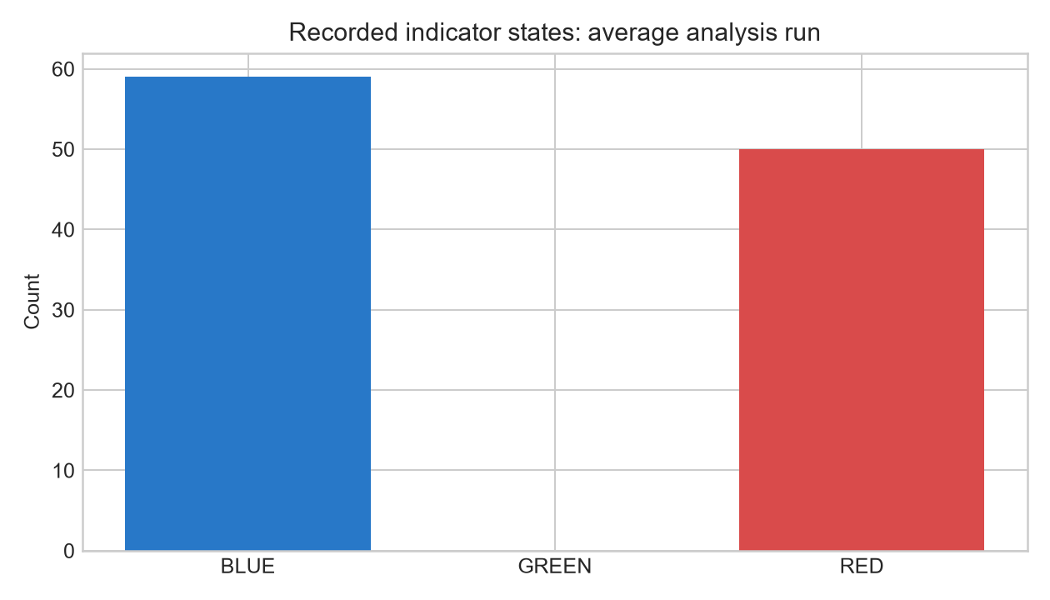
Figure: Recorded firmware indicator-state counts.
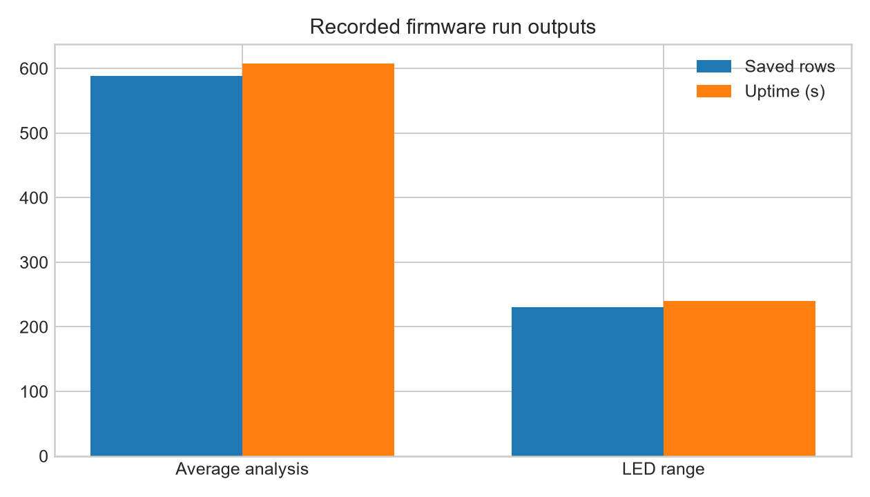
Figure: Recorded firmware run outputs.
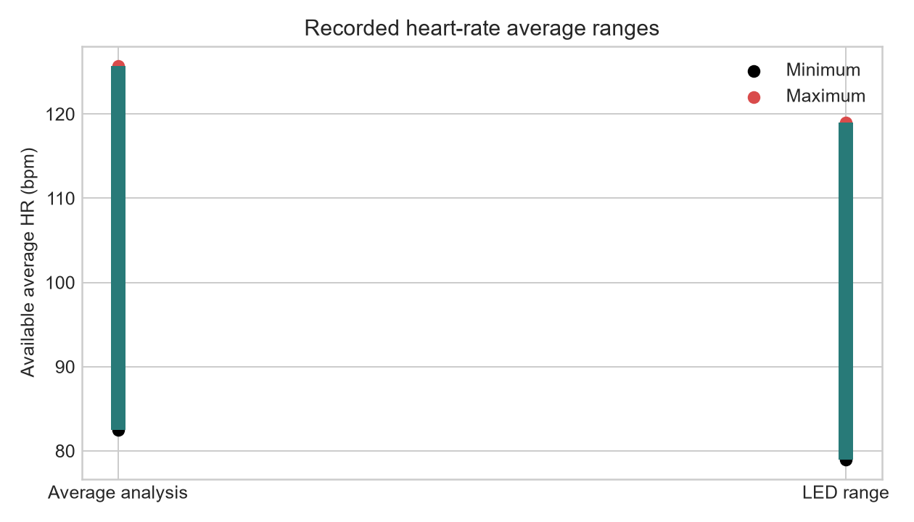
Figure: Recorded available heart-rate average ranges.

Dashboard screenshot requirements
Appendix I should contain the live monitoring screen, historical trend charts, risk-prioritisation screen, AI explanation screen, and alert/trend-warning screen. [INSERT FIGURES: capture these screens from the deployed dashboard; no screenshot files were found in the frontend source folder.]

