edX

GTx: CSE6040x

FA18: Computing for Data Analysis

# Module 0: Fundamentals (bootcamps)

## Topic 1: Python Essentials Notebook 1

[MSA Python Bootcamp – August 2018](http://datamastery.gitlab.io/msabc/august2018.html)

ITCS means [Interactive Think CS Textbook](http://interactivepython.org/runestone/static/thinkcspy/index.html)

IP means [Introducting Python](http://shop.oreilly.com/product/0636920028659.do)

TP means Think Python, 2nd Edition, by Allen B. Downey, O'Reilly Media, December 2015. Available free at <http://greenteapress.com/wp/think-python-2e/> and from O'Reilly at <http://shop.oreilly.com/product/0636920045267.do>

### Course Intro and Tool Set-up

#### ITCS – Introduction

* Algorithm: solution created through the problem solving process. Step by step list of instructions that if followed exactly will solve the problem under considerations.
* Goal in computer science is to take a problem and develop an algorithm that can serve as a general solution. Once we have such a solution, we can use our computer to automate the execution.
* Programming is a skill that allows a computer scientist to take an algorithm and represent it in a notation (a program) that can be followed by a computer.
* Python is a high-level language.
* Machine language (low-level language) is the encoding of instructions in binary so that they can be directly executed by the computer.
* High level languages:
  + Much easier to program
  + Take less time to write
  + Portable – can run on different kinds of computers with few or no modifications
* Two kinds of programs process high-level languages into low-level languages:
  + Interpreters
  + Compilers
* Two ways to use the Python interpreter:
  + Shell mode
    - Type python expressions into the Python Shell and the interpreter immediately shows the results
    - Working directly in the interpreter is convenient for testing short bits of code because you get immediate feedback. Think of it as scratch paper used to help you work out problems.
  + Program mode
* All programs do the following:
  + Accept input
  + Create an output
  + Perform math and logic
  + Have conditional execution
  + Repetition
* 3 types of errors:
  + Syntax: Syntax refers to the structure of a program and the rules about that structure
  + Runtime: error appears when you run the program. Aka exceptions
  + Semantic: your program will run, but it will not do the correct thing
* Programming languages are formal languages that have been designed to express computations

#### TP 1

* <>

#### Video: Getting Started (24.03)

* Cs2316.gatech.edu > resources
* “Computers are like onions, they are organized in layers and when you dig in they make you cry”
* Shell: application that gives you direct access to the operating systems services
* Folder = directory
* CMD – primary do two things: navigate to files and execute programs

#### Video: Intro to Python (29:43)

* Python is general purpose programming language, a glue language
* Different than e.g. SQL whose primary purpose is manipulating data
* [www.python.org](http://www.python.org) -> <https://docs.python.org>
* <https://github.com/csimpkins/course-tools>
  + Python script to upload course schedule to a website every semester
  + Finding best time to dive based on input of time range and dates from a list of ~1400
* Python is an interpretive programming language 🡪
  + You create a file e.g. hello.py
  + Feed that file into a python interpreter
  + Get a running program
* Contract to a compiled language e.g. C
  + Create a file e.g. hello.c
  + Feed that file into a compiler (e.g. gcc)
  + Get another file: hello.exe
  + Get a running program
* Java is a hybrid of these two approaches
  + Create a file e.g. hello.java
  + Feed that file into javac
  + Get another file hello.class
  + Feed that into java program
  + Get a running program
* 19:30 – directories? Sub directories
* Python interpreter has a REPL -> read, evaluate, print, loop
* Print() is a function that doesn’t return a value – if you don’t specify a value, it returns a special value – none.
* Get out of the REPL: exit() or Ctrl +Z
* Bash – born again shell -> install on Windows?

### Values and Variables

#### Video: Values and Variables (39:00)

* Variable: name that refers to a value
* Types:
  + Integers
    - E.g.1
    - Name: int
    - +: addition
    - *: multiplication
  + float
    - e.g. 2.2
    - name: float
  + string
    - e.g. “word”
    - name: str
    - +: concatenate
    - *: repetition
  + Boolean
    - E.g: true/false
    - Name: bool
* <variable name> = <value>
* Python indexes starting at 0
* [] = indexing

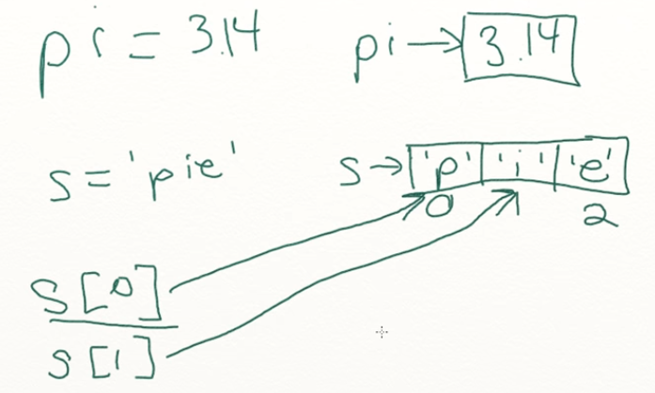

* Get the last value of a string: variable name[len(variable name) – 1]
* Get MID() aka string slicing🡪 variable name[start position : end position]

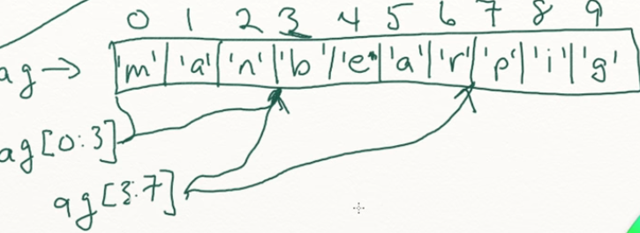

* Variables can be reassigned in the program. X can be multiple things
* Use () liberally so someone reading your code doesn’t have to think about order of operations
* Variables are names that refer to values
* The last value assigned to the variable is the one that will be used

### Functions

#### Slides: Functions

* A function is a reusable block of code
* Functions:
  + Have names
  + Contain a sequence of statements
  + Return values, either explicitly or implicitly
* Provide a list of parameter names inside the () of the function header, which creates local variables I n the function
* Parameters in functions local variables and are not visible outside the function
* Global variables are visible outside AND inside the function
  + global_hello = ‘Bonjour’
* a function can take any number of parameters

#### ITCS: 6 Functions

* <>

#### ITCS: 4 Python Little Turtles

* Allows us to draw pictures in Python
* “Turtle graphics, as it is known, is based on a very simple metaphor. Imagine that you have a turtle that understands English. You can tell your turtle to do simple commands such as go forward and turn right. As the turtle moves around, if its tail is down touching the ground, it will draw a line (leave a trail behind) as it moves. If you tell your turtle to lift up its tail it can still move around but will not leave a trail. As you will see, you can make some pretty amazing drawings with this simple capability.”
* First line: import turtle
* Python objects have:
  + Methods: e.g. forward, left, right
  + Attributes: e.g. color of canvas, width of the turtles tail, heading, position, etc.
* We can have many different turtles called “instances”
* For Loops
  + For <loop variable name> [sequence]:
    - Indented statement 1
    - Indented statement 2
  + : in python means the next line(s) are indented

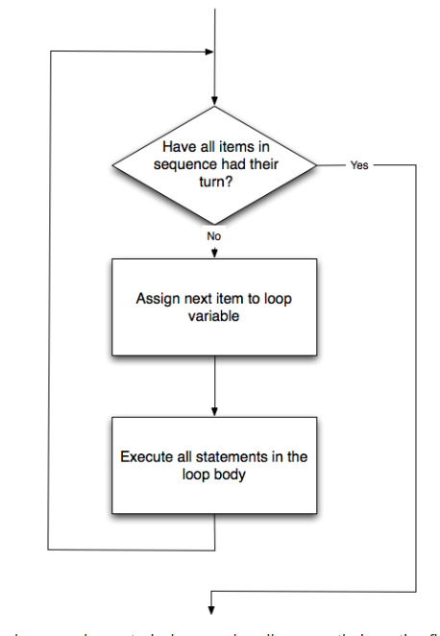

* + Python processes from left to right in the sequence
  + Range(start, beyond last, step)
    - Range(0,5,1) – positive counting up by 1
    - Range(10,0,-1) – negative counting down by 1
    - print(list(range(0, 19, 2)))
    - print(list(range(0, 20, 2)))
    - print(list(range(10, 0, -1)))

To-do:

Upgrade PIP: CMD > python -m pip install --upgrade pip

Install python packages: CMD>

python -m pip install requests 🡪 DONE

python -m pip install beautifulsoup4 🡪 DONE

python -m pip install sqlite 🡪 DID NOT INSTALL

python -m pip install pyqt5 🡪 DONE

python -m pip install ipython 🡪 DONE

python -m pip install numpy 🡪 DONE

python -m pip install pandas 🡪 DONE

python -m pip install matplotlib 🡪 DONE

python -m pip install jupyter 🡪 DONE

python –m pip install statsmodels scipy scikit-learn 🡪 DONE

Questions:

* Version of notepad++ on laptop? 7.4.2 has different default themes

## Assignment: Notebook 1 (Due Sept 3, 2018 at 11:59 UTC)

<>

# Module 1

## Topic 1

<>

## Assignment:

<>