Experiment 9

Interaction of Gamma Rays with Matter

By: Mark Holton
With: Scott Schmid
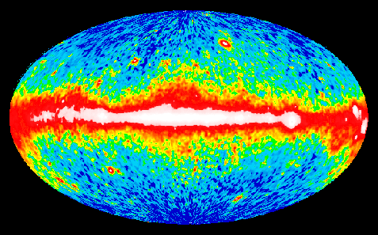
Gamma Ray All Sky Map
Picture Credit: NASA, Compton Gamma Ray Observatory

Explanation: What if you could "see" gamma rays? This computer processed image represents a map of the entire sky at photon energies above 100 million electron Volts. These gamma-ray photons are more than 40 million times more energetic than visible light photons and are blocked from the Earth's surface by the atmosphere. In the early 1990s NASA's Compton Gamma Ray Observatory, in orbit around the Earth, scanned the entire sky to produce this picture. A diffuse gamma-ray glow from the plane of our Milky Way Galaxy is clearly seen across the middle. The nature and even distance to some of the fainter sources remain unknown.

Abstract: These rays of electromagnetic radiation, called gamma rays having wavelengths of less than about 1nm are emitted when nuclei undergo transition from higher-energy to lower-energy states. There are three ways by which gamma rays interact with matter. They are through the photoelectric effect, Compton scattering, and pair production. In this lab gamma rays are detected by a “scintillation crystal made of thallium-activated sodium iodide. Gamma ray spectra displayed as graphs of number of gamma rays detected as a function of their energy (in keV). The samples were recorded for 60 seconds. The features of these spectra of ²⁴Na, ²²Na, ¹³⁷Cs (with and without a lead brick) were associated with their corresponding gamma interaction mechanism. While doing all of this, each spectrum was also calibrated, converting the channel units to voltage units (keV).

