POGIL Classwork

POGIL is an acronym for Process Oriented Guided Inquiry Learning. It is a student-centered, group-learning instructional strategy and philosophy developed through research on how students learn best.

1. Situation: The team wants to rush to get to the homework

A: Manager slows them down and makes sure everyone goes slow b/c in charge of grade of everyone on the test

1. Situation: Someone on the team gets excited and tries to grab pen from recorder

A: Purpose is to force verbalization of knowledge so everyone understands

1. Situation: Recorder is a boss and just decides to do it all themselves

A: Reflector should slow them down because they’re taking the

1. What is the purpose of POGIL. What does it look like when it’s going well?
2. What are signs that learning isn’t happening?
3. What roles do the POGIL roles map onto in real life?

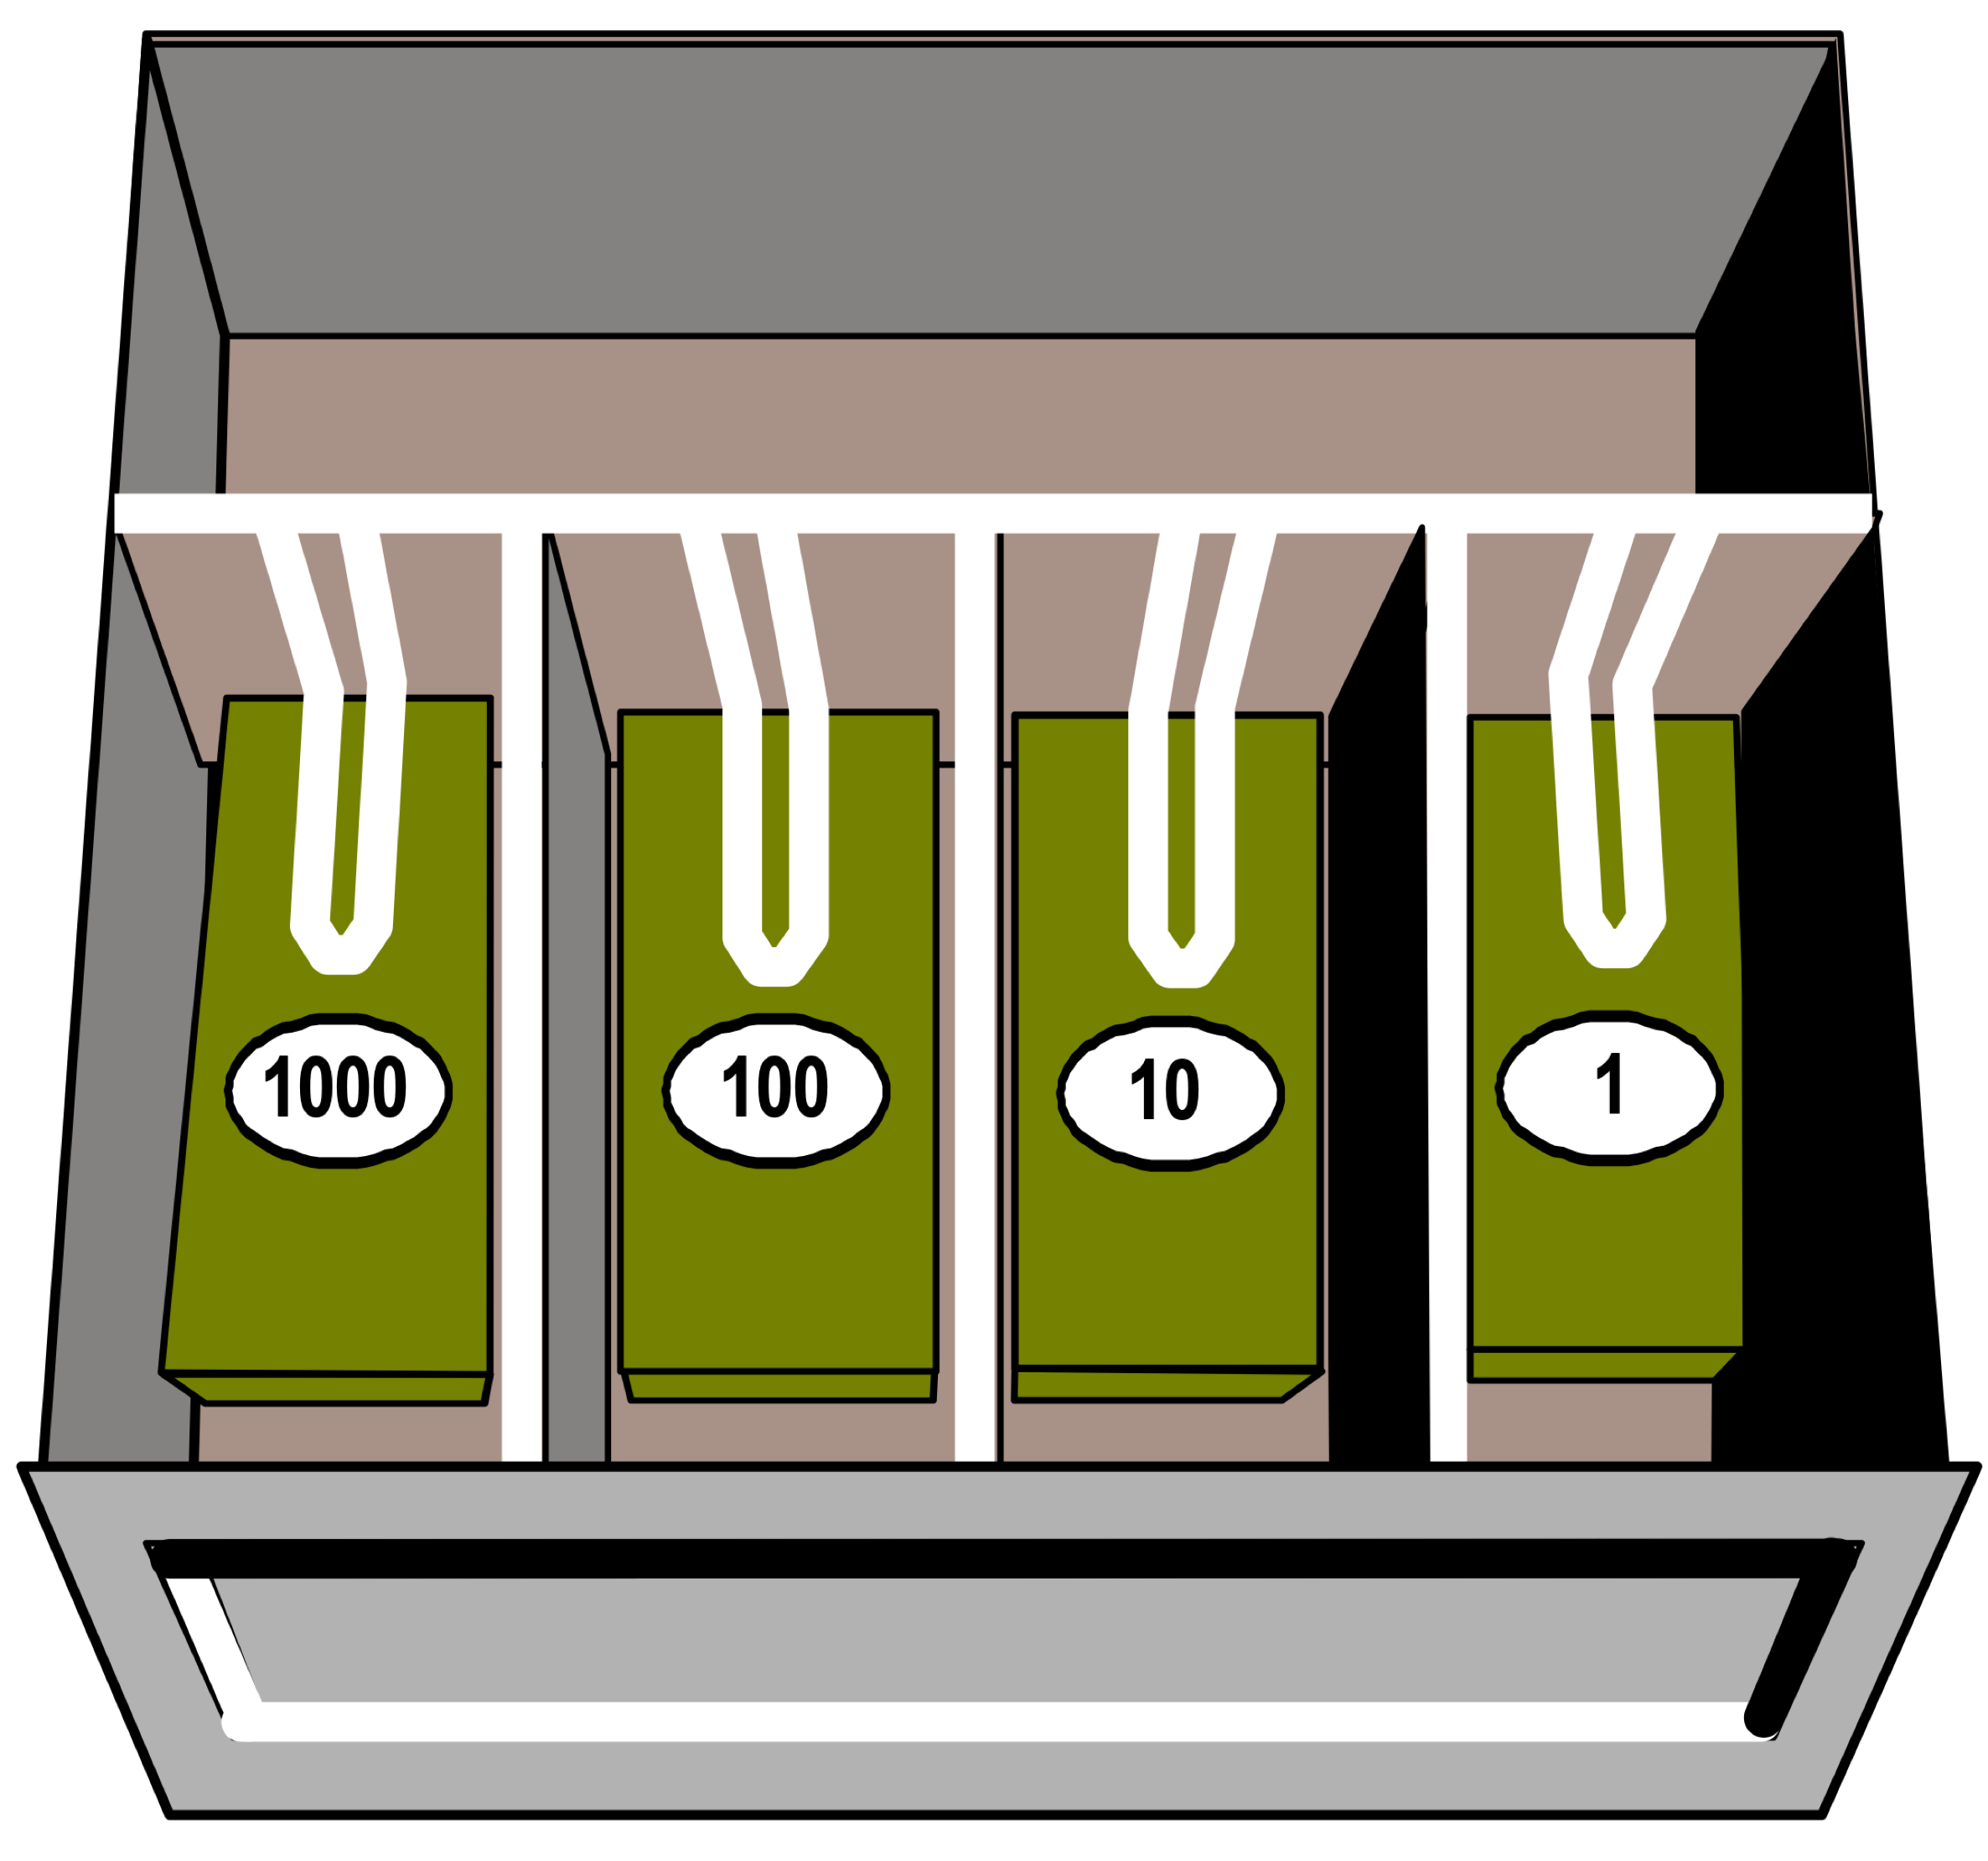

Since you hate to have more bills than strictly necessary, you will only keep bills in your cash box if it can’t be represented with less bills. If any bills can be replaced by a single bill of a higher value you will exchange them so that the minimal amount of bills will be retained.

Assume that you live in an economic system where you only have the bill-values shown…

|  |  |  |  |  |
| --- | --- | --- | --- | --- |
| Number of bills | | | | Total Amount of Money |
| 1000s | 100s | 10s | 1s | <- Bill slots |
|  |  |  |  | $4,213 |
|  |  |  |  |  |
|  |  |  |  |  |
|  |  |  |  |  |
|  |  |  |  |  |
|  |  |  |  |  |
|  |  |  |  |  |
|  |  |  |  |  |
|  |  |  |  |  |
|  |  |  |  |  |

1. What's the *minimum* number of each type of bill you would need to make $4,213. How many of each bill would you have? Write the numbers in the first row of the table above.
2. Show how your minimalist cashbox would hold some other amounts. Have each person in the group demonstrate at least ***two*** values in the table above. Keep your values under $8,000 for now.
3. Can you represent *every* possible value minimally? How or why not?
4. If you had a bigger cashbox (with more slots), what would be the values of the bills in the next slots? **Why**? What’s the pattern?
5. Assume that there are bills with larger values but you can't accept them because you don't have a place for them in your cashbox. What's the maximum amount of money you could hold in *this* cash box if you *still* insisted on minimalism?
6. How does the maximum amount you can store (#5) relate to the **next** potential bill value (#4)?
7. For any amount (but consider #5), what’s the maximum **number of bills** of any type that you will have?
8. Why wouldn't you want any more than this number of bills (#7) in *any* of the slots *ever*?
9. How does the bill maximum (#7) relate to the pattern of bill values from (#4)?

Minimalist Cashbox 2

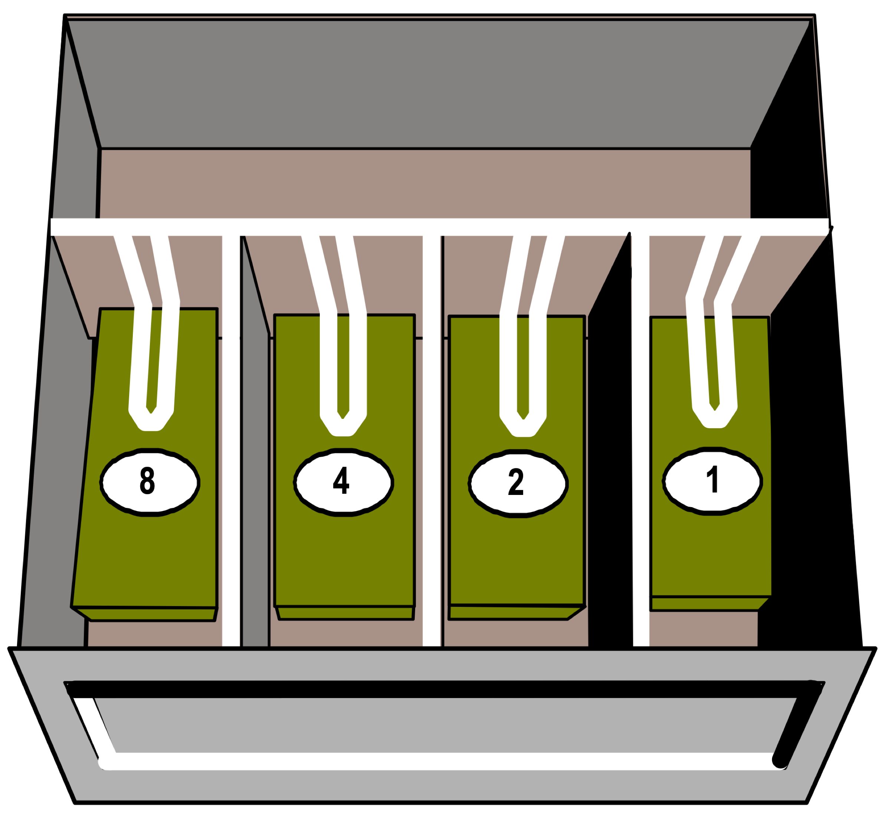

Assume that you live in a different world with a different economic system where you only have these bill-values…

|  |  |  |  |  |
| --- | --- | --- | --- | --- |
| Number of bills | | | | Total Amount of Money |
| 8s | 4s | 2s | 1s | <- Bill slots |
|  |  |  |  | $11 |
|  |  |  |  |  |
|  |  |  |  |  |
|  |  |  |  |  |
|  |  |  |  |  |
|  |  |  |  |  |
|  |  |  |  |  |
|  |  |  |  |  |
|  |  |  |  |  |

1. What's the *minimum* number of each type of bill you would need to make $11. How many of each bill would you have? Write the numbers in the first row of the table above.
2. Show how your minimalist cashbox would hold some different amounts. Have each person in the group demonstrate at least ***two*** values in the table above. Keep your values under $15 for now.
3. Can you represent *every* possible value? How or why not?
4. If you had a bigger cashbox (with more slots), what would be the values of the bills in the next slots? **Why**? What’s the pattern?
5. Assume that there are bills with larger values but you can't accept them because you don't have a place for them in your cashbox. What's the maximum amount of money you could hold in *this* cash box if you *still* insisted on minimalism?
6. How does the maximum amount you can store (#5) relate to the **next** potential bill value (#4)?
7. For any amount (but consider #5), what’s the maximum **number of bills** of any type that you have?
8. Why wouldn't you want any more than this number of bills (#7) in *any* of the slots *ever*?
9. How does the bill maximum (#7) relate to the pattern of bill values from (#4)

Minimalist Cashbox 3

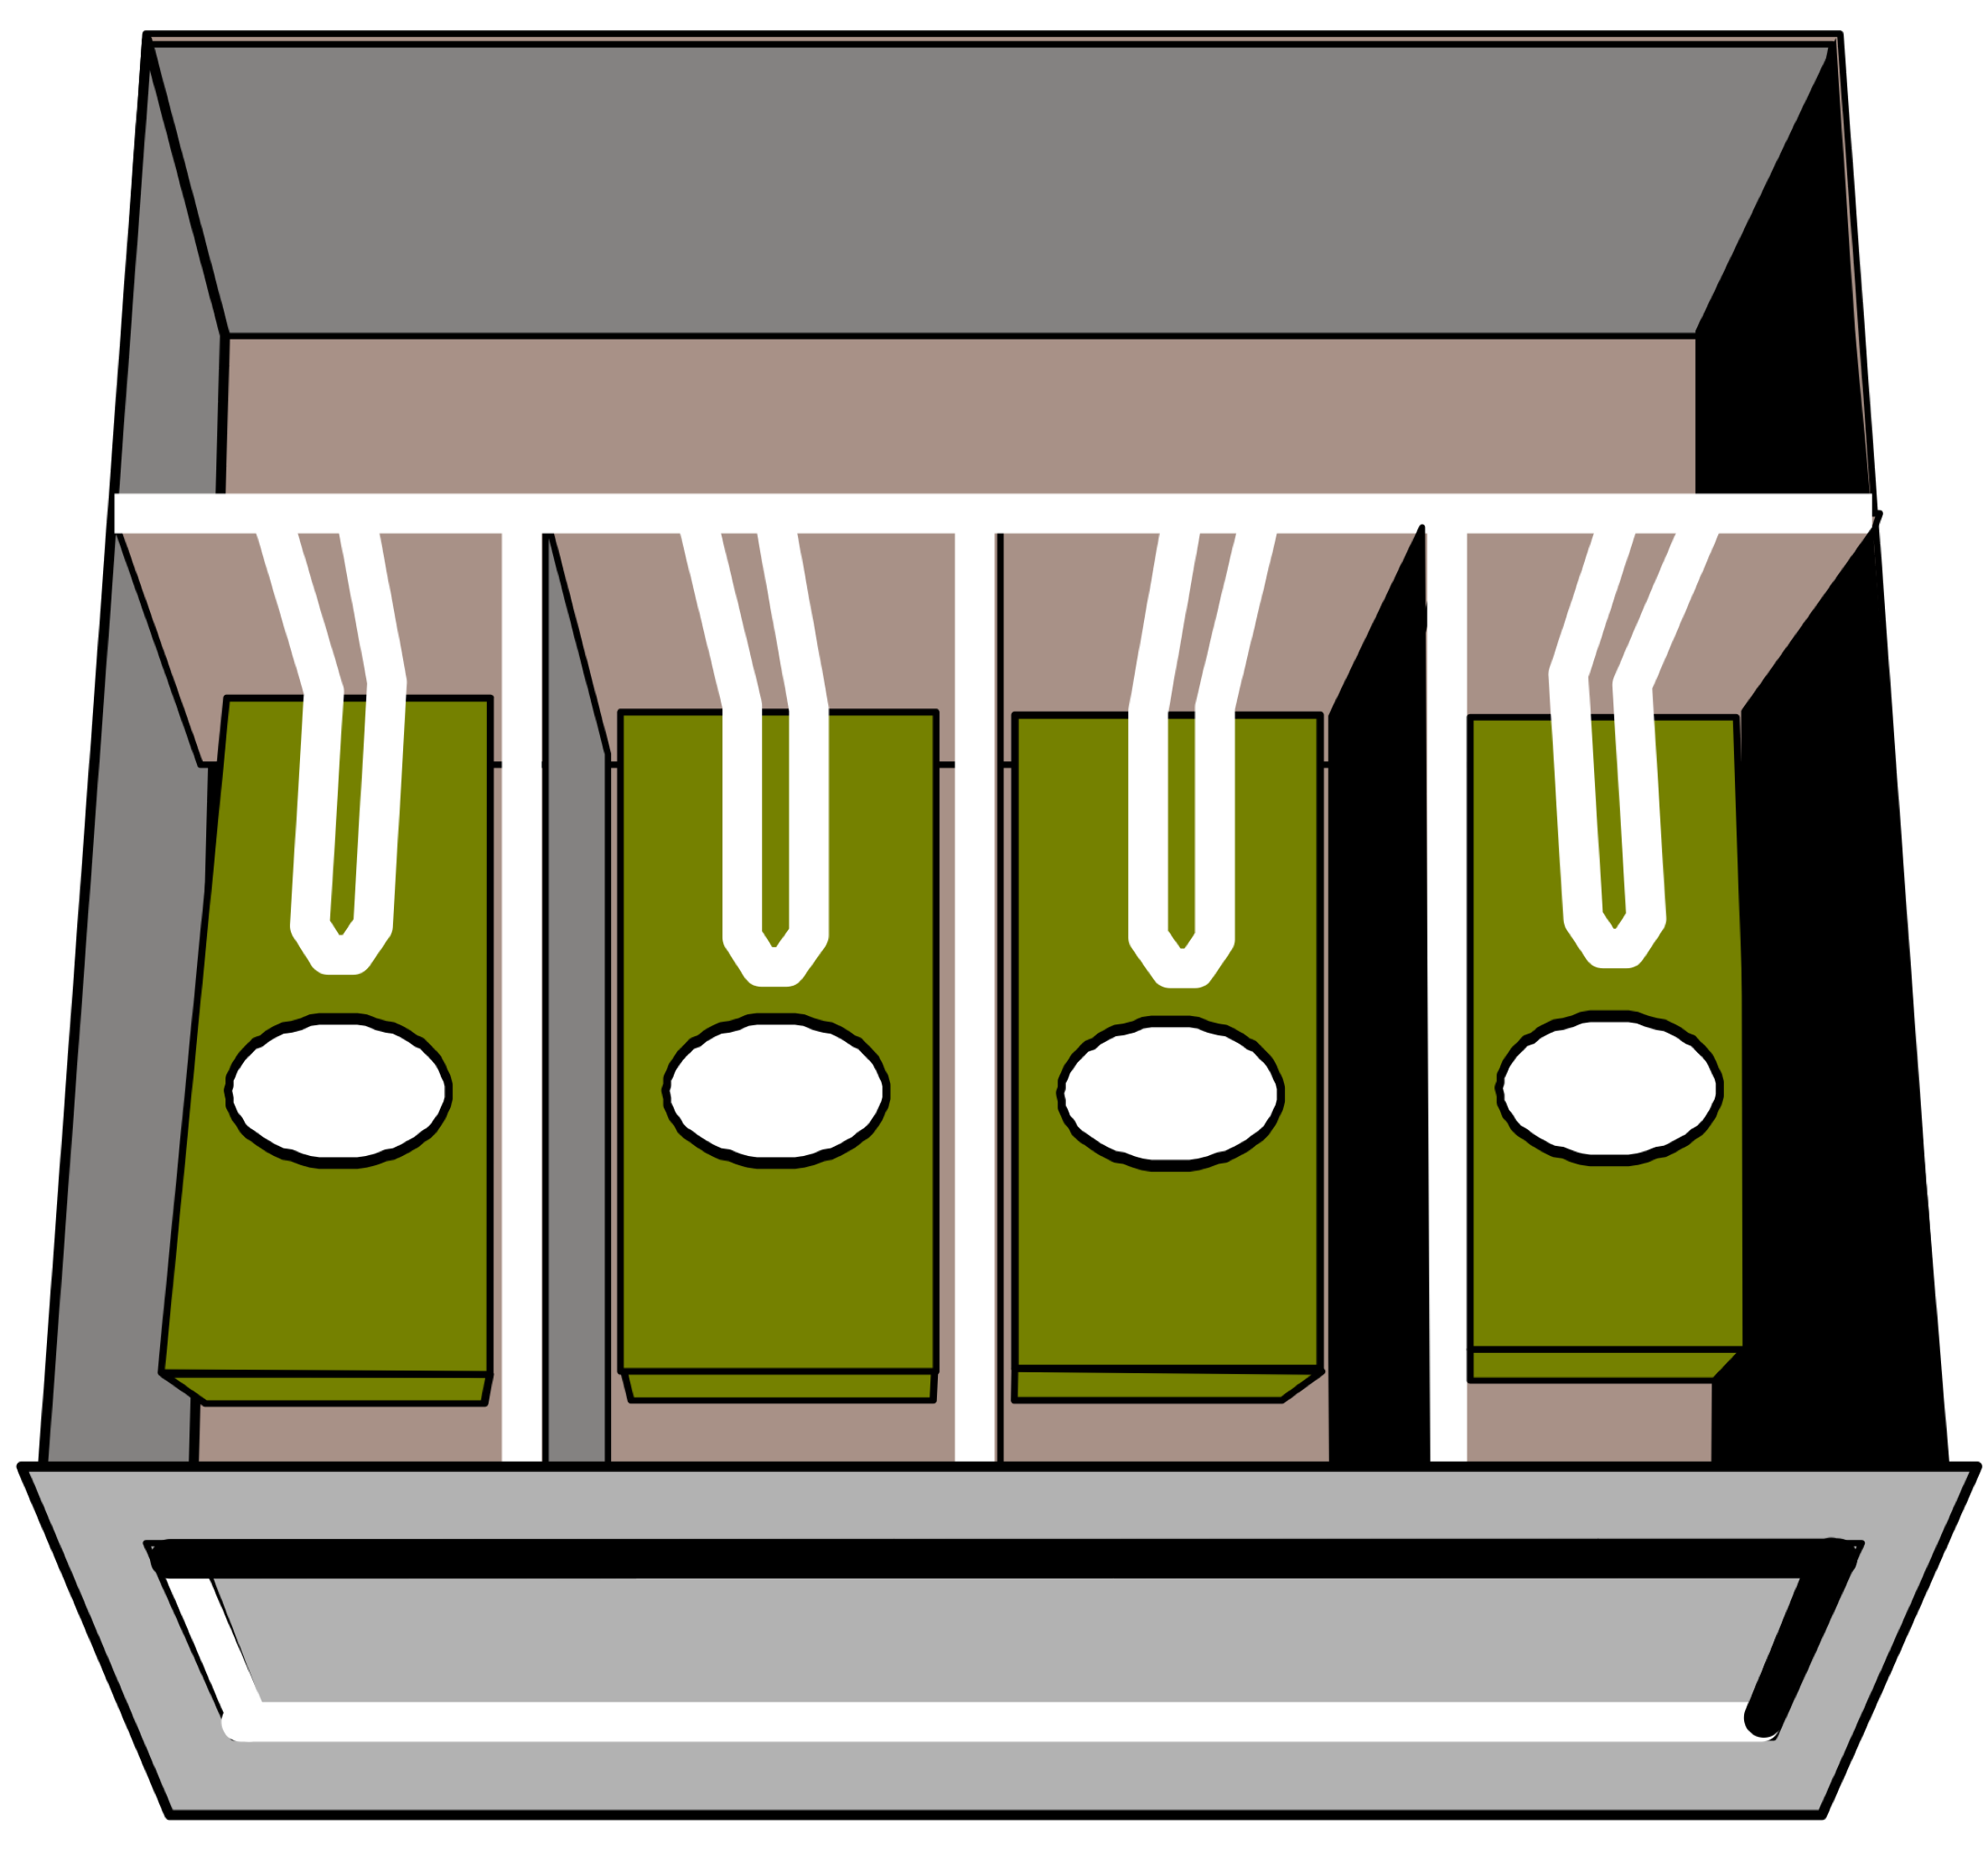

Assume that you live in a world where *you* get to determine the bill-values. The only catch is that your values have to go up by a common factor (as with the two previous cashboxes). Place monetary values in the ovals on the bills. Obviously, it should be different than either of the previous two systems.

Like the previous two systems, you will have to be able to represent *every* possible? If not, your system won’t be usable and you will have to revise your monetary system.

|  |  |  |  |  |
| --- | --- | --- | --- | --- |
| Number of bills | | | | Total Amount of Money |
|  |  |  |  | <- Bill slots |
|  |  |  |  |  |
|  |  |  |  |  |
|  |  |  |  |  |
|  |  |  |  |  |
|  |  |  |  |  |
|  |  |  |  |  |
|  |  |  |  |  |
|  |  |  |  |  |
|  |  |  |  |  |

1. Show how your minimalist cashbox would hold different amounts. Have each person in the group demonstrate at least ***two*** values in the table above.
2. If you had a bigger cashbox (with more slots), what would be the values of the bills in the next slots? **Why**? What’s the pattern?
3. Assume that there are bills with larger values but you can't accept them because you don't have a place for them in your cashbox. What's the maximum amount of money you could hold in *this* cash box if you *still* insisted minimalism?
4. How does the maximum amount you can store (#3) relate to the **next** potential bill value (#2)?
5. For any amount (but consider #3), what’s the maximum **number of bills** of any type that you have?
6. Why wouldn't you want any more than this number of bills (#5) in *any* of the slots *ever*?
7. How does the bill maximum (#5) relate to the pattern of bill values from (#2)?

Reflection

1. What are the advantages / disadvantages of each money system compared to the others?
2. What is the value you choose for the *first* bill for Cashbox 3? How does this compare to the other schemes that were given? Could the first value be anything else? Why or why not?
3. In a cash box, does it matter if the smallest bills are on the left or the right? In a number system, does it matter if the smallest place value is on the left or on the right? Why or why not?

Mathematically these cash boxes represent different number systems with different bases. Cashbox 1 is the decimal system that we’re most familiar with where the base is 10. Cashbox 2 is the binary number system (that computers use) where the base is 2. The place values (or slots in a cash box) are different for different number systems.

1. What is it that determines the base of the number you're dealing with?
2. What would the slots in a base 16 number system / cash box be?

________ ________ ________ ________

1. Minimizing bills is more important when you’re talking about a wallet (e.g., you don’t want to carry 100 one-dollar bills in your pocket). Why do you think your instructor didn’t use this as an example? (key words: “place value”)?
2. Explain this comic. Why is it funny?

