**Teaching the Science of Learning**

Yana Weinstein, Christopher R. Madan, and Megan A. Sumeracki

The science of learning has made a considerable contribution to our understanding of effective teaching and learning strategies. In this tutorial review, we focus on six specific cognitive strategies that have received robust support from decades of research: spaced practice, interleaving, retrieval practice, elaboration, concrete examples, and dual coding. We describe the basic research behind each strategy and relevant applied research, present examples of existing and suggested implementation, and make recommendations for further research that would broaden the reach of these strategies.

| **Learning strategy** | **Description** | **Application examples from a Psychology Class** |
| --- | --- | --- |
| Spaced practice | Creating a study schedule that spreads study activities out over time | Students can block off time to study and restudy key concepts such as action potentials and the nervous systems on multiple days before an exam, rather than repeatedly studying these concepts right before the exam |
| Interleaving | Switching between topics while studying | After studying the peripheral nervous system for a few minutes, students can switch to the sympathetic nervous system and then to the parasympathetic system; next time, students can study the three in a different order, noting what new connections they can make between them |
| Retrieval practice | Bringing learned information to mind from long-term memory | When learning about neural communication, students can practice writing out how neurons work together in the brain to send messages (from dendrites, to soma, to axon, to terminal buttons) |
| Elaboration | Asking and explaining why and how things work | Students can ask and explain why Botox prevents wrinkles: the nervous system cannot send messages to move certain muscles |
| Concrete examples | When studying abstract concepts, illustrating them with specific examples | Students can imagine the following example to explain the peripheral nervous system: a fire alarm goes off. The sympathetic nervous system allows people to move quickly out of the building; the parasympathetic system brings stress levels back down when the fire alarm turns off |
| Dual coding | Combining words with visuals | Students can draw two neurons and explain how one communicates with the other via the synaptic gap |

Spaced Practice

The benefits of spaced (or distributed) practice to learning are arguably one of the strongest contributions that cognitive psychology has made to education. The effect is simple: the same amount of repeated studying of the same information spaced out over time will lead to greater retention of that information in the long run, compared with repeated studying of the same information for

the same amount of time in one study session

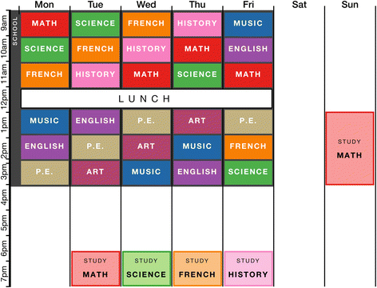

The figure above shows a spaced practice schedule for one week. This schedule is designed to represent a typical timetable of a high-school student. The schedule includes four one-hour study sessions, one longer study session on the weekend, and one rest day. Notice that each subject is studied one day after it is covered in school, to create spacing between classes and study sessions.

Interleaving

Another scheduling technique that has been shown to increase learning is interleaving. Interleaving occurs when different ideas or problem types are tackled in a sequence, as opposed to the more common method of attempting multiple versions of the same problem in a given study session (known as blocking). Interleaving as a principle can be applied in many different ways. One such way involves interleaving different types of problems during learning, which is particularly applicable to subjects such as math and. For example, in a study with college students, Rohrer and Taylor found that shuffling math problems that involved calculating the volume of different shapes resulted in better test performance 1 week later than when students answered multiple problems about the same type of shape in a row.

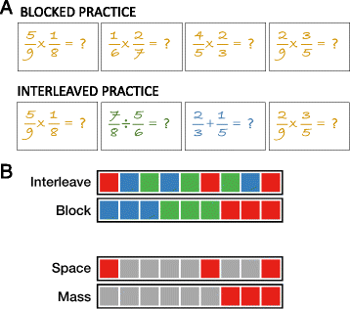

The figure above shows the difference between common (blocked) practice and interleaved practice. Figure **a** shows blocked practice and interleaved practice with fraction problems. In the blocked version, students answer four multiplication problems consecutively. In the interleaved version, students answer a multiplication problem followed by a division problem and then an addition problem, before returning to multiplication. For an experiment with a similar setup, see Patel et al.

Figure **b** shows an illustration of interleaving and spacing. Each color represents a different homework topic. Interleaving involves alternating between topics, rather than blocking. Spacing involves distributing practice over time, rather than massing. Interleaving inherently involves spacing as other tasks naturally “fill” the spaces between interleaved sessions.

Retrieval Practice

While tests are most often used in educational settings for assessment, a lesser-known benefit of tests is that they actually improve memory of the tested information. If we think of our memories as libraries of information, then it may seem surprising that retrieval (which happens when we take a test) improves memory; however, we know from a century of research that retrieving knowledge actually strengthens it. Testing was shown to strengthen memory as early as 100 years ago, and there has been a surge of research in the last decade on the mnemonic benefits of testing, or retrieval practice.

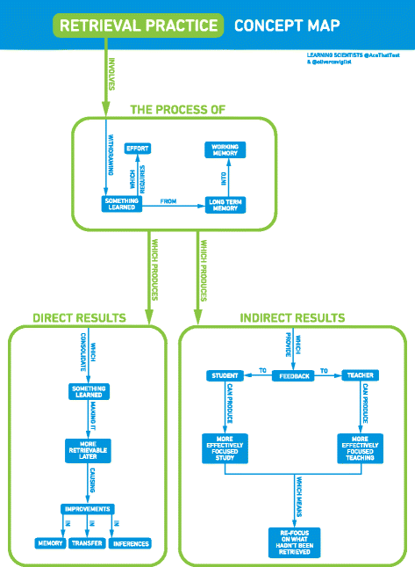

The figure above shows a concept map illustrating the process and resulting benefits of retrieval practice. Retrieval practice involves the process of withdrawing learned information from long-term memory into working memory, which requires effort. This produces direct benefits via the consolidation of learned information, making it easier to remember later and causing improvements in memory, transfer, and inferences. Retrieval practice also produces indirect benefits of feedback to students and teachers, which in turn can lead to more effective study and teaching practices, with a focus on information that was not accurately retrieved.

Elaboration

Elaboration involves connecting new information to preexisting knowledge. Anderson made the following claim about elaboration: “One of the most potent manipulations that can be performed in terms of increasing

a subject’s memory for material is to have the subject elaborate on the to-be-remembered material.” Postman defined elaboration most parsimoniously as “additions to nominal input”, and Hirshman provided an elaboration on this definition (pun intended!), defining elaboration as “A conscious, intentional process that associates to-be-remembered information with other information in memory.” However, in practice, elaboration could mean many different things. The common thread in all the definitions is that elaboration involves adding features to an existing memory.



The figure above shows an illustration of “how” and “why” questions (i.e., elaborative interrogation questions) students might ask while studying the physics of flight. To help figure out how physics explains flight, students might ask themselves the following questions: “How does a plane take off?”; “Why does a plane need an engine?” and “Why is there a downwash behind the wings?”.

Concrete Examples

Providing supporting information can improve the learning of key ideas and concepts. Specifically, using concrete examples to supplement content that is more conceptual in nature can make the ideas easier to understand and remember. Concrete examples can provide several advantages to the learning process: (a) they can concisely convey information, (b) they can provide students with more concrete information that is easier to remember, and (c) they can take advantage of the superior memorability of pictures relative to words.

The figure above shows an example of a concrete example.

Dual coding

Both the memory literature and folk psychology support the notion of visual examples being beneficial—the adage of “a picture is worth a thousand words” (traced back to an advertising slogan from the 1920s). Indeed, it is well-understood that more information can be conveyed through a simple illustration than through several paragraphs of text. Illustrations can be particularly helpful when the described concept involves several parts or steps and is intended for individuals with low prior knowledge.