Loop Activity

Scratch can be used to make some very cool art. In this activity, we’re going to combine using the pen extension, move blocks, and repeat blocks to make shapes. You can see below a script to draw a square.

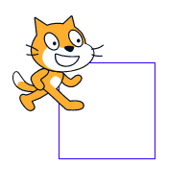

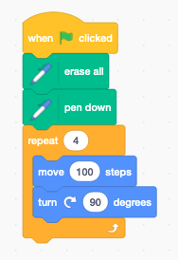

-- *yields* ->

In particular notice that:

* In the initialization:
  + We use the go to x, y block from the motion tab to set our initial position
  + We use the erase all block from the pen tab to clear the screen
  + We use the pen down block from the pen tab to lower the pen
* In the “game loop”
  + We only use the “movement” bit of the game loop

Assignment:

Using a repeat try to draw the following shapes:

* + Equilateral triangle
  + Pentagon
  + Hexagon
  + Octagon
  + Five-sided star
  + A cool shape of your own that has a repeat 100 loop in it

Each time you complete a shape, remove the when flag clicked block but keep the rest of the code somewhere on the side. This means the code is still there for reference but won't run. Once you have all six shapes, save the project as “NAME's Shapes” and turn it in to the class folder. If you do not finish it is homework due at the beginning of the next class.