Loop Activity

Scratch can be used to make some very cool art. Today, we’re going to combine using the pen extension, move, and repeat to make shapes. For example, the script below draws a square.

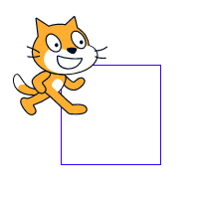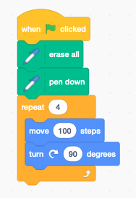

-- *yields* ->

In particular, notice that:

* We have a good “initialization”
* In the “loop” we only do simple moves and turns

Assignment:

Using repeat, try to draw the following shapes. Each time you complete a shape, **move the program into the “backpack”**, and then start a new piece of code.

* 1. Equilateral triangle
  2. Pentagon
  3. Hexagon
  4. Octagon
  5. Five-sided star
  6. A cool shape of your own that has a repeat 100 loop in it
  7. Make this shape:

* 1. A blue line drawing of a hexagon

     Description automatically generatedMake this shape:
  2. Make this shape (hint: you continually return to the middle)

* 1. A blue and white triangle pattern

     Description automatically generated with medium confidenceMake this shape (hint: you need to use both the pen up and pen down blocks):

Bonus 1: Make this shape (hint: using a goto block **in** the loop will help)

Bonus 2: Make this shape (hint: you need to use the change pen color by block)

