Tic Tac Toe

In previous worksheets, you used both repeat blocks and functions to avoid duplicating code. Below is some code to draw a tic-tac-toe board. Your goal is to create functions that make this code simpler. One important aspect is to give your new functions really intuitive names, so that it is easy to read the code and understand what it does.

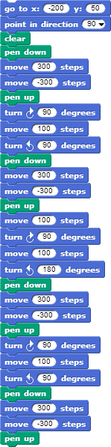

Problem taken from UCBerkeley 2010 CS10 course