Brick Layer

Your goal for this project is to build a wall of bricks like the one seen below. This problem is not just about drawing; it is also about practicing creating functions. You will draw the following brick wall by implementing the functions listed below.

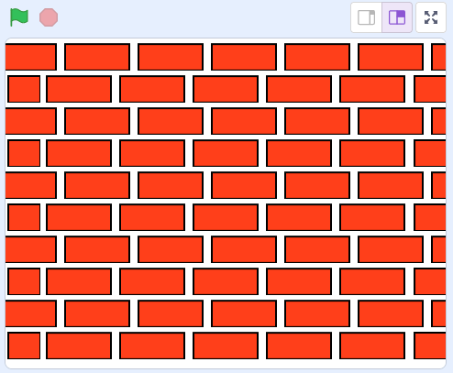

There are two kinds of rows in this brick wall:



Row A:



Row B:

**Note: You must implement the blocks described below in the correct order.**

The big idea is that there are two levels of functions. The first function uses two sub functions. In summary, you should implement the following blocks:

Level 1 Level 2



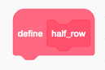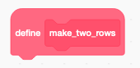

*Taken from UCBerkeley’s 2010 Fall CS10 class.