**Bits and Binary Review**

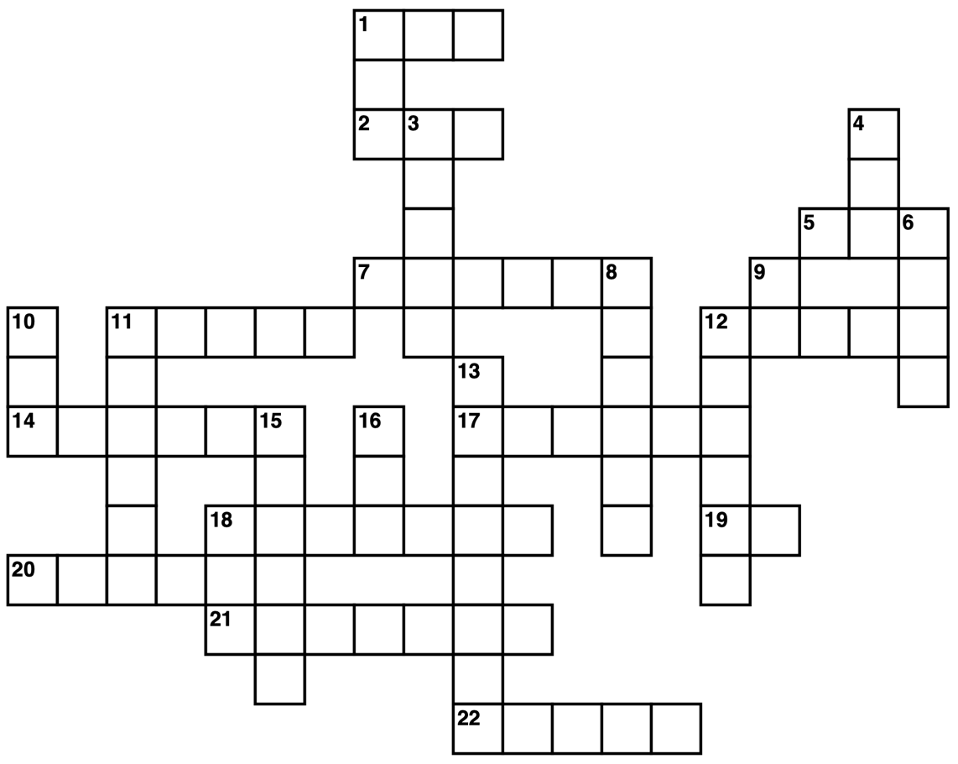

1

1

1

1

1

1

0 0 0 0

|  |  |
| --- | --- |
| **Across**  **[1]** The second highest possible number for a 7-bit binary number (decimal)  **[2]** The decimal number 280 (hexadecimal)  **[5]** The hexadecimal number fb (decimal)  **[7]** The decimal number 1 (binary | octal | hexadecimal)  **[11]** The binary number 10011100011010 (decimal)  **[12]** The loudest sound a speaker can make (binary)  **[14]** The color light grey where each LED is controlled by 2 bits  **[17]** The hexadecimal number B (decimal)  **[18]** The decimal number 77 (binary)  **[19]** The decimal number 31 (hexadecimal)  **[20]** ________ (Come up with your own question)  **[21]** The decimal number 112 (binary)  **[22]** 0X42, 0X45, 0X45, 0X46 in ASCII | **Down**  **[1]** The color white where each LED is controlled by 1 bit  **[3]** A skinny b/w BMP of a white picket fence (binary)  **[4]** The highest possible number for an 8-bit binary number (decimal)  **[6]** The largest possible 4-bit number (binary)  **[8]** The color dark grey where each LED is controlled by 2 bits  **[9]** The decimal number 81 (hexadecimal)  **[10]** The hexadecimal number 12c (decimal)  **[11]** The hexadecimal number 20 (binary)  **[12]** ________ (Come up with your own question)  **[13]** The binary number 1011 (hexadecimal)  **[15]** On, On, Off, Off, On, On  **[16]** The number 5 (binary) |

**Bits and Binary Review**

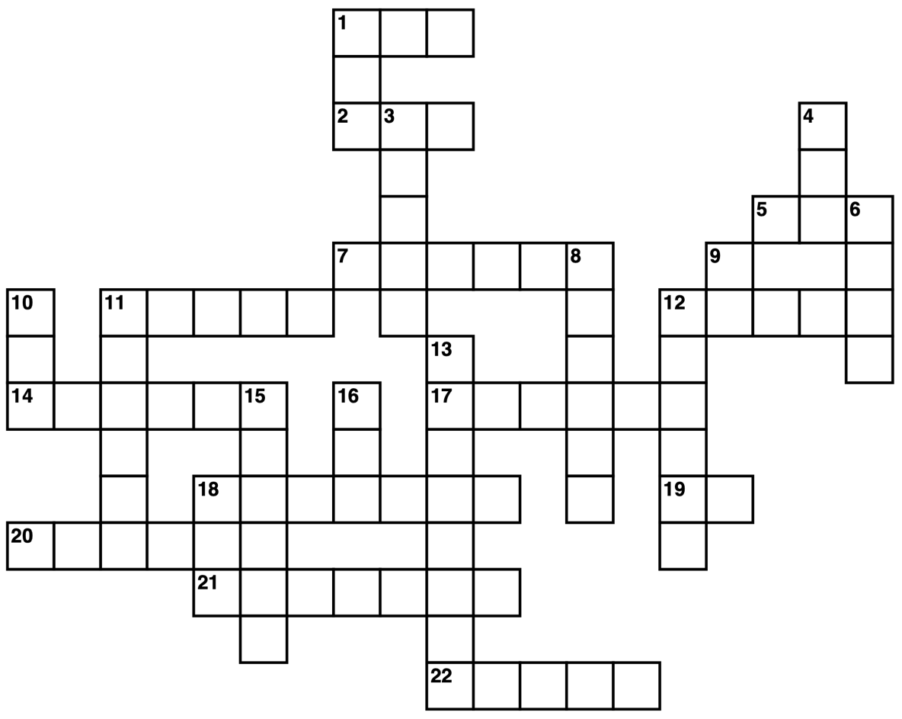

1

1

1

1

1

1

0 0 0 0

|  |  |
| --- | --- |
| **Across**  **[1]** The hexadecimal number 7E (decimal)  **[2]** The binary number 1110110 (decimal)  **[5]** The fourth highest 8-bit number (decimal)  **[7]** The second quietest noise a speaker can make (binary)  **[11]** The hexadecimal 12 number (binary)  **[12]** The decimal number 69905 (hexadecimal)  **[14]** The decimal number 21  **[17]** The color blue where each led is controlled by 2 bits  **[18]** The hexadecimal number F468D (decimal)  **[19]** The decimal number 31 (hexadecimal)  **[20]** ________ (Come up with your own question)  **[21]** The decimal number 112 (binary)  **[22]** The decimal number 48879 (hexadecimal) | **Down**  **[1]** The hexadecimal number 7 (binary)  **[3]** A skinny b/w BMP of a white picket fence (binary)  **[4]** 0X32, 0X35, 0X35 in ASCII  **[6]** The decimal number 15 (binary)  **[8]** On, Off, On, Off, On, Off  **[9]** The binary number 110011 (decimal)  **[10]** 0X33, 0X30, 0X30 in ASCII  **[11]** A space in ASCII (binary)  **[12]** ________ (Come up with your own question)  **[13]** The decimal number 11 (hexadecimal)  **[15]** The color purple where each led is controlled by 2 bits  **[16]** The letter "A" in ASCII (octal) |