**Fractals: The Hidden Dimension** Name: _______________

Use what you learn while watching Nova’s “Fractals, the Hidden Dimension” to answer the following questions. Feel free to answer the questions while you’re watching.

1. What is a fractal?
2. Who invented the concept of fractals?
3. How are fractals different from classical geometric shapes?
4. List four places where fractal are used/show up:
   1. __________________________
   2. __________________________
   3. __________________________
   4. __________________________
5. Draw three more levels of Cantor's 1893 "monsters" to the two levels seen below:
6. 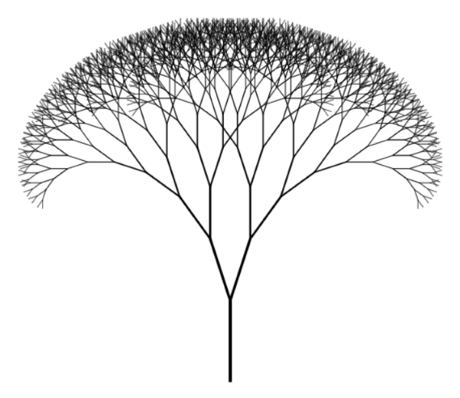Why is this representation of a tree a fractal?
7. In the space below, draw your own version of a few different fractal trees in order to create a fractal tree forest.