Fantastic Creatures and Where to Find Them

By: Newt Scamander

Dealing With Monsters:

Sometimes a monster just needs a friend. Create a copy of the original monster using the cp spell. An example of this command is cp FILE_TO_COPY NAME_OF_NEW_COPY .

Use this spell to create a duplicate monster called monster_friend.txt



Join Computer Club!!



Meeting 10/31 @ 3pm

Fantastic Creatures and Where to Find Them

By: Newt Scamander

Dealing With Monsters:

Sometimes a monster just needs a friend. Create a copy of the original monster using the cp spell. An example of this command is cp FILE_TO_COPY NAME_OF_NEW_COPY .

Use this spell to create a duplicate monster called monster_friend.txt



--- Walking Club ---

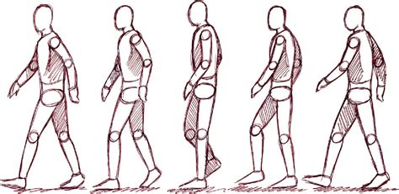

Walk This Way!!!

Meetings Wednesday @4:30 pm

Fantastic Creatures and Where to Find Them

By: Newt Scamander

Dealing With Monsters:

Sometimes a monster just needs a friend. Create a copy of the original monster using the cp spell. An example of this command is cp FILE_TO_COPY NAME_OF_NEW_COPY .

Use this spell to create a duplicate monster called monster_friend.txt



Vote



Class President

Megan

for