**Bits, Bytes, and Binary Review**

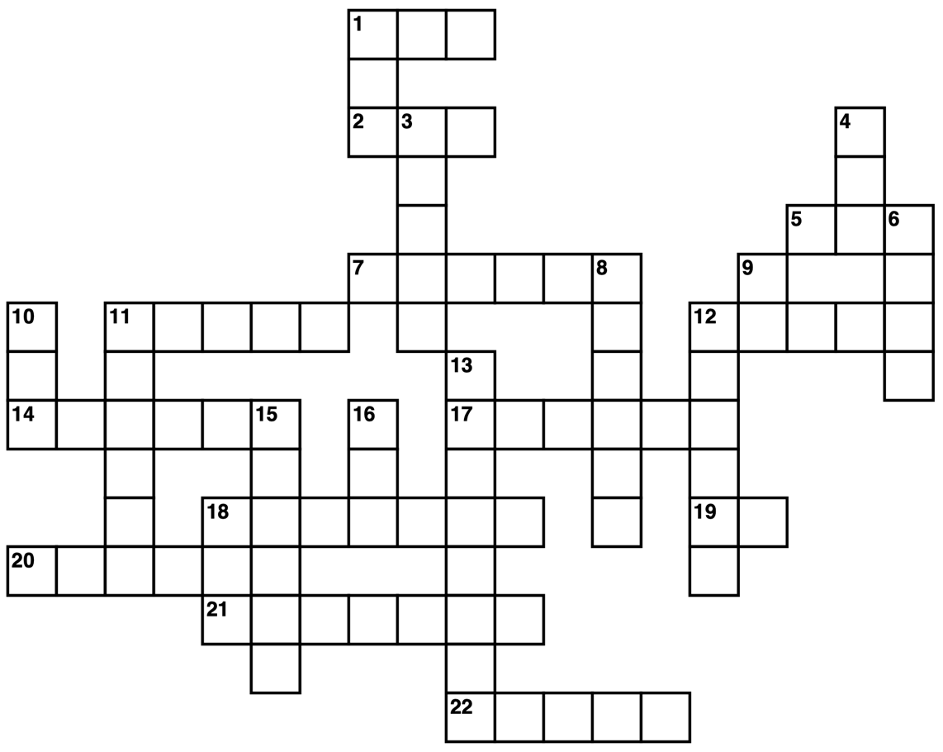

1

1

1

1

1

1

0 0 0 0

|  |  |
| --- | --- |
| **Across**  **[1]** The second highest possible number for a 7-bit binary number (in decimal)  **[2]** The number 0d280 in hex  **[5]** The number 0xfb in decimal  **[7]** The number 0d1 in binary  **[11]** The number 0b10011100011010 in decimal  **[12]** The number 0d69905 in hexadecimal  **[14]** The color dark grey where each LED is controlled by 2 bits  **[17]** The number 0xB in decimal  **[18]** The number 0d77 in binary  **[19]** In _ byte there are _ bits  **[20]** ________ (Come up with your own question)  **[21]** 0b100010 + 0b1001110 (in binary)  **[22]** 0X42, 0X45, 0X45, 0X46 in ASCII | **Down**  **[1]** The color white where each LED is controlled by 1 bit  **[3]** A skinny b/w BitPic of a white picket fence (binary)  **[4]** The highest possible number for 1-byte binary number (in decimal)  **[6]** The loudest sound a 4-bit speaker can make (binary)  **[8]** The color light grey where each LED is controlled by 2 bits  **[9]** The number 0d81 in hex  **[10]** The number 0x12c in decimal  **[11]** The number 0x20 in binary  **[12]** ________ (Come up with your own question)  **[13]** The number 0b1011 in hex  **[15]** On, On, Off, Off, On, On  **[16]** The 0d5 in binary |

Note: SHOW YOUR WORK on either this paper or another piece of paper

**Bits, Bytes, and Binary Review**

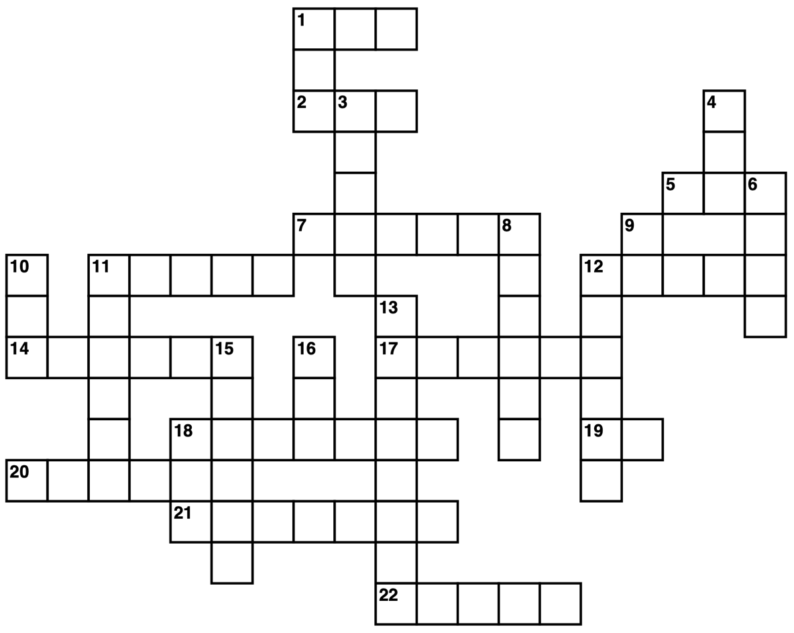

1

1

1

1

1

1

0 0 0 0

|  |  |
| --- | --- |
| **Across**  **[1]** The number 0x7E in decimal  **[2]** The number 0b1110110 in decimal  **[5]** The fourth highest 1-byte number (in decimal)  **[7]** The second quietest noise a 6-bit speaker can make (binary)  **[11]** The number 0x12 in binary  **[12]** The highest possible 5-bit number in binary  **[14]** The number 0d21 in binary  **[17]** The color blue where each LED is controlled by 2 bits  **[18]** The number 0xF468D in decimal  **[19]** In _ byte there are _ bits  **[20]** ________ (Come up with your own question)  **[21]** The number 0d112 in binary  **[22]** The number 0d48879 in hexadecimal | **Down**  **[1]** The number 0x7 in binary  **[3]** The number 0d21 in binary  **[4]** 0X32, 0X35, 0X35 in ASCII  **[6]** The number 0d15 in binary  **[8]** On, Off, On, Off, On, Off  **[9]** The number 0b110011 in decimal  **[10]** 0X33, 0X30, 0X30 in ASCII  **[11]** A space in ASCII (in binary)  **[12]** ________ (Come up with your own question)  **[13]** The number 0d11 in hexadecimal  **[15]** The color magenta where each LED is controlled by 2 bits  **[16]** 0b101101 + 0b111000 in decimal |

Note: SHOW YOUR WORK on either this paper or another piece of paper