Teaching the Science of Learning
By Yana Weinstein, Christopher R. Madan, and Megan A. Sumeracki
Note: This edition has been heavily edited for brevity and to focus on the core issues for this lesson
Essential questions:
- How does the research compare with your learning experience?
- What learning strategies do you see being used in the classes you take?
- What similarities are there between the way machines learn and humans learn?
- Which learning strategies have no comparable ones in ML and what does this say about the difference between humans and machines?
The science of learning has made a considerable contribution to our understanding of effective teaching and learning strategies. In this tutorial review, we focus on six specific cognitive strategies that have received robust support from decades of research: spaced practice, interleaving, retrieval practice, elaboration, concrete examples, and dual coding. We describe the basic research behind each strategy and relevant applied research [and] present examples of existing and suggested implementation.
Learning strategy | Description | Application examples from a Psychology Class
Spaced practice | Creating a study schedule that spreads study activities out over time | Students can block off time to study and restudy key concepts such as action potentials and the nervous systems on multiple days before an exam, rather than repeatedly studying these concepts right before the exam
Interleaving | Switching between topics while studying | After studying the peripheral nervous system for a few minutes, students can switch to the sympathetic nervous system and then to the parasympathetic system; next time, students can study the three in a different order, noting what new connections they can make between them
Retrieval practice | Bringing learned information to mind from long-term memory | When learning about neural communication, students can practice writing out how neurons work together in the brain to send messages (from dendrites, to soma, to axon, to terminal buttons)
Elaboration | Asking and explaining why and how things work | Students can ask and explain why Botox prevents wrinkles: the nervous system cannot send messages to move certain muscles
Concrete examples | When studying abstract concepts, illustrating them with specific examples | Students can imagine the following example to explain the peripheral nervous system: a fire alarm goes off. The sympathetic nervous system allows people to move quickly out of the building; the parasympathetic system brings stress levels back down when the fire alarm turns off
Dual coding | Combining words with visuals | Students can draw two neurons and explain how one communicates with the other via the synaptic gap
Spaced Practice
The benefits of spaced (or distributed) practice to learning are arguably one of the strongest contributions that cognitive psychology has made to education. The effect is simple: the same amount of repeated studying of the same information spaced out over time will lead to greater retention of that information in the long run, compared with repeated studying of the same information for the same amount of time in one study session. The benefits of distributed practice were first empirically demonstrated in the 19th century. As part of his extensive investigation into his own memory, Hermann Ebbinghaus found that when he spaced out repetitions across 3 days, he could almost halve the number of repetitions necessary to relearn a series of 12 syllables in one day. He thus concluded that “a suitable distribution of [repetitions] over a space of time is decidedly more advantageous than the massing of them at a single time.”
Spaced practice appears to be particularly useful at large retention intervals: in the meta-analysis by Cepeda et al., all studies with a retention interval longer than a month showed a clear benefit of distributed practice. The “new theory of disuse” provides a helpful mechanistic explanation for the benefits of spacing to learning. This theory posits that memories have both retrieval strength and storage strength. Whereas retrieval strength is thought to measure the ease with which a memory can be recalled at a given moment, storage strength (which cannot be measured directly) represents the extent to which a memory is truly embedded in the mind. When studying is taking place, both retrieval strength and storage strength receive a boost.
Teachers can introduce spacing to their students in two broad ways. One involves creating opportunities to revisit information throughout the semester, or even in future semesters. This does involve some up-front planning, and can be difficult to achieve, given time constraints and the need to cover a set curriculum. However, spacing can be achieved with no great costs if teachers set aside a few minutes per class to review information from previous lessons. The second method involves putting the onus to space on the students themselves. Of course, this would work best with older students – high school and above. Because spacing requires advance planning, it is crucial that the teacher helps students plan their studying. For example, teachers could suggest that students schedule study sessions on days that alternate with the days on which a particular class meets.
It is important to note that students may feel less confident when they space their learning than when they cram. This is because spaced learning is harder – but it is this “desirable difficulty” that helps learning in the long term.
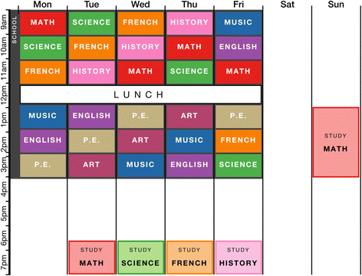
The figure above shows a spaced practice schedule for one week. This schedule is designed to represent a typical timetable of a high-school student. The schedule includes four one-hour study sessions, one longer study session on the weekend, and one rest day. Notice that each subject is studied one day after it is covered in school, to create spacing between classes and study sessions.
Interleaving
Another scheduling technique that has been shown to increase learning is interleaving. Interleaving occurs when different ideas or problem types are tackled in a sequence, as opposed to the more common method of attempting multiple versions of the same problem in a given study session (known as blocking). Interleaving as a principle can be applied in many different ways. One such way involves interleaving different types of problems during learning, which is particularly applicable to subjects such as math and physics. For example, in a study with college students, Rohrer and Taylor found that shuffling math problems that involved calculating the volume of different shapes resulted in better test performance 1 week later than when students answered multiple problems about the same type of shape in a row. The proposed explanation for the benefit of interleaving is that switching between different problem types allows students to acquire the ability to choose the right method for solving different types of problems rather than learning only the method itself, and not when to apply it.
Interleaving can be helpful in other situations that require discrimination, such as inductive learning. Kornell and Bjork examined the effects of interleaving in a task that might be pertinent to a student of the history of art: the ability to match paintings to their respective painters. Students who studied different painters’ paintings interleaved at study were more successful on a later identification test than were participants who studied the paintings blocked by painter.
For problem-based subjects, the interleaving technique is straightforward: simply mix questions on homework and quizzes with previous materials (which takes care of spacing as well); for languages, mix vocabulary themes rather than blocking by theme.
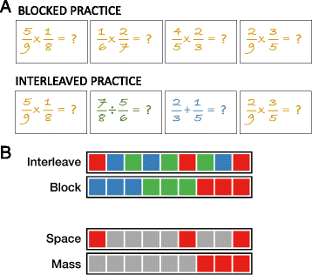
The figure above shows the difference between common (blocked) practice and interleaved practice. Figure a shows blocked practice and interleaved practice with fraction problems. In the blocked version, students answer four multiplication problems consecutively. In the interleaved version, students answer a multiplication problem followed by a division problem and then an addition problem, before returning to multiplication. For an experiment with a similar setup, see Patel et al. Figure b shows an illustration of interleaving and spacing. Each color represents a different homework topic. Interleaving involves alternating between topics, rather than blocking. Spacing involves distributing practice over time, rather than massing. Interleaving inherently involves spacing as other tasks naturally “fill” the spaces between interleaved sessions.
Retrieval Practice
While tests are most often used in educational settings for assessment, a lesser-known benefit of tests is that they actually improve memory of the tested information. If we think of our memories as libraries of information, then it may seem surprising that retrieval (which happens when we take a test) improves memory; however, we know from a century of research that retrieving knowledge actually strengthens it. Testing was shown to strengthen memory as early as 100 years ago, and there has been a surge of research in the last decade on the mnemonic benefits of testing, or retrieval practice. How does retrieval practice help memory? The act of retrieval itself is thought to strengthen memory.
The figure below shows a concept map illustrating the process and resulting benefits of retrieval practice. Retrieval practice involves the process of withdrawing learned information from long-term memory into working memory, which requires effort. This produces direct benefits via the consolidation of learned information, making it easier to remember later and causing improvements in memory, transfer, and inferences. Retrieval practice also produces indirect benefits of feedback to students and teachers, which in turn can lead to more effective study and teaching practices, with a focus on information that was not accurately retrieved.
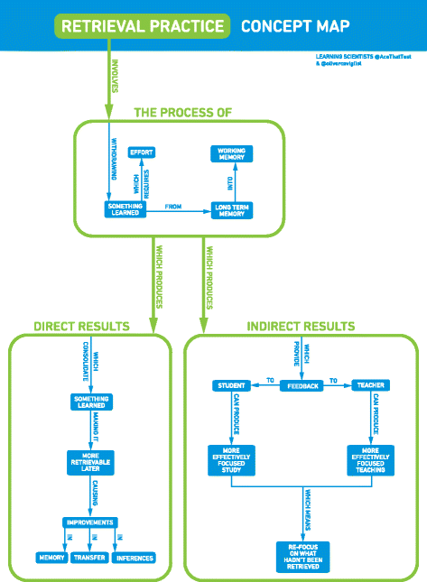
Practicing retrieval is a powerful way to improve meaningful learning of information, and it is relatively easy to implement in the classroom. For example, requiring students to practice retrieval can be as simple as asking students to put their class materials away and try to write out everything they know about a topic. Retrieval-based learning strategies are also flexible. Instructors can give students practice tests (e.g., short-answer or multiple-choice), provide open-ended prompts for the students to recall information or ask their students to create concept maps from memory.
Elaboration
Elaboration involves connecting new information to preexisting knowledge. Anderson made the following claim about elaboration: “One of the most potent manipulations that can be performed in terms of increasinga subject’s memory for material is to have the subject elaborate on the to-be-remembered material.” Postman defined elaboration most parsimoniously as “additions to nominal input”, and Hirshman provided an elaboration on this definition (pun intended!), defining elaboration as “A conscious, intentional process that associates to-be-remembered information with other information in memory.” However, in practice, elaboration could mean many different things. The common thread in all the definitions is that elaboration involves adding features to an existing memory.
One possible instantiation of elaboration is thinking about information on a deeper level. The levels (or “depth”) of processing framework, proposed by Craik and Lockhart, predicts that information will be remembered better if it is processed more deeply in terms of meaning, rather than shallowly in terms of form. Another mechanism by which elaboration can confer a benefit to learning is via improvement in. By this view, elaboration involves making information more integrated and organized with existing knowledge structures. By connecting and integrating the to-be-learned information with other concepts in memory, students can increase the extent to which the ideas are organized in their minds, and this increased organization presumably facilitates the reconstruction of the past at the time of retrieval.

The figure above shows an illustration of “how” and “why” questions (i.e., elaborative interrogation questions) students might ask while studying the physics of flight. To help figure out how physics explains flight, students might ask themselves the following questions: “How does a plane take off?”; “Why does a plane need an engine?” and “Why is there a downwash behind the wings?”.
Concrete Examples
Providing supporting information can improve the learning of key ideas and concepts. Specifically, using concrete examples to supplement content that is more conceptual in nature can make the ideas easier to understand and remember. Concrete examples can provide several advantages to the learning process: (a) they can concisely convey information, (b) they can provide students with more concrete information that is easier to remember, and (c) they can take advantage of the superior memorability of pictures relative to words.
Words that are more concrete are both recognized and recalled better than abstract words (e.g., “button” and “bound,” respectively). Furthermore, it has been demonstrated that information that is more concrete and imageable enhances the learning of associations, even with abstract content. Following from this, providing concrete examples during instruction should improve retention of related abstract concepts, rather than the concrete examples alone being remembered better. Concrete examples can be useful both during instruction and during practice problems. Having students actively explain how two examples are similar and encouraging them to extract the underlying structure on their own can also help with transfer.


The figure above shows an example of a concrete example.
Dual coding
Both the memory literature and folk psychology support the notion of visual examples being beneficial—the adage of “a picture is worth a thousand words” (traced back to an advertising slogan from the 1920s). Indeed, it is well-understood that more information can be conveyed through a simple illustration than through several paragraphs of text. Illustrations can be particularly helpful when the described concept involves several parts or steps and is intended for individuals with low prior knowledge.
In addition to being able to convey information more succinctly, pictures are also more memorable than words. In the memory literature, this is referred to as the picture superiority effect, and dual coding theory was developed in part to explain this effect. Dual coding follows from the notion of text being accompanied by complementary visual information to enhance learning. Paivio proposed dual coding theory as a mechanistic account for the integration of multiple information “codes” to process information. In this theory, a code corresponds to a modal or otherwise distinct representation of a concept—e.g., “mental images for ‘book’ have visual, tactual, and other perceptual qualities similar to those evoked by the referent objects on which the images are based.” Broadly, dual coding theory suggests that providing multiple representations of the same information enhances learning and memory, and that information that more readily evokes additional representations (through automatic imagery processes) receives a similar benefit.
Given that pictures are generally remembered better than words, it is important to ensure that the pictures students are provided with are helpful and relevant to the content they are expected to learn. Researchers have found that providing visual examples decreased conceptual errors. However, McNeill et al. also found that when students were given visually rich examples, they performed more poorly than students who were not given any visual example, suggesting that the visual details can at times become a distraction and hinder performance. Thus, it is important to consider that images used in teaching are clear and not ambiguous in their meaning.
Critically, dual coding theory is distinct from the notion of “learning styles,” which describe the idea that individuals benefit from instruction that matches their modality preference. While this idea is pervasive and individuals often subjectively feel that they have a preference, evidence indicates that the learning styles theory is not supported by empirical findings. That is, there is no evidence that instructing students in their preferred learning style leads to an overall improvement in learning (the “meshing” hypothesis). Moreover, learning styles have come to be described as a myth or urban legend within psychology.

