A Maze Game!

Today you are going to augment the maze game you created a few classes ago so that it is interactive. You will do this by adding a “game loop” to your pre-existing maze so that it responds to user input.
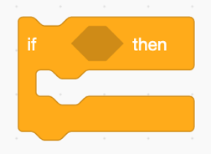
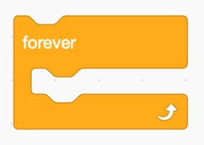

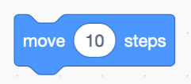



In the process you will be using move, forever, and if blocks to complete the project.

Assignment

User Controlled Sprite:

□ Make the program put the sprite in the proper position when the green flag is clicked
□ Make the program leave a line behind wherever the sprite goes
□ Make the program say “Woohoo!!!” when the sprite gets to the end of the maze
□ Make the program return the sprite back to the beginning whenever it touches a maze wall
□ Make the program return the sprite back to the beginning whenever it touches the edge
□ Make the sprite use the next costume block when it moves to look like its running

Bonus:

- Add a second level to your game (5pts)
Hint: You will need to use the switch backdrop to block
- Add a timer and give extra nice feedback if the user completes a level in a certain time (3pts)
- Add an “evil sprite” that chases you and sends you back to the start if you touch it (5pts)
- Add the concept of lives (5pts)
Hint: You will need to use variables

