Tron!

Today you are going to make a video game version of the beloved 1982 movie, Tron. You will do this by using a “game loop” to have the sprite(s) react to user input and detect collisions.

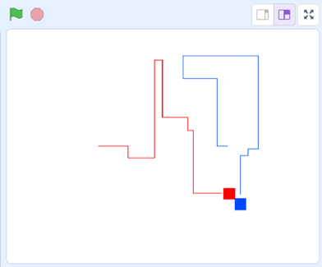

In the process you will be using move, forever, and conditional blocks to complete the project.

Assignment

User Controlled Sprite:

□ Make the program put the sprites in the proper position when the green flag is clicked
□ Make the program have the sprites point in the proper direction
□ Make the program leave a line behind wherever the sprites go
□ Make the program have a sprite that runs into a line say “I lose!”
□ Make the program have a sprite that runs into an edge say “I lose!”

Bonus:

- Give the sprites a cool “explosion animation” whenever they touch a wall/edge (5pts)
- Add the ability to do a speed boost when holding down a particular key (3pts)
- Add a “start screen” that greets both users when they start the game (5pts)
Hint: Using broadcasts will make things easier
- Add the concept of lives (7pts)
Hint: You will need to use variables
- Create “power ups” that randomly appear and make the user invincible for a bit (7pts)

