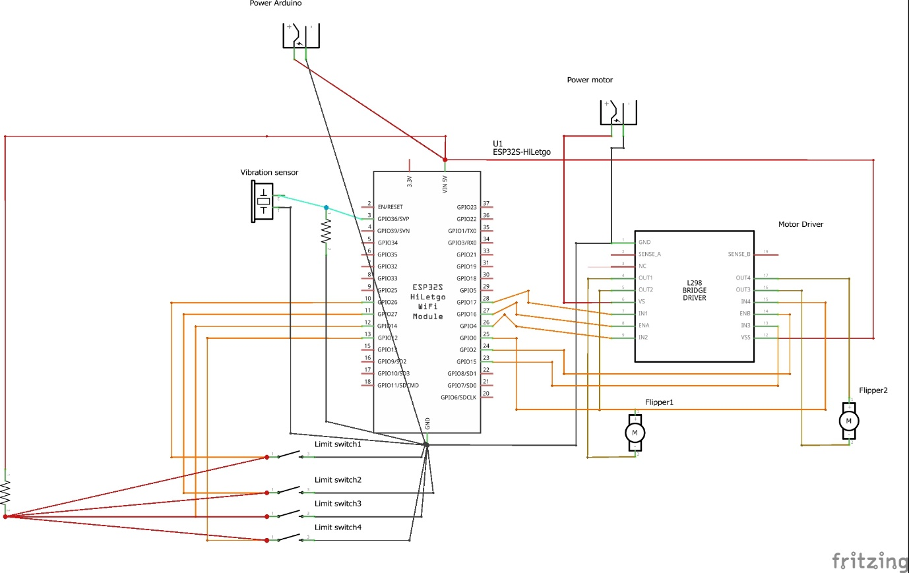

Parts required:

1x ESP32

2x Power source

2x DC Motors

1x L298 dual H-Bridge Motor Driver

8x Vibration sensors

4x Limit Switches