Instructions for downloading files for the November 30th R Code Club session

The code and data are in the MSTeams folder [Lesson4](https://cdc.sharepoint.com/:f:/r/teams/SDSB-GLITR-TheEpidemiologistRHandbookDSTDPRCodeClub/Shared%20Documents/Lesson4?csf=1&web=1&e=R74ZN7). Download the files from MSTeams.

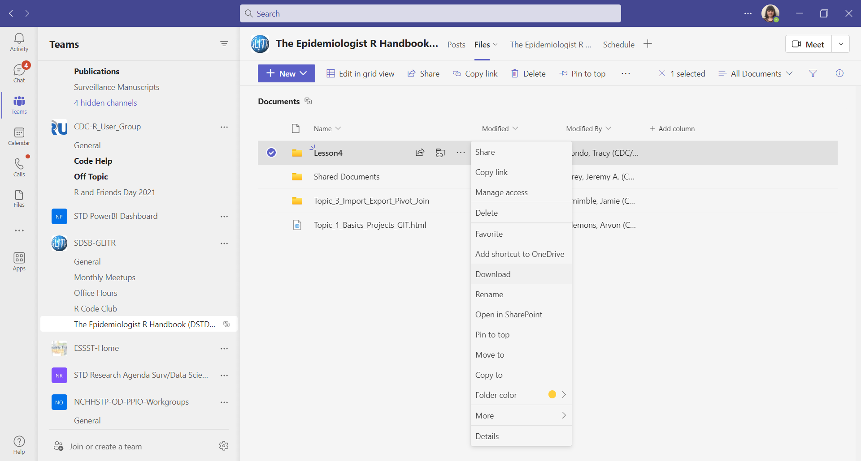

You will need to unzip the files and save them in a folder where you will create a new R project.

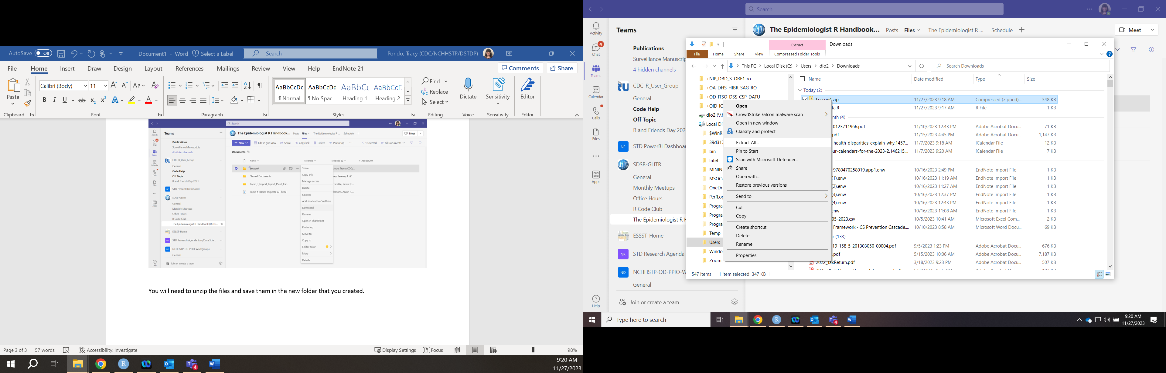

Unzip the data by clicking “Extract”.

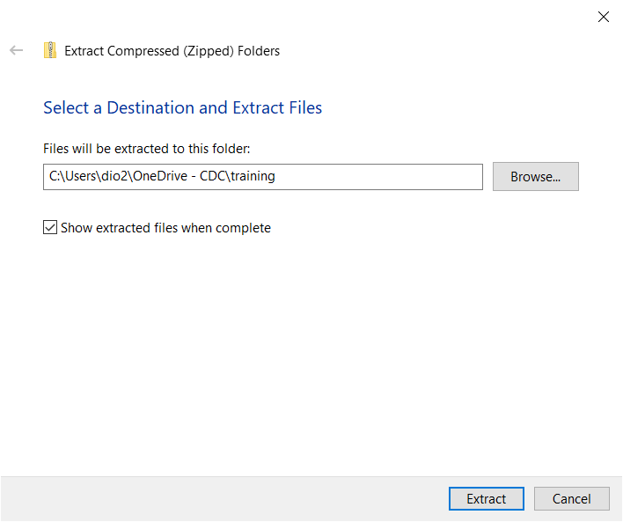

Open RStudio and create a new R project in the location where you saved the Lesson4 files.

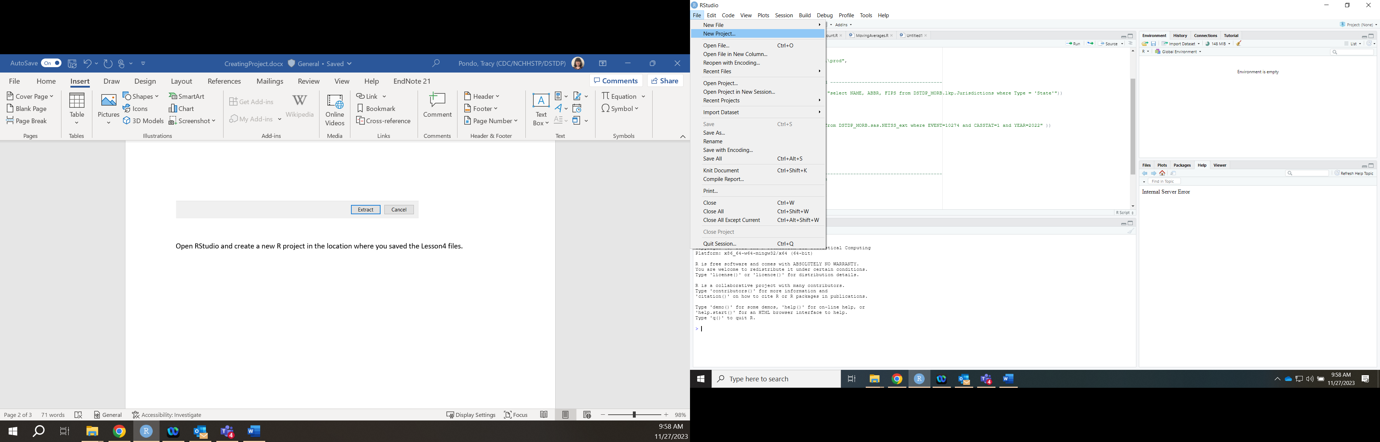

Select “Existing Directory” and browse for the folder that contains the R code and data. Then, click “Create Project”.

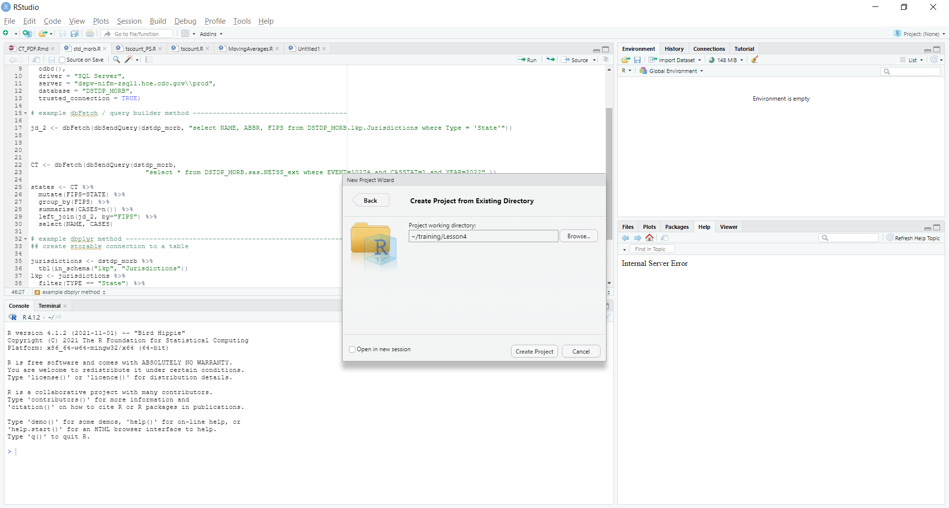

You should see all the files in the “Files” window in RStudio.

