**https://www.cnblogs.com/zidonghua/p/7436440.html**

**一、环境准备**

**小编环境：**

**1.win10 64位**

**2.JDK 1.8.0_66**

**3.tomcat 9.0.0.M4**

**4.jenkins 2.0**

**二、安装JDK**

**1.安装JDK教程很多，这里就不讲了，百度搜！**

**在系统环境变量里添加以下变量：**

**①JAVA_HOME：jdk的安装路径C:\Sun\Java\jdk**

**②CLASSPATH：“.;%JAVA_HOME%\lib;”**

**③Path：“;%JAVA_HOME%\bin”**

**2.检查环境是否成功（这一步很重要）**

**>>java -version**

**>>javac**

**(输入javac一定要看到中文的这些内容)**

**插件安装**[Email Extension Plugin](https://wiki.jenkins-ci.org/display/JENKINS/Email-ext+plugin)  [Subversion Plug-in](https://wiki.jenkins.io/display/JENKINS/Subversion+Plugin) [Workspace Cleanup Plugin](http://wiki.jenkins-ci.org/display/JENKINS/Workspace+Cleanup+Plugin)  [SSH plugin](http://wiki.jenkins-ci.org/display/JENKINS/SSH+plugin)  [Maven Integration plugin](https://wiki.jenkins.io/display/JENKINS/Maven+Project+Plugin) [Ant Plugin](https://wiki.jenkins-ci.org/display/JENKINS/Ant+Plugin)

**系统设置**

**环境变量**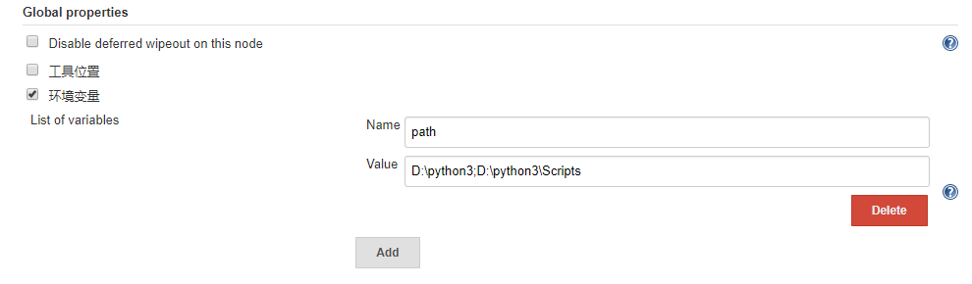

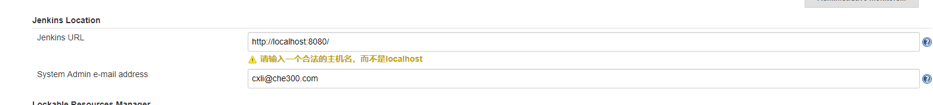

**邮件提醒，前提：下载插件【注意，下面的邮件提醒也要填，点击“高级”，填入相应的端口号等】**

端口号信息见邮箱的设置**：**

**如车300企业邮箱**

接收服务器：

**imap.exmail.qq.com(使用SSL，端口号993)**

发送服务器：

**smtp.exmail.qq.com(使用SSL，端口号465)**

**邮件发送方账号密码验证**

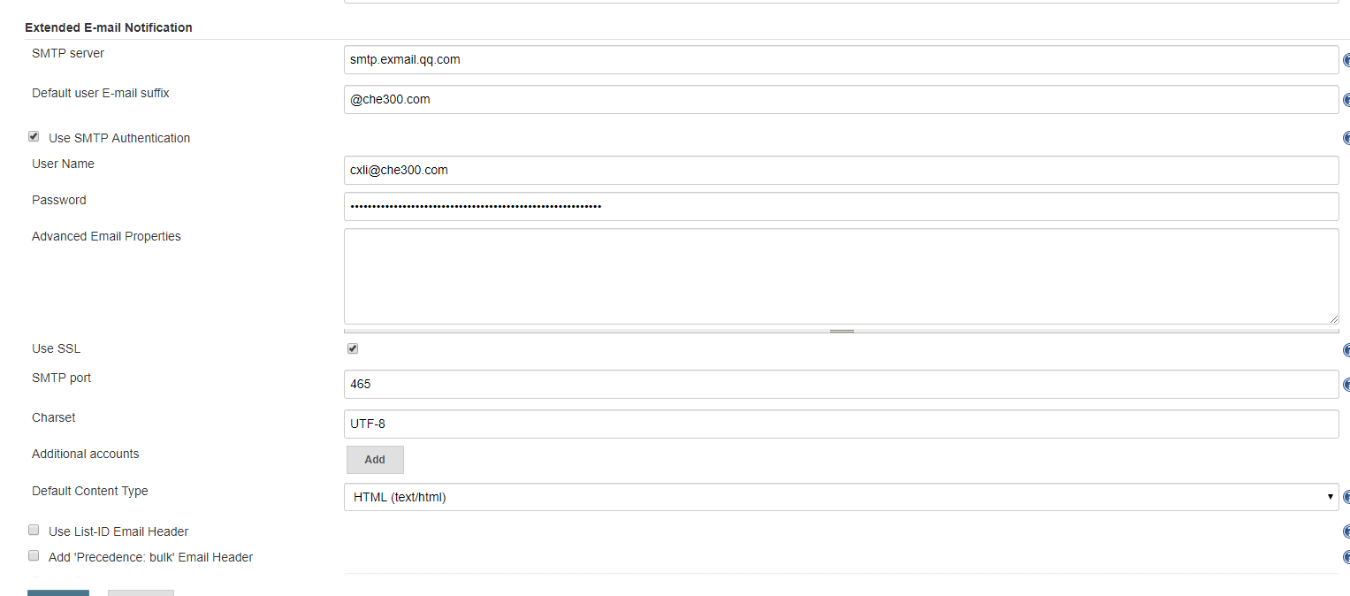

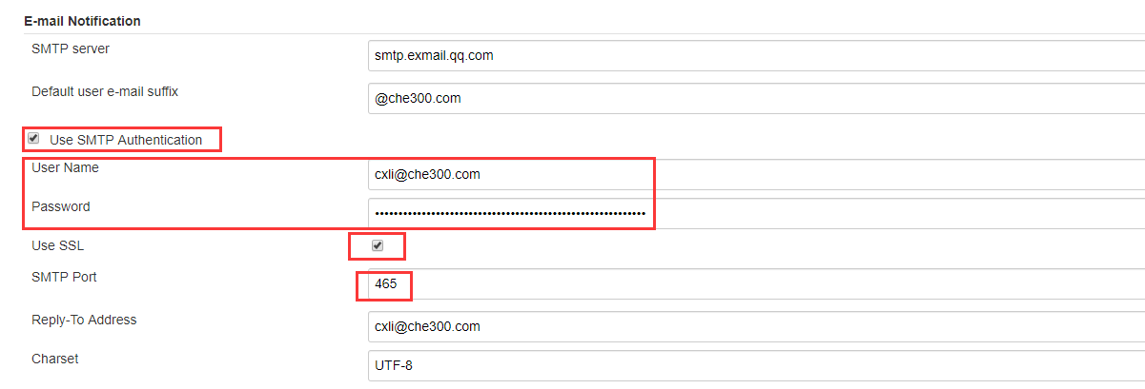

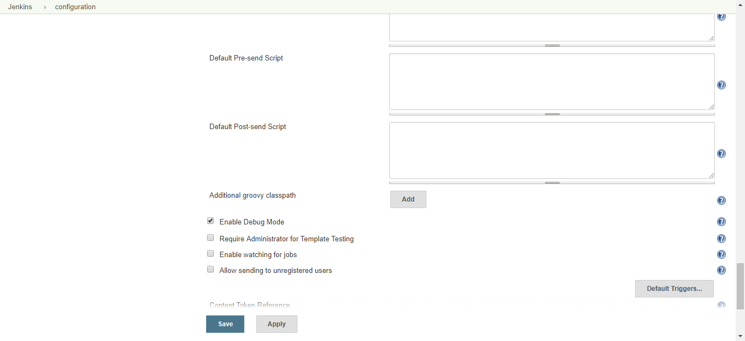

**项目配置页面**

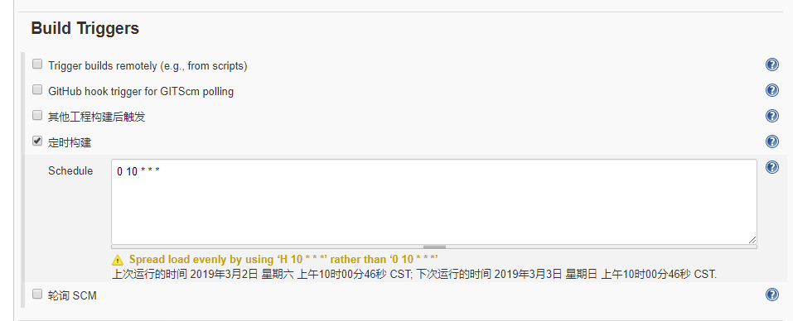

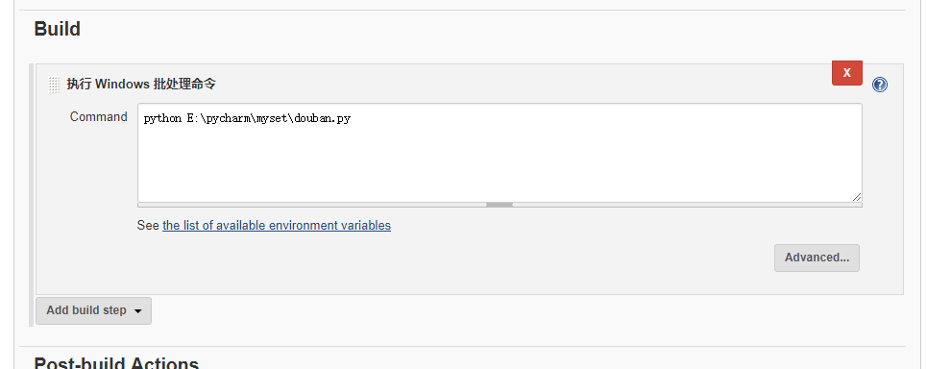

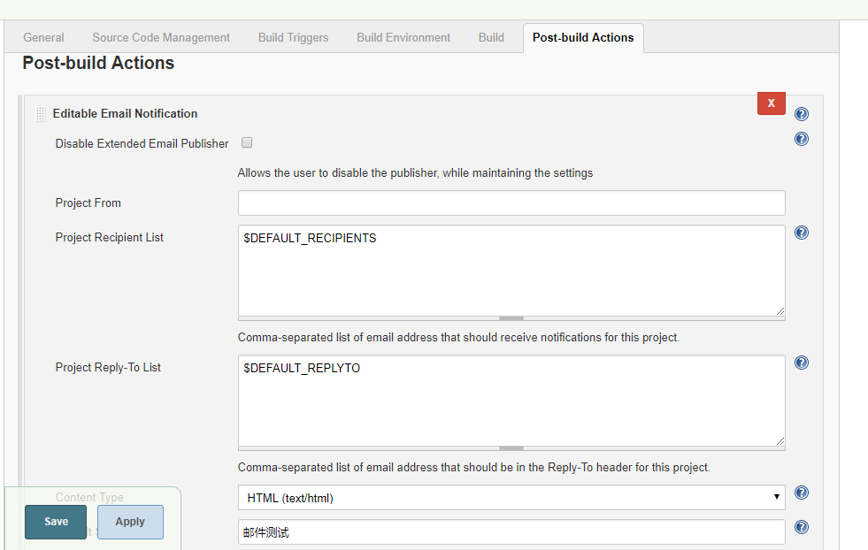

**邮件默认内容Default Content：**

$DEFAULT_CONTENT

<!DOCTYPE html>

<html>

<head>

<meta charset="UTF-8">

<title>${PROJECT_NAME}-第${BUILD_NUMBER}次构建日志</title>

</head>

<body leftmargin="8" marginwidth="0" topmargin="8" marginheight="4"

offset="0">

<table width="95%" cellpadding="0" cellspacing="0"

style="font-size: 11pt; font-family: Tahoma, Arial, Helvetica, sans-serif">

<tr>

<td>(本邮件是程序自动下发的，请勿回复！)</td>

</tr>

<tr>

<td><h2>

<font color="#0000FF">构建结果 - ${BUILD_STATUS}</font>

</h2></td>

</tr>

<tr>

<td><br />

<b><font color="#0B610B">构建信息</font></b>

<hr size="2" width="100%" align="center" /></td>

</tr>

<tr>

<td>

<ul>

<li>项目名称 ： ${PROJECT_NAME}</li>

<li>构建编号 ： 第${BUILD_NUMBER}次构建</li>

<li>触发原因： ${CAUSE}</li>

<li>构建日志： <a href="${BUILD_URL}console">${BUILD_URL}console</a></li>

<li>构建  Url ： <a href="${BUILD_URL}">${BUILD_URL}</a></li>

<li>工作目录 ： <a href="${PROJECT_URL}ws">${PROJECT_URL}ws</a></li>

<li>项目  Url ： <a href="${PROJECT_URL}">${PROJECT_URL}</a></li>

</ul>

</td>

</tr>

<tr>

<td><b><font color="#0B610B">Changes Since Last

Successful Build:</font></b>

<hr size="2" width="100%" align="center" /></td>

</tr>

<tr>

<td>

<ul>

<li>历史变更记录 : <a href="${PROJECT_URL}changes">${PROJECT_URL}changes</a></li>

</ul> ${CHANGES_SINCE_LAST_SUCCESS,reverse=true, format="Changes for Build #%n:<br />%c<br />",showPaths=true,changesFormat="<pre>[%a]<br />%m</pre>",pathFormat="    %p"}

</td>

</tr>

<tr>

<td><b>Test Informations</b>

<hr size="2" width="100%" align="center" /></td>

</tr>

<tr>

<td><pre

style="font-size: 11pt; font-family: Tahoma, Arial, Helvetica, sans-serif">Total:${TEST_COUNTS,var="total"},Pass:${TEST_COUNTS,var="pass"},Failed:${TEST_COUNTS,var="fail"},Skiped:${TEST_COUNTS,var="skip"}</pre>

<br /></td>

</tr>

<tr>

<td><b><font color="#0B610B">构建日志 (最后 100行):</font></b>

<hr size="2" width="100%" align="center" /></td>

</tr>

<tr>

<td><textarea cols="80" rows="30" readonly="readonly"

style="font-family: Courier New">${BUILD_LOG, maxLines=100}</textarea>

</td>

</tr>

</table>

</body>

</html>

Attachments（附件）：应该是workspace下生成的文件。

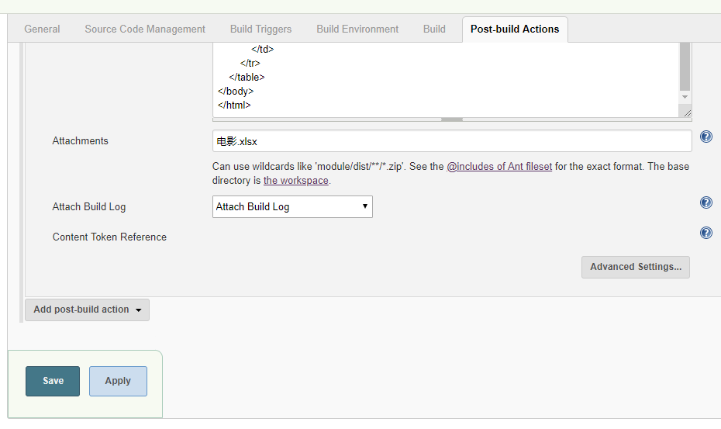

然后在上图的Advanced setting设置构建成功/失败后的邮件接收者【必填】，不然邮件发给谁。

