TYPE II-ENERGY EFFICIENCY IMPROVEMENT PROJECTS
Project participants shall apply the general guidelines to small-scale (SSC) clean development mechanism (CDM) methodologies, Guidelines on the demonstrating of additionality of SSC project activities at http://cdm.unfccc.int/Reference/Guidclarif/index.html#meth mutatis mutandis.
II.Q. Energy efficiency and/or energy supply projects in commercial buildings

Technology/Measure
      - This methodology is applicable to on-site building energy supply and whole building energy efficiency projects whose associated emission reductions can be determined with a whole building computerized simulation tool.

Applicability conditions
      - The methodology applies to commercial buildings for both retrofit and new construction (i.e. Greenfield) projects. Allowable projects include energy efficient building design features; energy efficient appliances, equipment and/or technologies; energy management controls; on-site renewable energy projects; on-site cogeneration; and/or fossil fuel switching – alone or in combination.
      - All technologies (e.g. equipment or appliances) used in the project activity must be new and not transferred from another project activity.
      - This methodology is not applicable to project activities that affect off-site district heating and/or cooling plants and distribution networks even if they supply energy to the subject building(s).
      - If the energy efficient equipment contains refrigerants, then the refrigerant used in the project case shall have no Ozone Depleting Potential (ODP).
      - If the project activity includes fuel switching, the requirements in AMS-III.B “Switching fossil fuels” for establishing a baseline for fuel switching shall be followed.
      - None of the project equipment, systems or actions used for claiming emission reductions may be included in another CDM project in order to avoid possible double counting of emission reductions.
      - The Project Design Document (PDD) shall document how the potential for double counting of emission reductions, for example due to equipment manufacturers or others claiming credit for emission reductions for project activities, are avoided.
      - The aggregate electricity savings by a single project shall not exceed 60 GWh per year.

Boundary
      - The project activity boundary encompasses the physical extent of the building site(s) where the emission avoidance projects are implemented.

Ex ante emission reduction calculations
      - The ex ante baseline emissions scenario shall be based on the characteristics and operation of the existing building(s) (Retrofit) or the building(s), which would have been constructed in the absence of the CDM project activity (New Construction). The sources of data used to establish the baseline building energy use shall be cited and referenced in the PDD.
        - In the case of a retrofit of an existing building (Retrofit), the ex ante baseline emissions scenario is based on the energy consumed over the past 12 months in the subject building(s)(refer to Figure 1, left pathway in “Baseline”);
        - In the case of the construction of a new building (New Construction), the ex ante baseline emissions scenario shall be based on one of the following two approaches (refer to Figure 1, right pathway in “Baseline”):
          - Where there is a legally mandated code on energy performance and/or equipment performance standard(s), the baseline emissions scenario is based on minimum energy requirements in the building code and/or equipment performance standard(s) for the subject building type(s) or classification(s) in the same climate zone (e.g. in kWh/m²/year); or
          - Where there is no legally mandated building code nor equipment performance standard(s) on energy performance, the baseline emissions scenario is based on the average energy consumption in buildings of the same or similar building type, usage or classification as the subject building(s) within the same climate zone. Additional guidelines included in appendix 2 can be referred in this regard.
      - The ex ante project scenario shall be based on a whole building computerized simulation model of the proposed project building(s) using the average or typical weather for that location, the proposed physical building characteristics (referred to as Base building setting or “B” setting) and its operating, building control strategies and occupancy settings (referred to as “T” settings).
        - In Retrofit, the building model’s B settings should reflect the changes associated with the project activity compared to the baseline scenario, and the T operating and occupancy settings should match the conditions in the baseline case (refer to Figure 1);
        - In New Construction, the building model’s B and T settings should reflect the characteristics of the project activity.
      - The ex ante emissions reduction is estimated as the difference between baseline and project scenario energy use with the application of applicable emission factors. If the project activity involves equipment with refrigerants, refrigerant emissions shall be determined and taken into account according to the provisions of AMS-II.K “Installation of co-generation or tri-generation systems supplying energy to commercial building”. Ex ante emission reductions are assumed to be the same for each year of the crediting period as determined above.
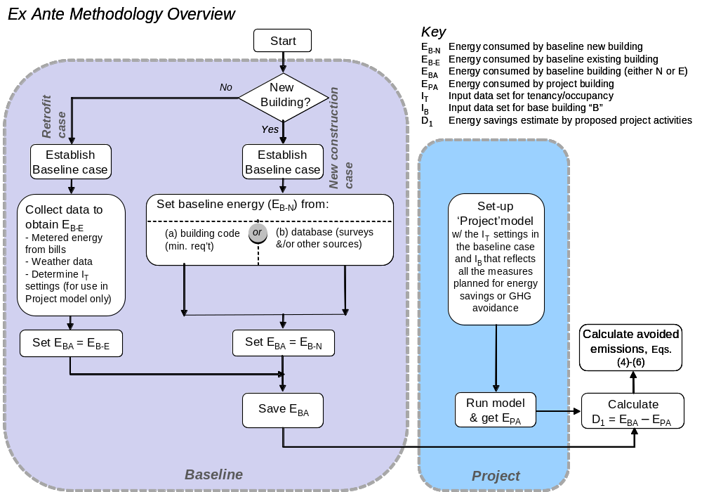

Figure 1: Flowchart of the ex ante methodology

Ex post emission reduction calculations
      - The avoided GHG emissions between the baseline and the project activity is determined using a whole building computerized simulation tool to generate energy use estimates (calibrated models) of the baseline building(s) scenario and the project building(s) scenario with emission reductions calculated based on the differences in energy use and emissions between the baseline and project scenarios (Figure 2) using weather and building occupancy experienced during each year of the crediting period (ex post).
      - Only whole building computerized simulation tools that have successfully met the analytical verification and have a current empirical validation requirements as defined in the International Energy Agency’s BESTEST protocol can be used with this methodology.
      - Project participants must demonstrate that the building energy simulations (and related calibrations) have been performed by skilled operator(s) as demonstrated by having at least three years of relevant experience and professional education and/or training.
Baseline emissions
      - For Retrofits, the baseline emissions scenario is based on the energy consumed over a period of a year as calculated using a calibrated whole building model of the subject baseline building(s) (see Figure 2, “Baseline”). The model’s B building settings for the baseline scenario should match the original building features before the retrofit. However, should activities associated with the project activity (for example if major modifications to the building are the primary activity taking place) require compliance with a legally mandated and enforced energy performance code and/or equipment standard(s), the baseline emissions scenario shall be based on minimum energy requirements in the building code and/or equipment performance standard(s) for the subject building type(s) or classification(s) in the same climate zone (e.g. in kWh/m²/year).
The baseline model’s weather, and T settings, shall match those in the calibrated model of the project activity building(s) (see Figure 2, “Model modification”).
      - For New Construction, the baseline emissions scenario is based on the energy consumed over a period of a year as calculated, using a calibrated model, of a “reference” baseline building, generated by a whole building computerized simulation tool, which is described below.
- The reference baseline model shall be configured as a building on the project site that matches the project’s building type (see appendix 1, definition and types of commercial buildings) and size (i.e. height or number of floors, and floor area), with a window-to-wall ratio and front façade orientation on the site the same as that can be demonstrated as typical of the project location (i.e. in the neighbourhood). Additional guidelines included in the appendix 2 can be referred in this regard. The reference baseline model shall exclude all the project activity measures such that the B building settings for the baseline scenario will be that which would have been constructed in the absence of the project activities;
- The baseline model’s weather, and tenancy T settings shall match those in the calibrated model of the project activity building(s) (see Figure 2, “Model modification”);
- Where there is a legally mandated code on energy performance at the time of project implementation, if the baseline energy consumption as calculated using whole building computerized simulation tool are lower than those associated with the minimum energy requirements in the building code for the subject building type(s) or classification(s) in the same climate zone (e.g. in kWh/m²/year), then the simulation results shall be used as the baseline. However, if the baseline energy consumption from simulation is higher than those associated with the minimum energy requirements in the building code, then the latter shall be used as the baseline.
      - An exception to paragraph 17’s building simulation model’s treatment of the tenancy-related T and base-building related B settings is applicable where a special tenancy lease arrangement is in place in, or part of, the CDM project activity. In this case, any T settings identified above that are included in a legally binding tenancy lease arrangement will be considered to be part of the CDM project activity’s settings for the model. The baseline data in this case will then be the prevailing industry practice in the country of the project activity.
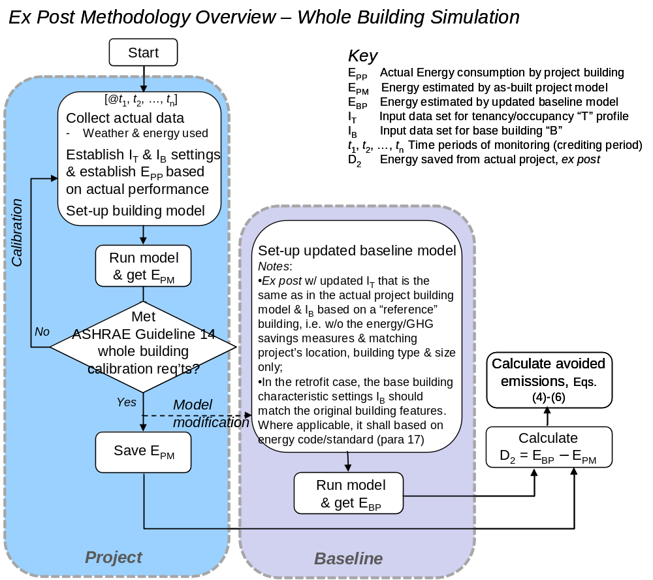

Figure 2: Flowchart of the ex post methodology using a whole building simulation tool

Emission reductions
      - A calibrated building model of the subject project building(s) is developed to: (a) match (via calibration) the actual energy consumption of the project building; (b) estimate baseline building energy consumption; and (c) determine the electrical and thermal energy savings between the project and baseline buildings (refer to Figure 2), which are then multiplied by appropriate emissions factors.
      - For both Retrofit and New Construction projects, the calibrated building model is established after the end of the first year of project (building) operation and when 12 months of energy use data under expected (“full”) operations are available for the project building. The model is established and calibrated using the: (a) as-built project building characteristics; (b) weather, building operating characteristics, building control strategies and settings, and building occupancy experienced during the same 12 month period for which energy use data under expected (full) operations are available; and (c) actual annual energy used in the building during the first full year of project building operation. The project building model is calibrated using actual energy data as shown in Figure 2 and the modelling process is conducted as described below.
Step 1: The following data are collected for the project building:
- Physical base B properties of the building: (i) building envelope (e.g. building geometry, location of building surfaces such as windows, building shades, relative position of the building thermal zones) and (ii) thermal properties (layer-by-layer description of the building materials with their conductivity, specific heat, and density);
- Specification of the space conditioning system, including its performance;
- Control systems;
- Information about the tenancy-related T settings: (i) internal loads (occupancy or average number of people per time period; lighting and equipment power density; internal load schedules); and (ii) building operations (control temperatures, window opening and related schedules, reflecting occupant behaviour); and the actual weather data and energy consumption in the first 12 months of building operation.
Step 2: Model calibration
- A simulation input file for the project building is developed based on input data from Step 1;
- The computer simulation results for the project building are compared to the actual energy consumption during the same 12 month period for which energy use data under expected (full) operations are available, and the whole building model is calibrated following the ”Whole Building Calibrated Simulation” path in ASHRAE Guideline 14-2002.
Step 3: Computer simulation and energy savings
- After the project model calibration has been completed in Step 2, the calibrated model is representative of the project building(s);
- The calibrated model is modified to represent the baseline building(s) as described above in paragraph 17;
- Calibrated models of the project building and the baseline building are completed for each crediting period year using weather, building operating characteristics, building control strategies and settings, and building occupancy settings, referred to as “T” settings, for each year of the crediting period.
Step 4: Documentation. The following information is reported as part of the annual emission savings documentation
- Software Version: Report the name and version number of the whole building simulation software used, including certification or evidence of BESTEST validation;
- Steps 1 and 3 input files to define the project and baseline building models, ex ante and ex post, including: (i) building physical properties; (ii) characteristics of the space conditioning system; (iii) initial load and operating assumptions; (iv) typical year weather file; (v) occupancy schedules; (vi) HVAC and lighting control settings; and (vii) lighting schedules; and
- Step 2 information documenting the calibration process, including: (i) initial simulation results for baseline building; and (ii) accuracy with which the simulation results match the calibration energy data.
- Physical base B properties of the baseline and project buildings, including but not limited to: (i) building envelope (e.g. building geometry, location of building surfaces such as windows, building shades, relative position of the building thermal zones) and (ii) thermal properties (layer-by-layer description of the building materials with their conductivity, specific heat, and density);
- Specification of the space conditioning system of the project and baseline buildings;
- Specification of the control systems and control settings of the project and baseline buildings;
- Information about actual baseline and project buildings’ tenancy-related T settings: (i) internal loads (occupancy or average number of people per time period; lighting and equipment power density; internal load schedules), and (ii) building operations (control temperatures, window opening and related schedules, reflecting occupant behaviour);
- Weather files for the project location with hourly data of temperature, humidity, wind direction and speed, total and diffuse solar radiation;
- Any other relevant information, including special tenancy lease arrangements, if applicable; and
- Name and qualifications of the person(s) involved in the computer simulation analyses and calibration.
      - The avoided emissions are calculated as follows:
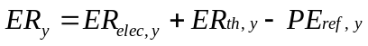 (1)
Where:
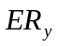 | Emission reductions in year y, tCO₂
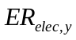 | Emission reductions from electricity savings in year y, tCO₂
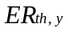 | Emission reductions from thermal energy savings in year y, tCO₂
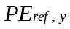 | Where applicable, project emissions from physical leakage of refrigerant, with a GWP greater than zero, from new cooling equipment in year y, determined in accordance with relevant provision in AMS-II.K. (tCO₂e/yr)
The calculation of emissions reductions from electricity is as follows:
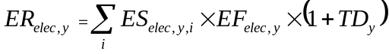 (2)
Where:
 | Emission reductions from electricity savings in year y, tCO₂
 | Building counter (e.g. building 1, building 2, building 3, etc.)
 | Crediting period year
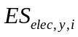 | Difference in electricity consumption between baseline building(s) and project building(s) as indicated by calibrated computer model(s) in year y for building i, MWh. To be determined annually
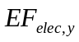 | Electricity emission factor for year y, as per the procedures of AMS-I.D “Grid connected renewable electricity generation”, tCO₂/MWh
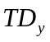 | Average annual technical grid losses (transmission and distribution) during year y for the grid serving the project residences, expressed as a fraction. This value shall not include non-technical losses such as commercial losses (e.g. theft/pilferage). The average annual technical grid losses shall be determined using recent, accurate and reliable data available for the host country. This value can be determined from recent data published either by a national utility or an official governmental body. Reliability of the data used (e.g. appropriateness, accuracy/uncertainty, especially exclusion of non technical grid losses) shall be established and documented by the project participant. A default value of 0.1 shall be used for average annual technical grid losses, if no recent data are available or the data cannot be regarded as accurate and reliable. In the case that electricity is not from the grid, TD_{y} = 0
The calculation of emissions reductions from thermal energy is as follows:
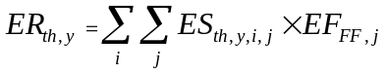 (3)
Where:
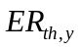 | Emission reductions from thermal energy savings in year y, tCO₂
 | Building counter (e.g. building 1, building 2, building 3, etc.)
 | Fossil fuel type
 | Crediting period year
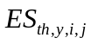 | Difference in fossil fuel consumption between baseline building(s) and project building(s) as indicated by calibrated computer model(s) in year y for building i, TJ. To be determined annually. In the case of fuel switch, the types of the baseline/project fuel and their corresponding CO₂ emission factors shall be taken into account
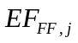 | CO₂ emission factor of the fossil fuel that would have been used in the baseline plant, (tCO₂/TJ), obtained from reliable local or national data if available, otherwise, IPCC default emission factors are used. In the case of fuel switch, the types of the baseline/project fuel and their corresponding CO₂ emission factors shall be taken into account

Leakage
      - No leakage is expected.

Monitoring
      - The following data and calibration documentation are needed to allow for accurate recreation of the baseline and project models by qualified modelers and shall be archived and made available to the DOE:
        - Ex ante baseline building data. The actual sources of data used to establish the baseline building energy use intensity should be provided and the data analysis process documented;
        - Parameters indicated in paragraph 21 Step 4 (b) and 4 (c).
      - Monitoring during the crediting period shall include:
        - Weather data, typically obtained from third-party sources (frequency: monthly);
        - Electricity emission factor (if applicable), according to AMS-I.D ;
        - Energy consumption (electrical and/or thermal, as appropriate to the project activity) of the project building(s) on at least a monthly basis;
        - Base building B substantive setting change(s) such that a recalibration of model(s) is required (frequency: annual);
        - Substantive occupancy or tenancy-related T setting change(s) including lighting and HVAC schedules and control settings such that a recalibration of model(s) is required (see frequency: annual).

Project activity under a programme of activities
      - The methodology is applicable to a programme of activities, no additional leakage estimations are necessary other than that indicated under leakage section above.

Appendix 1

Terms and definitions
Building site | The lot boundary where the building is located
On-site building energy supply | Energy supply system that is within the building itself or the building site
Whole building computer simulation | A whole building energy computer simulation tool is a computer program that has the minimum basic capability of modeling and calculating the energy flows and annual energy demand in a complete building system considering its orientation, shape and envelope, heating, ventilation and air conditioning (HVAC), the number of occupants and the operating hours. Additional capability may include energy use prediction for lighting, hot water system, power/plug loads and equipment and supplementary services for tenants (e.g. chilled water). Some tools can also take into account on-site energy generator(s). This methodology is focused on total energy consumption in a building when fully operational with tenants and users. Thus, if the simulation tool selected does not cover the total building consumption (and only has the minimum capability described above), other methods or specialist tools should be used to estimate the additional energy use to obtain the whole building operational energy consumption. The BESTEST verification and validation requirement applies only to the whole building computer simulation tool used for the space conditioning – or heating and cooling – loads in the building under given occupancy and operational settings
Climate zone | Classification of climate within a given area (zone) that is deemed to be the same for the purpose of building energy performance measurement, assessment and/or modelling (e.g. same average rainfall, wind, and temperature). Areas with a different set of climate characteristics are assigned different climate zones
Commercial building | A building that is primarily used for commercial purposes, but excluding industrial production. Private sector commercial buildings include commercial offices, shopping centers, apartments, hotels, private hospitals and private educational facilities. Government buildings include government offices, government owned health facilities (hospitals), government owned educational facilities, galleries, museums, law courts and correctional centers
Base building setting or “B” setting | Base building physical data are not the same as baseline building. Base building characteristics refer to the whole building simulation model’s input data set and settings that can be separated from individual commercial building tenant ’s decisions or responsibility (please see “T” below). Base building includes building envelope features, building central services, heating, ventilation and air conditioning (HVAC) system, control systems, exterior lighting, hot water system, car parking ventilation and lighting, fans (kitchen, toilet, refuse, etc), supplementary service for tenants (e.g. chilled water, condenser water, etc), energy sources, and on-site generator(s), if any
Occupancy or tenancy related settings or “T” setting | The occupancy or tenancy related settings (T) in the whole building simulation model are the individual commercial building variables that are associated with tenancy decision and behavior, such as tenant lighting, power/plug loads (including appliances and office equipment) and supplementary air conditioning units, and hours of operation/occupancy including the facility manager’s operational settings
Terms used in Figure 1 | E_{B-N} Energy consumption by baseline new building(new construction case)  E_{B-E} Energy consumption by baseline existing building (retrofit case)  E_{BA} Energy consumption by Baseline building (either new construction or retrofit case)  E_{PA} Energy consumption by project building  I_{T} input data set for tenancy/occupancy, i.e., “T” settings  I_{B} Input data set for base building characteristics, i.e., “B” settings  D₁ Energy savings estimate by proposed project activities
Terms used in Figure 2 | E_{PP} Actual Energy consumption by project building (during every monitoring period)  E_{PM} Energy consumption estimated by as-built project model  E_{BP} Energy consumption estimated by updated baseline model  I_{T} Input data set for tenancy/occupancy “T” profile  I_{B} Input data set for base building “B”  T₁,t₂,…t_{n} Time periods of monitoring (crediting period)  D₂ Energy savings achieved by proposed project activities

Appendix 2
Steps for identifying new construction project baseline buildings where there is no legally mandated energy performance code
Step 1: Identification of building unit categories
A building category shall be defined for each project building. Examples of categories are high-rise commercial buildings, and retail buildings. The chosen category(ies) shall be clearly presented in the PDD, and remain the same for the entire crediting period(s).
Step 2: Identification of baseline buildings
A baseline building shall be identified for each building unit category i defined in Step 1.The baseline building units are identified as building in circumstances similar to the building(s) constructed in the project activity. In order to ensure similarity between the baseline and the project buildings, the baseline building shall consist of buildings in same category i as defined in appendix 1:
- That do not belong to a registered CDM project activity using this methodology;
- That are located in the same municipality as the project building units. That are located in an area with similar socio-economic conditions to the one in which the project building units are located;
- That have been built and then occupied within the three years prior to the start of the project activity;
- That are located in a region with annual heating degree days (HDD) and cooling degree days (CDD) in a range from 80% to 120% of the average value of the region that the project building units are located in;
- That have a comparable size to the project building units, defined as the Gross Floor Area (GFA) of a baseline building unit being in the range from 50% to 150% of the average GFA of the project building units in building category i;
- That are operated on annual average at least 30 hours/week either in a low-rise or high-rise building).

- - - - -
History of the document
Version | Date | Nature of revision(s)
01.0 | 20 July 2012 | EB 68, Annex 19  Initial adoption.
Decision Class: Regulatory
Document Type: Standard
Business Function: Methodology

See appendix 1for Terms and Definitions applicable for the purpose of this methodology.
Possible sources for this information may be the national statistics agency (preferred), an industry association or from relevant literature (e.g. industry or research reports/papers).
For example, using a Typical Meteorological Year (TMY) weather file, source to be documented and included in the PDD.
The Building Energy Simulation Test (BESTEST) is a methodology for testing computer models (as implemented in software tools) using a combination of empirical validation, analytical verification and comparative analysis techniques. eQUEST and EnergyPlus are two examples of computer models/tools that have been certified per the BESTEST protocol. For more information for eQUEST and other eligible computer models/tools, please refer to <http://doe2.com/DOE2/index.html> and <http://apps1.eere.energy.gov/buildings/tools_directory/>.
See also the terms and definitions in appendix 1.
See paragraph 21 for model calibration procedures.
The project activity itself is assumed to not trigger an energy code or equipment standard requirements.
A special tenancy lease arrangement includes various forms of legally binding energy efficiency-focused contracts, or “green lease” contracts (covering broader environmental impact considerations).
A simple illustrative example is setting the building simulation model for the baseline (without special lease arrangement) for tenant lighting and plug-loads (e.g. computers and office equipment) based on common procurement specifications (e.g. from government or industry data sources). Note that since special tenancy lease arrangements can vary from one case to another, the actual terms planned in the CDM project activity should be clear and included as a key part of project documentation. Whole building simulation models for both baseline and project buildings should then reflect these arrangements accordingly.
Expected or full operations means operated on annual average at least 30 hours/week; see also appendix 2, Step 2, last item.
For projects supplied by district heating or cooling, the overall thermal efficiency of the district system is included in the model. Although emission reductions from improvements to the district system are outside the scope of this methodology, its efficiency is necessary to derive the net emission reductions from measures applied to the buildings.
Calibration is the process of adjusting the input data or parameters in a model (as opposed to changing the form of the model) to match its output with the measured data from the real-world system. During this process, assumptions about the building’s internal loads and operational characteristics are adjusted to produce a closer match between the simulated and actual energy usage.
American Society of Heating, Air Conditioning, and Refrigeration Engineers Guideline 14-2002 Measurement of Energy and Demand Savings, or current version.
This requirement is assumed to be determined, ex ante, by observation or review of public records but not by baseline building occupant surveys.
A building unit is considered to be in operation for the amount of hours the building unit is utilized for its main purpose (e.g. office work for an office building unit). The building unit might as well consume energy in other hours (e.g. standby energy consumption in the building unit during night time). However, those hours are not counted towards the operating hours.

