Task1 )

Security Check for argc in command-line

Task2)
displaying the number of channels & key wait.

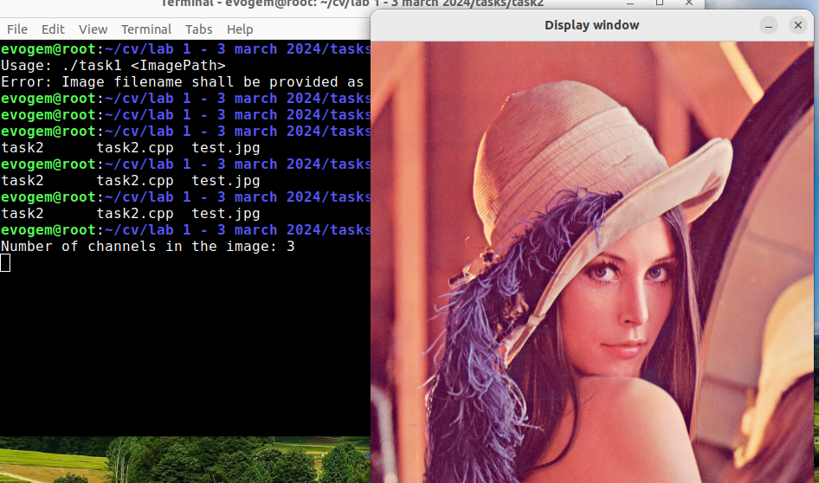

Task 3)

OpenCV behavior = BGR

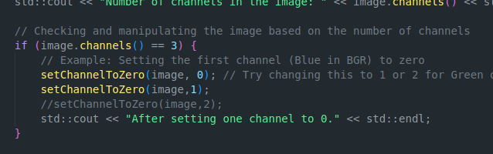
Task3 – Outputs)

- Setting Blue & Green to “0”.
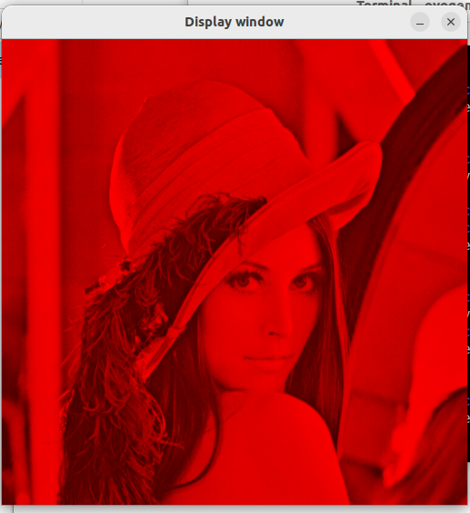

- Setting Blue to “0” only:

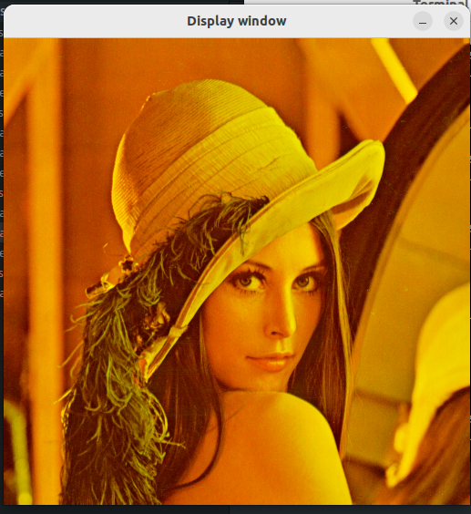

Task 4 – Ouput )

- Turning each channel to 0 & save the output using “imwrite”.

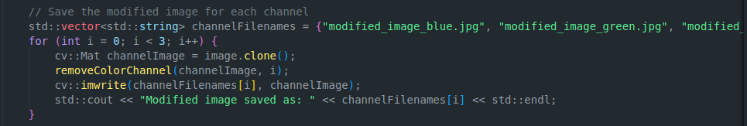

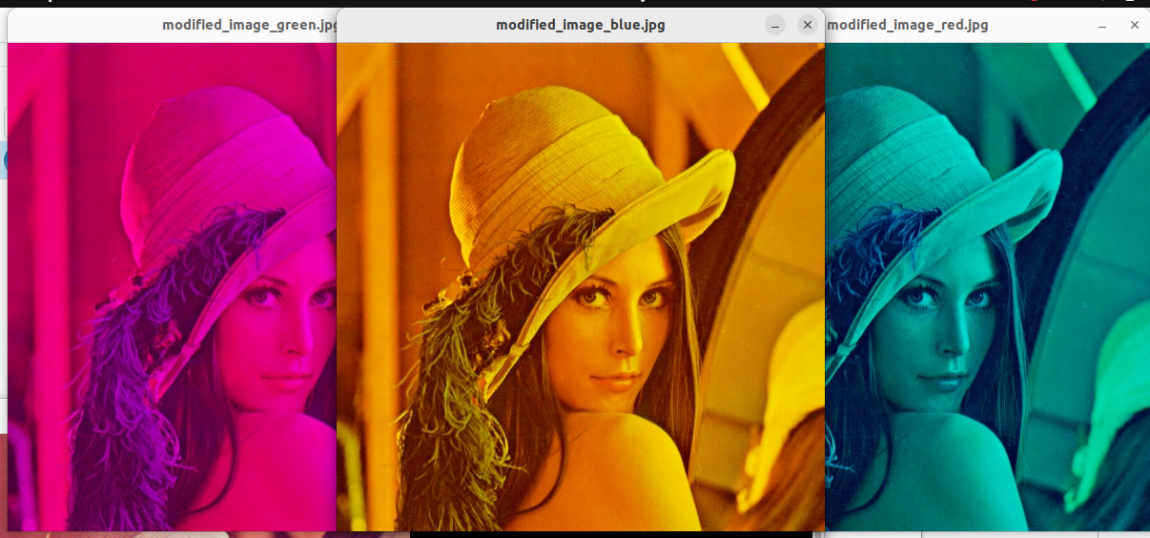

Task5 – Output)

- Using nested loops to create gradients using single pixel write.
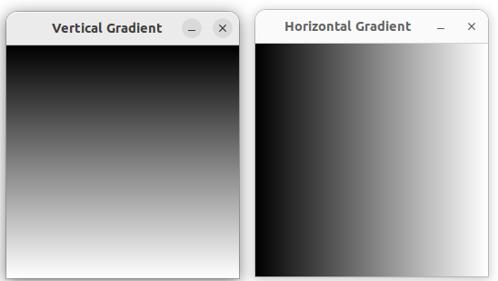

- Creating chessboards using square sizes to write different pixel sized chessboards.
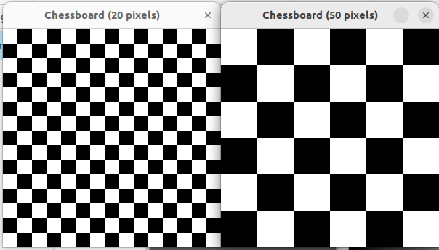
- Using nested loops to grid the total size file and checking regions to draw the squares.

