1. 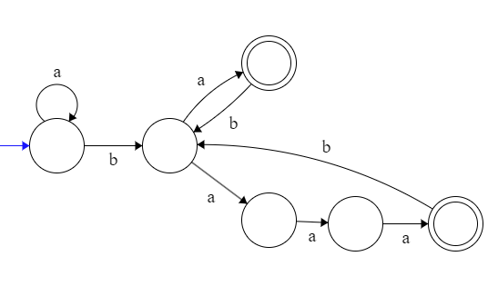
2. -
3. a(b\*aa\*)\*+b(a\*bb\*)\*
4. Diagram

   Description automatically generated
5. 