1. 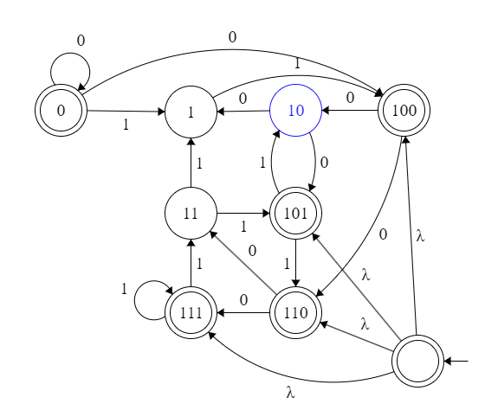

|  |  |
| --- | --- |
| aa | aaa |
| aab | aab |
| aabb | aba |
| aabbb | abb |
| aabbbb | baa |
| aabbbbb | bab |
| aabbbbbb | bba |
| aabbbbbbb | bbb |

1. Either one needs to have aa and have rest b after the a or have character of multiple of 3
2. Must start with aa and rest be b with multiples of 3
3. Must start with aa and rest be b without having multiples of 3 characters
4. Must have mutiples of 3 characters without starting with aa or aab*
5. Must start with aa and rest be b without having multiples of 3 characters or Must have mutiples of 3 characters without starting with aa or aab*