Jonathan Kim

CS 2690-001

Program 2

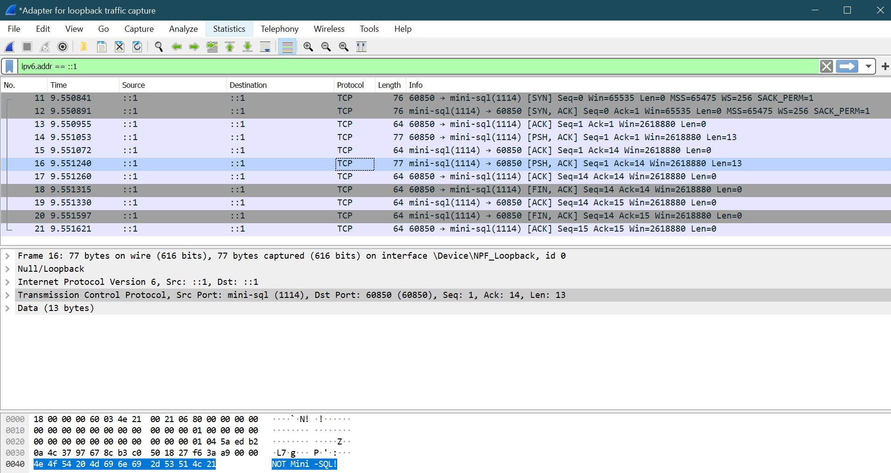

1. Explain why Wireshark thinks that your client and server are exchanging Mini SQL messages

The reason why Wireshark thinks that the client and servers are exchanging Mini SQL messages is because the message needs to go through port 1114, which in this case, Wireshark thinks port 1114 is mini-SQL.