**Mid-Term Exam**

**Manage your time.**

**Students are allowed to use any material on Canvas and TEAMS for the course.**

**Textbook is permitted for the exam.**

**Calculator is permitted. Must show your work.**

**No other internet resources are allowed for the exam.**

**Students are required to upload their solutions on Canvas no later than 11:59 pm of the same**

**day.**

**Name: Hoyoung Kim**

**UVU id: 10829866**

1. (20 points, Chapter 1). The set of data given below is a set of samples from a population.

Answer to the following questions. Show your work.

𝑋 = [ 5 , 1 ,0 , 2 , 52 , 39 , 99 , 14 ]

a) Mean

(0 + 1 + 2 + 5 + 14 + 39 + 52 + 99)/8 = 26.5

b) Median

(5 + 14)/2 = 9.5

c) 1 st Quartile

(1+2) /2 = 1.5

d) 60 th Percentile

5 + (0.8 * (14 - 5)) = 12.2

2. (10 points, Chapter 2). 𝑋 is a discrete random variable with the following outcomes and

probabilities.

𝑥 0 1 3 4 5

𝑝(𝑋=𝑥) 0.1 0.2 0.2 0.4 0.1

Answer to the following parts. Show your work.

a) 𝑝(1≤𝑥<3)=?

P(x=1) + p(x=2)

1 = 0.1 + 0.2 + 0.2 + 0.4 + 0.1 + x, x = 0

So

0.2 + 0 = 0.2

b) Mean (expected value) of 𝑥.

(0 * 0.1) + (1 * 0.2) + (2 * 0) + (3 * 0.2) + (4 * 0.4) + (5 * 0.1) = 2.9

c) Median of 𝑥.

3, since there is 0 to 5 and although 2 is not listed, there is still 6 numbers between 0 to 5 including 0 and 5.

3. (10 points, Chapters 4) A set of measurements is given as follows.

𝑋 = [0 , 1 , 0 , 0 , 1 , 0 , 1 , 0 , 0 , 1]

We want to approximate the source of this data with Bernoulli distribution, i.e.,

𝑋~𝐵ernoulli (𝛾), where 𝛾 = 𝑝(𝑋 = 1).

a) Approximate 𝛾 based on the given data.

1s = 4

0s = 6

Total = 10

4/10 = 0.4

b) Sketch the histogram of data

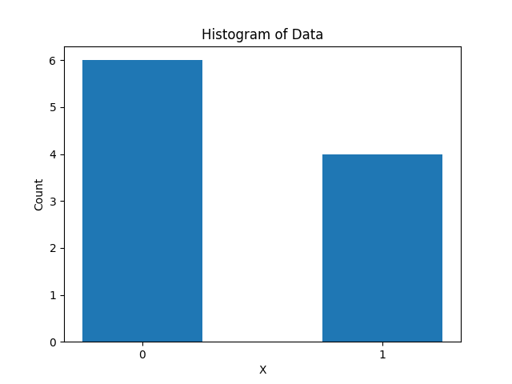

c) Sketch the normalized version of the histogram.

For 0’s, 6/n so 6/10 = 0.6

1’s, 4/n so 4/10 = 0.4

4. (10 points, Chapter 2) Find the linear transformation that transforms 𝑋~𝑁(1,4) to

𝑍~𝑁(0,1). Show that this transformation actually works (find the transformation 𝐙,

and show that 𝝁z= 𝟎 and (𝝈z^2) = 1).

Note: For the Gaussian distribution 𝑥~𝑁(𝜇𝑥, (𝝈x^2)), the probability density function is defined as

𝑓(𝑥) = (1/sqrt(2pi(𝝈x^2))) e(-1/(2(𝝈x^2)))(x-𝜇x)2

Given that mean = 1,

z = (x-u)/s so z = (x-1)/sqrt(2) = (sum(x)-1)/sqrt(2) = (1-1)/sqrt(2) = 0

and variance (𝝈z^2)

v[(x-1)/sqrt(2)] = ½ v(x) = ½ * 2 = 1

so mean = 0 and variance = 1

5. (10 points, Chapter 4) A set of measurements is given as follows.

𝑋 = [1 , 2 , 5 , 8 , 3, 10 , 10]

We want to approximate the source of this data with Gamma distribution, i.e.,

𝑋~ Gamma(a, 𝑏), where a and b are the shape and rate parameters of Gamma

distribution.

For Gamma distribution, the mean and variance can be found from the below equations.

𝜇x = a/b

(𝝈x^2) = a/b2

Find the parameters ‘𝒂’ and ‘𝒃’ of Gamma distribution to fit the data. Show your work.

(1 + 2 + 5 + 8 + 3 + 10 + 10) / 7 = 5.5714

s^2 = ((1 - 5.5714)^2 + (2 - 5.5714)^2 + (5 - 5.5714)^2 + (8 - 5.5714)^2 + (3 - 5.5714)^2 + (10 - 5.5714)^2 + (10 - 5.5714)^2)/(7-1) = 14.2857

since a/b^2 is 14.2857 and (𝝈x^2) = s^2 = a/b^2

a/b *1/b = 14.2857

5.5714 *1/b = 14.2857 so b = 5.5714 / 14.2857 = 0.3899

Then using the equation we can do

a = 14.2857 * 0.3899^2 = 2.1717

6. (15 points, Chapter 2) A lot of 10 components contains 3 that are defective. Two

components are drawn at random and tested. Let A be the event that the first component

drawn is defective, and let B be the event that the second component drawn is defective.

a) Find 𝑃(𝐴) = 3/10

b) Find 𝑃(𝐵|𝐴) = 2/9

c) Find 𝑃(𝐴 ∩ 𝐵) = (3/10) * (2/9) = 6/90

d) Find 𝑃(𝐵) = P(A)P(B/A)+ p(A̅)P(B/ A̅)

P(A̅) = 1 - P(A) = 1 - (3/10) = 7/10

P(B|A̅) = 3/9

(2/9) * (3/10) + (3/9) * (7/10) = 0.3

e) Are A and Find 𝐵 independent? Explain.

No they are not, since for them to be independent P(A ∩ B)= P(A) x P(B)

But P(A ∩ B) = 6/90 and P(A) x P(B) = 0.3 * 3/10 = 0.09 or 9/100

7. (10 points, Chapter 2) Assume that there is a continuous random variable X with the

following probability density function.

𝑓(𝑥) = { c(1-x2), 0<x<2

0, otherwise

a) Find the constant c, such that f(x) becomes a probability density function (pdf).

c[2 - (2^3)/3] - c[0 - (0^3)/3] = 1

c = -3/2

b) Find the mean (expected value) of the random variable x.

mean = 3 (work for both a and b shown below)

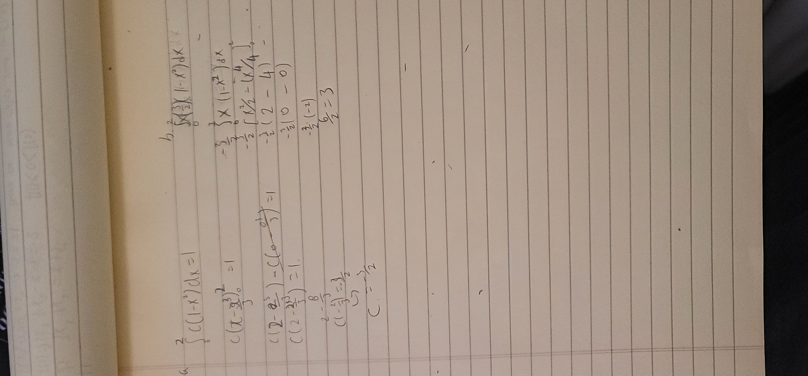

8. (15 points, Chapter 3) Suppose that X and Y are two independent measurements. We

can treat these measurements as random variables, where X has the mean of 1 and

standard deviation of 2 (meaning X=1±2), and Y has the mean of 2 and the standard

deviation of 1 (meaning Y=2±1). For the transformations below, find the mean,

variance, and the standard deviation.

a) X+Y

Mean: E(X + Y)= E(X) + E(Y) =μ_x + μ_y= 1+2 = 3

Variance: Var(X + Y) = Var(X) + Var(Y) = σ_x^2 + σ_y^2 = 4 + 1 = 5

standard deviation: σ_(X + Y) = sqrt(Var(X + Y)) = sqrt(5) = 2.23

b) X+Y+1

Mean: E(X + Y + 1)= E(X) + E(Y) + 1 =μ_x + μ_y +1= 1+2+1 = 4

Variance: Var(X + Y +1) = Var(X) + Var(Y) = σ_x^2 + σ_y^2 = 4 + 1 = 5

standard deviation: σ_(X + Y + 1) = sqrt(Var(X + Y+1)) = sqrt(5) = 2.23

c) X-2Y-1

Mean: E(X - 2Y -1)= E(X) - 2E(Y) -1 =μ_x - 2μ_y -1= 1-4-1 = -4

Variance: Var(X - 2Y - 1) = Var(X) + 2Var(Y) = σ_x^2 + 4σ_y^2 = 4 + 4(1) = 8

standard deviation: σ_(X + Y) = sqrt(Var(X + Y)) = sqrt(8) = 2.82