Q1. (25 Points)

import numpy as np

method_a = np.array([18.0, 18.0, 19.0, 20.0, 21.0, 22.0, 22.5, 23.3, 24.0, 24.0, 24.5, 25.0, 25.0, 25.4, 26.2, 26.4])

method_b = np.array([18.6, 18.9, 19.2, 19.6, 20.1, 20.3, 20.4, 20.4, 20.5, 20.6, 21.2, 22.0, 22.0, 22.3, 22.5, 23.6])

a = np.mean(method_a)

b = np.mean(method_b)

m_a = np.median(method_a)

m_b = np.median(method_b)

q1_a = np.percentile(method_a, 25)

q3_a = np.percentile(method_a, 75)

q1_b = np.percentile(method_b, 25)

q3_b = np.percentile(method_b, 75)

std_a = np.std(method_a, ddof=1)

std_b = np.std(method_b, ddof=1)

print("Mean A:", a)

print("Mean B:", b)

print("Median A:", m_a)

print("Median B:", m_b)

print("First Quartile A:", q1_a)

print("Third Quartile A:", q3_a)

print("First Quartile B:", q1_b)

print("Third Quartile B:", q3_b)

print("Standard Deviation A:", std_a)

print("Standard Deviation B:", std_b)

Mean A: 22.76875

Mean B: 20.762500000000003

Median A: 23.65

Median B: 20.45

First Quartile A: 20.75

Third Quartile A: 25.0

First Quartile B: 19.975

Third Quartile B: 22.0

Standard Deviation A: 2.8200989935343284

Standard Deviation B: 1.4056433876817171

**Q2.** (25 Points)

1. 2099, 2030
2. 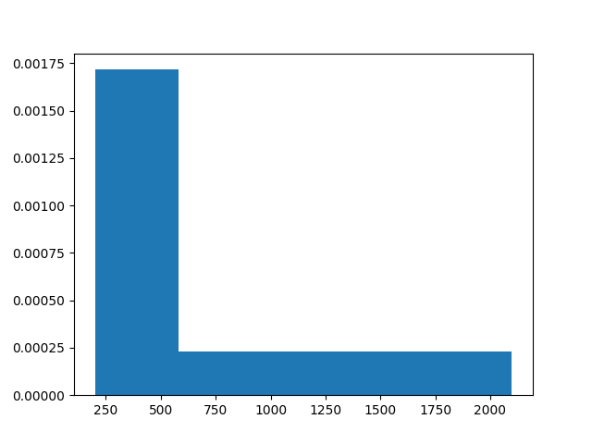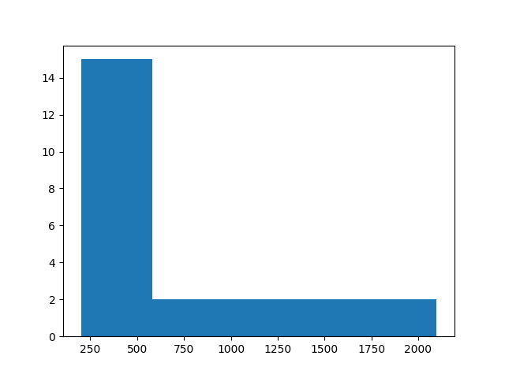

**Q3.** (25 Points)

1. Mean = (0 * 27 + 1 * 22 + 2 * 30 + 3 * 12 + 4 * 7 + 5 * 2) / 100

= (0 + 22 + 60 + 36 + 28 + 10) / 100

= 156 / 100

= 1.56

1. sqrt((27*(0-1.56)^2 + 22*(1-1.56)^2 + 30*(2-1.56)^2 + 12*(3-1.56)^2 + 7*(4-1.56)^2 + 2*(5-1.56)^2) / 99) = 1.30515682714
2. since the median lies within 50th and 51st value, median = 2 as 2 children was between 50 and 79 women
3. q1 = 1

**Q4.** (25 Points)

Relative frequency should equal 1 and since existing relative frequency adds up to 0.85, 1 - 0.85 is 0.15 so we can estimate that missing relative frequency is about 0.15