asvc

Desktop Control Console

STATUS  PROPOSED |  | OWNER  CODEX ENGINEERING |  | LAST UPDATED  AUG 09, 2026

Authors | Codex engineering
Reviewers | Project owner
Related docs | README.md; src/model.rs; src/daemon.rs
Scope | Native desktop control console for local services

1. Abstract
asvc adds a native desktop control surface to the existing Rust CLI and daemon. The console gives developers one calm place to see registered services, start or stop them, restart safely, and inspect recent output without taking ownership away from the daemon.
The first release targets one local machine, one daemon, and the existing JSON-over-local-IPC protocol. It does not introduce remote orchestration, a second process supervisor, or a new persistent state model. The daemon remains authoritative for service definitions, process lifecycle, status, and log history.

2. Goals and Non-Goals
Goals | Non-goals
Make service state scannable in under five seconds. | Remote fleet management.
Make start, stop, restart, and logs reachable without memorizing commands. | Replacing the CLI or daemon.
Preserve daemon ownership, deduplication, and existing request contracts. | A second process manager or registry.
Fail visibly and safely when the daemon or service action fails. | Guaranteeing service health beyond the local machine.

3. Background and Problem Statement
Today, asvc already prevents duplicate local development processes by routing CLI and agent operations through one daemon. The missing surface is a desktop workflow: users must remember commands, scan terminal output, and mentally correlate service names, process state, ports, and failures.
The desktop boundary is intentionally thin. The UI owns presentation state and user intent; a background worker owns the async client connection; the daemon owns registry and process truth; managed services own their stdout and stderr. The invariant is simple: every UI action is a daemon request, and every displayed state is refreshed from daemon responses.

4. Proposed Architecture

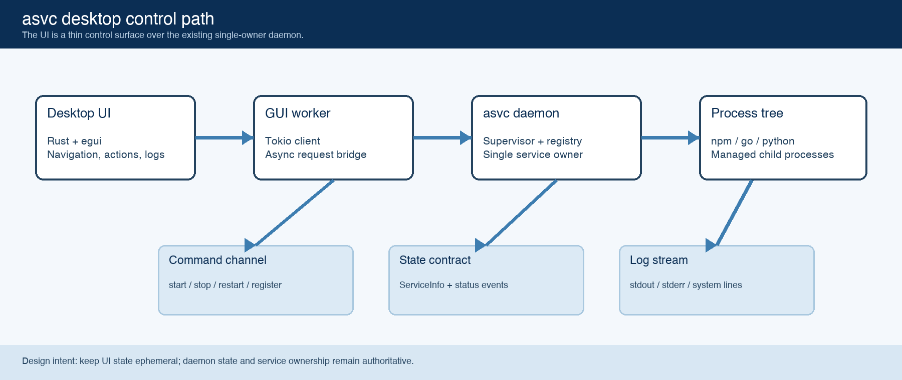
Figure 1. asvc desktop control path.

Core components

Component | Responsibility | Primary storage | Failure behavior
Desktop UI | Renders dashboard, service list, detail view, actions, and logs. Sends user intent to the worker. | Ephemeral UI state | Degrades to an error notice when the worker cannot send or receive.
GUI worker | Owns one async Client connection and translates UI commands into daemon requests. | Tokio task + IPC stream | Keeps UI responsive; reports request errors and stops cleanly when the window closes.
Daemon / Supervisor | Authoritative registry, lifecycle state, deduplication, process groups, and event publication. | registry.json + log files | Existing daemon behavior remains unchanged; one service action can fail without corrupting others.
Service process tree | Runs the user command with captured cwd, env, port metadata, and optional autorestart. | OS process state + logs | Exited or errored services remain visible with exit information and recent output.
Status and log contract | Carries ServiceInfo, LogLine, and status/log events across the existing local protocol. | JSON frames over Unix socket / Windows loopback | Malformed or timed-out responses surface as a visible UI error.

5. Request Lifecycle
- Launch: the no-argument binary opens the native window and starts the worker; the worker connects to or auto-spawns the daemon.
- Refresh: the worker requests list and maps ServiceInfo records into sidebar, dashboard, and detail state.
- Action: a user clicks start, stop, restart, remove, or register; the worker sends one typed JSON request.
- Observation: the daemon performs the operation and returns the response; the worker publishes a notice or error and refreshes the list.
- Logs: selecting a service requests the latest 300 LogLine records; the UI renders timestamps and stream colors with truncation.
- Failure: connection errors, unknown services, startup failures, and daemon timeouts are shown as notices without blocking the UI thread.
- Close: dropping the UI command channel lets the worker exit; the daemon and managed services keep their existing lifecycle semantics.

6. API and Data Contracts

Primary data contract

Field | Type | Required | Description
ServiceSpec.name | string | Yes | Stable deduplication key for a registered local service.
ServiceSpec.command | string | Yes | Shell command executed by the supervisor in the captured cwd.
ServiceSpec.cwd | string | Yes | Working directory used for start and later restart operations.
ServiceInfo.status | enum | Yes | Stopped, starting, running, stopping, exited, or errored.
ServiceInfo.pid | u32? | No | Current process identifier when a process is present.
LogLine.stream | enum | Yes | stdout, stderr, or system; controls rendering emphasis.
LogLine.line | string | Yes | One captured output line; displayed with bounded width.

Contract guarantees

- The daemon is the source of truth for service state; the UI never fabricates a running state after an action.
- Every request has a client-side id and is correlated to one response; asynchronous events are retained until consumed.
- A service name is the idempotency boundary already enforced by the supervisor; repeated start requests do not create a second instance.
- The UI stores no durable service definition or secret; it rehydrates from the daemon on refresh and restart.
The primary interface is the existing newline-delimited JSON protocol implemented by Client and daemon.
The source contract is maintained in src/model.rs and the request handlers in src/daemon.rs; desktop actions must reuse those shapes.

7. Consistency, Idempotency, and Replay

Consistency comes from the single daemon connection and supervisor ownership model. The UI may refresh optimistically in timing, but it only displays confirmed ServiceInfo. Restart and start are safe to repeat because service names are deduplicated; log reads are repeatable snapshots.
Scenario | Expected behavior | Reasoning
Repeated start | Daemon returns the existing service instance or starts it once. | Name-based supervisor deduplication.
Action request fails | No local UI state is committed; error remains visible and next refresh rehydrates truth. | The daemon remains authoritative.
Timeout or partial failure | Show error notice; preserve the service definition and allow a later retry. | No speculative process ownership in UI.
Refresh during action | Latest completed daemon response wins; transitional status remains visible until next refresh. | Status transitions come from ServiceInfo.

8. Security and Privacy Considerations

- The desktop client uses the existing local Unix socket or Windows loopback endpoint; no remote listener or new authentication surface is introduced.
- Service environment values and command strings can contain sensitive local configuration. The UI displays the command only as a truncated, user-visible diagnostic and does not transmit it externally.
- Logs remain in the existing ASVC_HOME log directory. The UI requests recent lines through the daemon rather than reading arbitrary files.
- Destructive actions are explicit: remove requires an in-app confirmation, while start, stop, and restart use existing daemon semantics.
- No new retention policy is introduced in the desktop layer; historical log retention remains governed by the current daemon and filesystem behavior.

9. Operational Readiness
Signal | SLO or alert | Owner | Launch gate
Daemon reachability | Initial connect succeeds or a clear startup error is shown | Desktop | Required
Action response | Start/stop/restart notice plus refreshed ServiceInfo | Desktop + daemon | Required
UI responsiveness | Actions run off the UI thread; window remains interactive | Desktop | Required
State drift | Refresh reconciles UI against daemon every two seconds | Desktop | Recommended
Regression safety | cargo test --locked remains green | Engineering | Required
Rollout constraint: ship the desktop console behind the existing binary entry point; validate on macOS first, then build and test Windows/Linux packaging before calling the desktop surface stable.

10. Alternatives Considered

Alternative | Why it was considered | Why it was not selected
Tauri + React | Strong visual system and web UI ecosystem. | Adds a second frontend toolchain and more packaging/runtime surface than this Rust-first utility needs now.
Native egui | Single Rust binary, direct reuse of the daemon client, fast iteration. | Requires deliberate custom layout and design tokens; selected for the first native console.
CLI only | Already implemented and excellent for agents. | Does not solve human discoverability, service scanning, or persistent visual monitoring.
Electron | Mature desktop web runtime and rich UI libraries. | Large runtime and Node packaging cost conflicts with the project’s native-binary distribution model.

11. Open Questions
- Should the packaged desktop app add a system-tray menu, or is ordinary taskbar/dock minimization sufficient?
- Should the UI expose a locale switch and fully localize labels, or follow the CLI locale configuration?
- Should logs gain search, stream filters, and a configurable retention window in the next iteration?
- Which packaging targets and signing/notarization requirements are needed for release distribution?

12. Decision and Next Steps
Proceed with the native Rust desktop console as the human control surface while retaining the CLI as the agent and automation interface. The first milestone is a visually coherent dashboard/detail flow; the next is visual QA with representative service names and long commands; packaging, tray behavior, and localization follow after the core workflow is stable.
Milestone | Deliverable | Exit criteria
M1 | Rework dashboard, navigation, detail, and logs | No clipping; UI remains responsive
M2 | Exercise long commands, failed starts, empty state, and 8+ services | Visual review passes; errors remain actionable; logs stay bounded
M3 | Build native release artifacts and test macOS minimization | Release binary launches, daemon reconnects, and taskbar/dock behavior is acceptable
M4 | Add tray/localization/search decisions from open questions | Scope is approved and regression suite remains green

Use footnotes for definitions, assumptions, or terms that need precision without interrupting the main narrative.

