Visual Basic RDLC Report

1. Layout

The layout of application.

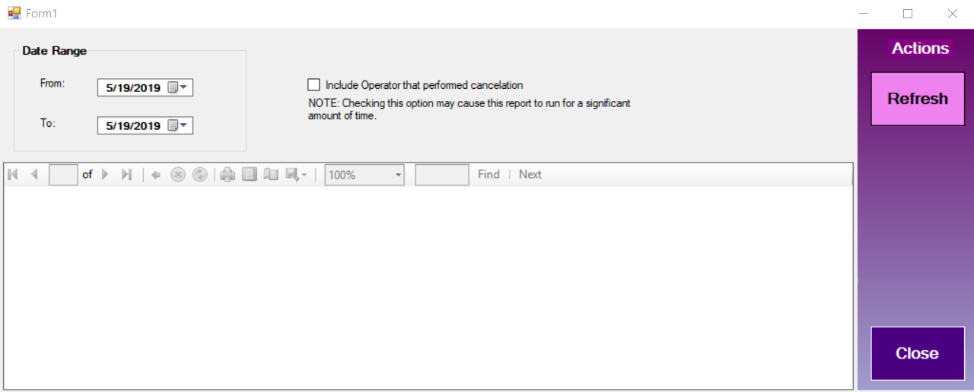

1. Database creation

MS SQL Server Management Studio is used to create a toy database.

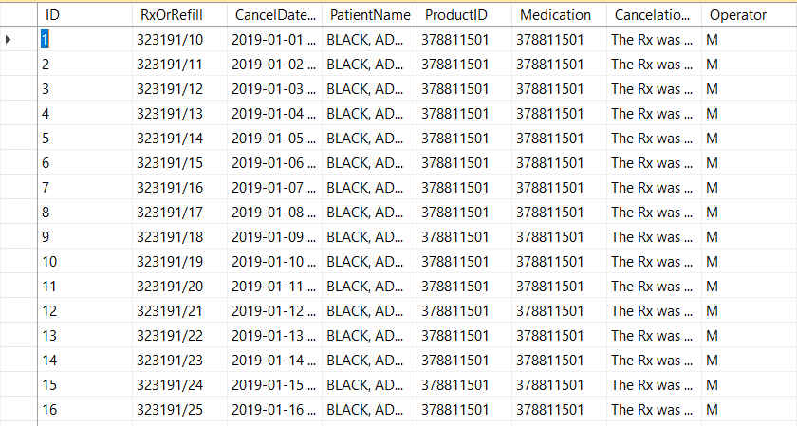

1. Functionality (“Refresh” button and “Include…” checkbox)

“Refresh” button displays records according to DateTimePicker Range.

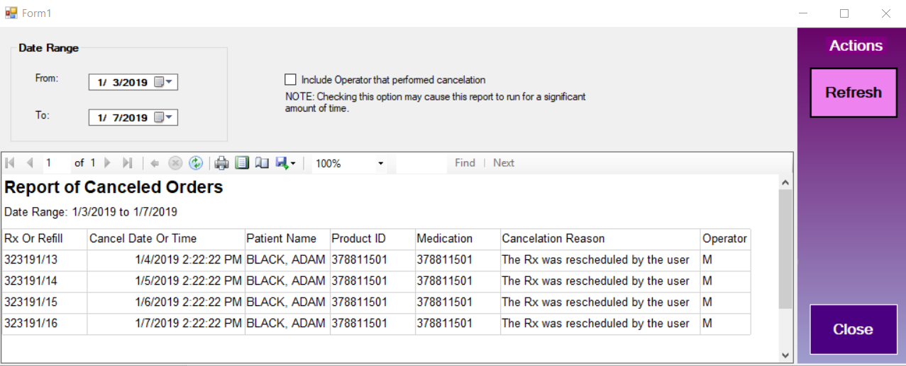

“Include …” checkbox controls the visibility of “Operator” Column.

