Design Documentation-Devices

Interactive House

Project Members

Reference | Name | Email
A | Samuel Mcmurray | Samuel_joseph.mcmurray0004@stud.hkr.se
B | Mustafa Ismail | mustafa.ismail0007@stud.hkr.se
C | Ibrahim Ahmed Ali | ibrahim.ahmed_ali0003@stud.hkr.se
D | Osayomore Edugie | Osayomore.edugie0004@stud.hkr.se

Revision History

Date | Version | Description | Author
04/10/2021 | 1.0 | Initial Design | A, B, C, D

Design item List
Requirement Name | Priority
D1. Use Case Diagram | Essential/Desirable/Optional
D2. Class Diagram - Overall | Essential
D3. Class Diagram- Abstract Devices and the classes that inherit. | Essential
D4 | . . .
D5
D6
D7
D8
D9
D10

Design Item Descriptions

D1
A more exhaustive description of design item 1, followed by a figure/drawing that further specifies the design item 1.
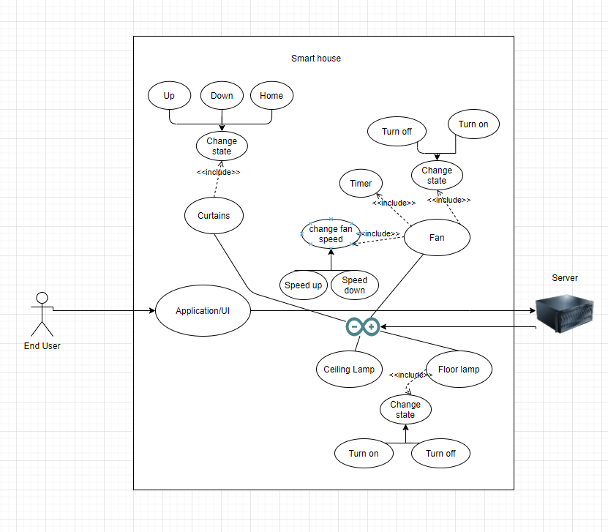

D2
This is the class diagram for the devices we have the overall structure here.

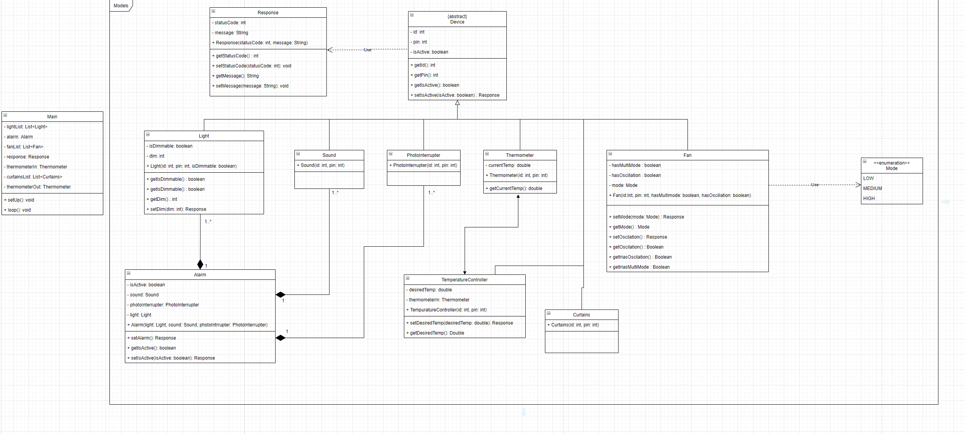

D3
The first class we created was an abstract device class which has a variable for the id of the device as an int, the pin of the device as an int, and a Boolean that is used to determine the state of the device. The functions used in this class are getId which returns an int, getPin which also returns an int, getIsActive which returns a Boolean, and setIsActive which takes a Boolean and returns a responsefrom our Response class.

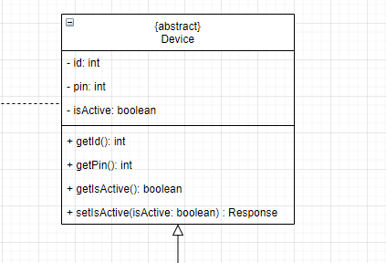

The classes that inherit from the device class are light which is for the lamps, sound which is apart of the composition in the alarm class, photo interrupter which also is apart of the composition in the alarm class, thermometer class, curtains class, and fan class.

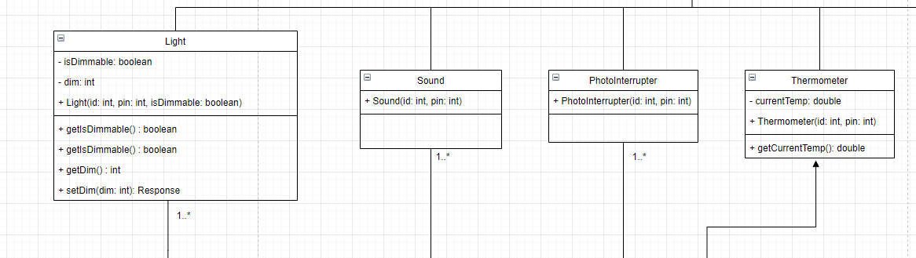

The light class has a isDimmable boolean to determine the type of the light it is, dim which will set the dim desired dimness, the constructor which takes an id, pin and isDimmable. The functions for the light class are getIsDimmable which returns a boolean, getDim which returns an int, and setDim which takes an int and returns a response
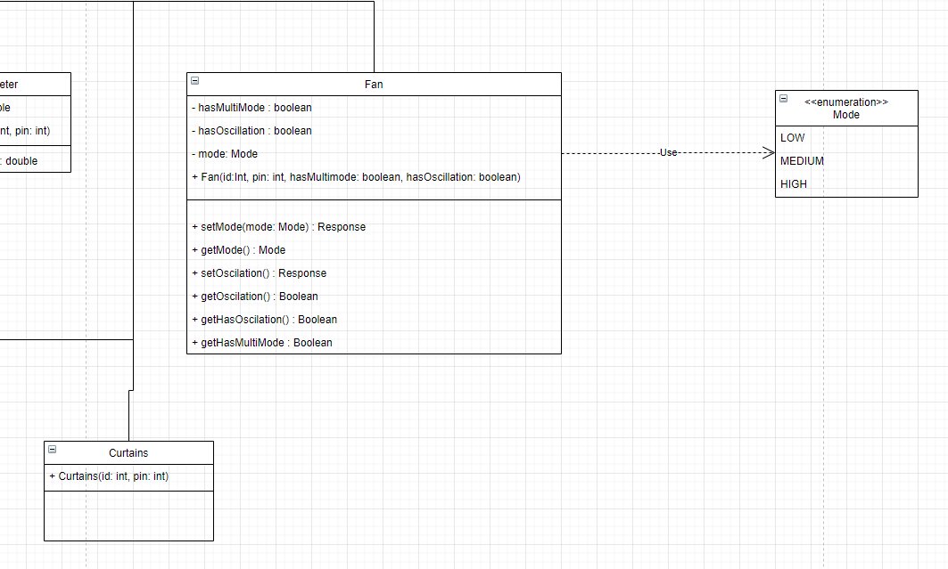

D4

. . .

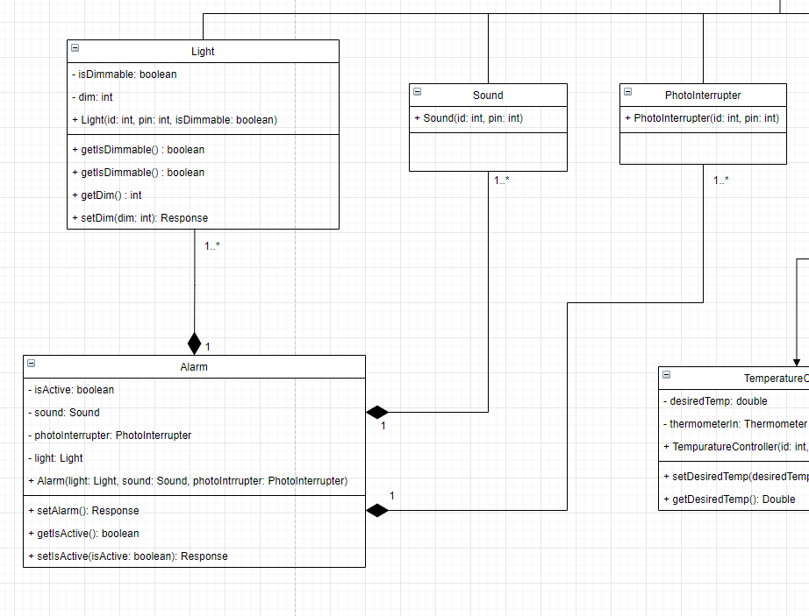

D5

. . .

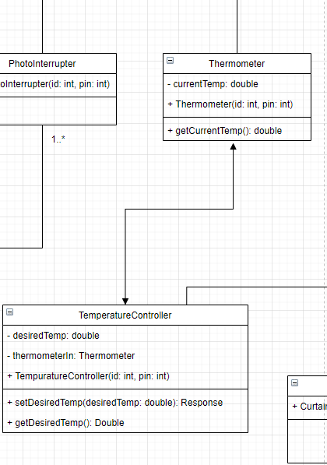

D6

. . .

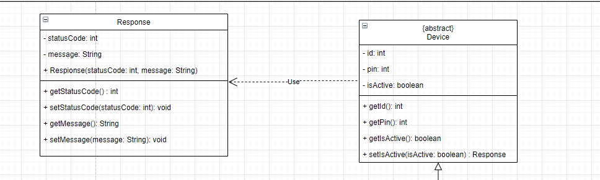

D7

. . .

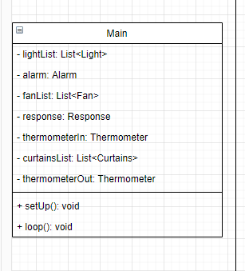

D8

. . .

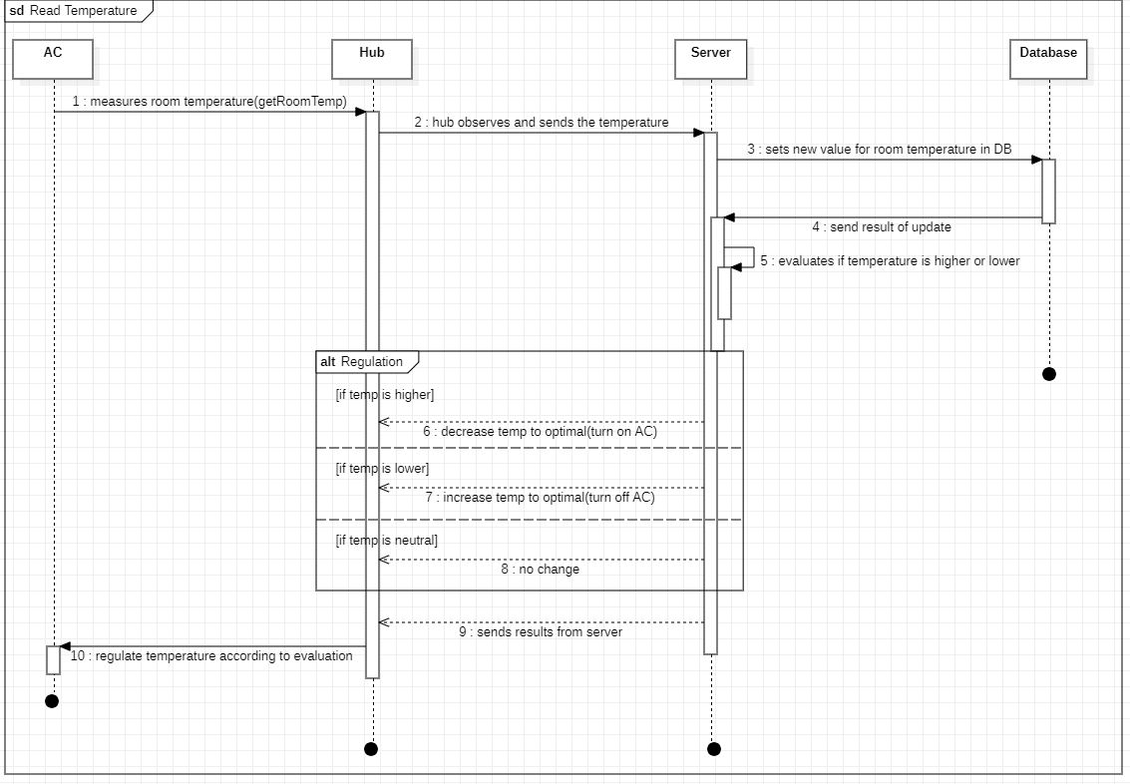

D9

. . .

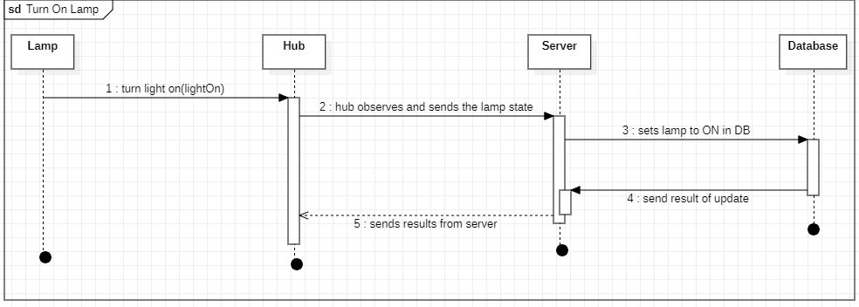

D10

. . .

