***Software Requirement Specification***

***for***

**Referral Marketing System (RMS)**

A. Domain Model (Logical View) 2

B. Functional Requirement (FR) 3

1. System Security 3

2. Subscriber Management 4

3. Channel Management 4

4. Post Management 4

5. Affiliate Management 4

6. Discount Code 5

7. Share Management 5

8. Order Management 5

9. Customer Management 5

10. Product Management 5

11. Performer Management 5

12. Commission Management 6

13. Payment Management 6

14. Web Info 6

15. Guide Management 6

16. Configuration Management 6

17. Bill Management 6

18. Notification Management 6

C. Business Flows, Business Rules (Process View) 7

1. Business Flows 7

2. Business Rules 8

D. Non-Functional Requirement (NFR) 9

1. Performance 9

2. Availability 9

3. Scalability 9

4. Security 9

E. System Architecture (Development View) 10

F. Physcial Diagram (Deployment View) 11

# Domain Model (Logical View)

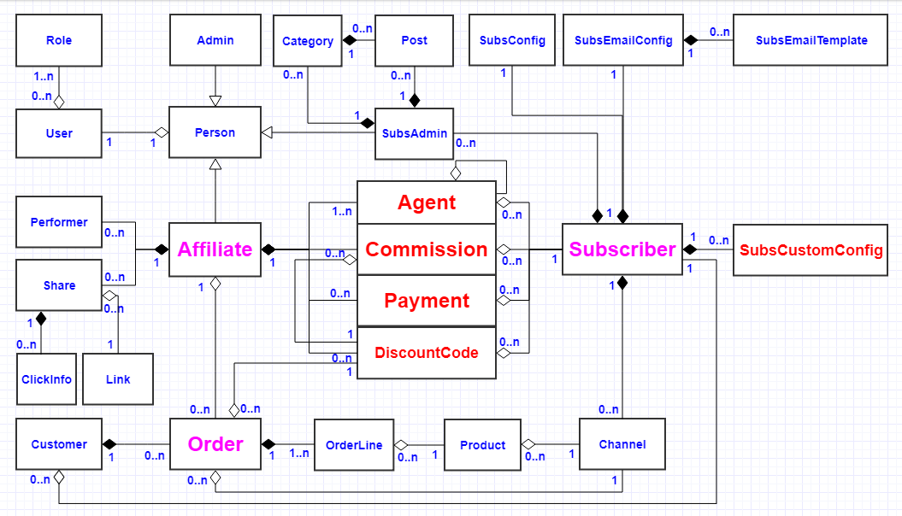

# Functional Requirement (FR)

**Danh sách từ viết tắt**

|  |  |
| --- | --- |
| CAD (1) | Commission As Default |
| **COAN (1)** | **Commission On Affiliate Network** |
| **COSAL (1)** | **Commission On Same Affiliate Level** |
| COPG (1) | Commission On Priority Group |
| CFE (1) | Commission For Ever |
| COPP (n) | Commission On Product Price |
| COPPR (n) | Commission On Product Price Range |
| COOV (n) | Commission On Order Value |
| COASV (n) | Commission On Affiliate Sales Value |
|  |  |

**Roles:**

1. **ADMIN**
2. **AFFILIATE**
3. **CHANNEL**
4. **SUBS_ADMIN**
5. **ACCOUNTANT**
6. **VISITOR**

**Danh sách Features/User Stories**

## System Security

1. Sign In/Out (VISITOR)
2. Search Admins (ADMIN)
3. Create an Admin (ADMIN)
4. Update an Admin (ADMIN)
5. Delete an Admin (ADMIN)
6. Search SubsAdmins (ADMIN, SUBS_ADMIN)
7. Create a SubsAdmin for a Subscriber (ADMIN, SUBS_ADMIN)
8. Update a SubsAdmin (ADMIN, SUBS_ADMIN)
9. Delete a SubsAdmin (ADMIN, SUBS_ADMIN)
10. Activate an Affiliate (VISITOR)
11. Verify phone of an Affiliate (AFFILIATE)

## Subscriber Management

1. Search Subscribers (ADMIN)
2. Create a Subscriber (ADMIN)
3. Update a Subscriber (ADMIN)
4. Upload Subscribers from an excel file (ADMIN)
5. Update a SubsConfig (SUBS_ADMIN)
6. Update a SubsEmailConfig (SUBS_ADMIN)
7. **Search SubsCustomConfigs (SUBS_ADMIN)**
8. Update a SubsCustomConfig-CAD (SUBS_ADMIN)
9. Update a SubsCustomConfig-COAN (SUBS_ADMIN)
10. Update a SubsCustomConfig-COSAL (SUBS_ADMIN)
11. Update a SubsCustomConfig-COPG (SUBS_ADMIN)
12. Update a SubsCustomConfig-CFE (SUBS_ADMIN)
13. Create a SubsCustomConfig-COPPR (SUBS_ADMIN)
14. Update a SubsCustomConfig-COPPR (SUBS_ADMIN)
15. Create a SubsCustomConfig-COOV (SUBS_ADMIN)
16. Update a SubsCustomConfig-COOV (SUBS_ADMIN)
17. Create a SubsCustomConfig-COASV (SUBS_ADMIN)
18. Update a SubsCustomConfig-COASV (SUBS_ADMIN)
19. **View a Subscriber (ADMIN, SUBS_ADMIN)**

## Channel Management

1. Search Channels (ADMIN, SUBS_ADMIN)
2. Create a Channel for a Subscriber (SUBS_ADMIN)
3. Update a Channel (SUBS_ADMIN)
4. **View a Channel (ADMIN, SUBS_ADMIN)**

## Post Management

1. Search Posts (AFFILIATE, SUBS_ADMIN)
2. Create a Post (SUBS_ADMIN)

## Affiliate Management

1. Search Affiliates (ADMIN, SUBS_ADMIN)
2. Create an Affiliate (CHANNEL, ADMIN, AFFILIATE, SUBS_ADMIN)
3. Update an Affiliate (ADMIN, AFFILIATE, SUBS_ADMIN)
4. Remind INACTIVE Affiliates (SUBS_ADMIN)
5. Export Affiliates to an excel file (ADMIN, SUBS_ADMIN)
6. Promote Affiliates (SUBS_ADMIN)
7. **View an Affiliate (ADMIN**, **AFFILIATE, SUBS_ADMIN)**

## Discount Code

1. Search DiscountCodes (AFFILIATE)
2. Create a DiscountCode (AFFILIATE)
3. Update a DiscountCode (AFFILIATE)

## Share Management

1. Search Shares (AFFILIATE, SUBS_ADMIN)
2. Update stats for a Share (CHANNEL)

## Order Management

1. Search Orders (AFFILIATE, SUBS_ADMIN)
2. Create an Order (CHANNEL, AFFILIATE, SUBS_ADMIN)
3. Update an Order (AFFILIATE, SUBS_ADMIN)
4. Approve an Order (SUBS_ADMIN)
5. Reject an Order (SUBS_ADMIN)
6. Export Orders to an excel file (AFFILIATE, SUBS_ADMIN)
7. **View an Order (AFFILIATE**, **SUBS_ADMIN)**

## Customer Management

1. Search Customers (ADMIN, SUBS_ADMIN)
2. Export Customers to an excel file (ADMIN, SUBS_ADMIN)

## Product Management

1. Search Products (SUBS_ADMIN)
2. **View a Product (SUBS_ADMIN)**

## Performer Management

1. Evaluate Performers (SUBS_ADMIN)
2. Search Performers (SUBS_ADMIN)

## Commission Management

1. Search Commissions (AFFILIATE, SUBS_ADMIN)
2. Export Commissions to an excel file (AFFILIATE, SUBS_ADMIN)

## Payment Management

1. Search Payments (AFFILIATE, ACCOUNTANT)
2. Create a Payment (AFFILIATE, ACCOUNTANT)
3. Update a Payment (AFFILIATE, ACCOUNTANT)
4. Accept a Payment (ACCOUNTANT)
5. Reject a Payment (ACCOUNTANT)
6. Export Payments to an excel file (AFFILIATE, ACCOUNTANT)

## Web Info

1. **View Dashboard (ADMIN, AFFILIATE,** **SUBS_ADMIN)**
2. **View network of Affiliates (AFFILIATE, SUBS_ADMIN)**

## Guide Management

1. Update Guide for SubsAdmin (ADMIN)
2. Update Guide for Affiliate (ADMIN)
3. View Guide (AFFILIATE, SUBS_ADMIN)

## Configuration Management

1. Update PackageConfig (ADMIN)
2. Update EmailConfig (ADMIN)
3. Integrate with CRM (ADMIN)
4. Integrate with Infusion (ADMIN)

## Bill Management

1. Generate Bills (SYSTEM)
2. Search Bills (ADMIN, SUBS_ADMIN)
3. Confirm a Bill paid (ADMIN)

## Notification Management

1. Show Notifications (SYSTEM)

# Business Flows, Business Rules (Process View)

## Business Flows

Refer to files:

* RMS_Biz Flow 01_Affiliate Registration.jpg
* RMS_Biz Flow 02_eCommerce Transaction.jpg
* RMS_Biz Flow 03_Affiliate Commission.jpg

## Business Rules

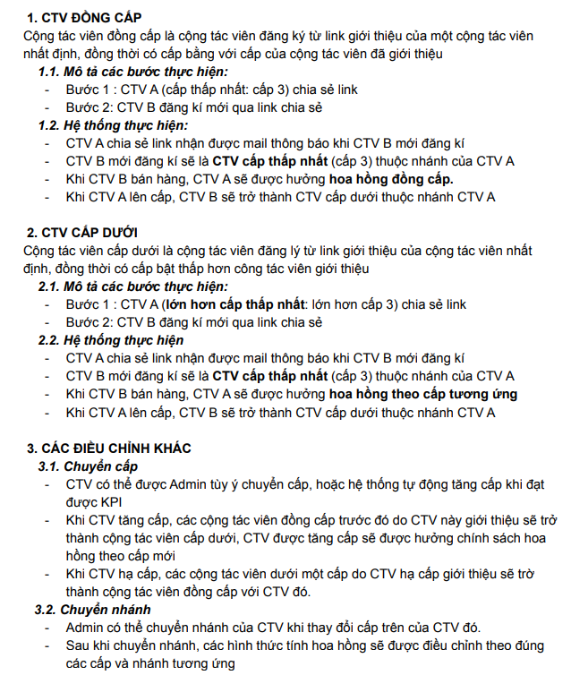

File: RMS_CẤU TRÚC SƠ ĐỒ TRẢ THƯỞNG 3 CẤP.docx

# Non-Functional Requirement (NFR)

## Performance

RMS can support 3k CCR (Con-Current Requests)

## Availability

RMS can up 99%.

## Scalability

RMS can scale both vertically and horizontally.

## Security

RMS supports JWT and one-way hashed password for authentication.

# System Architecture (Development View)

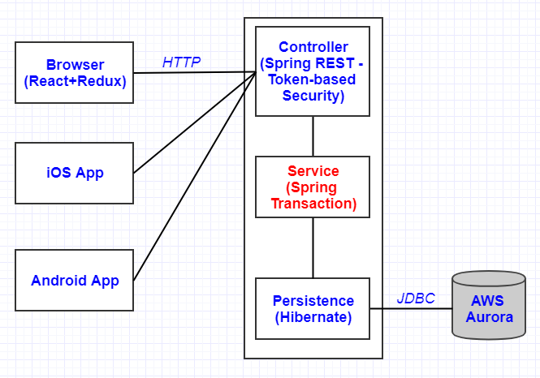

# Physcial Diagram (Deployment View)

