## Task

The main tasks of this laboratory work are:

* implement a class for representing a character string in C++, not using the STL library containers and algorithms;
* extend python interpreter functionality with the implemented class.

If you do additional tasks, the task list increases.

## Result

In the course of work, a «MyString» was developed in the C ++ language. All the required functionality has been implemented. Class was tested in “Visual Studio” (pictures 1 - 2) The main idea was to avoid coping previous code, so most methods call each other to get their goals.

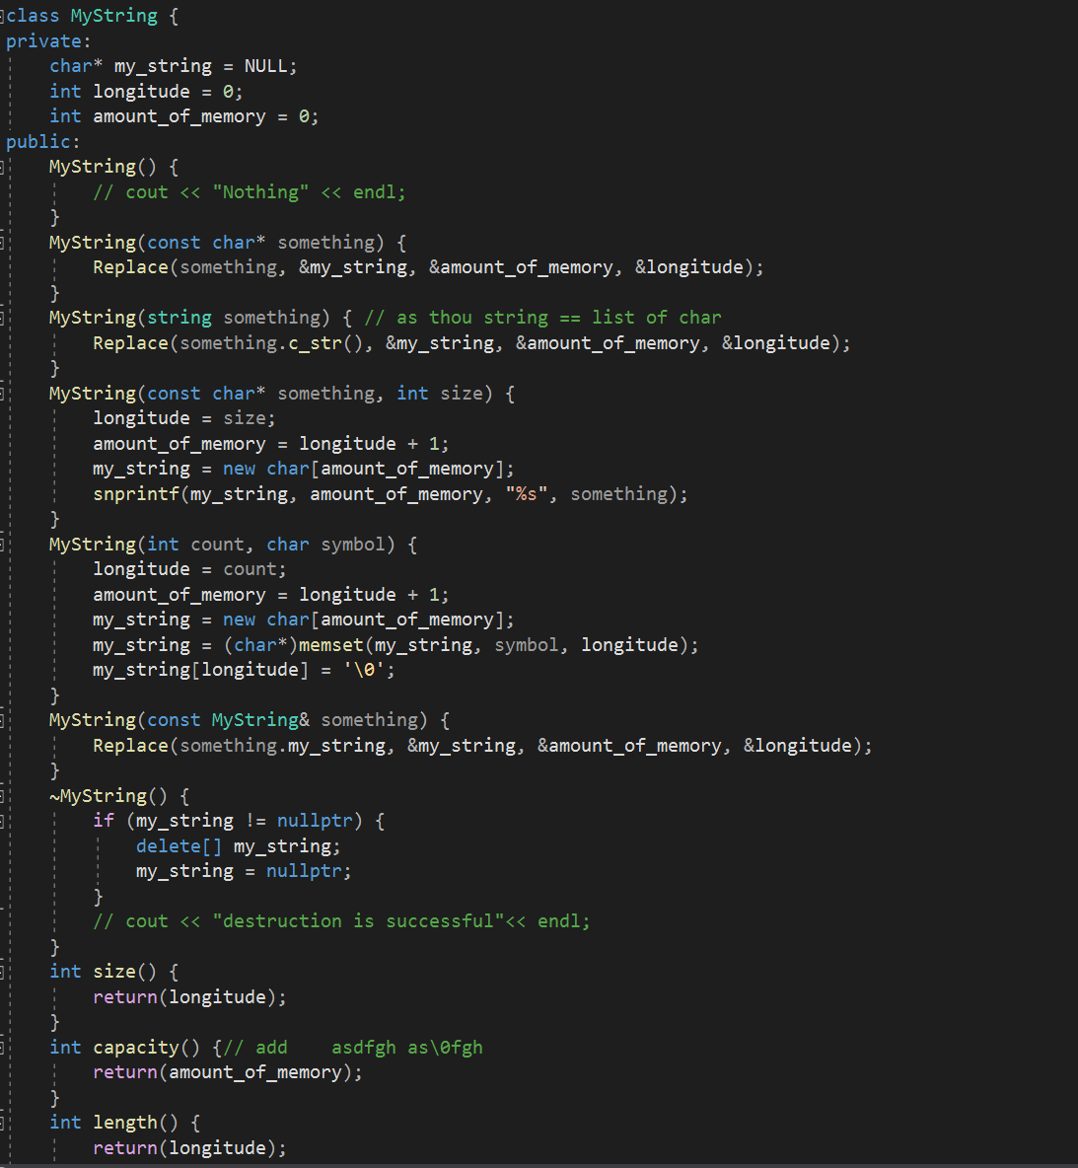

Picture 1 - «MyString» .cpp file.

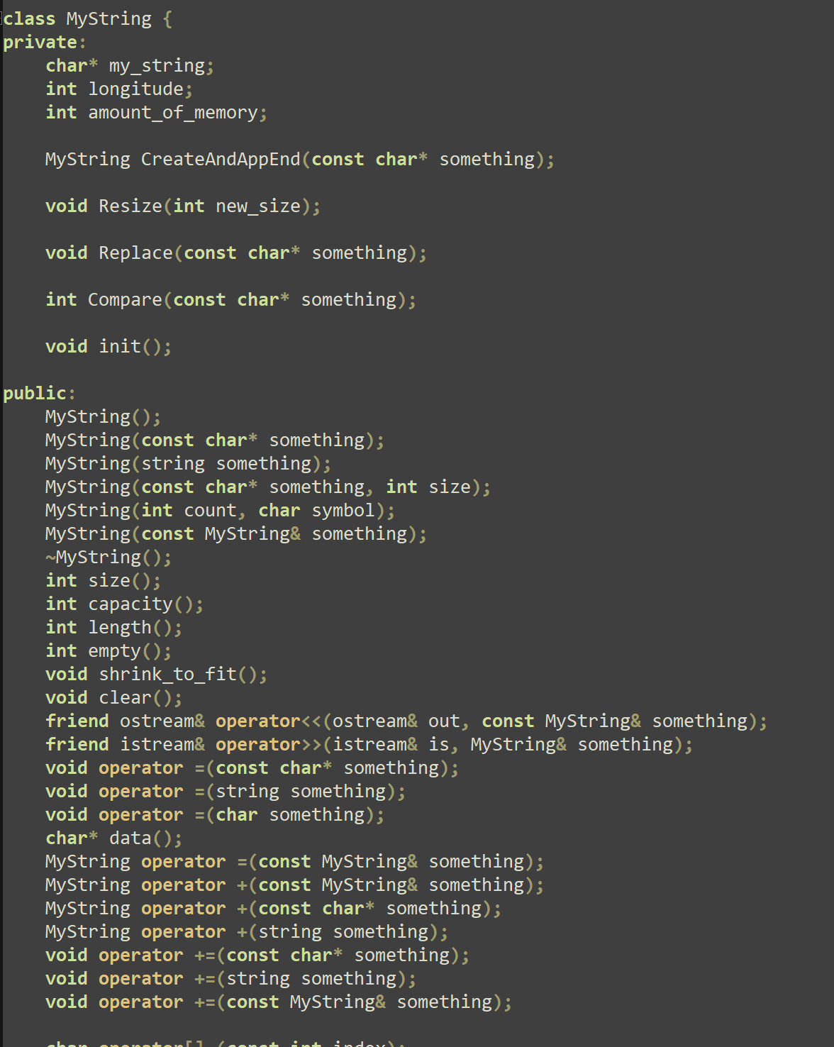

Picture 2 – «MyString» .h file.

## Python wrapping

Moreover, with the help of “swig” was realized python wrapper of “MyString”. Firstly, to create python wrapper I created need to create “MyString.i”, where I described my string header (picture 3).

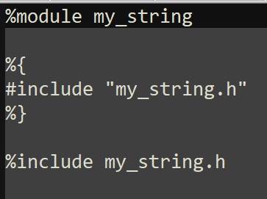

Picture 3 – Describing of MyString.h

Also, I used realization of my string (.cpp file). Finally, I compiled “MyString.py” to “describe” module in Python. With the help of all these files I created “MyString” library in python (picture 4)

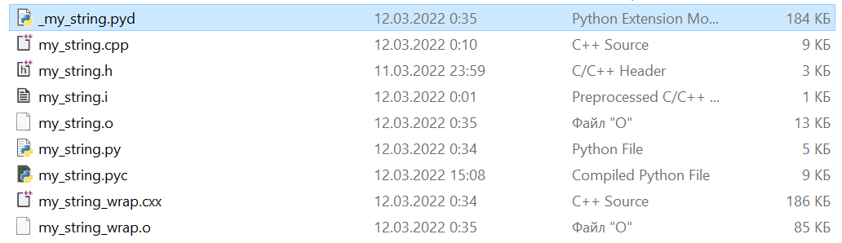

Picture 4 – All used files

After building the module launch python interpreter and import “MyString library. Some functions you can see on Picture 4.



Picture 5 – Example of working