Integrating resilience from individual to community
Hung-wei Lin, October 2026

1 Question & Plan
Resilience is a property that can be quantified at more than one level of biological organisation, and the metrics obtained at each level need not agree (Figueiredo et al., 2026; Segrestin & Lepš, 2022). A disturbance may lower the vital rates of individual plants while leaving population growth rate largely unaffected (Hilde et al., 2020), or suppress individual populations while total community cover remains stable (Loreau & De Mazancourt, 2013; Zhao et al., 2022). In Chapter 1 of my doctoral thesis, I systematically review how ecologists have quantified resilience and the research contexts in which these quantifications are embedded (Lin, et al., 2026a). These contexts include the level of biological organisation at which resilience is measured, the state variable used to quantify it, and the type of disturbance considered. Chapter 2 examines the relationship between life-history traits and population-level resilience, specifically how these traits predict the contribution of transient dynamics to fluctuations in population growth rate under stochastic environments (Lin, et al., 2026b). Here, in Chapter 3, I plan to measure resilience at all three levels (i.e., individual, population, and community) within a single system, from the same data, using a single model, and examine the key drivers of community resilience.
Q1. When factors at every level of biological organisation are considered together, which of them governs how strongly an individual, a population, and the whole community respond to environmental change?
The candidate factors are the individual's own size, the life-history traits of its population, and the crowding from conspecific and heterospecific neighbours, reflecting the strength of intraspecific and interspecific interactions (Adler et al., 2010; Chu & Adler, 2015). The environmental change of interest is interannual climate variation; local conditions of each quadrat, such as grazing intensity, enter as covariates, with quadrat-level random effects absorbing local variation that these covariates do not capture.
To answer this question, I will use the above factors to jointly fit a multilevel Bayesian model for the vital rates of individual plants (Part A) and to run counterfactual simulations of population and community dynamics (Part B), respectively. I detail both approaches (i.e., Part A and Part B) in the following sections.
Q2. Does the strength of conspecific and heterospecific interactions shift with environmental conditions, and does that shift enhance the resilience of the community?
These two types of interactions provide important links between individuals and populations, and between populations and communities, respectively (Bolnick et al., 2011). However, the effects of temporal variation in these interactions on the resilience of community remain poorly understood (Calleja-Solanas et al., 2025).
I will examine the extent to which the interaction effects vary with environmental conditions using the model (Part A). Then, I will control the variations of interactions in counterfactual simulations to quantify the contribution of time-varying interactions to community-level resilience (Part B). Further details follow in the next sections.

2 Part A: A multilevel Bayesian model
To quantify how factors at each level of organisation shape individual responses to environmental change, I will jointly fit a multilevel Bayesian model to three vital rates: (1) survival and (2) growth of each plant, and (3) recruitment of new plants in each quadrat. The data come from chart quadrats, permanent 1-m² plots in which every perennial plant was mapped each year: sagebrush steppe at Dubois, Idaho (1923–1957; Zachmann et al., 2010), with prairies at Miles City, Montana (1932–1945; Anderson et al., 2011) and Hays, Kansas (1932–1972; Adler et al., 2007) as replicate systems. I will fit the same model to each site separately and treat agreement among sites as a test of generality. Plants are followed from year to year by their mapped positions (Lauenroth & Adler, 2008). Fitting the vital rates jointly lets each plant's random effects covary across vital rates (Cam et al., 2002) and yields one posterior from which every derived quantity inherits its uncertainty.
The model groups its predictors into four blocks: one for each level of organisation, and one for the interactions between plants (Fig. 1). (1) Individual: a plant's size and the grazing intensity of its quadrat, the latter included to control for grazing treatments rather than as a focal driver, with random effects of quadrat nested within quadrat group. (2) Population (each species at a site forms one population): a life-history trait partly explains how species differ in their responses, while additional species-level variation remains free of the trait. (3) Community: annual climate (water-year precipitation), shared by all plants at the site, with year random effects absorbing the variation that climate leaves unexplained. (4) Interactions: crowding by conspecifics, heterospecific grasses and heterospecific shrubs, each summed over neighbours weighted by their size and distance through a single kernel estimated from the data (Teller et al., 2016); the life-history trait also partly explains species differences in crowding effects.
Q1 concerns how strongly each level responds to environmental change, so the quantities of interest are the interactions between climate and the other factors. Each block has its own climate modulator (Fig. 1): δ_{size} for plant size, d1_{climate} for the life-history trait, and δ_{x} for each type of crowding (x = intra, grass, shrub).
The same model answers the first half of Q2. The interaction strength a plant experiences in a given year combines the species baseline β_{x} with modulation by plant size (θ_{x}), local environment (ω_{x}), climate (δ_{x}) and year. The posterior of δ_{x} shows whether, and in which direction, climate shifts each type of interaction.
To scale up to populations and the community, I will combine the fitted survival and growth with recruitment, which depends on the cover of each species in the previous year (Chu & Adler, 2015), into an integral projection model (IPM) for each species. Each IPM projects the size distribution, and hence the cover, of its population from one year to the next. From the IPMs, I will decompose the response of the population growth rate (λ) to climate into its direct effect (β_{climate}) and its modulation of other effects (δ_{size} and δ_{x}); weighting these contributions by cover extends the decomposition to community cover. The counterfactual simulations in Part B then test the same question directly.
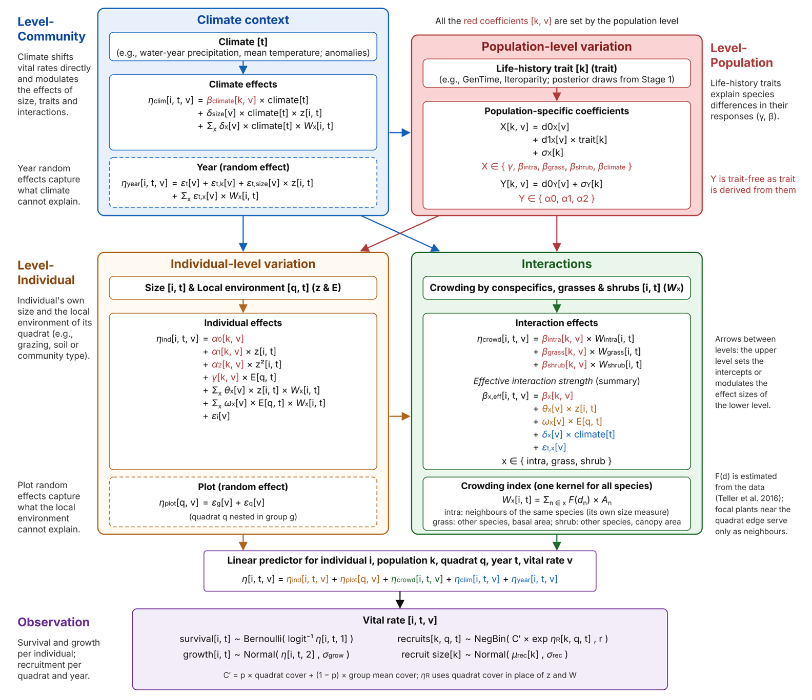
Figure 1. Structure of the multilevel vital-rate model (Part A).

3 Part B: Counterfactual simulations
To quantify the contribution of each factor to community resilience directly, I will run counterfactual simulations from the posterior of Part A (Fig. 2). Each simulation projects every population forward with its IPM under a given sequence of climate years and records total community cover, as the state variable. Community cover is the summed cover of all species mapped with a size; species mapped only as points (mostly forbs) enter the simulations as neighbours held at their observed abundance, a provisional choice until their share of cover is resolved. Because the future positions of plants are unknown, the crowding that each population experiences will be recomputed every year from the simulated cover of conspecific and heterospecific populations, as a mean-field approximation of the observed neighbourhoods (Adler et al., 2010; Chu et al., 2016). I will calibrate this approximation against the crowding observed in census years before running the simulations.
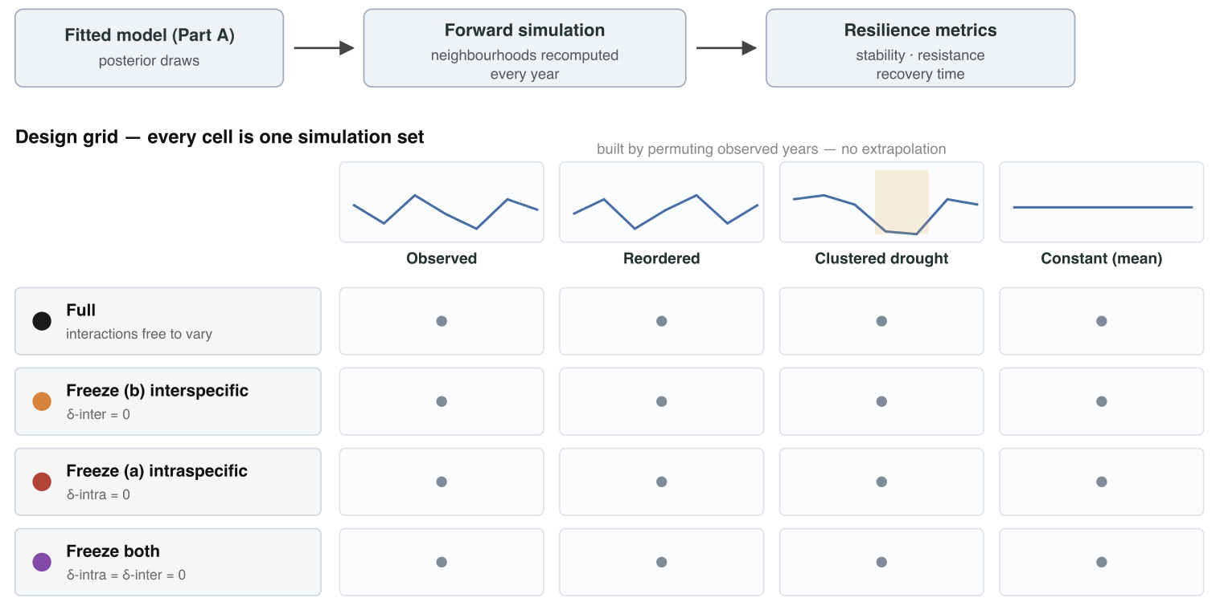
Figure 2. Counterfactual simulation workflow and scenario design.
From each simulated trajectory, I will compute three resilience metrics (Fig. 3; Lin et al., 2026a): (1) temporal stability, the mean of total cover divided by its standard deviation; (2) resistance, one minus the relative drop in cover in dry years; and (3) recovery rate, the inverse of the number of years needed to return to baseline. The same metrics computed from the cover of each population provide their population-level counterparts.
To test whether climate-driven shifts in interaction strength enhance community resilience (Q2), I will compare the full model with three frozen scenarios, in which the interspecific modulators (δ_{grass} and δ_{shrub}), the intraspecific modulator (δ_{intra}), or all three are set to zero (Fig. 2). Because climate is centred, a frozen interaction is held at its mean-climate strength rather than removed, so the scenarios differ only in whether interaction strength responds to climate. The difference in each resilience metric between the full and a frozen scenario quantifies the contribution of that climate response to community resilience. I expect freezing to lower temporal stability and resistance, and to slow recovery (Fig. 4). Each scenario will be run under four climate sequences: the observed sequence, random reordering of the observed years, sequences that cluster the driest years, and a constant mean climate (Fig. 2).
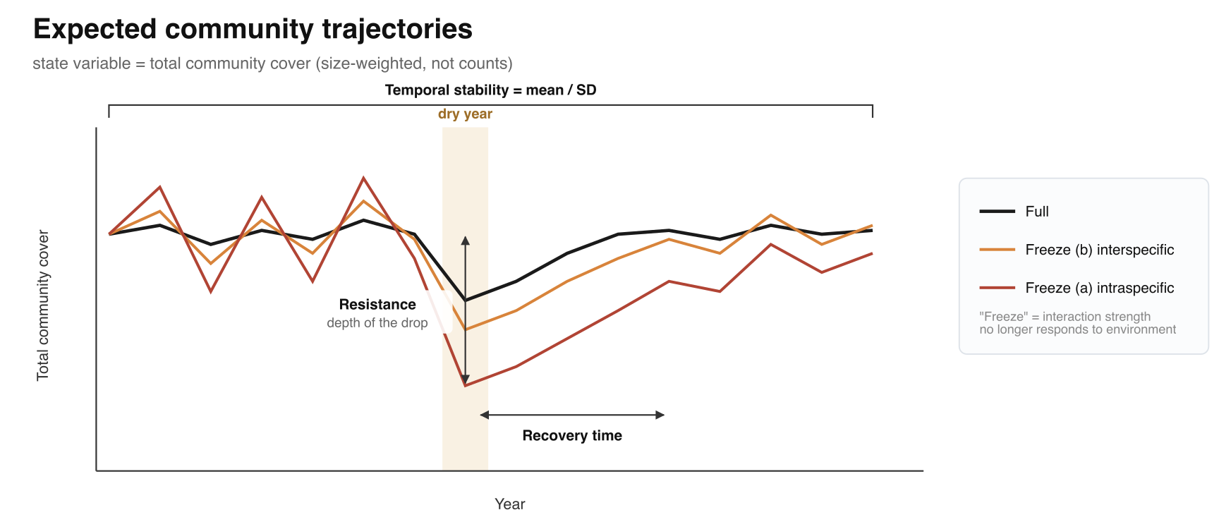
Figure 3. Hypothetical community trajectories under full and frozen interactions.
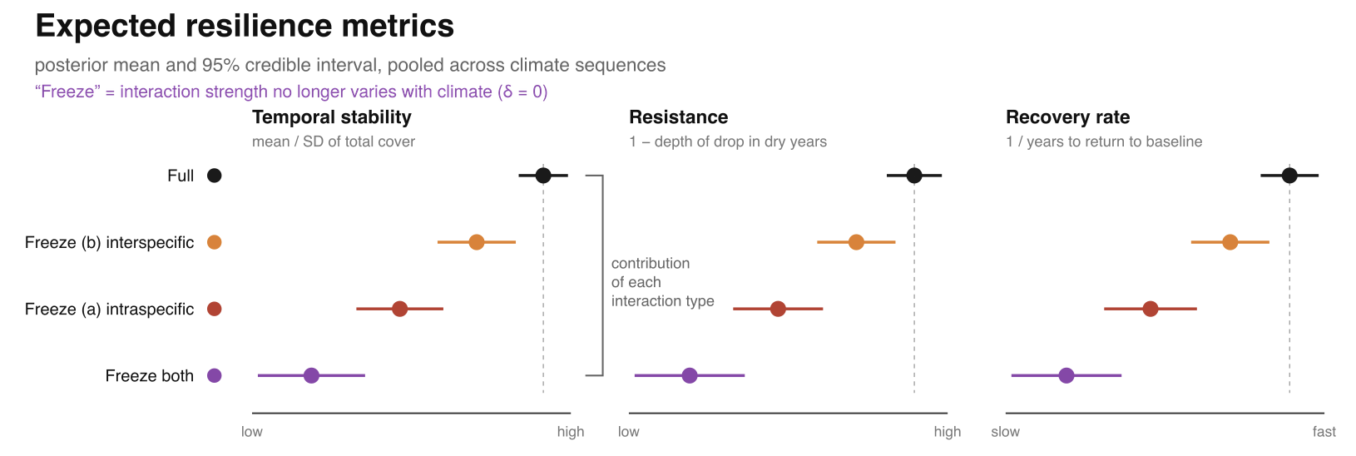
Figure 4. Hypothetical resilience metrics across scenarios.
The same procedure extends to Q1. Setting δ_{size} to zero removes the size dependence of climate responses at the individual level, whereas setting d1_{climate} and σ_{climate} to zero forces all populations to share one climate response and thereby removes response diversity at the population level. Ranking the loss of community resilience across these scenarios, alongside the interaction scenarios above, will reveal which level governs the response of the whole community, and whether it is the same factor that dominates individual responses in Part A.

4 References
Adler, P. B., Ellner, S. P., & Levine, J. M. (2010). Coexistence of perennial plants: An embarrassment of niches. Ecology Letters, 13(8), 1019–1029.
Adler, P. B., Tyburczy, W. R., & Lauenroth, W. K. (2007). Long-term mapped quadrats from Kansas prairie: A unique source of demographic information for herbaceous plants. Ecology, 88, 2673.
Anderson, J., Vermeire, L., & Adler, P. B. (2011). Fourteen years of mapped, permanent quadrats in a northern mixed prairie, USA. Ecology, 92(8), 1703.
Bolnick, D. I., Amarasekare, P., Araújo, M. S., Bürger, R., Levine, J. M., Novak, M., Rudolf, V. H., Schreiber, S. J., Urban, M. C., & Vasseur, D. A. (2011). Why intraspecific trait variation matters in community ecology. Trends in Ecology & Evolution, 26(4), 183–192.
Calleja-Solanas, V., Bartomeus, I., & Godoy, O. (2025). Time-varying interactions drive species coexistence via rainfall variation. bioRxiv, 2025.11. 28.690940.
Cam, E., Link, W. A., Cooch, E. G., Monnat, J.-Y., & Danchin, E. (2002). Individual covariation in life-history traits: Seeing the trees despite the forest. The American Naturalist, 159(1), 96–105.
Chu, C., & Adler, P. B. (2015). Large niche differences emerge at the recruitment stage to stabilize grassland coexistence. Ecological Monographs, 85(3), 373–392.
Chu, C., Kleinhesselink, A. R., Havstad, K. M., McClaran, M. P., Peters, D. P., Vermeire, L. T., Wei, H., & Adler, P. B. (2016). Direct effects dominate responses to climate perturbations in grassland plant communities. Nature Communications, 7(1), 11766.
Figueiredo, L., Scherer, C., Kramer‐Schadt, S., Cabral, J. S., Kéfi, S., Van den Brink, P. J., & Radchuk, V. (2026). estar: An R package to measure ecological stability. Methods in Ecology and Evolution, 17(4), 1090–1100.
Hilde, C. H., Gamelon, M., Sæther, B.-E., Gaillard, J.-M., Yoccoz, N. G., & Pélabon, C. (2020). The demographic buffering hypothesis: Evidence and challenges. Trends in Ecology & Evolution, 35(6), 523–538.
Lauenroth, W. K., & Adler, P. B. (2008). Demography of perennial grassland plants: Survival, life expectancy and life span. Journal of Ecology, 96(5), 1023–1032.
Lin, H., Hernandez, C., Jaggi, H., ZUO, W., Tuljapurkar, S. D., & Salguero-Gomez, R. (2026). Life history traits predict the contribution of transient dynamics to variation in population growth. bioRxiv, 2026.08. 28.747639.
Lin, H., Moorthy, S. M. K., Hector, A., & Salguero-Gómez, R. (2026). Still Lost in Definitions: How ‘Resilience’ Is Used in Ecology. bioRxiv, 2026.06. 03.729936.
Loreau, M., & De Mazancourt, C. (2013). Biodiversity and ecosystem stability: A synthesis of underlying mechanisms. Ecology Letters, 16, 106–115.
Segrestin, J., & Lepš, J. (2022). Towards a better ecological understanding of metacommunity stability: A multiscale framework to disentangle population variability and synchrony effects. Journal of Ecology, 110(7), 1632–1645.
Teller, B. J., Adler, P. B., Edwards, C. B., Hooker, G., & Ellner, S. P. (2016). Linking demography with drivers: Climate and competition. Methods in Ecology and Evolution, 7(2), 171–183.
Zachmann, L., Moffet, C., & Adler, P. (2010). Mapped quadrats in sagebrush steppe: Long-term data for analyzing demographic rates and plant–plant interactions. Ecology, 91(11), 3427.
Zhao, L., Wang, S., Shen, R., Gong, Y., Wang, C., Hong, P., & Reuman, D. C. (2022). Biodiversity stabilizes plant communities through statistical-averaging effects rather than compensatory dynamics. Nature Communications, 13(1), 7804.

