Integrating resilience from individual to community
Hung-wei Lin, September 2026

1 Question & Plan
Resilience is a property that can be quantified at more than one level of biological organisation, and the metrics obtained at each level need not agree (Figueiredo et al., 2026; Segrestin & Lepš, 2022). A disturbance may lower the vital rates of individual plants while leaving population growth rate largely unaffected (Hilde et al., 2020), or suppress individual populations while total community cover remains stable (Loreau & De Mazancourt, 2013; Zhao et al., 2022). In the Chapter 1 of my doctoral thesis, I systematically review how ecologists have quantified resilience and the research contexts in which these quantifications are embedded (Lin, et al., 2026a). For examples, at which level of biological organisation resilience is measured, which state variable is used to quantify it, and which type of disturbance is considered. Chapter 2 examines the relationship between life-history traits and population-level resilience, specifically how these traits predict the contribution of transient dynamics to fluctuations in population growth rate under stochastic environments (Lin, et al., 2026b). Here, in Chapter 3, I plan to measure resilience at all three levels (i.e., individual, population, and community) within a single system, from the same data, using a single model, and examine the key drivers of community resilience.
Q1. When factors at every level of biological organisation are considered together, which of them governs how strongly an individual, a population, and the whole community respond to environmental change?
The candidate factors are the individual's own size, the life-history traits of its population, and the crowding degree from conspecific and heterospecific neighbours, reflecting the strength of intraspecific and interspecific interaction (Ray et al., 2023). Ideally, I should quantify the environment both as the climate of the focal year and as the microsite a plant occupies (Blonder et al., 2018). Alternatively, the microsite environmental factor could be replaced by plot-level random effects.
To answer this question, I will use the above factors to jointly fit a multilevel Bayesian model for four vital rates of each individual (Part A) and to run counterfactual simulations of population and community dynamics (Part B), respectively. I detail both approaches (i.e., Part A and Part B) in the following sections.
Q2. Does the strength of conspecific and heterospecific interactions shift with environmental conditions, and does that shift enhance the resilience of the community?
These two types of interactions provide important links between individuals and populations, and between populations and communities, respectively (Bolnick et al., 2011). However, the effects of temporal variation in these interactions on the resilience of community remain poorly understood (Calleja-Solanas et al., 2025).
I will examine the extent to which the interaction effects vary with environmental conditions using the model (Part A). Then, I will control the variations of interactions in counterfactual simulations to quantify the contribution of time-varying interactions to community-level resilience (Part B). I detail further details in the following sections.

2 Part A: A multilevel Bayesian model
To quantify how factors at each level of organisation shape the response of individuals to environmental change, I will jointly fit a multilevel Bayesian model to four vital rates of every individual: (1) survival; (2) growth; (3) flowering probability; and (4) fecundity, the number of inflorescences produced by a flowering individual (Blonder et al., 2018). Fitting the four vital rates jointly lets each individual's random effects covary across vital rates (Cam et al., 2002), and yields one posterior from which every derived quantity in Parts A and B inherits its uncertainty.
The linear predictor of each vital rate is the sum of four components; each tied to one level of organisation (Fig. 1). At the individual level, the model includes a plant's own size and the microenvironment it occupies, derived from the high-resolution environmental layers of Blonder et al. (2018). An individual random intercept absorbs persistent differences among plants that these covariates do not capture. At the population level, differences among populations are partly explained by a life-history trait, while also allowing for additional variation that is unrelated to the trait. Intraspecific and interspecific crowding, as a proxy of interaction, are quantified from the mapped positions and sizes of neighbours in the raw census data (Blonder et al., 2018; Ray et al., 2023). Annual climate enters as one value per year for the whole site, centred across years, also with year random effects that absorb the among-year variation that climate does not explain.
Q1 asks which factor governs how strongly each level responds to environmental change, so the quantities of interest are the interactions between climate and the other factors rather than their main effects. Each level has its own climate modulator (Fig. 1): δ_{size} describes how the climate response of an individual changes with its size; d1_{climate} describes how the climate response of a population changes with its life-history trait; and δ_{intra} and δ_{inter} describe how the strength of intraspecific and interspecific interactions changes with climate.
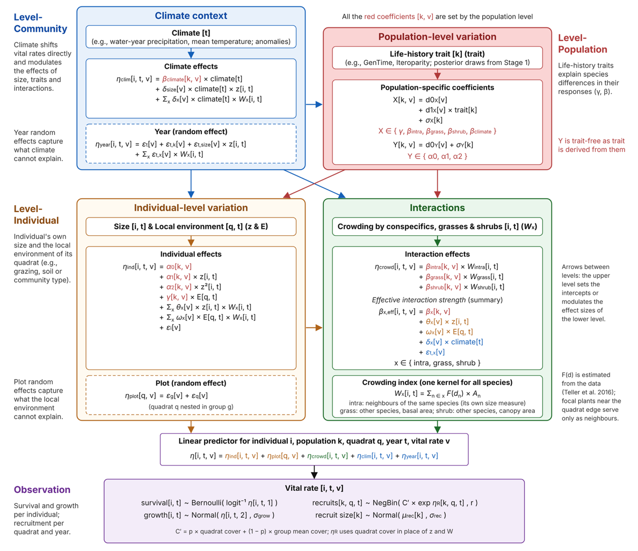
Figure 1. Structure of the multilevel vital-rate model (Part A).
The same model answers the first half of Q2. The strength of intraspecific interaction that an individual experience in a given year is a sum across levels: the population baseline β_{intra}, modulated by the individual's size (θ_{intra}) and microenvironment (ω_{intra}), by climate (δ_{intra}), and by unexplained year effects. The posteriors of δ_intra and δ_inter indicate whether, and in which direction, climate shifts each type of interaction.
Part A quantifies how each factor shapes individual vital rates, but not how populations and the community respond. To link the two levels, I will combine the fitted vital rates with a recruitment submodel, which links new recruits to the inflorescence production and cover of the previous year, into an integral projection model (IPM) for each population. Because the vital rates depend on climate, crowding and year effects, each IPM projects the size distribution, and hence the cover, of its population from one year to the next. From these IPMs, I will quantify how the population growth rate (λ) responds to climate, both its direct effect (β_climate) and its modulation of other effects (δ_size, intra and δ_inter). Summing these contributions across populations, weighted by their cover/abundance, extends the decomposition to the community cover/abundance. These analytical results indicate which factor governs the response of populations and the community, whereas the counterfactual simulations in Part B provide a more direct and robust test of the same question.
3 Part B: Counterfactual simulations
To quantify the contribution of each factor to community resilience directly, I will run counterfactual simulations from the posterior of Part A (Fig. 2). Each simulation projects every population forward with its IPM under a given sequence of climate years and records total community cover/abundance, as the state variable. Because the future positions of plants are unknown, the crowding that each population experiences will be recomputed every year from the simulated cover of conspecific and heterospecific populations, as a mean-field approximation of the observed neighbourhoods (Chu et al., 2016). I will calibrate this approximation against the crowding observed in census years before running the simulations.
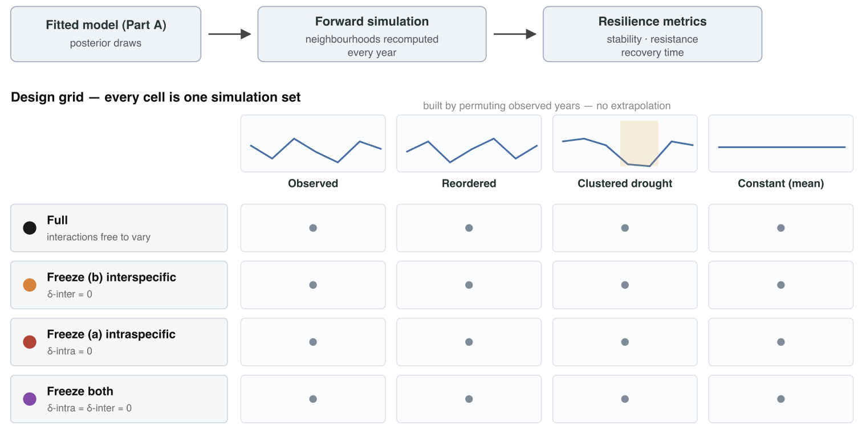
Figure 2. Counterfactual simulation workflow and scenario design.
From each simulated trajectory, I will compute three resilience metrics (Fig. 3; Lin et al., 2026a): (1) temporal stability, the mean of total cover/abundance divided by its standard deviation; (2) resistance, one minus the relative drop in cover in dry years; and (3) recovery rate, the inverse of the number of years needed to return to baseline. The same metrics computed from the cover of each population provide their population-level counterparts.
To test whether climate-driven shifts in interaction strength enhance community resilience (Q2), I will compare the full model with three frozen scenarios, in which δ_{inter}, δ_{intra}, or both are set to zero (Fig. 2). Because climate is centred, a frozen interaction is held at its mean-climate strength rather than removed, so the scenarios differ only in whether interaction strength responds to climate. The difference in each resilience metric between the full and a frozen scenario quantifies the contribution of that climate response to community resilience. I expect freezing to lower temporal stability and resistance, and to slow recovery (Fig. 4). Each scenario will be run under four climate sequences: the observed sequence, random reordering of the observed years, sequences that cluster the driest years, and a constant mean climate (Fig. 2).
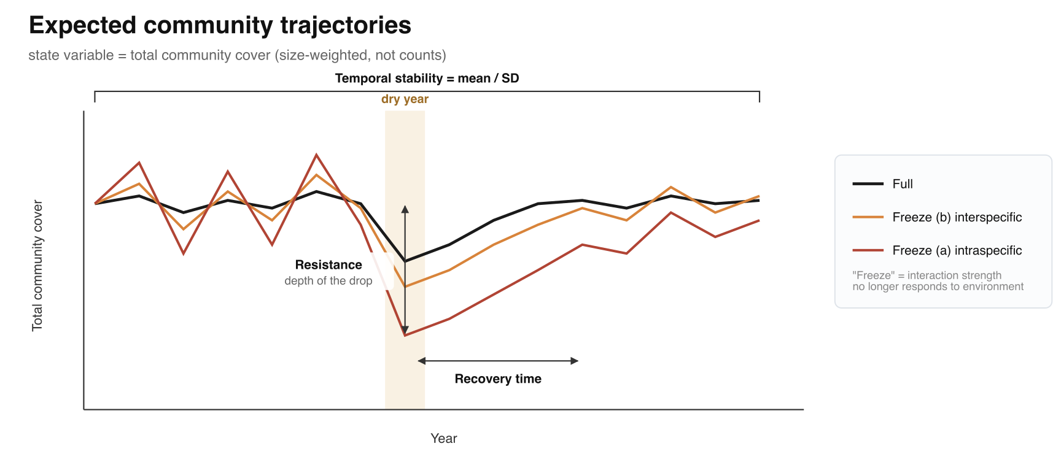
Figure 3. Hypothetical community trajectories under full and frozen interactions.
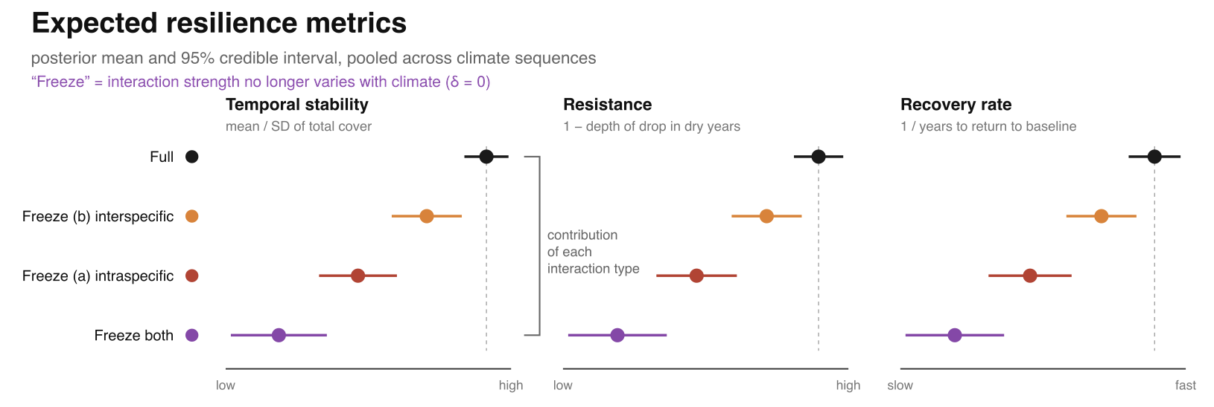
Figure 4. Hypothetical resilience metrics across scenarios.
The same procedure extends to Q1. Setting δ_{size} to zero removes the size dependence of climate responses at the individual level, whereas setting d1_{climate} and σ_{climate} to zero forces all populations to share one climate response and thereby removes response diversity at the population level. Ranking the loss of community resilience across these scenarios, alongside the interaction scenarios above, will reveal which level governs the response of the whole community, and whether it is the same factor that dominates individual responses in Part A.

4 Reference
Blonder, B., Kapas, R. E., Dalton, R. M., Graae, B. J., Heiling, J. M., & Opedal, Ø. H. (2018). Microenvironment and functional‐trait context dependence predict alpine plant community dynamics. Journal of Ecology, 106(4), 1323–1337.
Bolnick, D. I., Amarasekare, P., Araújo, M. S., Bürger, R., Levine, J. M., Novak, M., Rudolf, V. H., Schreiber, S. J., Urban, M. C., & Vasseur, D. A. (2011). Why intraspecific trait variation matters in community ecology. Trends in Ecology & Evolution, 26(4), 183–192.
Calleja-Solanas, V., Bartomeus, I., & Godoy, O. (2025). Time-varying interactions drive species coexistence via rainfall variation. bioRxiv, 2025.11. 28.690940.
Cam, E., Link, W. A., Cooch, E. G., Monnat, J.-Y., & Danchin, E. (2002). Individual covariation in life-history traits: Seeing the trees despite the forest. The American Naturalist, 159(1), 96–105.
Chu, C., Kleinhesselink, A. R., Havstad, K. M., McClaran, M. P., Peters, D. P., Vermeire, L. T., Wei, H., & Adler, P. B. (2016). Direct effects dominate responses to climate perturbations in grassland plant communities. Nature Communications, 7(1), 11766.
Figueiredo, L., Scherer, C., Kramer‐Schadt, S., Cabral, J. S., Kéfi, S., Van den Brink, P. J., & Radchuk, V. (2026). estar: An R package to measure ecological stability. Methods in Ecology and Evolution, 17(4), 1090–1100.
Hilde, C. H., Gamelon, M., Sæther, B.-E., Gaillard, J.-M., Yoccoz, N. G., & Pélabon, C. (2020). The demographic buffering hypothesis: Evidence and challenges. Trends in Ecology & Evolution, 35(6), 523–538.
Lin, H., Hernandez, C., Jaggi, H., ZUO, W., Tuljapurkar, S. D., & Salguero-Gomez, R. (2026). Life history traits predict the contribution of transient dynamics to variation in population growth. bioRxiv, 2026.08. 28.747639.
Lin, H., Moorthy, S. M. K., Hector, A., & Salguero-Gómez, R. (2026). Still Lost in Definitions: How ‘Resilience’ Is Used in Ecology. bioRxiv, 2026.06. 03.729936.
Loreau, M., & De Mazancourt, C. (2013). Biodiversity and ecosystem stability: A synthesis of underlying mechanisms. Ecology Letters, 16, 106–115.
Ray, C. A., Kapas, R. E., Opedal, Ø. H., & Blonder, B. W. (2023). Linking microenvironment modification to species interactions and demography in an alpine plant community. Oikos, 2023(3), e09235.
Segrestin, J., & Lepš, J. (2022). Towards a better ecological understanding of metacommunity stability: A multiscale framework to disentangle population variability and synchrony effects. Journal of Ecology, 110(7), 1632–1645.
Zhao, L., Wang, S., Shen, R., Gong, Y., Wang, C., Hong, P., & Reuman, D. C. (2022). Biodiversity stabilizes plant communities through statistical-averaging effects rather than compensatory dynamics. Nature Communications, 13(1), 7804.

