Long-term seedling and small sapling census data from the Barro Colorado Island 50 ha Forest Dynamics Plot, Panama

Liza S. Comita*^{1,2}, Salomón Aguilar², Stephen P. Hubbell^{2,3}, Rolando Pérez²,

¹ School of the Environment, Yale University, New Haven, CT 06511, USA
² Smithsonian Tropical Research Institute, Apartado Postal 0843-03092, Panamá, República de Panamá
³ Department of Ecology and Evolutionary Biology, University of California, Los Angeles, CA 90095, USA

*Corresponding author; Email: liza.comita@yale.edu

Metadata S1.

Class I: Data set descriptors

A. Data set identity: Long-term seedling and small sapling census data from the Barro Colorado Island 50 ha Forest Dynamics Plot, Panama

B. Data set identification code: BCI_seedlings_2001_2018

C. Data set description

1. Originators

Liza S. Comita, School of the Environment, Yale University, New Haven, CT 06511, USA; Smithsonian Tropical Research Institute, Apartado Postal 0843-03092, Panamá, República de Panamá (liza.comita@yale.edu)

Stephen P. Hubbell, Department of Ecology and Evolutionary Biology, University of California, Los Angeles, CA 90095, USA; Smithsonian Tropical Research Institute, Apartado Postal 0843-03092, Panamá, República de Panamá (shubbell@eeb.ucla.edu)

2. Abstract

Tropical forests are well known for their high woody plant diversity. Processes occurring at early life stages are thought to play a critical role in maintaining this high diversity and shaping the composition of tropical tree communities. To evaluate hypothesized mechanisms promoting tropical tree species coexistence and influencing composition, we initiated a census of woody seedlings and small saplings in the permanent 50 ha Forest Dynamics Plot (FDP) on Barro Colorado Island (BCI), Panama. Situated in old-growth, lowland tropical moist forest, the BCI FDP was originally established in 1980 to monitor trees and shrubs ≥1 cm diameter at 1.3 m above ground (dbh) at ca. 5-yr intervals. However, critical data on the dynamics occurring at earlier life stages were initially lacking. Therefore, in 2001 we established a 1-m² seedling plot in the center of every 5 x 5 m section of the BCI FDP. All freestanding woody individuals ≥20 cm tall and <1 cm dbh (hereafter referred to as seedlings) were tagged, mapped, measured, and identified to species in 19,313 1-m² seedling plots. Because seedling dynamics are rapid, we censused these seedling plots every 1-2 years. Here we present data from the 14 censuses of these seedling plots conducted between the initial census in 2001 to the most recent census, in 2018. This data set includes nearly 1M observations of ~185,000 individuals of >400 tree, shrub, and liana species. These data will permit spatially-explicit analyses of seedling distributions, recruitment, growth, and survival for hundreds of woody plant species. In addition, the data presented here can be linked to openly-available, long-term data on the dynamics of trees and shrubs ≥1cm dbh in the BCI FDP, as well as existing data sets from the site on climate, canopy structure, phylogenetic relatedness, functional traits, soil nutrients, and topography.

D. Key words

Advanced regeneration; Barro Colorado Island (BCI); Forest Dynamics Plot (FDP); ForestGEO; Panama; regeneration niche; seedling bank; seedling growth; seedling recruitment; seedling survival; species coexistence; tropical forest

Class II. Research origin descriptors

A. Overall project description

1. Identity: Long-term seedling and small sapling census in the Barro Colorado Island 50 ha Forest Dynamics Plot, Panama

2. Originators: See Class I. C: 1. Originators.

3. Period of Study: 2001-2018

4. Objective: The seedling and small sapling census project was initiated to complement long-term monitoring of larger sapling and adult shrubs, lianas, and trees in the BCI 50 ha Forest Dynamics Plot (FDP), Panama. Established in 1980, the BCI FDP initially included only a census of trees and shrubs ≥1 cm diameter at 1.3 m above ground (dbh) at 5-year intervals (Hubbell and Foster 1983, Condit 1998). We established a seedling and small sapling census in 2001 to better understand woody plant dynamics in smaller size classes over shorter time intervals (Comita et al. 2007a, Comita and Hubbell 2009).

5. Abstract:

See section Class I. C. 2. Abstract above.

6. Sources of funding

The BCI census of seedlings and small saplings was funded by the U.S. National Science Foundation (grants: DEB-0075102, DEB-0823728, DEB-0640386, DEB-1242622, DEB-1464389). Additional funding was provided by Ohio State University and Yale University.

B. Specific subproject description

1. Site description

a. Site type: lowland Neotropical forest

b. Geography: Barro Colorado Island (BCI), Panama (9°9' N, 79°51' W)

c. Habitat: Semideciduous, tropical moist forest

d. Geology: The 50-ha plot is on a level plateau at 140 m above sea level and includes gentle slopes (up to 20° inclination). The soils are mostly well weathered kaolinitic Oxisols (John et al. 2007) and are well-drained except for a ~1.5 ha area of seasonally inundated swamp (Harms et al. 2001).

e. Watersheds, hydrology: N/A

f. Site history: The majority of the 50-ha plot is considered old growth forest, with the exception of ~2 ha of old secondary (>100 year) forest on the north-eastern edge (Hubbell and Foster 1983). Trees and shrubs ≥1 dbh in the BCI FDP were first censused in 1982-83 and then recensused at ~5 year intervals since 1985, generating spatially-explicit data on the recruitment, growth and survival of >300 woody plant species (Condit 1998). Lianas ≥1 dbh were censused in the BCI FDP in 2007 and 2017 (Schnitzer et al. 2012). Complete data from all censuses of trees and shrubs ≥1 dbh in the BCI FDP, as well as topographic data, are available on Dryad (Condit et al. 2019). Soil data for the BCI FDP can be downloaded from the ForestGEO website at https://forestgeo.si.edu/sites/neotropics/barro-colorado-island/bci-maps/bci-soil-maps. Canopy density data (for 1983-2012) are available on the Smithsonian data depository (Hubbell et al. 2014). Data on functional traits (wood specific gravity, seed mass, maximum height, and leaf mass per area) for species in the BDI FDP can be found in Wright et al. (2010). A community phylogeny for tree species in the BCI FDP was constructed using DNA barcode sequences by Kress et al. (2009).

g. Climate: Tropical; Average daily temperature of ~26°C; Mean annual rainfall of ~2600 mm, with most falling during the 8-month wet season from May to December (Windsor 1990). For detailed descriptions of the climate, geology, and flora of BCI see Leigh et al. (1982), Leigh (1999) and Croat (1978). Climate data for BCI are available from STRI’s physical monitoring program at https://biogeodb.stri.si.edu/physical_monitoring/research/barrocolorado.

2. Sampling design:

a. Design characteristics: The BCI 50-ha plot is gridded into 1250 20x20 m quadrats (q20), which are further subdivided into 16 5x5 m subquadrats (p5) (Figure 1). The 20x20 m quadrats are assigned X coordinates ranging from 0 to 49 (west to east) and Y coordinates of 0 to 24 (south to north), such that the quadrat in the southwest corner of the plot is (0,0) and the quadrat in the northeast corner of the plot is (49,24). Within each 20x20 m quadrat, the 5x5 m subquadrats are numbered as shown in Fig. 1.

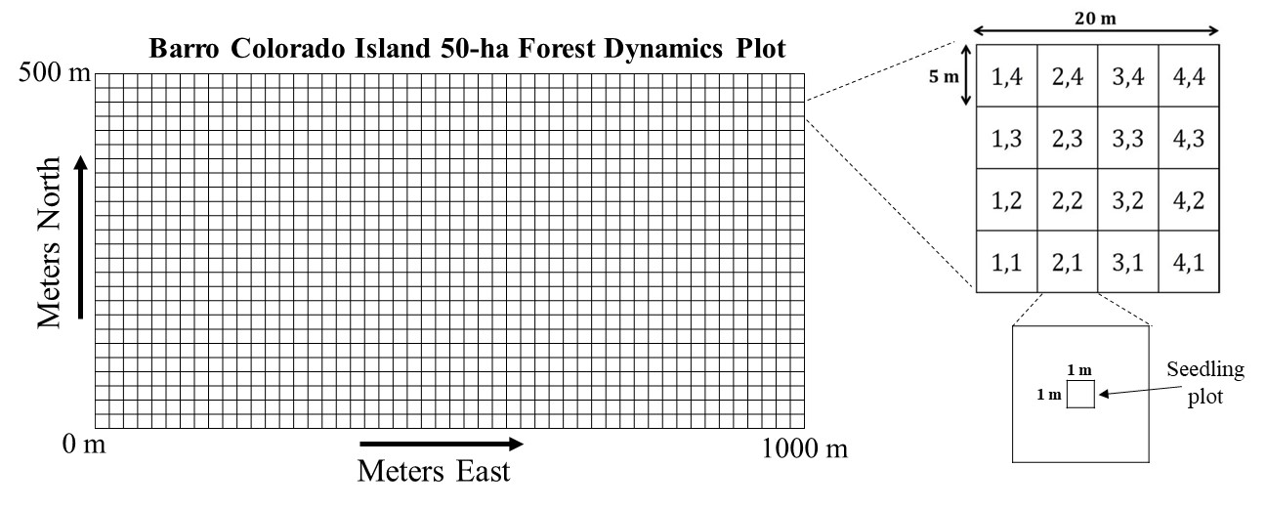
Figure 1. Gridded map of the 50 ha BCI FDP showing 20 x 20 m quadrats (q20). Enlarged 20x20 m quadrat shows the layout of 5x5 m subquadrats (p5), and enlarged 5 x5 m subquadrat shows the location of the 1-m² seedling plot in the center of each 5 x 5 m subquadrat.

In 2001, a 1x1 m seedling plot was established in the center of every 5x5 m subquadrat of the BCI 50 ha plot, resulting in a total of 20,000 1-m² seedling plots uniformly distributed across the 50 ha plot. Two diagonal corners of each seedling plot were permanently marked with short PVC posts to aid in plot relocation in future censuses. Each seedling plot is assigned the number of the 20x20 m quadrat (q20) and 5x5 m subquadrat (p5) in which it is located. Note that seedlings were censused consistently in only 19,313 of these seedling plots (96.6%) (see Section II.B.3a below).

b. Permanent plots: The BCI 50 ha Forest Dynamics Plot is 1000 m by 500 m. See 2a above for description of 1x1m seedling plots with the 50 ha Plot.

c. Data collection period, frequency, etc.: Data collection took place between January 2001 and August 2018 over the course of 14 field seasons. The temporal details for each census are listed hereafter chronologically:

- Census 1: January 16 – October 04, 2001 (number of field days: 150)
- Census 2: January 17 – May 23, 2002 (number of field days: 89)
- Census 3: January 21 – October 21, 2003 (number of field days: 125)
- Census 4: January 19 – June 11, 2004 (number of field days: 96)
- Census 5: January 17 – October 27, 2006 (number of field days: 123)
- Census 6: January 12 – October 28, 2008 (number of field days: 199)
- Census 7: February 16 – August 31, 2009 (number of field days: 135)
- Census 8: March 01 – December 01, 2011 (number of field days: 187)
- Census 9: May 05 – November 29, 2012 (number of field days: 146)
- Census 10: January 29 – August 19, 2013 (number of field days: 131)
- Census 11: January 28 – August 27, 2014 (number of field days: 117)
- Census 12: February 15 – October 24, 2016 (number of field days: 121)
- Census 13: February 21 – October 25, 2017 (number of field days: 134)
- Census 14: February 21 – August 02, 2018 (number of field days: 97)

3. Research methods

a. Field/laboratory: The initial census of the seedling plots took place between January and October 2001. In this census, all free-standing woody plants ≥20 cm tall and <1 cm dbh (hereafter referred to as seedlings) were tagged, measured, mapped, and identified to species within each 1-m² seedling plot. We included tree and shrub seedlings, as well as liana seedlings that were not yet climbing on another individual or twining along the forest floor. Each seedling received a numbered tag that was unique within its 1-m² seedling plot. Within the database, each seedling is assigned a unique ID consisting of its q20, p5, and tag number (Table 1). Seedling height was measured to the nearest mm as the length of the main stem from the ground to base of the uppermost leaf (i.e., apical meristem). Individuals >3 m tall were difficult to measure accurately in the field and thus were all assigned a value of 3000 mm. In cases where it was not possible to identify the main stem (i.e., in shrubs with many branches), the longest branch was measured as the main stem (by stretching the stem to its maximum length or bending the tape measure to follow the full length of the stem). The number of stems was recorded for each seedling as the number of stems that began branching off at <10 cm height. In addition, the total number of fully expanded leaves was recorded for each seedling. For seedlings with <50 leaves, the actual number of leaves was counted; for seedlings with ≥50 and <100 leaves, leaf number was recorded as 50; and for seedlings with ≥100 leaves, leaf number was recorded as 100. Diameter at 130 cm above ground (dbh) was recorded for individuals when applicable (i.e., >130 cm tall).

Seedlings were mapped to the nearest ~5 cm on paper maps in the field to aid in relocating seedlings in future censuses, but those data were not entered into a computer. Therefore, in the database all seedlings are assigned the xy-coordinate of the center of the 1x1 m seedling plot in which they are located (i.e., within ~0.7 m accuracy).

Recensuses of the seedling plots were conducted annually between 2001 and 2018, except in years when trees ≥1cm dbh were censused (2005, 2010, and 2015) and in 2007 (due to funding issues). In each recensus, the status (alive/dead) and height, stem number, and dbh (if applicable) was recorded for survivors, and all (free-standing, woody) new recruits ≥20 cm tall were tagged, mapped, identified, and measured. Leaf number was recorded in the 2002, 2003, and 2004 recensuses only. In 2002, the status of previously tagged seedlings was recorded, but height, stem and leaf number were only measured for new recruits due to limited funds that year. In recensuses, the status (alive/dead) of tagged liana seedlings that later started climbing or twining (code = V; Table 1) continued to be recorded (along with the dbh, if applicable), but not the height, leaf, or stem number. For individuals initially tagged in the seedling census that later were tagged in censuses of trees and lianas ≥1 cm dbh (code = Ca or Cl, respectively; Table 1), we recorded the tag number from the tree or liana census and stopped monitoring the plant in the seedling census.

A total of 20,000 1-m² seedling plots were initially established, but seedlings were only censused consistently in 19,313 (96.6%) of the plots because some plots were skipped to avoid disturbing other long-term research projects located adjacent to the trail system running through the 50-ha plot. Any data from these skipped plots were therefore removed from the dataset entirely to avoid confusion. A list of all the 1-m² seedling plots, their coordinates, and whether they were censused or skipped is included with the data set.

b. Instrumentation: Two diagonal corners of each 1-m² seedling plot were marked with PVC tubes. Each seedling in the census was tagged with a numbered plastic band (plastic bandettes, National Band & Tag Company, Newport, KY, USA https://nationalband.com/products/plastic-banettes) (Figure 2). Tag numbers ranged from 1 to 1000, with most between 1 to 200 (due to limited availability from the company), and were orange, pink, white, or yellow in color (the colors most visible on the forest floor).

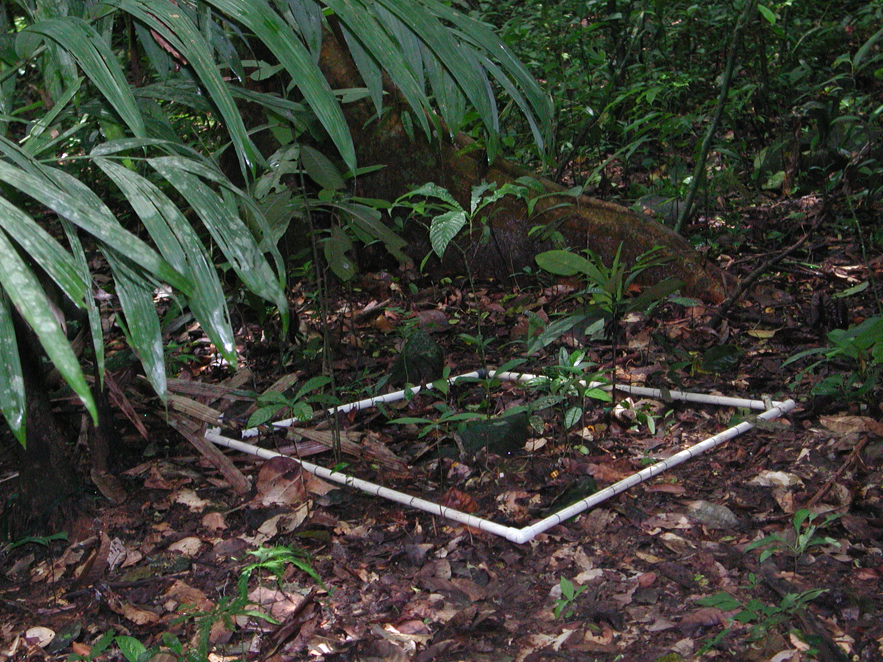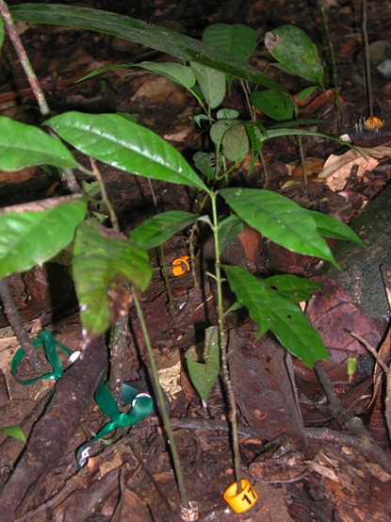
Figure 2. Photo of a 1x1 m seedling plot (with PVC frame placed for sampling) in the BCI 50-ha FDP, and a close up image of seedlings tagged with numbered plastic bands. (Photo credit: Liza Comita)

c. Taxonomy and systematics: Taxonomy follows the BCI 50-ha Plot Taxonomy (Condit et al. 2020). Species were identified in the field by trained field technicians and confirmed by head botanists (R. Perez, S. Aguilar) when necessary, based on Croat (1978) and Correa et al. (2004). A small percentage (~0.3%) of tagged seedlings could not be positively identified and assigned the species code UNKNWN, but these were nearly always seedlings lacking leaves and/or that died before identification could be confirmed by a head botanist. Therefore, they are unlikely to be species that were not already found in the seedling census. There were a few seedlings (<0.06% of all individuals) that were recognized as distinct morphospecies and could be identified in the field to the genus or family level. These were assigned unique species codes, but their species identities were never formally verified. Additional resources related to Panamanian tree and liana species identification and information can be found at https://forestgeo.si.edu/explore-data/flora-panama.

Palm seedlings (family Arecaceae) were excluded from the seedling census because of the difficulty of measuring height growth accurately. Liana seedlings were included in the seedling census if they were not yet climbing on another plant or twining along the forest floor. A list of all the species recorded in the seedling census is included with the data set.

d. Permit history: Permission for this project was granted by the Smithsonian Tropical Research Institute, which grant permits for scientific research in the Barro Colorado Natural Monument. Separate Panamanian government permits are not required for research within the Barro Colorado Natural Monument.

e. Legal/organizational requirements: This project was approved by and registered with the Smithsonian Tropical Research Institute, Panama.

4. Project personnel

Principal investigators: Liza Comita, Stephen Hubbell

Associated investigators (head botanists): Salomón Aguilar, Rolando Pérez

Database managers: Suzanne Lao, Daniel J. Johnson, Ryan Dougherty

Technicians: Eric Manzané, Blexein Contreras, Arturo Morris, Evelyn Sánchez, Diógenes Ibarra, David Brassfield, Jose Rincon, Oldemar Valdés, Irene Torres, Luis Aguilar, Guillermo Aguilar, Antonio Aguilar, Biancolini Castro, Mitzila Gaitan, Roni Saenz, Johana Balbuena, Didimo Urena, Mario Bailon, Fernando Garcia, Oscar López, Pablo Ramos, Osmar Agrazal, Nefertaris Daguerre, Nelson Jaen, Javier Ballesteros.

Class III: Data set status and accessibility

A. Status

1. Latest update: 29 November 2022

2. Latest archive date: 29 November 2022

3. Metadata status: Metadata are complete. The most recent update was on 9 May 2023.

4. Data verification: A thorough inspection of the data was conducted during the data aggregation process when .CSV files were combined for any data entry issues or inconsistences. Lastly, we checked the data before the initial submission to Ecology.

B. Accessibility

1. Storage location and medium:

A static version of this data set is stored as supplementary information with this Ecology Data Paper.

2. Contact persons:
In the event that an error is detected in the data set or for questions about the data set, please contact: Liza S. Comita, School of the Environment, Yale University, New Haven, CT 06511, USA; (email: liza.comita@yale.edu)
3. Copyright restrictions:

This data set can be freely used for non‐commercial purposes.

4. Proprietary restrictions:

We request that users of these data cite this data paper in all publications resulting from the use of this data set.

5. Costs: None

Class IV: Data structural descriptors

A. Data set file

1. Identity: DataS1.zip

2. Size: 8.16 MB when zipped, 68.4 MB when unzipped

3. Format and storage mode: All files are available in comma‐separated values (csv) format.

4. Header information: Variable information detailed in Class IV – B section “Variable information”.

5. Alphanumeric attributes: Mixed

6. Special characters / fields: NA indicates missing data

7. Authentication procedures: N/A

B. Variable information

Table 1. Variable information for “BCI.seedling.census.data.2001.to.2018.csv”. This file contains the information for all seedlings tagged and monitored in 19,313 1-m² plots in 14 censuses, including plot location, seedling measurements, status, and identification.

Variable | Definition | Unit | Data type |  |  |  |  | Data format
 |  |  | Storage type | Codes | Range Min | Range Max | Missing Value | Length | Decimal
ID | Unique ID number for individual seedlings | number | numeric |  | 120001 | 4924440972 | without | up to 11 numbers | 1
plot.x | x-coordinate of the center of the seedling plot in the 50-ha plot in meters east of the southwest corner of the BCI FDP (0,0) | meters | numeric |  | 2.5 | 997.5 | without | up to 4 numbers | 1
plot.y | y-coordinate of the center of the seedling plot in the 50-ha plot in meters north of the southwest corner of the BCI FDP (0,0) | meters | numeric |  | 2.5 | 497.5 | without | up to 4 numbers | 1
plotnum | Unique assigned plot number | whole number | numeric |  | 1 | 20,000 | without | Up to 5 numbers | 0
tag | Tag number in the field (.1 was added in the database for duplicated tags in the same seedling plot) | number | numeric |  | 1 | 9762 | NA | up to 6 numbers | 1
spp | Species code | qualitative | text |  |  |  | without | up to 6 characters
date.mdy | Julian date as MONTH/DAY/YEAR when seedling was measured | qualitative | text |  |  |  | without | up to 10 characters
census | Year that census took place | year | numeric |  | 2001 | 2018 | without | 4 numbers | 0
height | Length of the stem in mm (i.e., height); measured to nearest mm for plants <3000 mm tall; entered as 3000 for plants ≥3000 mm tall | mm | numeric |  | 0 | 3000 | NA | up to 4 numbers | 0
dbh | Diameter of main stem at 1.3 m above ground in mm; measured for plants ≥1.3 m tall | mm | numeric |  | 0 | 75.5 | NA | up to 3 numbers | 1
stems | Number of stems | whole number | numeric |  | 0 | 14 | NA | up to 2 numbers | 0
leaves | Number of leaves; exact count up to 50; entered as 50 for plants with 50-99 leaves, and as 100 for plants with ≥100 leaves | whole number | numeric |  | 0 | 100 | NA | up to 3 numbers | 0
status | Whether a seedling was alive, dead, or had entered main tree or liana census | qualitative | text | A: alive  D: dead or presumed dead  Z: seedling was tagged in the census of trees/lianas ≥1 dbh and is no longer monitored in the seedling census. |  |  | without | 1 character
codes | Codes that aid in seedling status description, separated by semicolons when multiple codes apply | qualitative | text | Ca: Censo de Arboles = seedling now has tag in main tree census (i.e., ≥1 dbh)  Cl: Censo de Lianas = seedling now has tag in main liana census (i.e., ≥1 dbh)  D: dead seedling  E: >50% of leaves with sign of pathogen infection  H: >50% of leaves with herbivore damage  L: leaning/ bent over,  Lb: pinned by fallen branch, Lh: pinned by leaf litter,  Lv: pinned by liana/vine  M: multiple stems (not used in all censuses)  N: nothing found, no tag, no dead stem (presumed dead)  P: problem in the field; most were resolved  Pveg: species considered clonal  R: broken stem/resprouted  Rap: rapidly growing species  S1: code used in 2016 for seedlings that were wilted  S2: code used in 2016 for seedlings totally dried out and almost dead, but not completely dead  T: only tag found (seedling presumed dead)  V: liana/vine that is twining along ground or climbing on another plant  W: previously tagged seedling alive in 2001 that wasn’t remeasured in 2002. Only new recruits were tagged and monitored in the 2002 census |  |  | NA | up to 10 characters

Table 2. Variable information for “BCI.seedling.plot.info.csv”. This file contains a list of all 20,000 1-m² seedling plots established in the BCI 50-ha plot, and whether or not they were consistently censused. Of those plots, 19,313 were regularly censused while 687 were typically skipped to avoid disturbing other long-term research projects located nearby. There are no missing values.

Variable | Definition | Unit | Data type | Range Min | Range Max
plot.number | Unique number assigned to each plot | whole number | numeric | 1 | 20,000
q20 | 20x20 quadrat within the BCI 50-ha FDP | whole number | numeric | 0 | 4924
p5 | 5x5 subquadrat within the 20x20 quadrat (see Fig. 1) | whole number | numeric | 11 | 44
x | x-coordinate of the center of the seedling plot in the 50-ha plot in meters east of the southwest corner of the BCI FDP (0,0) | meters | numeric | 2.5 | 997.5
y | y-coordinate of the center of the seedling plot in the 50-ha plot in meters north of the southwest corner of the BCI FDP (0,0) | meters | numeric | 2.5 | 497.5
censused | 1 = plot censused  0 = plot not censused | whole number | Boolean | 0 | 1

Table 3. Variable information for “BCI.seedling.census.species.list.csv”. This file contains a list of the species encountered in 14 censuses of 19,313 1-m² seedling plots between 2001 and 2018 in the Barro Colorado Island 50-ha Forest Dynamics Plot, Panama.

Variable | Definition | Unit | Data type | Codes | Range Min | Range Max | Miss. Value
spp.code | Six-letter unique species code | qualitative | text |  |  |  | UNKNWN = individual seedlings that were unable to be identified
genus | Genus | qualitative | text |  |  |  | NA
species | Species | qualitative | text |  |  |  | NA
family | Plant family | qualitative | text |  |  |  | NA
growth.form | Plant category based on species architecture | qualitative | text | L = liana,  S = shrub,  U = understory tree, M = midstory tree, T = canopy tree |  |  | NA

Class V. Supplemental descriptors

A. Data acquisition

1. Data forms or acquisition methods: Data were entered directly in the field into handheld computers (initially HP “palmtop” personal digital assistants and later iPads). Seedlings were mapped to the nearest ~5 cm on paper maps in the field to aid in relocating seedlings in future censuses, but those data were not entered into a computer.

2. Location of completed data forms: Original data files are stored on the computer of Liza Comita (and backed up on a Yale University server).

3. Data entry verification procedures: In each census, data sheets were scanned for missing or anomalous values and programs were run to identify values that were outside acceptable ranges for a given variable or, in the case of height, where values were much smaller or larger than in the prior census. In cases where potential errors were identified, measurements were rechecked in the field and corrected if needed.

B. Quality assurance/quality control procedures: The data set was extensively reviewed on multiple occasions throughout the lifetime of the project. Species identifications were updated with the most recent verified species name. Seedlings previously marked as dead in one census but later identified as alive in a subsequent census had their status updated to alive in prior censuses after first verifying it was the same tagged individual (vs a duplicated tag number). We ensured that all individuals were assigned a unique ID number in the database (i.e., no duplicates; any duplicates were resolved by adding .1 to the end of the ID number) and a valid species code. All variables were checked for outliers and corrected if a mistake had clearly been made (e.g., a date outside the range of dates when the census took place in a given year).

C. Related materials: Paper maps are located in the CTFS-ForestGEO office on Barro Colorado Island, Panama.

D. Computer programs and data-processing algorithms: N/A

E. Archiving

1. Archival procedures: online

2. Redundant archival sites: N/A

F. Publications and results: Subsets of this dataset have been used in the following publications: Goldsmith et al. (2006), Comita et al. (2007a), Comita et al. (2007b), Engelbrecht et al. (2007), Comita and Goldsmith (2008), Comita and Engelbrecht (2009), Comita et al. (2009), Comita and Hubbell (2009), Comita et al. (2010), Jones et al. (2011), Comita and Engelbrecht (2014), Zhu et al. (2015), Murphy et al. (2016), Visser et al. (2016), Bruijning et al. (2017), Johnson et al. (2017), Marden et al. (2017), Murphy et al. (2017), Ruger et al. (2018), Stump and Comita (2018), Sugiyama et al. (2018), Visser et al. (2018), Zhu et al. (2018), Marchand et al. (2020), Comita et al. (2023).

G. History of data set usage

1. Data request history: Subsets of this data set were used in the publications listed above.

2. Data set update history: N/A

3. Review history: N/A

4. Questions and comments from secondary users: N/A

Acknowledgments

This material is based upon work supported by the U.S. National Science Foundation under grants no. 0075102, 0823728, 0640386, 1242622, 1464389, and 1845403, primarily through the Long Term Research in Environmental Biology (LTREB) Program. Additional funding was provided by Ohio State University and Yale University. Logistical support was provided by the University of Georgia, the Smithsonian Tropical Research Institute, ForestGEO, and the Center for Tropical Forest Science-Panama. We are indebted to the numerous field technicians who collected the seedling data in this project, including Eric Manzané, Blexein Contreras, Arturo Morris, Evelyn Sánchez, Diógenes Ibarra, David Brassfield, Jose Rincon, Oldemar Valdés, Irene Torres, Luis Aguilar, Guillermo Aguilar, Antonio Aguilar, Biancolini Castro, Mitzila Gaitan, Roni Saenz, Johana Balbuena, Didimo Urena, Mario Bailon, Fernando Garcia, Oscar López, Pablo Ramos, Osmar Agrazal, Nefertaris Daguerre, Nelson Jaen, and Javier Ballesteros. We thank Rick Condit for technical advice, and Suzanne Lao, Daniel J. Johnson, Ryan Dougherty and Luke Browne for assistance with database management.

References

Bruijning, M., M. D. Visser, H. C. Muller-Landau, S. J. Wright, L. S. Comita, S. P. Hubbell, H. de Kroon, E. Jongejans, M. G. Neubert, and A. A. Winn. 2017. Surviving in a cosexual world: a cost-benefit analysis of dioecy in tropical trees. The American Naturalist 189:297–314.
Comita, L. S., S. Aguilar, R. Perez, S. Lao, and S. P. Hubbell. 2007a. Patterns of woody plant species abundance and diversity in the seedling layer of a tropical forest. Journal of Vegetation Science 18:163-174.
Comita, L. S., R. Condit, and S. P. Hubbell. 2007b. Developmental changes in habitat associations of tropical trees. Journal of Ecology 95:482-492.
Comita, L. S., R. P. Dougherty, S. Aguilar, and R. Pérez. 2023. Long-term census of seedlings and small saplings in the Barro Colorado Island 50-ha Forest Dynamics Plot, Panama. In The First 100 Years of Research on Barro Colorado: Plant and Ecosystem Science, H. C. Muller-Landau and S. J. Wright, eds. Smithsonian Institution Scholarly Press, Washington, DC.
Comita, L. S., and B. Engelbrecht. 2014. Drought as a driver of tropical tree species regeneration dynamics and distribution patterns. Pages 261-308 in D. A. Coomes, D. F. R. P. Burslem, and W. D. Simonson, editors. Forests and Global Change. Cambridge University Press, Cambridge.
Comita, L. S., and B. M. J. Engelbrecht. 2009. Seasonal and spatial variation in water availability drive habitat associations in a tropical forest. Ecology 90:2755-2765.
Comita, L. S., and G. R. Goldsmith. 2008. Impact of research trails on seedling dynamics in a tropical forest. Biotropica 40:251-254.
Comita, L. S., G. R. Goldsmith, and S. P. Hubbell. 2009. Intensive research activity alters short-term seedling dynamics in a tropical forest. Ecological Research 24:225-230.
Comita, L. S., and S. P. Hubbell. 2009. Local neighborhood and species' shade tolerance influence survival in a diverse seedling bank. Ecology 90:328-334.
Comita, L. S., H. C. Muller-Landau, S. Aguilar, and S. P. Hubbell. 2010. Asymmetric density dependence shapes species abundances in a tropical tree community. Science 329:330-332.
Condit, R. 1998. Tropical Forest Census Plots. Springer-Verlag, Berlin.
Condit, R., R. Perez, S. Aguilar, S. Lao, and R. Foster. 2019. Complete data from the Barro Colorado 50-ha plot: 423617 trees, 35 years. Dryad, Dataset, https://doi.org/10.15146/5xcp-0d46
Condit, R., R. Perez, S. Aguilar, S. Lao, R. Foster, and S. Hubbell. 2020. BCI 50-ha Plot Taxonomy. Dryad, Dataset, https://doi.org/10.15146/R3FH61
Correa, M. D. A., C. Galdames, and M. Stapt. 2004. Catálogo de las plantas vasculares de Panamá. Quebecor World Bogotá, S.A., Bogotá, Columbia.
Croat, T. B. 1978. Flora of Barro Colorado Island. Stanford University Press, Stanford, CA.
Engelbrecht, B. M. J., L. S. Comita, R. Condit, T. A. Kursar, M. T. Tyree, B. L. Turner, and S. P. Hubbell. 2007. Drought sensitivity shapes species distribution patterns in tropical forests. Nature 447:80-82.
Goldsmith, G. R., L. S. Comita, L. L. Morefield, R. Condit, and S. P. Hubbell. 2006. Long-term research impacts on seedling community structure and composition in a permanent forest plot. Forest Ecology and Management 234:34-39.
Harms, K. E., R. Condit, S. P. Hubbell, and R. B. Foster. 2001. Habitat associations of trees and shrubs in a 50-ha neotropical forest plot. Journal of Ecology 89:947-959.
Hubbell, S., L. Comita, S. Lao, and R. Condit. 2014. Barro Colorado Fifty Hectare Plot Census of Canopy Density, 1983-2012. Smithsonian Research Online, DOI dx.doi.org/10.5479/data.bci20140711.
Hubbell, S. P., and R. B. Foster. 1983. Diversity of canopy trees in a neotropical forest and implications for conservation. Pages 25-41 in S. L. Sutton, T. C. Whitmore, and A. C. Chadwick, editors. Tropical Rain Forest: Ecology and Management. Blackwell Scientific, Oxford.
John, R., J. W. Dalling, K. E. Harms, J. B. Yavitt, R. F. Stallard, M. Mirabello, S. P. Hubbell, R. Valencia, H. Navarrete, M. Vallejo, and R. B. Foster. 2007. Soil nutrients influence spatial distributions of tropical tree species. Proceedings of the National Academy of Sciences of the United States of America 104:864-869.
Johnson, D. J., R. Condit, S. P. Hubbell, and L. S. Comita. 2017. Abiotic niche partitioning and negative density dependence drive tree seedling survival in a tropical forest. Proceedings of the Royal Society B: Biological Sciences 284:20172210.
Jones, F. A., D. L. Erickson, M. A. Bernal, E. Bermingham, W. J. Kress, E. A. Herre, H. C. Muller-Landau, and B. L. Turner. 2011. The roots of diversity: below ground species richness and rooting distributions in a tropical forest revealed by DNA barcodes and inverse modeling. Plos One 6.
Kress, W. J., D. L. Erickson, F. A. Jones, N. G. Swenson, R. Perez, O. Sanjur, and E. Bermingham. 2009. Plant DNA barcodes and a community phylogeny of a tropical forest dynamics plot in Panama. Proceedings of the National Academy of Sciences 106:18621-18626.
Leigh, E. G. J. 1999. Tropical Forest Ecology: A View from Barro Colorado Island. Oxford University Press, Oxford.
Leigh, E. G. J., S. A. Rand, and D. M. Windsor. 1982. The Ecology of a Tropical Forest: Seasonal Rhythms and Long-term Changes. Smithsonian Institution Press, Washington, D. C.
Marchand, P., L. S. Comita, S. J. Wright, R. Condit, S. P. Hubbell, and N. G. Beckman. 2020. Seed-to-seedling transitions exhibit distance-dependent mortality but no strong spacing effects in a Neotropical forest. Ecology 101.
Marden, J. H., S. A. Mangan, M. P. Peterson, E. Wafula, H. W. Fescemyer, J. P. Der, C. W. dePamphilis, and L. S. Comita. 2017. Ecological genomics of tropical trees: how local population size and allelic diversity of resistance genes relate to immune responses, cosusceptibility to pathogens, and negative density dependence. Molecular Ecology 26:2498-2513.
Murphy, S. J., K. Salpeter, and L. S. Comita. 2016. Higher β‐diversity observed for herbs over woody plants is driven by stronger habitat filtering in a tropical understory. Ecology 97:2074-2084.
Murphy, S. J., T. Wiegand, and L. S. Comita. 2017. Distance‐dependent seedling mortality and long‐term spacing dynamics in a neotropical forest community. Ecology Letters 20:1469-1478.
Ruger, N., L. S. Comita, R. Condit, D. Purves, B. Rosenbaum, M. D. Visser, S. J. Wright, and C. Wirth. 2018. Beyond the fast-slow continuum: demographic dimensions structuring a tropical tree community. Ecology Letters 21:1075-1084.
Schnitzer, S. A., S. A. Mangan, J. W. Dalling, C. A. Baldeck, S. P. Hubbell, A. Ledo, H. Muller-Landau, M. F. Tobin, S. Aguilar, D. Brassfield, A. Hernandez, S. Lao, R. Perez, O. Valdes, and S. R. Yorke. 2012. Liana abundance, diversity, and distribution on Barro Colorado Island, Panama. PLoS ONE 7: e52114.
Stump, S. M., and L. S. Comita. 2018. Interspecific variation in conspecific negative density dependence can make species less likely to coexist. Ecology Letters 21:1541-1551.
Sugiyama, A., L. S. Comita, T. Masaki, R. Condit, and S. P. Hubbell. 2018. Resolving the paradox of clumped seed dispersal: positive density and distance dependence in a bat-dispersed species. Ecology 99:2583-2591.
Visser, M. D., M. Bruijning, S. J. Wright, H. C. Muller-Landau, E. Jongejans, L. S. Comita, and H. de Kroon. 2016. Functional traits as predictors of vital rates across the life cycle of tropical trees. Functional Ecology 30:168-180.
Visser, M. D., S. A. Schnitzer, H. C. Muller-Landau, E. Jongejans, H. de Kroon, L. S. Comita, S. P. Hubbell, and S. J. Wright. 2018. Tree species vary widely in their tolerance for liana infestation: A case study of differential host response to generalist parasites. Journal of Ecology 106:781-794.
Windsor, D. M. 1990. Climate and moisture variability in a tropical forest: long-term records from Barro Colorado Island, Panama. Smithsonian Institution Press, Washington, D. C.
Wright, S. J., K. Kitajima, N. J. B. Kraft, P. B. Reich, I. J. Wright, D. E. Bunker, R. Condit, J. W. Dalling, S. J. Davies, S. Diaz, B. M. J. Engelbrecht, K. E. Harms, S. P. Hubbell, C. O. Marks, M. C. Ruiz-Jaen, C. M. Salvador, and A. E. Zanne. 2010. Functional traits and the growth-mortality trade-off in tropical trees. Ecology 91:3664-3674.
Zhu, Y., L. S. Comita, S. P. Hubbell, and K. P. Ma. 2015. Conspecific and phylogenetic density-dependent survival differs across life stages in a tropical forest. Journal of Ecology 103:957-966.
Zhu, Y., S. A. Queenborough, R. Condit, S. P. Hubbell, K. P. Ma, and L. S. Comita. 2018. Density-dependent survival varies with species life-history strategy in a tropical forest. Ecology Letters 21:506-515.

