Integrating resilience from individual to community
Hung-wei Lin, September 2026

1 Question
Resilience is a property that can be read at more than one level of biological organisation, and the readings need not agree. For example, a drought may lower some vital rates of plant individuals while their population growth rate persists, or suppress some populations while total community cover remains stable. This project measures resilience at all three levels (i.e., individual, population & community) in one system, from the same data, with one model, and asks what governs each reading.
Q1. When factors at every level are considered together, which of them governs how strongly an individual, a population, and the whole community respond to environmental change?
The candidates are the individual's own size, life-history traits of its populations, and the density of conspecific and heterospecific neighbours (intraspecific and interspecific interaction). Ideally, we should measure the environment both as the microsite a plant occupies and as the climate of the year.
Q2. Do the strengths of conspecific and heterospecific effects shift with environmental conditions, and does that shifting raise the resilience of the community?
Q2 can be answered by holding those strengths fixed and recomputing the resilience measures under different scenarios. (see example diagram below)
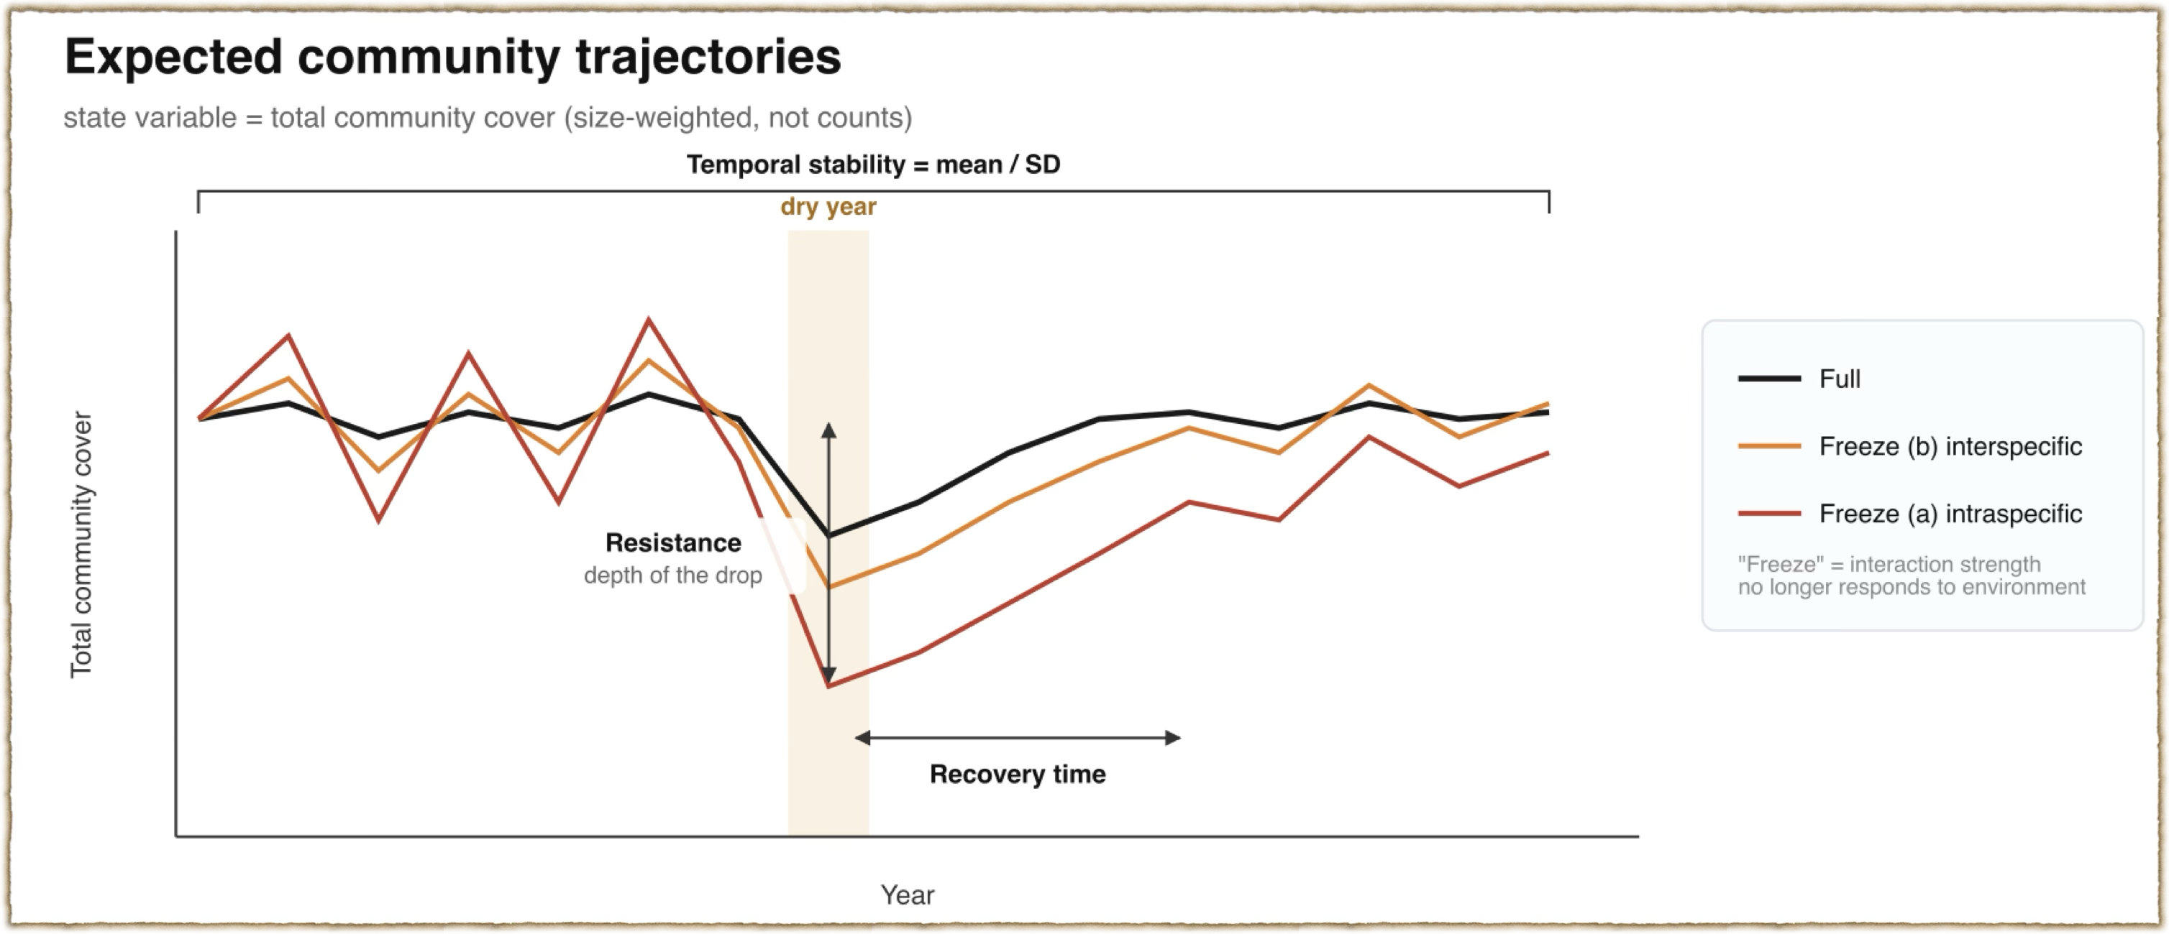

2 State variable of resilience at each level
Level | What responds
Individual | Survival, growth, flowering and seed production of one plant
Population | The growth rate of one species / Total cover summed over all individuals
Community | Total cover summed over all species / species composition
The three readings come from one fitted object. Four vital rates are modelled jointly for every plant in every year, so the same coefficients propagate upward: integrating over the size distribution gives the population measures, and summing populations gives total cover and its behaviour across years.
The counterfactual in Q2 works on that same object. A fitted model is re-run with one feature removed — the dependence of neighbour effects on the environment — and the resilience measures are recomputed. The difference between the two runs is the amount of resilience attributable to that feature. The same procedure can be pointed at any other component, which is what makes it the tool for Q1 as well as Q2.

3 The model
All four vital rates are fitted together in a hierarchical model. Species-level coefficients are drawn toward a regression on a life-history axis, so that species differences are expressed through traits. Individual size, microsite and neighbour densities enter the linear predictor. Annual climate enters both on its own and in interaction with the neighbour terms.
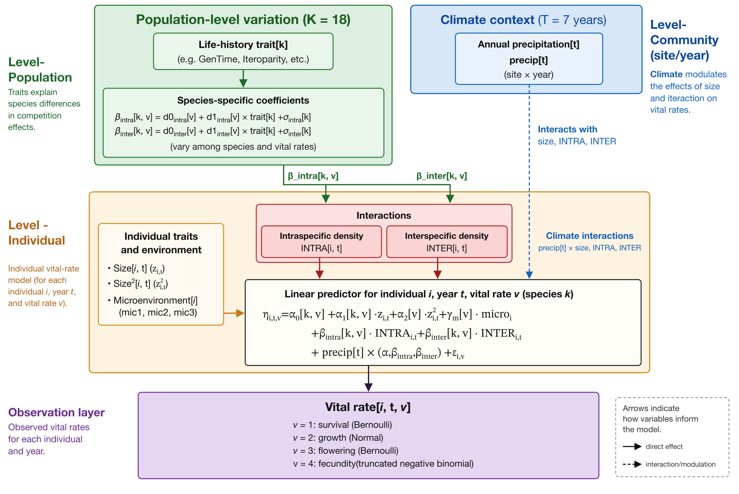

4 Data required
The table lists the data I hope to obtain.
Carries | Quantity
Individual factor | Size, and all the vital rates of each individual every year
Individual factor | Position in the plot, and site-wide coordinates recovered from the constant per-plot offset
Population factor | Thirty mean functional traits per species (optional), in case I did not find a best life-history trait
Micro environment | 27-layer raster at 10 cm resolution
Macro environment | Site climate by year: precipitation, air and soil temperature, soil water, radiation
Macro environment | A multi-decadal record, so each year can be placed as a departure from a long-term mean (optional)

5 Contingency plan
The focus of Q2 will initially be on the contribution of time-varying intraspecific and interspecific interactions to community resilience, as I consider these two mechanisms to provide important links between individuals and populations, and between populations and communities. However, if the results indicate that these interactions are relatively insensitive to environmental conditions and make only a limited contribution to resilience, I can instead use counterfactual simulations of community dynamics to investigate the consequences of fixing other factors that show significant effects in the model. These could include differences among individuals or populations, as well as temporal variation. This alternative approach would still allow me to examine how different factors operating from the individual to community level contribute to community resilience.

