Exercise 1: Layered model

Model

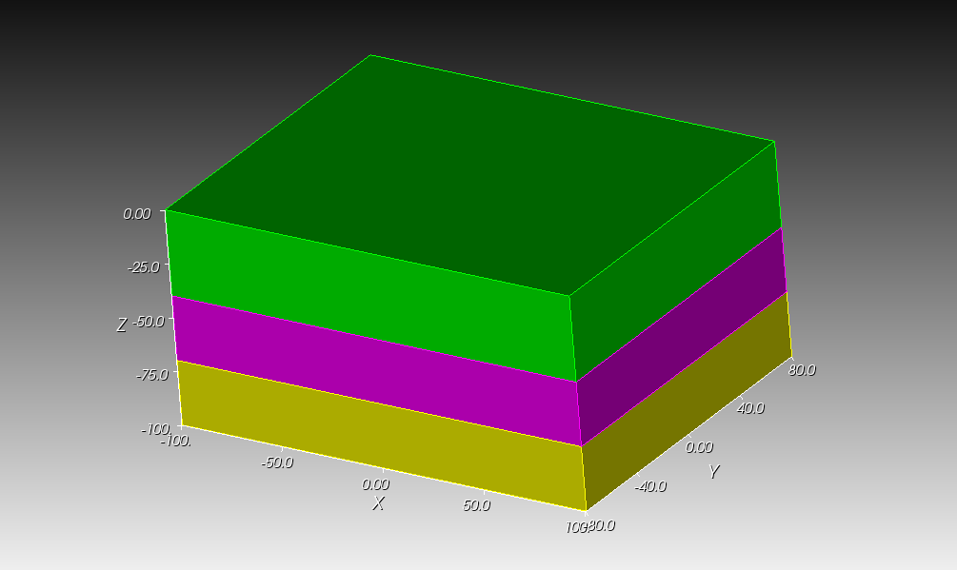

This model of size 200 X 160 X 100 consists of three geological layers. Two interfaces are located at z = -70 and z = -40, respectively.

Task

- Create a brick of size 200 X 160 X 100. Transform the brick to appropriate position.
- Use webcut operation to create layers.
- Define different mesh sizes in three layers, and mesh the model. What do you see?
- Delete all meshes, and use commands: imprint all and merge all.
- Redefine the uniform mesh size of 10.
- Mesh the model. How is it different from previous mesh?
- Check mesh quality.
- Assuming velocity decreases from bottom to top, gradually refine the mesh in top two layers. How can you decrease slenderness of the elements?
- Define mesh blocks and surface side sets.

Learning points: Always use commands imprint all and merge all before meshing. Always check mesh quality
Exercise 2: Finite fault

Model

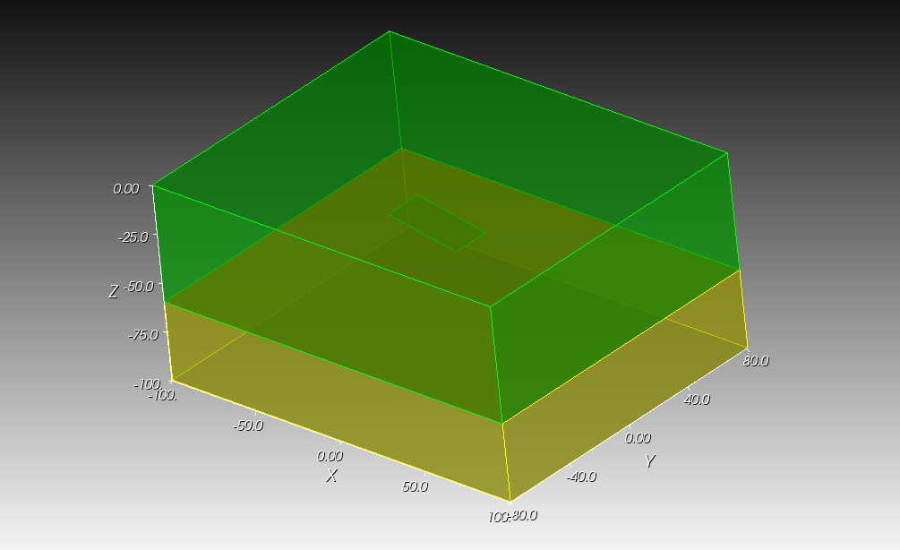
This model of size 200 X 160 X 100 consists of two layers. The layer interface is located at z = -60. A fault plane of size 40 X 20 is located at (0, 0, -30). The fault has a dip of 10° along X-axis.

Task

- Create a brick of size 200 X 160 X 100.
- Use webcut operation to create layers.
- Create fault plane of size 40 X 20 and rotate to appropriate angle.
- Use subtract operation to embed fault plane on the top layer.
- Define appropriate mesh size, and mesh the model. What happens?
- Use fault plane and its lines to webcut top layer into simple volumes.
- Mesh the model and check mesh quality.
- Define mesh blocks and surface side sets.

Learning points: Hexahedral meshing is not always automatic. Complex volumes have to be broken down into simpler volumes.
Exercise 3: Salt model

Model
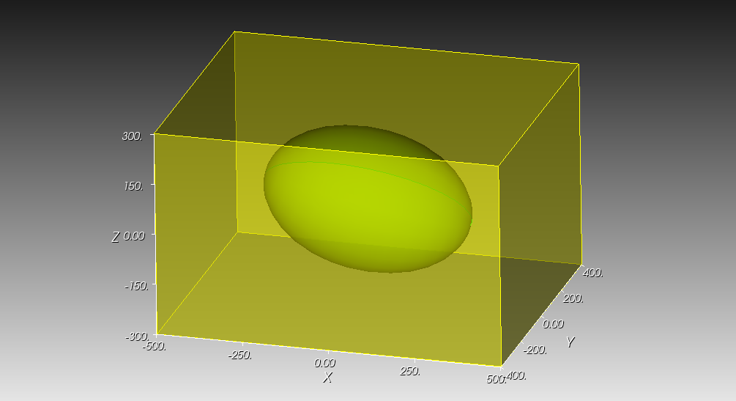
This model of size 1000 X 800 X 600 consists of an ellipsoidal salt body. The ellipsoid is centrally located and has a major radius of 300 and minor radius 200. It is inclined at angle of 10° with X axis.

Task

- Create a brick of size 1000 X 800 X 600.
- Create an ellipsoid of major and minor radii of 300 and 200, respectively. Rotate the ellipsoid at angle of 10°.
- Use subtract operation to embed the ellipsoid on the brick.
- Use “webcut” operation to create layers.
- Define appropriate mesh size, and mesh the model. What happens? Try different mesh schemes.
- Design a suitable strategy, use webcut operations, and mesh the model.
- Check mesh quality.
- Define mesh blocks and surface side sets.

Learning points: Embedding objects. Using different mesh schemes.
Exercise 4: Laboratory scale cylindrical sample

Model
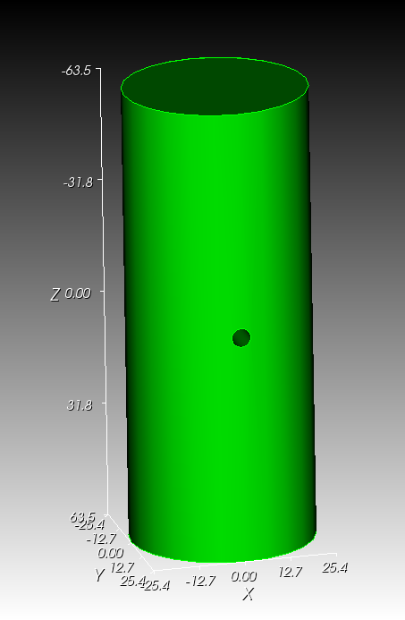
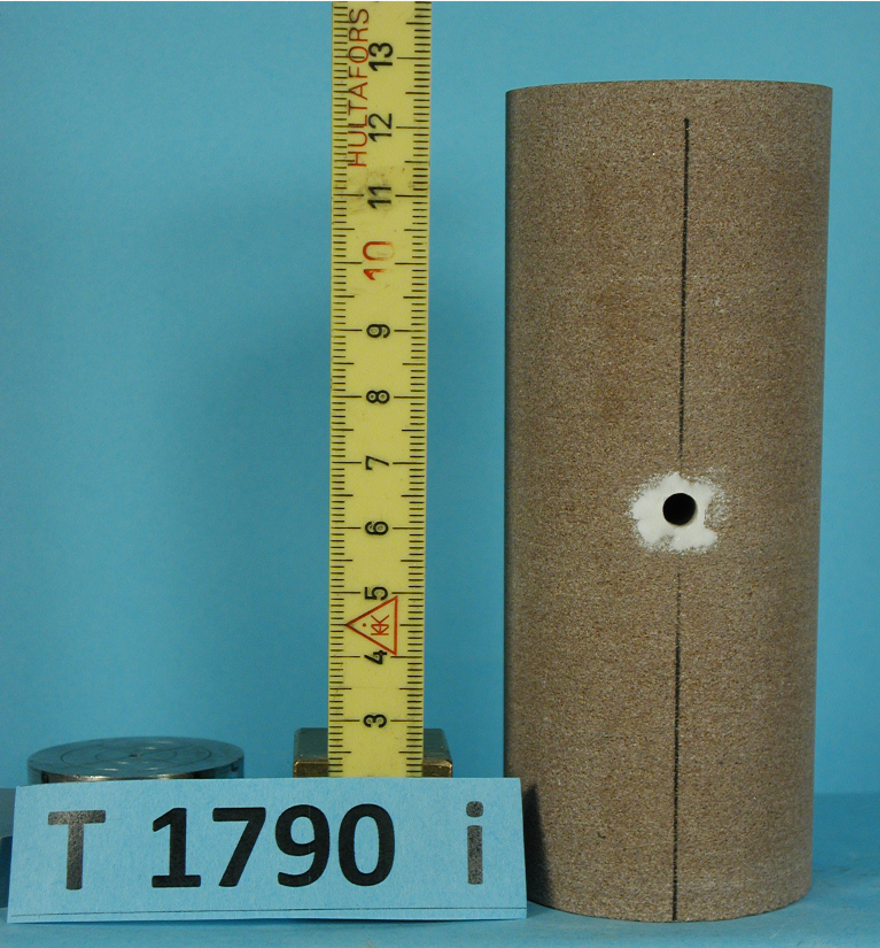

This actual sandstone laboratory sample has height of 127 and radius of 25.4. A borehole of 2.6 radius is drilled through the center.

Task

- Create a cylinder of height 127 and radius 25.4.
- Create a cylinder of height 60 (or > 50.8. Why?) and radius 2.6. Rotate to appropriate orientation.
- Use subtract operation to embed borehole.
- Define appropriate mesh size, and mesh the model. What happens? Try different mesh schemes.
- Use webcut operation to simplify volumes.
- How can you take advantage of symmetry for efficient meshing?
- Mesh the model. Check mesh quality.
- Define mesh blocks and surface side sets.

Learning points: Creating cavities. Taking advantage of symmetry of the model. Using copy operation.

Exercise 5: Mountain model

Model
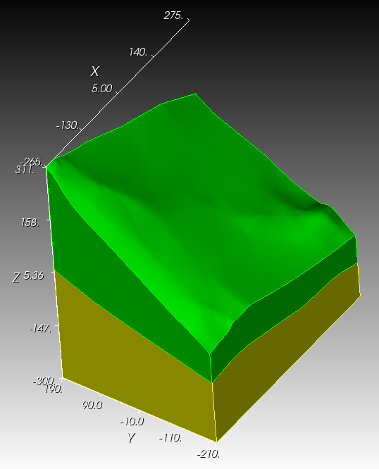
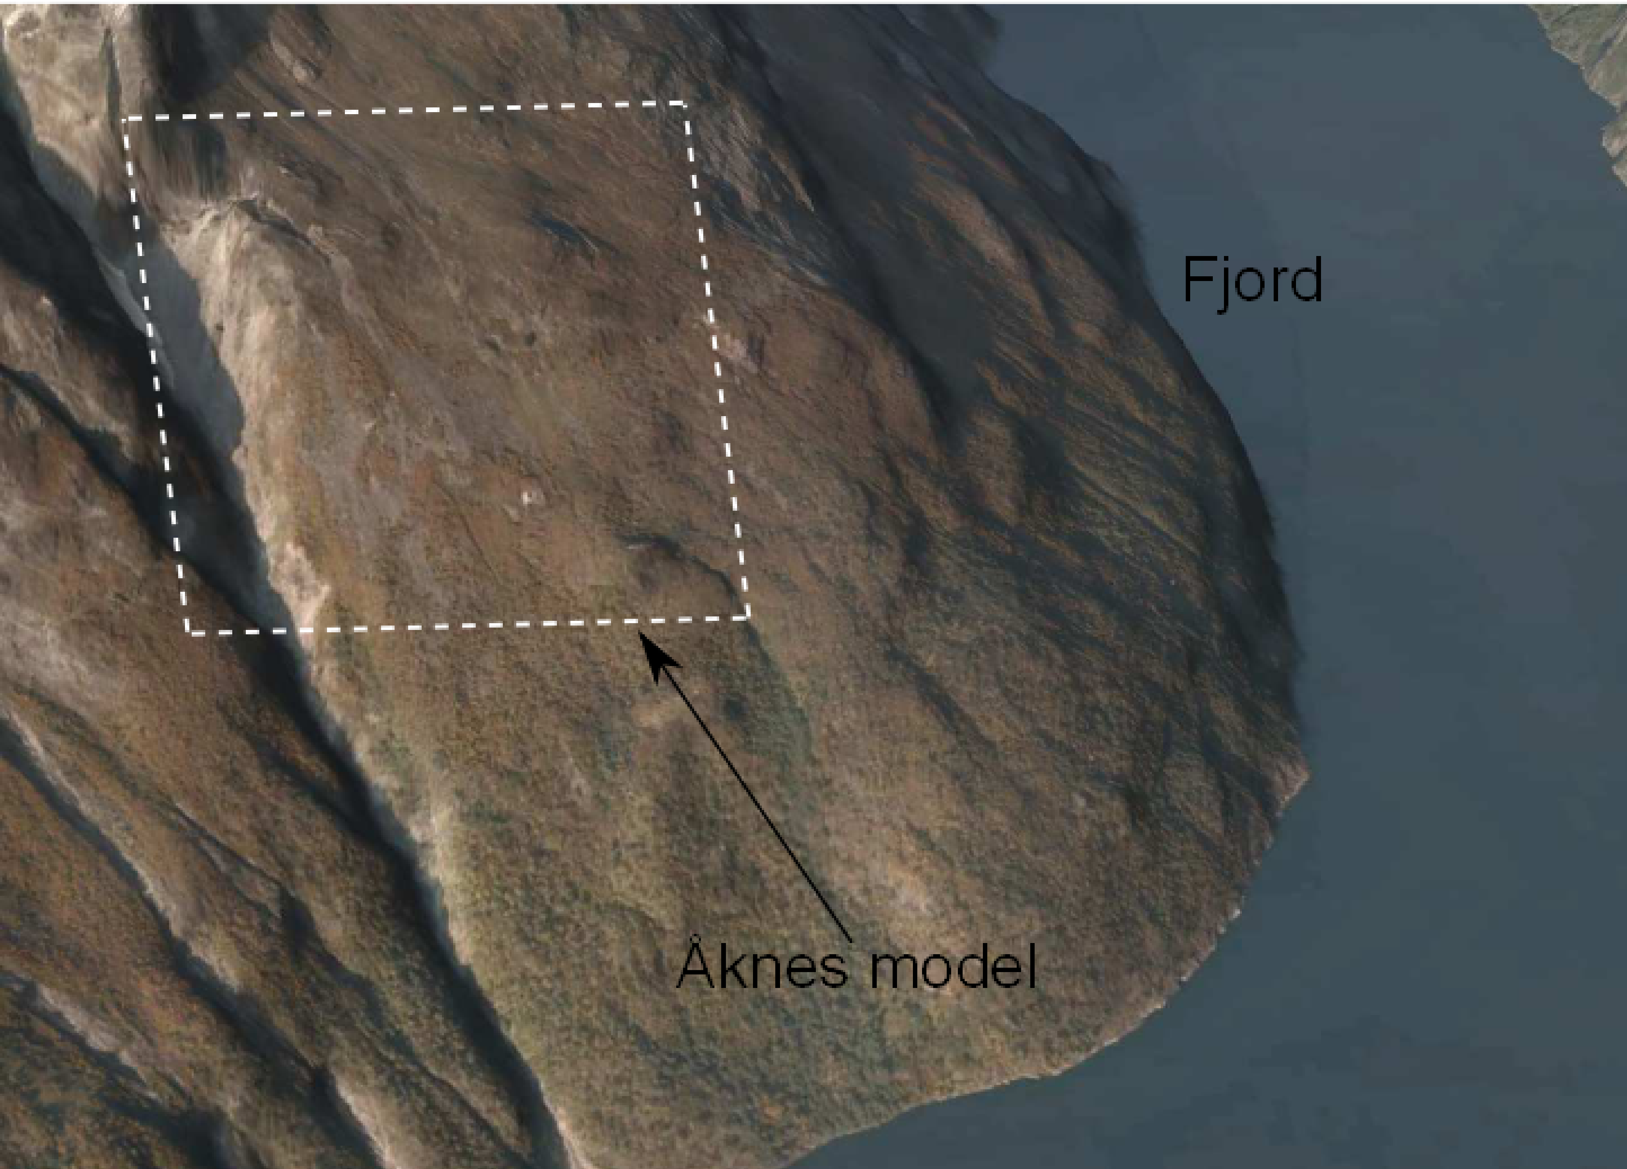

This mountain model consists of two layers. Topography and interface are provided in the files mountain_topography.stl and mountain_interface.stl, respectively.

Task

- Import two files mountain_topography.stl and mountain_interface.stl. What do you see? What geometry engines each surface belong to?
- Build a model from these two surfaces. What happens?
- Create ACIS geometry engine surfaces from existing surfaces. Build a model. If necessary use webcut operation.
- Delete mesh size. Select appropriate mesh schemes, and mesh the model.
- Define mesh blocks and surface side sets.

Learning points: Importing models. Observing the advantage and disadvantage of different geometry engines. Converting to ACIS geometry engine. Using general surface for webcut operation.

