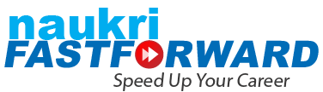

Steps to Set Up your Profile

***Note: Content to update your LinkedIn Profile is provided after the Steps to update LinkedIn.***

LinkedIn is a powerful platform for networking, job opportunities, and personal branding. It connects professionals globally, helping them showcase their skills, share insights, and stay updated on industry trends. For job seekers and recruiters, LinkedIn streamlines hiring processes, making it a go-to for career growth and recruitment. Additionally, LinkedIn aids businesses in lead generation and reaching targeted audiences, supporting both individual and organizational success.

**Register at LinkedIn.** :

* Go to the LinkedIn **sign-up** page.
* Enter your **first and last name, email address**, and **create a password**.
* **Verify** your email address.
* Add more details to your profile, including photos and experience.

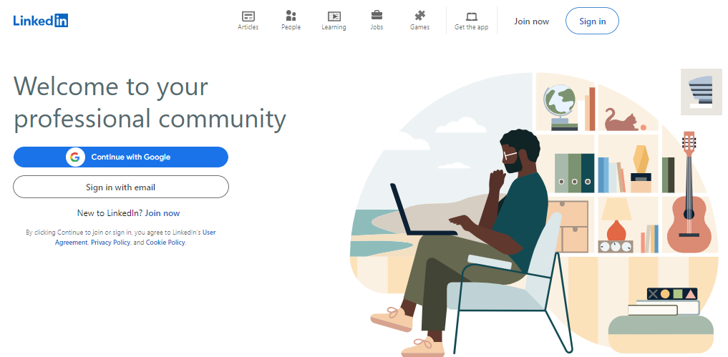

Click here to **Sign in**

**LinkedIn Page:** Your LinkedIn homepage would look similar to the following sample.

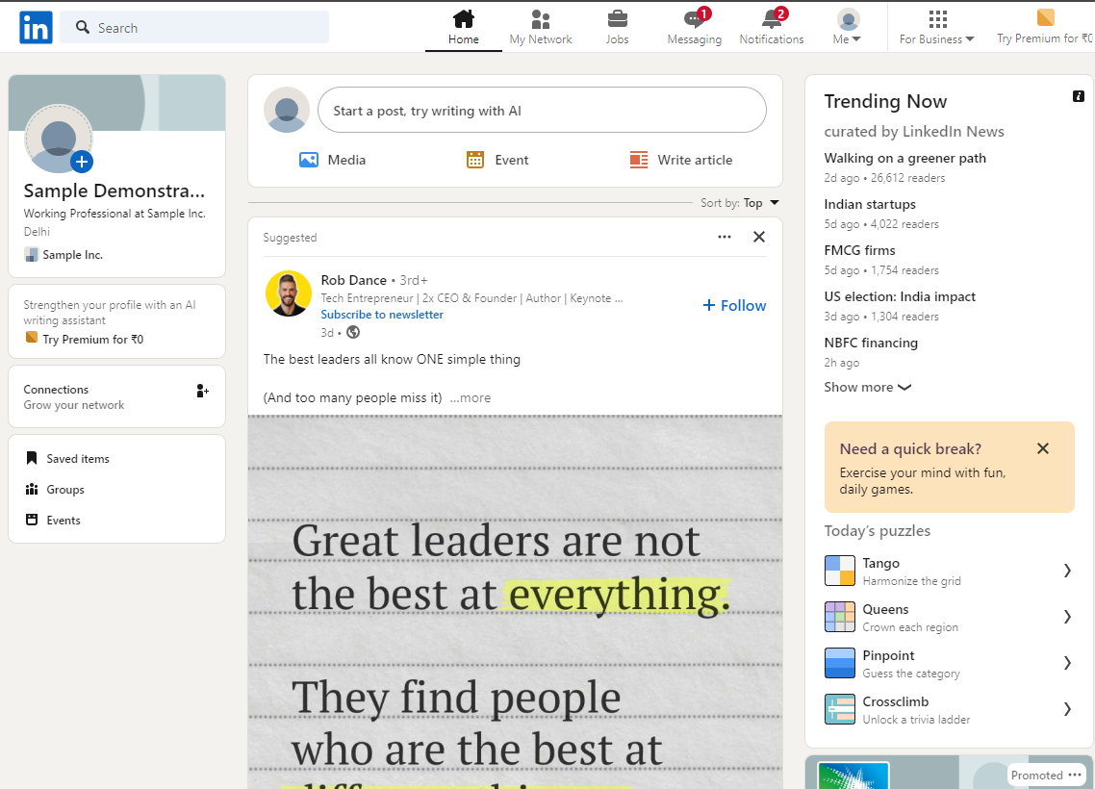

**The “Me” tab:** This is the sixth tab from left after the search option. The **"Me"** tab on LinkedIn is your personal profile menu. It provides quick access to settings, account management, and other profile options. Click on it and view your profile.



The “Me” tab, **Click here**

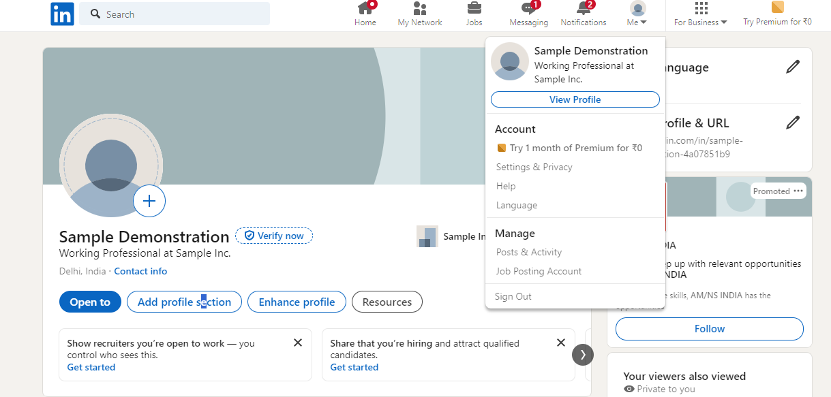

The “View Profile” tab, **Click here**

**Add Profile Section:**

The **Add Profile Section** on LinkedIn allows you to enrich your profile with essential details such as **Experience**, **Education**, **Skills**, and **Accomplishments**. This feature highlights your background and achievements, making your profile more appealing to recruiters and connections. The sections are organized into three main categories—**Core**, **Recommended**, and **Additional**—each containing specific sub-sections, as illustrated in the image below.

Here, you will be able to edit various sections such as About, Education, Skills etc.

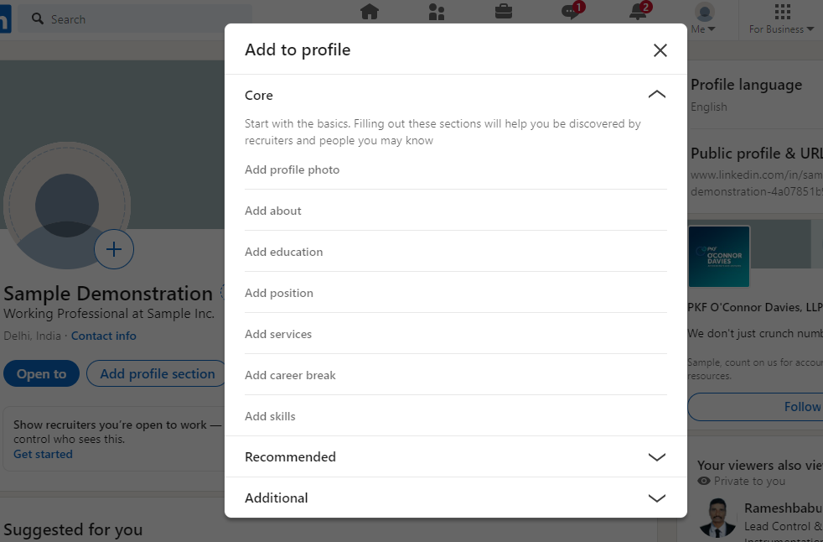

Here, you will be able to edit various sections such as Licenses & Courses etc.

Here, you will be able to edit various sections such as Volunteer Experience, Publications, Projects, Honors & Awards, Languages etc.

You may click or upload your picture here to represent yourself to other people on LinkedIn. It is always suggested to put a photo.

|  |  |  |
| --- | --- | --- |
| **CORE** | **RECOMMENDED** | **ADDITIONAL** |

**Add Resume Draft:** The following are the steps to upload the resume,

* Open LinkedIn, click on the **"Me"** icon at the top right, and select **Setting & Privacy**.
* On the left hand side under **Setting**, Click on **Data Privacy**
* Scroll down to find **Job Seeking Preference**, click on **Job Application Settings**.
* Click on **Upload Resume**

|  |  |
| --- | --- |
| **1** | **2** |
|  |  |
| **3** | **4** |

**EDUCATION: (Me > View Profile > Add Profile Section > Core > Add Education)**

It is important to fill this section, because companies may have minimum education requirements for their roles. Additionally, in case the recruiter knows about your institute or is an alumni also, by chance, then it can help your chances.

***Note****:* *You can refer to the Education section in your resume to fill up information in this segments*

|  |  |
| --- | --- |
|  |  |

**WORK EXPERIENCE: (Me > View Profile > Add Profile Section > Core > Add Position)**

***Note:*** *You can refer to the Work Experience section in your resume to fill up information in this segment. The order in which you enter the information does not matter as LinkedIn re-arranges it from most recent to oldest.*

|  |  |
| --- | --- |
|  |  |

|  |  |
| --- | --- |
| **SKILLS: (Me > View Profile > Add Profile Section > Core > Add Skills)**  It is important to adds the right skills, since recruiters often search for candidates based on the skills required in the position they are looking to fill. | **LICENCES & CERTIFICATIONS: (Me > View Profile > Add Profile Section > Recommended > Add Licenses & Certifications)**  Be sure to mention any relevant certifications you have, be sure to show it. |

|  |  |
| --- | --- |
| **COURSES: (Me > View Profile > Add Profile Section > Recommended > Add Courses)**  Adding courses to your LinkedIn profile can enhance your professional presence and make you more attractive to recruiters and connections. | **PROJECTS: (Me > View Profile > Add Profile Section > Recommended > Add Projects)**  Adding project details gives an idea of specific knowledge and skills you have, and exactly how you have used them. |

**RECOMMENDATIONS: (Me > View Profile > Add Profile Section > Additional > Add Recommendations)**

Here are a few polished examples of recommendations:

* "[Name] excelled in [add an accomplishment]. His/Her role included [add task one] and [add task two], and he/she consistently ensure their KPIs are updated and adhered to, helping me understand what went well and what could be improved. I am confident that [Name] will achieve great things in their career."
* "I’m continually impressed by [Name]'s ability to [add a skill], a talent he/she leverage effectively when preparing and presenting to clients and colleagues. With laser-like focus and an analytical mindset, his/her energy was infectious, driving us toward major goals."
* "[Name] is exceptional at [add a skill]. Organized, meticulous, and a fast learner, these traits were invaluable when [add something the person did]. His/Her quick grasp of market dynamics allowed him/her to strategically choose the best path forward. It was a pleasure working alongside [Name]."

|  |  |
| --- | --- |
| **HONORS & AWARDS: (Me > View Profile > Add Profile Section > Additional > Add Honors & Awards)** | **LANGUAGES: (Me > View Profile > Add Profile Section > Additional > Add Languages)** |

**DISCLAIMER:**

* **Maintaining Compliance and Privacy**: To ensure strict adherence to compliance standards and safeguard your privacy, we are unable to directly update or modify your LinkedIn profile on your behalf.
* **Optimizing Contact Information**: Enhance your LinkedIn presence by updating your contact details, including your phone number and email address. This will make it easier for others to discover and connect with you on the platform.

**CONTENT FOR UPDATING YOUR LINKEDIN PROFILE**

**About**

Hello! I am an experienced Product Developer with over 3 years of expertise in designing, developing, and deploying innovative software solutions, particularly in the education sector. My journey has been centered around creating impactful features that cater to client needs within a B2B startup environment. I possess strong technical leadership skills in full-stack software development, including API development and integration, and have successfully led teams through the entire development cycle while balancing client expectations with technical feasibility.

I excel in defining and communicating product vision and strategy, conducting market analysis, and developing product roadmaps. My proficiency in building relationships with key stakeholders ensures alignment with product strategy and delivery goals. I am passionate about developing growth strategies that enhance user acquisition, engagement, and retention. My experience includes managing product backlogs, ensuring timely delivery of high-quality features, and continuously improving business processes to drive product success.

Key Achievements:

- Launched a Payroll feature that generated INR 500k in revenue within six months, significantly contributing to company growth.

- Reduced overhead costs by 15% through the implementation of a cloud-based management system, benefiting over 30 schools.

- Increased user engagement by 30% through the deployment of over 50 APIs, enhancing platform functionality.

- Awarded the title of Top Fellow during the Product Management Fellowship, distinguishing myself among over 350 participants.

- Spearheaded the optimization of existing APIs, resulting in a 30% increase in performance and cost savings for the organization.

**Education**

School: NextLeap

Degree: Product Management Fellowship

Field of Study: Product Management

Start Year: Jan 2024

End Year: May 2024

Grade: [Please Mention]

Activities and societies: Recognized as Top Fellow for outstanding performance among over 350 students. Successfully completed weekly product management projects covering key areas like problem definition, user research, ideation, validation, metric-based decision-making, and solution development.

School: Vidyavardhini College of Engineering and Technology

Degree: Bachelor of Engineering (BE)

Field of Study: Engineering

Start Year: Jun 2017

End Year: Aug 2021

Grade: CGPA 8.35/10.00

Activities and societies: [Please Mention]

**Work Experience**

Title: Product Developer

Employment Type: Full-time

Company name: Newton Classroom

Location: Hyderabad

Location Type: [Please Mention]

Start date: Nov 2023

End Date: Present

Description: In my current role as a Product Developer at Newton Classroom, I engage with educational institutions to gather insights on user requirements and translate these needs into actionable product features. I collaborate with cross-functional teams to design and implement scalable backend systems that support over 20,000 users across multiple schools. My responsibilities include leading the development of APIs for functionalities such as payroll, attendance, and transportation, conducting user research to refine product features, and managing the product backlog to prioritize features based on user feedback and business objectives. I also facilitate communication between technical teams and stakeholders to ensure clarity on project goals and deliverables.

Achievements: I successfully launched a Payroll feature that generated INR 500k in revenue within six months, significantly contributing to the company's growth. Additionally, I enhanced operational efficiency by reducing overhead costs by 15% through a cloud-based management system, benefiting over 30 schools. My efforts led to a 30% increase in user engagement through the deployment of over 50 APIs, and I was recognized for outstanding performance as the Top Fellow during the Product Management Fellowship. Furthermore, I spearheaded the optimization of existing APIs, resulting in a 30% increase in performance and notable cost savings for the organization.

Title: Software Engineer

Employment Type: Full-time

Company name: Capgemini

Location: Pune

Location Type: [Please Mention]

Start date: Sep 2021

End Date: Nov 2023

Description: As a Software Engineer at Capgemini, I spearheaded the development of over 10 APIs, establishing core backend functionality for client products. I overhauled more than 3 reusable UI components, which accelerated development velocity by 30% while optimizing user experience. My role involved orchestrating cross-functional collaboration to refine BOM creation processes and streamline quoting workflows using Infor CPQ.

Achievements: My contributions led to significant improvements in development efficiency and user experience. The APIs I developed formed the backbone of the client product, enabling seamless functionality and enhancing overall performance. My efforts in optimizing UI components resulted in a marked increase in development speed, allowing the team to deliver high-quality solutions more rapidly.

**Skills**

Product Strategy

Product Roadmap

Backlog Management

Agile Methodology

Scrum Framework

User Stories

Cross-functional Collaboration

Stakeholder Management

Feature Prioritization

Market Research

Product Lifecycle Management

Product Development

Product Launch

Client Engagement

Requirements Gathering

Product Innovation

Customer Experience (CX)

Data-Driven Decision Making

UX/UI Collaboration

Risk Management

**License & Certification**

Name: Product Management Fellowship

Issuing organization: NextLeap

Issue Date: Jan 2024

Expiration Date: [Please Mention]

Credential ID: [Please Mention]

Credential URL: [Please Mention]

**Courses**

Course Name: Product Management Fellowship

Number: [Please Mention]

Associated with: NextLeap

**Projects**

Project Name: Newton - Cloud-based K-12 Management System

Description: Engineered a cloud-based K-12 management system “Newton” for Indian educators, enhancing operational efficiency and user engagement across multiple educational institutions.

**Honors & Awards**

Title: Top Fellow

Associated with: Product Management Fellowship

Issuer: NextLeap

Issue Date: [Please Mention]

Description: Recognized for outstanding performance among over 350 participants during the Product Management Fellowship, demonstrating exceptional skills in product management and development.

**Languages**

Language: [Please Mention]

Proficiency: [Please Mention]