**6Ⅹ6 pattern data collection using SerialEM with large beam-image shift**

Equipment: FEI Titan Krios with K2 submit camera and FEI Talos Artica with K2 submit camera

SerialEM version: 3.6.22

Only for micro-array holey grids (e.g. Quantifoil, Cflat, GiG, cryoMatrix et al.)

**0**. Go through the steps 1 to 4 in the excel file “stigma_coma_fitting_protocol”.

**1.** Move to the selected grid square, adjust to stage Z to the eucentric height, and do montage for the whole square.

**2.** Add point at the center of every 6Ⅹ6 pattern as the protocol figure 1.

To properly identify each 6Ⅹ6 pattern, polygon can be added to separate the area of each 6Ⅹ6 pattern.

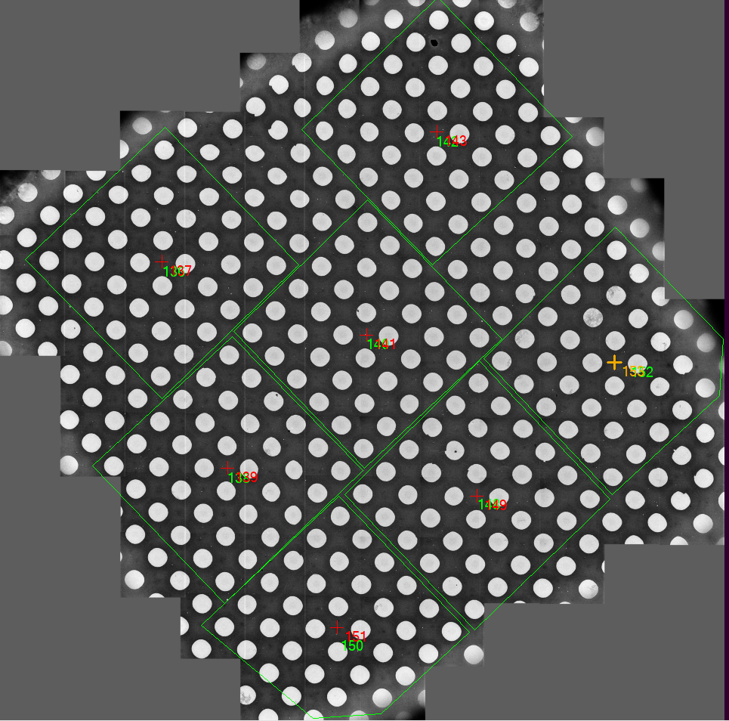

**Protocol figure 1.** SerialEM montage of one grid square. Each 6Ⅹ6 pattern was highlighted in green polygon. The center of each 6Ⅹ6 pattern was marked with one point.

**3.** run and edit the script “6_6_preparation” to make sure the data can be collected at the center of each hole. The main editions are listed in protocol figure 2. Copy the well edited script clauses of position definition from script “6_6_preparation” to script “6_6”.



**Protocol figure 2.**  The parameters in SerialEM scripts “6_6” and “6_6_preparation” to control the data collection positions in each 6Ⅹ6 pattern. The color-coated areas (blue, green, red and purple) represent the control clauses in script and the equivalent data collection positions in the montage image. The orange color-coated values can be modified to make sure the image data can be taken in the designed positions. The script “6_6_preparation” which carries the same script clauses of position definition as the script “6_6” helps to modify the orange color-coated values by imaging the data collection position in low-magnification View mode.

**4.**  Run SerialEM script “6_6” for 6Ⅹ6 pattern data collection. The defocus range can be changed at parameters “MinDefocus” and “MaxDefocus” in this script.

**No fix pattern data collection using SerialEM with large beam-image shift**

Equipment: FEI Titan Krios with K2 submit camera and FEI Talos Artica with K2 submit camera

SerialEM version: 3.6.22

Available for all kinds of grids including lacy, micro-array holey grids.

**0.**  Go through the steps 1 to 4 in the excel file “stigma_coma_fitting_protocol”.

**1.**  Move to the selected grid square, adjust to stage Z to the eucentric height, and do montage for the whole square.

**2.**  Add points manually or automatically to the positions where the image data would like to be collected as the protocol figure 3.

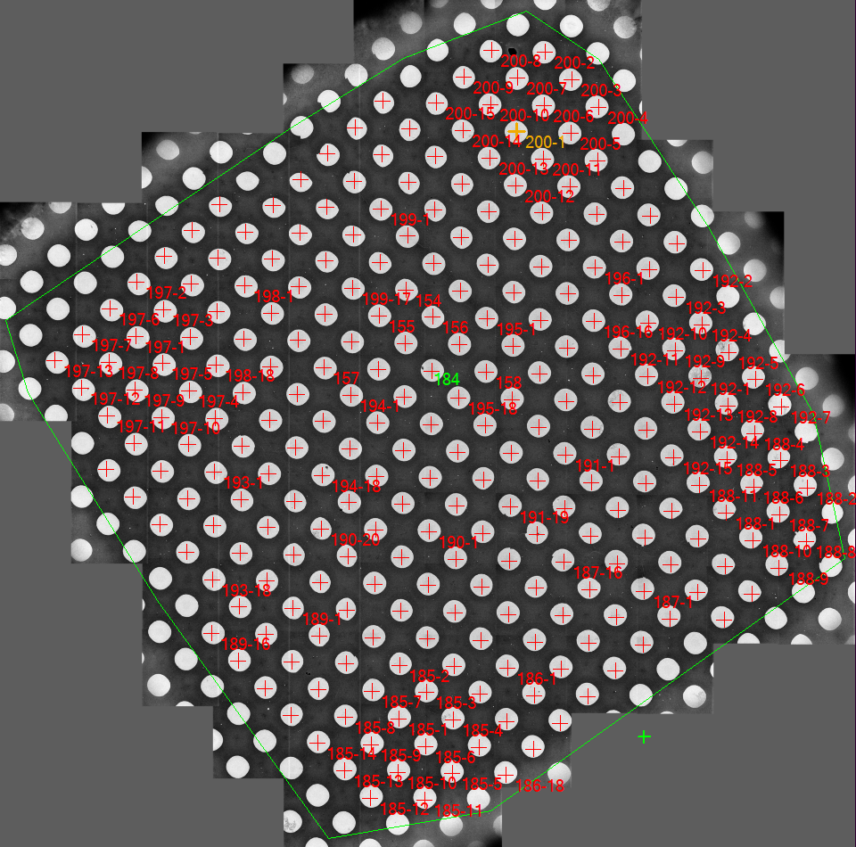

**Protocol figure 3.** SerialEM montage of one grid square. Each designed position was added as one acquisition point which was marked in red.

**3.**  use the python3 script “Nav_edit” to edit the navigator file with all the added points. The purpose of this edition is to add note “1” or “2” to each point and only add marker “A” to the first point of each group. See Protocol figure 4 for more details.



**Protocol figure 4.** The function of python3 script “Nav_edit”. Input file name of the navigator file with all points added, the output navigator file, the start and the end point number. Select option “acquire focus” in the orange rectangle. Depending on the method of point addition, choose option “manual_pick” or “auto_pick” in the green rectangle. Then click button “edit Nav file” in red rectangle to finish the edition. After edition, note “1” and marker “A” were added to the first point of each group, while note “2” was added to the other points of each group.

**4.**  Run SerialEM script “data_collection_free”. The defocus range can be changed at parameters “MinDefocus” and “MaxDefocus” in this script.