CSC212: Practical 1, Term 3
Name: Miguel Wentzel
Student no: 4478677
Course: CSC212
Year: 2026

B(1) Worst-case running time
Algorithm 1: O(n²). For each positive element, a sequential search may examine up to all n elements to find its negative. In the worst case this gives n searches of up to n elements, so the running time is O(n²).
Algorithm 2: O(n). The two indices move through the sorted array from opposite ends. On each iteration either i increases or j decreases, so the total number of movements is at most proportional to n.

B(2) Which algorithm is more efficient?

Algorithm 2 is more efficient in terms of asymptotic running time because it is O(n), whereas Algorithm 1 is O(n²).

B(3) Runtime in seconds
Input 1:
Algorithm 1: 0.01806024 s
Algorithm 2: 0.001527631 s
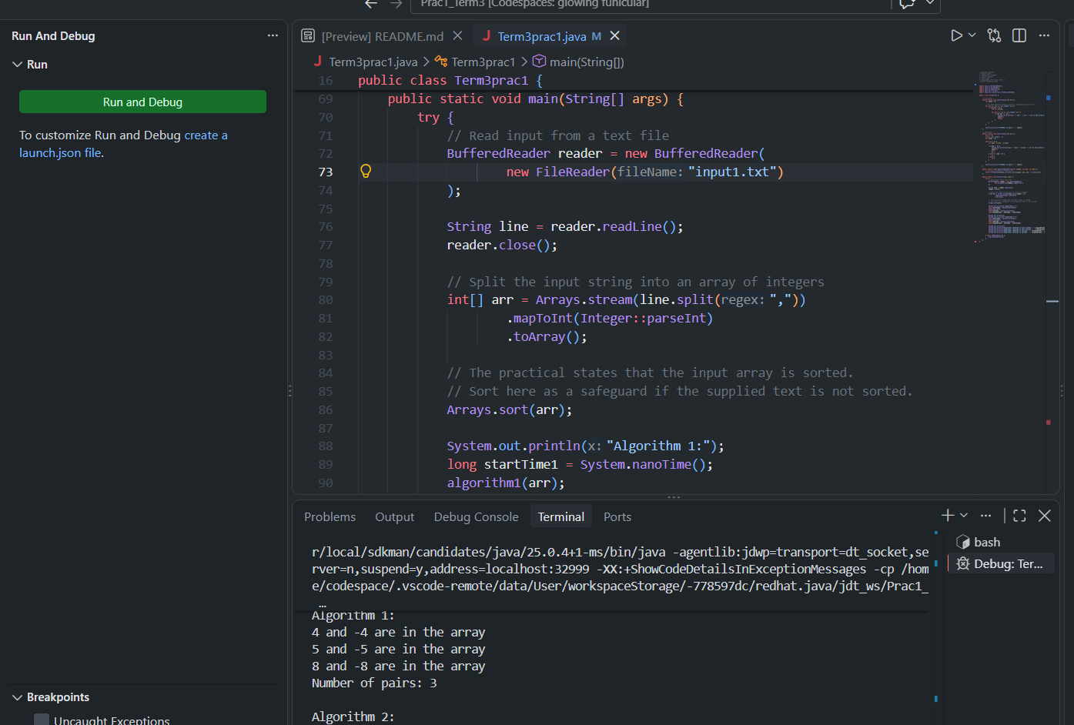
Pairs: 3

Input 2:
Algorithm 1: 0.008417252 s
Algorithm 2: 0.001623319 s
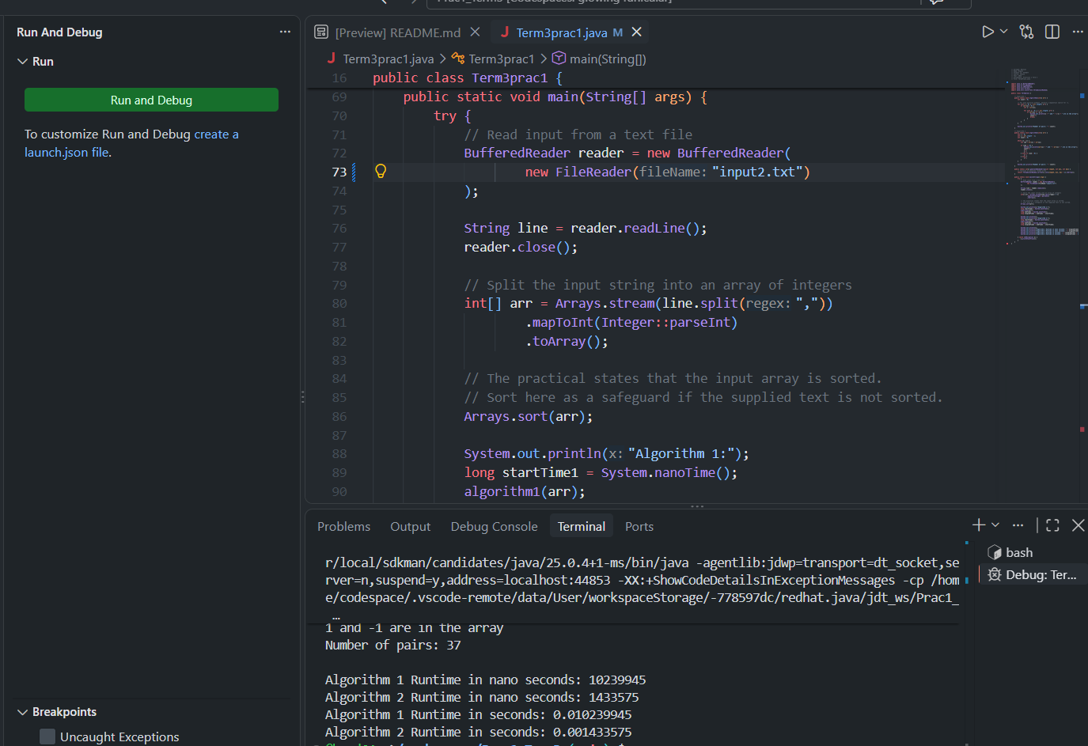
Pairs: 37

B(4) Does the runtime support B(2)?
Yes. The results support B(2) because Algorithm 2 has a shorter runtime than Algorithm 1 for the tested inputs. This agrees with the theoretical analysis that Algorithm 2 is O(n), while Algorithm 1 is O(n²). Therefore, Algorithm 2 is more efficient, especially as the input size increases.

B(5) Random input sizes, tables and graph
Algorithm 1
Input size | Runtime (seconds)
400 | 0.002636081
800 | 0.003033023
1 600 | 0.003282520
3 200 | 0.003839376
6 400 | 0.004775495
12 800 | 0.011425382
25 600 | 0.052765580
51 200 | 0.169481271

Algorithm 2
Input size | Runtime (seconds)
400 | 0.000019376
800 | 0.000030146
1 600 | 0.000052759
3 200 | 0.000057427
6 400 | 0.000171320
12 800 | 0.000311381
25 600 | 0.000617232
51 200 | 0.001175374

Graph Growth Rate
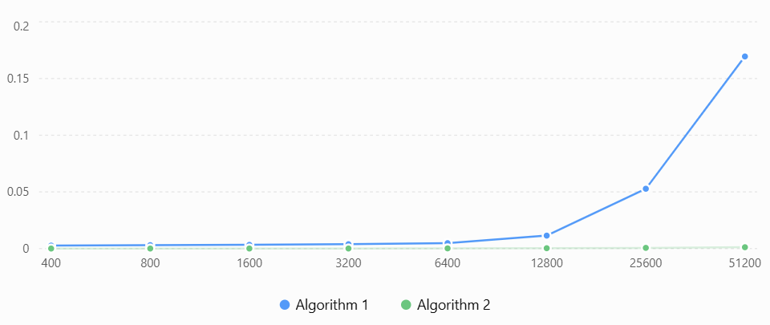

B(6) Growth-rate explanation
The graph shows that Algorithm 1 increases much faster as the input size increases. This is consistent with its O(n²) growth rate because it uses a sequential search for each positive element. Algorithm 2 increases much more slowly because its two-pointer approach has an O(n) growth rate. The runtime results therefore show the difference in growth between the two algorithms, especially for larger input sizes.

