**NAME (write legibly):**___________________________________

**ECE3056A: Power Extra Credit:** This is an OPTIONAL homework, worth 2 points of your course grade. You will not be penalized if you choose not to submit. This question WILL be graded and you will receive points only for correct answers. Turn in a HARDCOPY during class on Monday (17th Nov)

Note: This question spans two pages (graphs are provided with each sub-question for your benefit).

We have three workloads: A, B, and C. A is completely serial. B has 50% serial portion followed by 50% code that is perfectly parallelizable. C is 100% parallelizable. We have a uniprocessor machine M1 that runs at 1GHz. This machine consumes a power of 100 watts, out of which 25 watts is leakage power. All three programs have an execution time of one second on M1. As power is 100W, the energy consumption for all the three workloads would be 100 WattSec, or equivalently 100 Joules, as shown below.

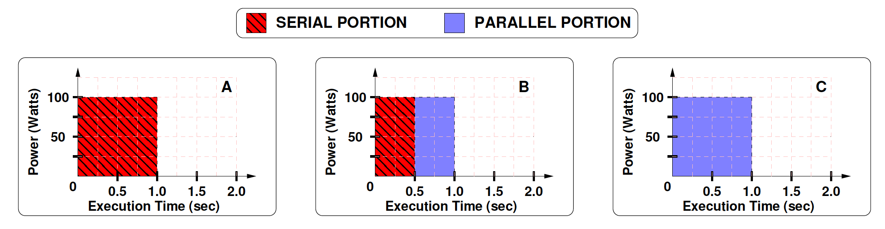

We are considering a dual core machine M2 that consists of cores identical to that of M1. To maintain a power budget of 100W, M2 divides the power budget equally between the two cores. (Note: Given that each core continues to consume 25W of leakage power, the total active power is now reduced from 75W for M1 to 50W for M2).

1. What is the new frequency when both cores are in operation? _0.693GHz____

Assume we do not have design resources to implement any power gating, or clock gating, or DVFS on M2.

What is the execution time and energy consumption with M2?

|  |  |  |  |
| --- | --- | --- | --- |
| M2 | A | B | C |
| Execution Time (sec) | 1.442 | 1.082 | 0.721 |
| Energy (Joules) | 144.2 | 108.2 | 72.1 |

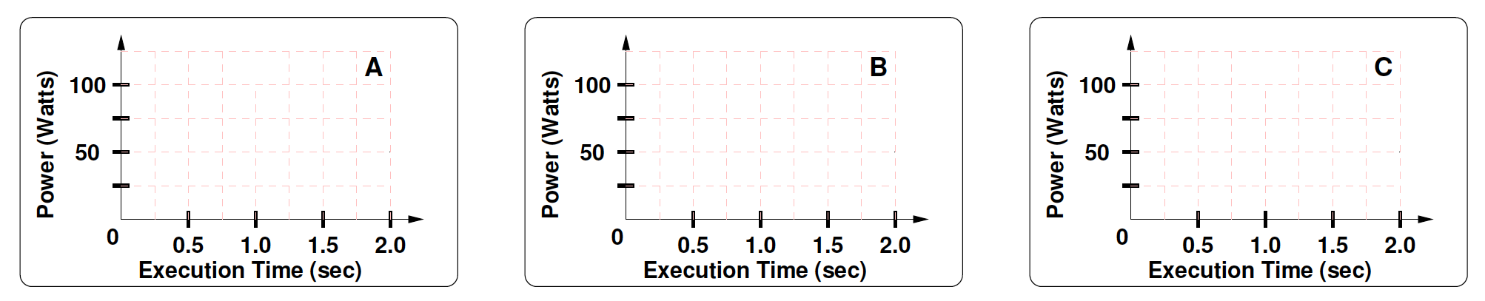

1. Now assume that we have clock gating. When we clock gate the inactive core, we continue to operate the active core at the frequency determined in (1). What is the average power and energy consumed with M2?

|  |  |  |  |
| --- | --- | --- | --- |
| M2 | A | B | C |
| Average Power (Watts) | 75 | 83.3 | 100 |
| Energy (Joules) | 108.2 | 90.13 | 72.1 |



1. Now for (2) assume that we use the power saved from clock gating of the inactive core to increase the frequency of the active core. What is the frequency of the active core, when the other is inactive? _0.87358GHz____

What is the execution time, and energy with M2? (Note: power remains constant at 100Watts).

|  |  |  |  |
| --- | --- | --- | --- |
| M2 | A | B | C |
| Execution Time (sec) | 1.145 | 0.933 | 0.721 |
| Energy (Joules) | 114.5 | 93.3 | 72.1 |



1. Now assume we have power gating. When we power gate the inactive core, we continue to operate the active core at the frequency determined in (1). What is the average power and energy consumed with M2?

|  |  |  |  |
| --- | --- | --- | --- |
| M2 | A | B | C |
| Average Power (Watts) | 50 | 66.63 | 100 |
| Energy (Joules) | 72.1 | 72.1 | 72.1 |



1. Now for (4) assume that we use the power saved from power gating of the inactive core to increase the frequency of the active core. What is the frequency of the active core, when the other is inactive? __1GHz___

What is the execution time, and energy consumption with M2? Note: The power remains constant at 100W.

|  |  |  |  |
| --- | --- | --- | --- |
| M2 | A | B | C |
| Execution Time (sec) | 1 | 0.861 | 0.721 |
| Energy (Joules) | 100 | 86.1 | 72.1 |

