From a Crop's Environmental Fingerprint to Global Yield Trends
An exploratory, inferential and multivariate analysis of Smart-Farming agro-environmental data

Final Project — Analysis and Visualization of Complex Agro-Environmental Data (2372)
GreenDS MSc · Instituto Superior de Agronomia, Universidade de Lisboa · 2025/2026

Aster Noel Dsouza · 29211
David Heleno Bebiano da Costa Morais · 29400

Datasets: Crop Recommendation (Kaggle) · Crop Yield (Kaggle) · OECD/FAO crop production

Contents
Contents 2
1. Introduction 3
1.1 Questions and working hypotheses 3
1.2 Objectives 3
2. Database description 4
3. Exploratory data analysis 5
3.1 Preprocessing and data quality 5
3.2 Univariate analysis 6
3.3 Bivariate analysis, correlation and outliers 7
3.4 Statistical inference — estimation and bootstrapping 8
3.5 Hypothesis testing 9
3.6 Multivariate analysis — PCA, LDA and clustering 10
3.7 Geographical and temporal patterns (real FAO/OECD data) 12
4. Discussion and conclusions 14
5. References 14
Annex — Python code and AI-usage declaration 16

1. Introduction
Deciding what to grow and understanding how productive it will be are two of the oldest questions in agriculture, and both are fundamentally agro-environmental: a crop thrives only where soil chemistry and climate fall within its tolerances, and the yield it ultimately delivers depends on management, geography and a changing climate. This project treats those questions as a data-analysis problem. Rather than building predictive models (the focus of our parallel Applied Machine Learning project), here we follow the analysis-and-visualization workflow of this course — questions, data preparation, summary statistics, exploratory analysis, inferential statistics and a final visual narrative — to tell a coherent story from complex agro-environmental data.
We combine three datasets that span scales from the individual plot to the planet. A Crop Recommendation dataset records the soil nutrients and local climate associated with 22 crops, letting us characterise the environmental “fingerprint” of each crop. A large synthetic Crop Yield dataset lets us probe which management and site factors are associated with productivity. Finally, a real FAO/OECD dataset of national crop yields adds the geographical and temporal dimension that agro-environmental analysis demands, covering 48 countries and the period 1990–2025.

1.1 Questions and working hypotheses
The analysis is organised around three linked questions, each with a testable hypothesis:
- Q1 — Environmental requirements. Do the major crop groups (cereals, pulses, fruits, commercial crops) occupy distinct, separable regions of soil–climate space? H1: their mean nutrient and climate requirements differ significantly.
- Q2 — Drivers of yield. In the crop-yield data, which factors are associated with higher yield? H2: management variables (irrigation, fertiliser) are associated with yield, beyond site descriptors such as soil type or region.
- Q3 — Geographical and temporal patterns. How have real national crop yields changed over time and how do they vary across regions? H3: yields have risen significantly since 1990 and differ significantly between world regions.

1.2 Objectives
The objective is to demonstrate the full toolkit of the course on a single coherent theme: clean and describe the data; characterise distributions and relationships through univariate and bivariate analysis; quantify uncertainty with estimation and resampling; test the hypotheses with appropriate parametric and non-parametric methods; reduce dimensionality and reveal structure with PCA, LDA and clustering; and communicate the findings through clear static and interactive visualisations. Throughout, chart design follows the balance advocated by Alberto Cairo’s “visualization wheel” (favouring functionality, density and familiarity over decoration), so that each figure is read quickly and honestly.

2. Database description
Crop Recommendation (core). 2,200 observations described by seven numeric soil and climate variables — nitrogen (N), phosphorus (P) and potassium (K) in kg/ha, temperature (°C), relative humidity (%), soil pH and rainfall (mm) — and a label naming one of 22 crops. The classes are perfectly balanced (100 rows each), with no missing values and no duplicate rows, which makes it an ideal, clean substrate for multivariate analysis. For group-level analysis we map the 22 crops onto four agronomic groups: cereals (200), pulses (700), fruits (1000) and commercial crops (300).
Variable (unit) | Mean | SD | Min | Max | Skew | Distribution
N (kg/ha) | 50.5 | 36.9 | 0.0 | 140.0 | 0.51 | non-normal
P (kg/ha) | 53.4 | 33.0 | 5.0 | 145.0 | 1.01 | non-normal
K (kg/ha) | 48.1 | 50.6 | 5.0 | 205.0 | 2.37 | non-normal
temperature (°C) | 25.6 | 5.1 | 8.8 | 43.7 | 0.18 | non-normal
humidity (%) | 71.5 | 22.3 | 14.3 | 100.0 | -1.09 | non-normal
ph (pH) | 6.5 | 0.8 | 3.5 | 9.9 | 0.28 | non-normal
rainfall (mm) | 103.5 | 55.0 | 20.2 | 298.6 | 0.97 | non-normal
Table 1. Descriptive statistics of the seven predictors in the Crop Recommendation dataset (n = 2,200).
OECD/FAO crop production (geographical & temporal). After keeping yield records (t/ha), 6,826 country–crop–year observations remain, covering 48 reporting entities, four staple crops (maize, rice, wheat, soybean) and the years 1990–2025. Five entries are regional aggregates (e.g. WLD, EU28) which we use as reference series but exclude from country-level comparisons.
Crop Yield (supporting, synthetic). 60,000 rows with four categorical descriptors (region, soil type, crop, weather), two management flags (irrigation, fertiliser) and three numeric variables, mapping to a yield in t/ha. The only data-quality defect is 13 physically impossible negative yields (0.022%), addressed in §3.1. Being synthetic, it is treated cautiously and used only to illustrate categorical hypothesis testing.

3. Exploratory data analysis
This chapter is the analytical core. It moves from data cleaning and single-variable description, through relationships and formal hypothesis tests, to multivariate structure and finally to geographical and temporal patterns in real data.
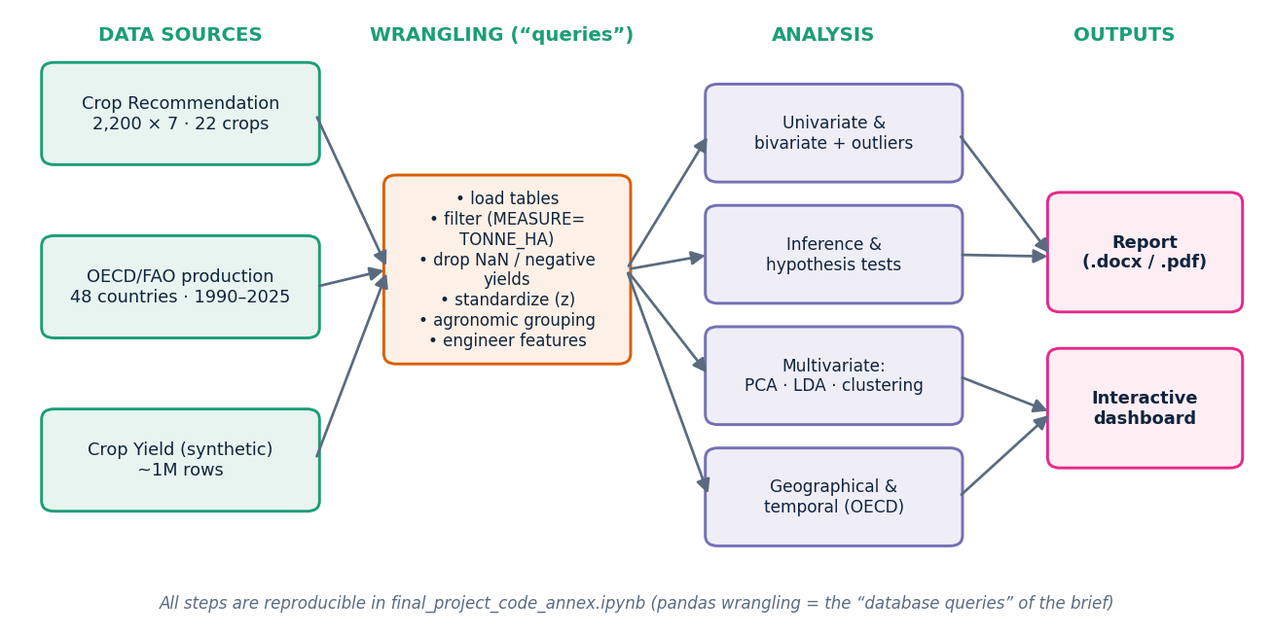
Figure 1. Analysis pipeline: three data sources are wrangled (the project’s “database queries”, performed in pandas) into a clean analytical table, then passed through four families of methods to the report and dashboard.

3.1 Preprocessing and data quality
Data preparation followed the pipeline in Figure 1. Each source was loaded, the OECD table filtered to yield records (MEASURE = TONNE_HA) and reshaped, missing and impossible values dropped, the predictors standardized, and the 22 crops mapped onto four agronomic groups. These pandas operations are the equivalent of the database queries and wrangling step required by the brief; no separate SQL database was needed because the sources are flat CSV files.
The clean Crop Recommendation table needed no imputation. The synthetic Crop Yield table, by contrast, contained 13 negative yields — an artefact of the Gaussian noise used to generate it. Because a negative harvest is physically meaningless we removed those rows (Figure 2) and engineered a rainfall-intensity feature, rain-per-day = rainfall ÷ days-to-harvest, which is more physical than total rainfall alone.
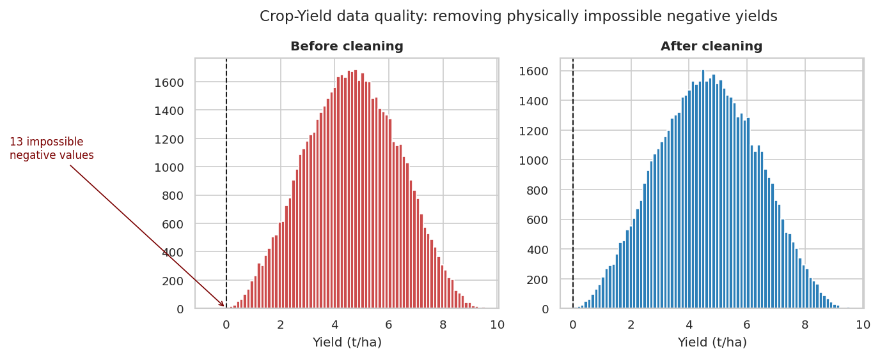
Figure 2. Distribution of synthetic crop yield before and after removing physically impossible negative values.

3.2 Univariate analysis
The seven predictors show markedly different shapes (Figure 3). Potassium is strongly right-skewed (skew = 2.37) because a few fruit crops require very high K; humidity is left-skewed (skew = -1.09), bunching toward saturation; pH is the most symmetric. A D’Agostino–Pearson omnibus test rejects normality for all 7 variables (p < 0.001 in every case). This is expected — each variable mixes 22 crop-specific modes — and it justifies using rank-based, non-parametric tests alongside the parametric ones later.
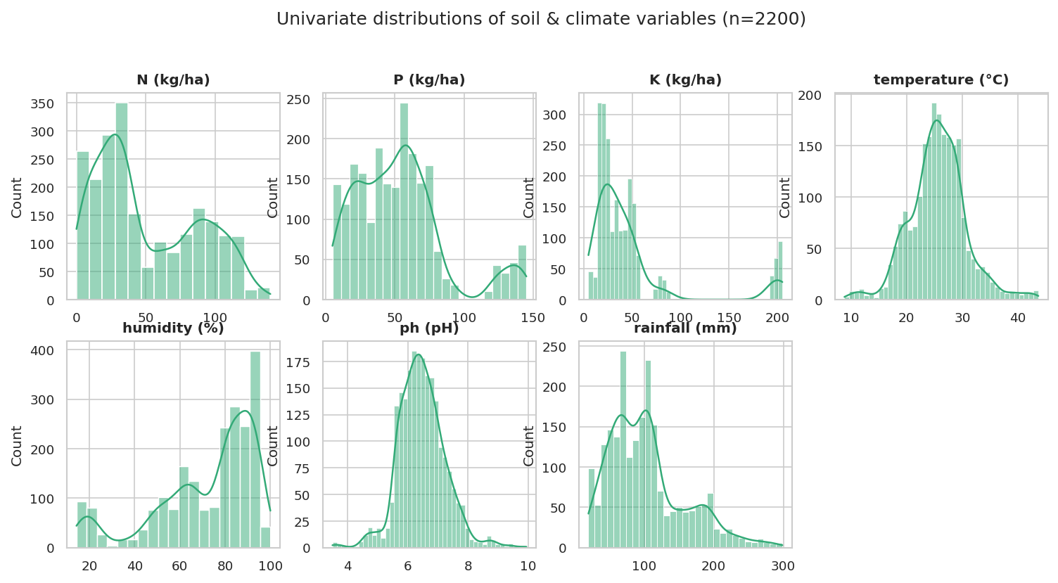
Figure 3. Histograms with kernel-density overlays for the seven soil and climate variables.
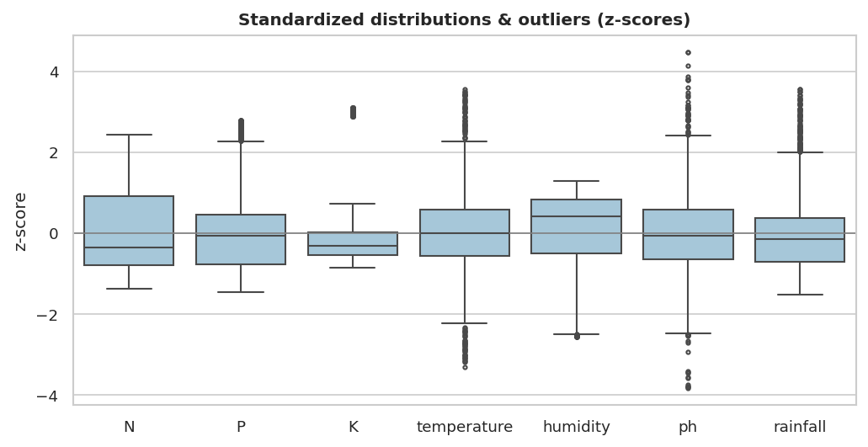
Figure 4. Standardized (z-score) box plots, showing spread and outliers on a common scale.

3.3 Bivariate analysis, correlation and outliers
Across the seven predictors only one strong linear relationship stands out: phosphorus and potassium (P–K) correlate at r = 0.74 (Figure 5), consistent with their shared role as fertiliser macronutrients applied together. Every other pair is weak (|r| < 0.25), so the variables largely carry independent information — a useful property for the dimensionality reduction in §3.6. Colouring the P–K and humidity–rainfall planes by crop group (Figure 6) already reveals separation: a compact high-P/high-K cloud of fruits sits apart from the rest.
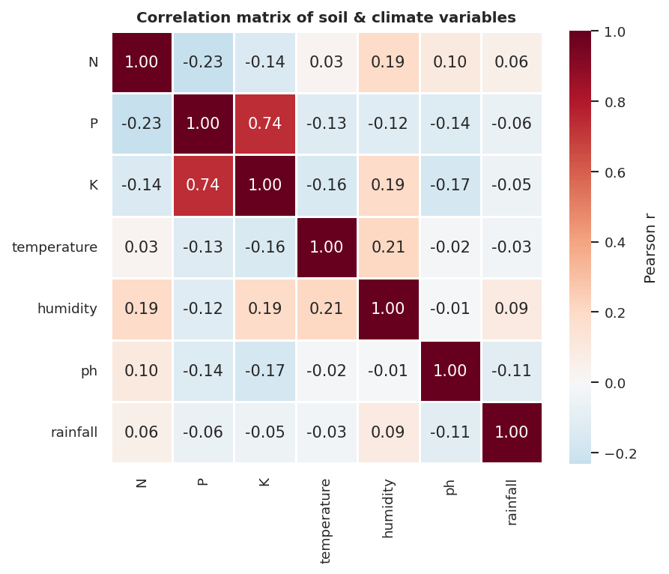
Figure 5. Pearson correlation matrix of the seven predictors.
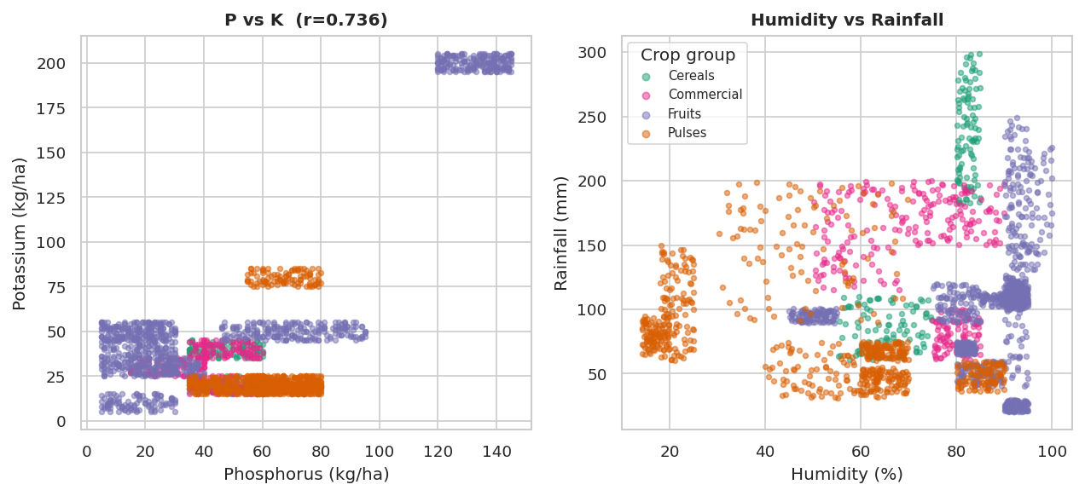
Figure 6. Bivariate scatter of P vs K and humidity vs rainfall, coloured by crop group.
Group box plots (Figure 7) make the contrasts concrete: cereals demand the most rainfall and high nitrogen; pulses are frugal in both; commercial crops sit high on nitrogen and potassium; fruits span a wide humidity range. Outliers flagged by the box plots are agronomically plausible (e.g. very high-K fruits) and were therefore retained rather than removed.
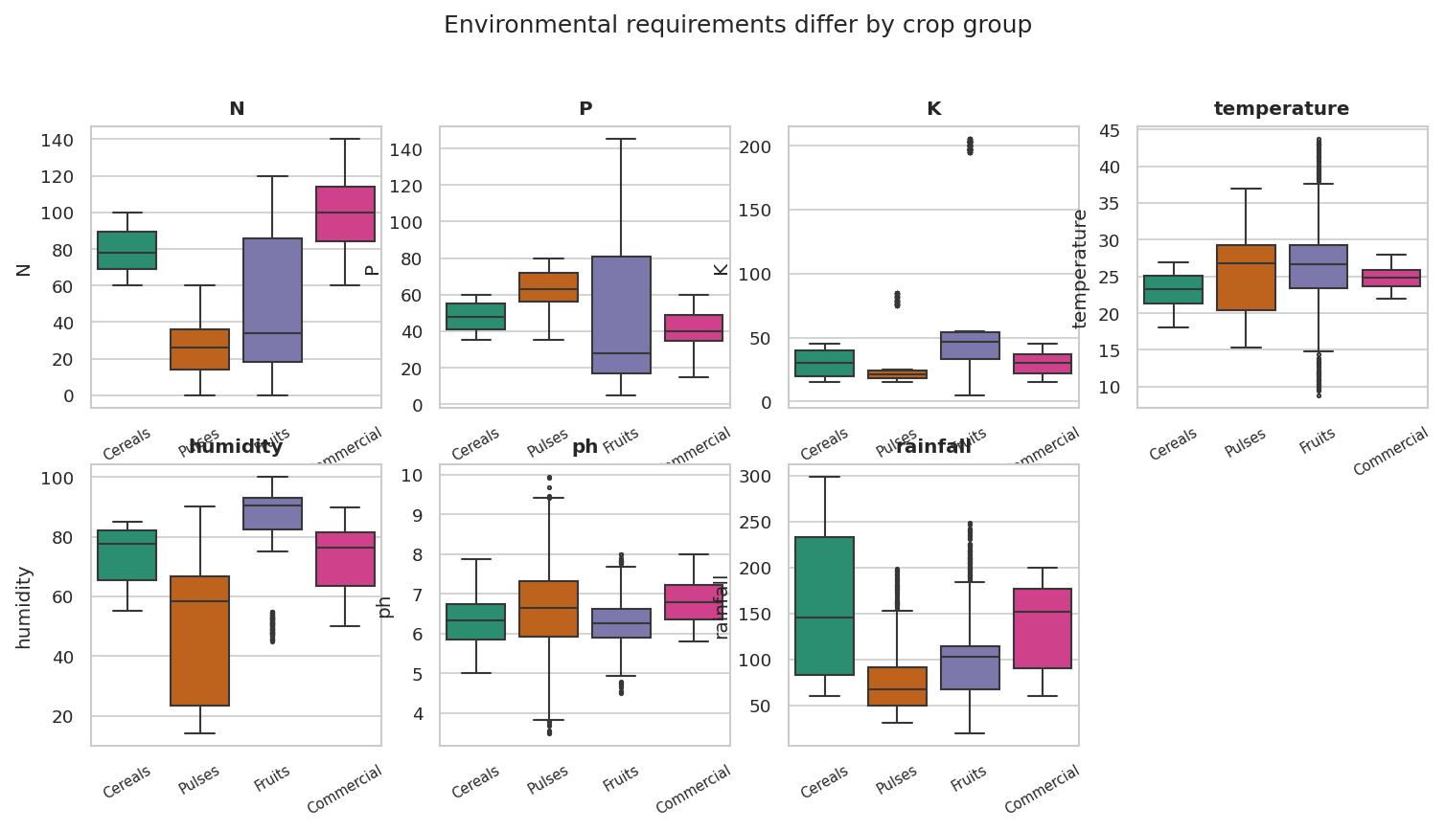
Figure 7. Distribution of each predictor across the four crop groups.

3.4 Statistical inference — estimation and bootstrapping
Before formal testing we quantify the precision of our estimates. Using a non-parametric bootstrap (4,000 resamples), the 95% confidence interval for mean rainfall is [149, 171] mm for cereals and only [76, 81] mm for pulses (Figure 8). The intervals are tight and, for most pairs of groups, non-overlapping — an early visual signal that the group differences are real and not sampling noise.
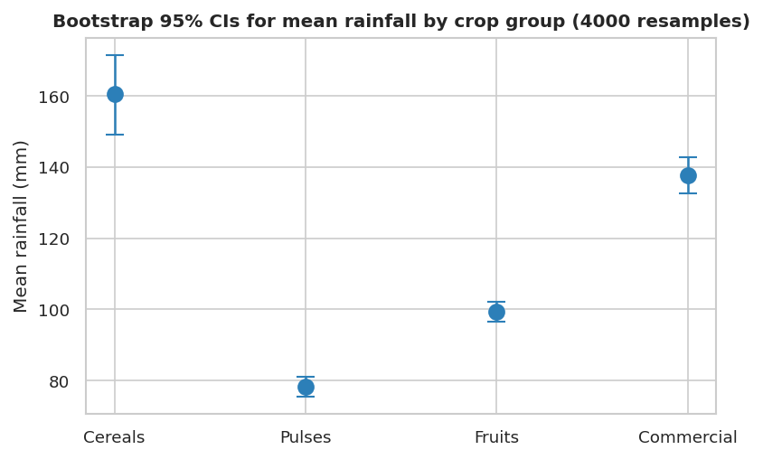
Figure 8. Bootstrap 95% confidence intervals for mean rainfall by crop group (4,000 resamples).

3.5 Hypothesis testing
Q1 — do crop groups differ environmentally? For each variable we ran a one-way ANOVA and, because the data are non-normal, the non-parametric Kruskal–Wallis test. Both reject the null of equal groups for every variable (Table 2). Effect sizes (η²) show the differences are largest for humidity and nitrogen (η² ≈ 0.45 and 0.43) and rainfall (η² = 0.22): these are the variables that most distinguish the groups.
Variable | ANOVA F | ANOVA p | Kruskal–Wallis p | η²
N | 557.3 | < 0.001 | < 0.001 | 0.43
P | 34.7 | < 0.001 | < 0.001 | 0.04
K | 151.5 | < 0.001 | < 0.001 | 0.17
temperature | 31.6 | < 0.001 | < 0.001 | 0.04
humidity | 598.9 | < 0.001 | < 0.001 | 0.45
ph | 59.2 | < 0.001 | < 0.001 | 0.07
rainfall | 206.3 | < 0.001 | < 0.001 | 0.22
Table 2. Tests of equality of the four crop groups for each predictor (df = 3 between groups; n = 2,200).
A focused contrast confirms the pattern: cereals average 79 kg/ha of nitrogen versus 26 kg/ha for pulses, a gap that is overwhelmingly significant (Welch t = 52, p < 0.001; Mann–Whitney corroborates, p < 0.001) — and biologically sensible, since legumes fix their own nitrogen.
Q2 — drivers of (synthetic) yield. Here the tests are most revealing for what they do not find. Yield does not differ significantly across soil types (ANOVA F = 0.66, p = 0.65) or regions (F = 0.36, p = 0.78), and crop is independent of region (χ² = 7.9, p = 0.93, Cramér’s V = 0.007). Only the management flags carry signal: irrigated plots yield 5.26 t/ha versus 4.05 t/ha without (t = 93, p < 0.001). The lesson is methodological: in this synthetic set, structure was injected only through management variables, a clean illustration of why hypothesis testing — not eyeballing — is needed to separate real effects from noise, and a caution about external validity (§4).

3.6 Multivariate analysis — PCA, LDA and clustering
Principal Component Analysis on the standardized predictors shows that the environmental space is genuinely multidimensional: PC1 explains 28%, PC2 18% and PC3 15% of variance, needing three components to pass 60% (Figure 9). PC1 is a soil-fertility axis dominated by P and K (loadings +0.64 and +0.62); PC2 is a moisture/temperature axis led by humidity (+0.74). In the biplot (Figure 10) the fruits separate cleanly along the high-P/K direction, while cereals, pulses and commercial crops overlap more — structure that a supervised method can sharpen.
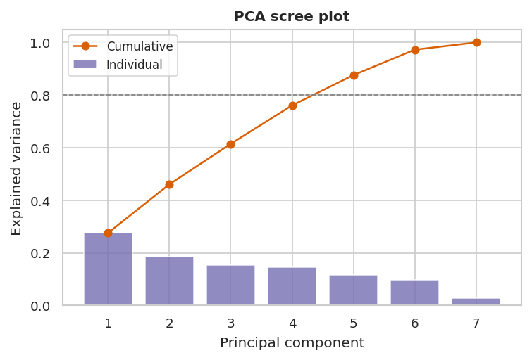
Figure 9. PCA scree plot: individual and cumulative explained variance.
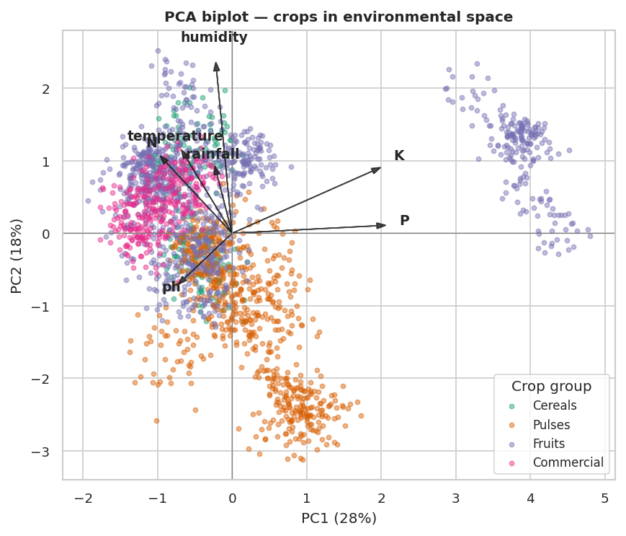
Figure 10. PCA biplot (PC1 vs PC2) with variable loadings, points coloured by crop group.
Linear Discriminant Analysis finds the axes that best separate the four groups. The first discriminant captures 70% of between-group variance and the second 28%, so separation is essentially two-dimensional (Figure 11). Re-substitution accuracy is 85%, with pulses, fruits and commercial crops recovered well (recall 0.96, 0.84, 0.92) but cereals poorly (recall 0.42). The cereal result is informative rather than a failure: rice (very wet) and maize (moderate) are environmentally so different that “cereals” is not a coherent niche — a point clustering reinforces.
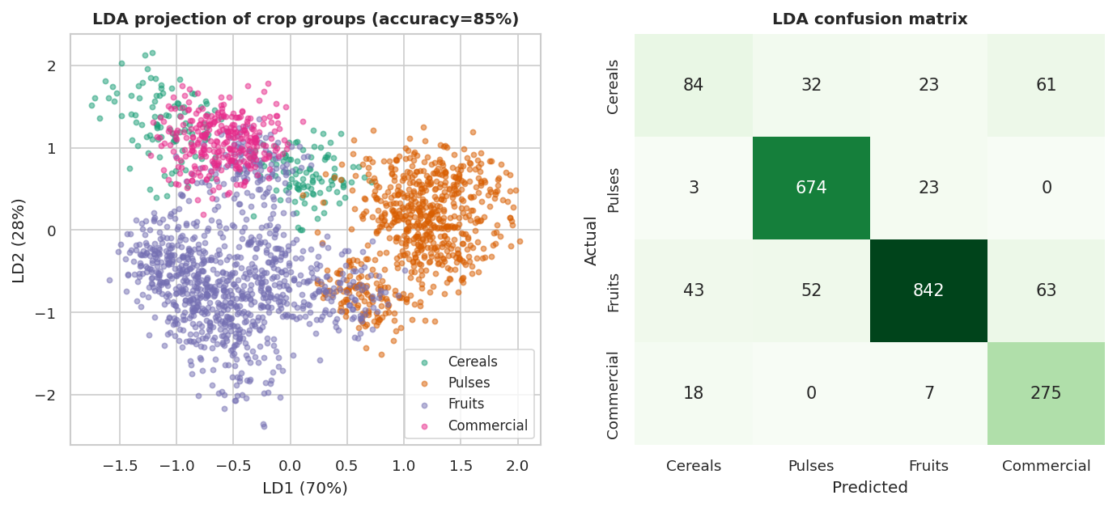
Figure 11. LDA projection of the four crop groups (left) and confusion matrix (right).
Unsupervised Ward hierarchical clustering of the 22 crop means (Figure 12) and a four-cluster cut tell the same story from the data’s own perspective. Apple and grapes split off first as distinctive high-potassium temperate fruits; a large warm, high-rainfall cluster groups rice and maize with tropical fruits and the commercial crops; and a tight cluster collects most pulses (blackgram, chickpea, lentil, mothbeans, mungbean…). K-means agrees only modestly with the agronomic labels (Adjusted Rand Index = 0.34, purity = 0.72), confirming that environmental niche cuts across botanical taxonomy.
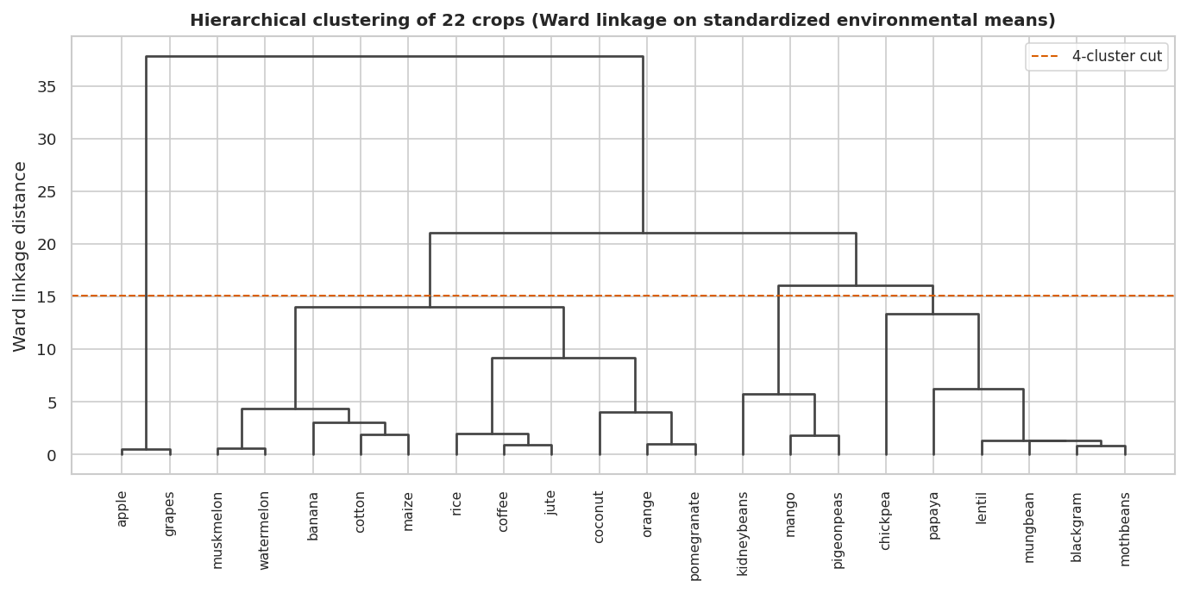
Figure 12. Ward hierarchical clustering of the 22 crops on standardized environmental means.

3.7 Geographical and temporal patterns (real FAO/OECD data)
Temporal. World average yields rose steadily and significantly for all four staples between 1990 and 2025 (Figure 13). Maize grew fastest at +0.77 t/ha per decade (r = 0.98, p < 0.001, a 54% rise), followed by rice (+0.34) and wheat (+0.34); soybean rose more slowly. The trends are near-linear, reflecting decades of improved varieties and inputs.
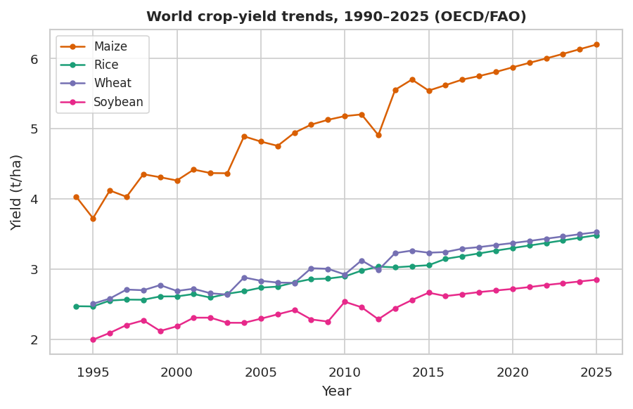
Figure 13. World crop-yield trends, 1990–2025 (FAO/OECD).
Geographical. Maize yields differ significantly across continents (one-way ANOVA F = 3.0, p = 0.028, η² = 0.24). Oceania leads (8.6 t/ha), with the Americas (6.0) and Europe (5.4) close behind, while Africa trails markedly (2.8 t/ha) — the familiar yield gap between industrialised and developing agriculture (Figure 14). An interactive choropleth and trend explorer accompany this section in the project dashboard.
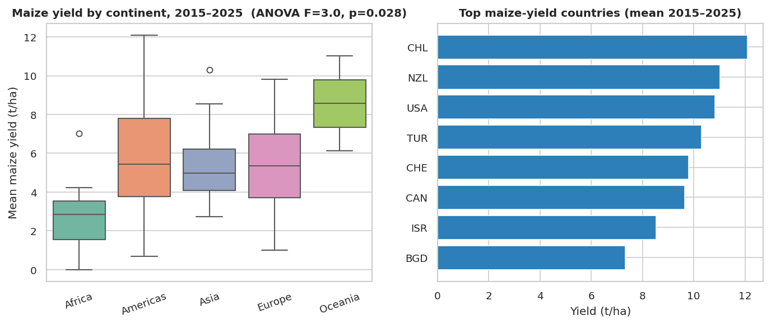
Figure 14. Maize yield by continent (left) and the highest-yielding countries (right), mean 2015–2025.

4. Discussion and conclusions
The three questions resolve into one coherent narrative. First, crops occupy distinct and statistically separable envelopes in soil–climate space (H1 supported): every environmental variable differs across groups, most strongly for humidity, nitrogen and rainfall, and these differences are large enough for an LDA to recover most groups at 85% accuracy. The structure is genuinely multivariate — no single component dominates — organised around a fertility (P–K) axis and a moisture (humidity) axis.
Second, the agronomic grouping is a convenience, not a natural law. Clustering and the poor recall of “cereals” show that environmental niche crosses botanical boundaries: rice belongs with the warm, wet tropical crops, not with maize. For an analyst this is a reminder that meaningful groupings should be discovered from the data, not assumed.
Third, the contrast between the synthetic and the real datasets is the project’s sharpest methodological lesson. In the synthetic yield data only the injected management effects (irrigation, fertiliser) were detectable, while soil, region and weather were noise (H2 only partially supported, and only for management). Conclusions drawn from such data would not transfer to the field — a concrete case of weak external validity. The real FAO/OECD data, by contrast, show robust and interpretable structure: significant yield growth since 1990 (H3 supported) and a significant, policy-relevant geographical gap between high-yielding Oceania/Americas and low-yielding Africa.
Limitations. The Crop Recommendation data are augmented/semi-synthetic and Indian in origin, so absolute ranges may not generalise; the crop-yield set is fully synthetic and used only illustratively; and the FAO/OECD panel is unbalanced across countries and years. Future work could substitute the Portuguese INE agricultural census to bring the analysis to civil-parish resolution, and add spatial autocorrelation and mixed-effects trend models.
Take-home message. Treating agronomy as agro-environmental data analysis works: simple, well-chosen statistics and visualisations recover the environmental logic of where crops grow, expose when a dataset is too clean to be true, and quantify how the world’s harvests are changing in space and time.

5. References
Cairo, A. (2013). The Functional Art: An Introduction to Information Graphics and Visualization. New Riders. (Visualization wheel.)
Ingle, A. Crop Recommendation Dataset. Kaggle. https://www.kaggle.com/datasets/atharvaingle/crop-recommendation-dataset
Otiattakorah, S. Agriculture Crop Yield Dataset. Kaggle. https://www.kaggle.com/datasets/samuelotiattakorah/agriculture-crop-yield
OECD (2024). Crop production (indicator). doi: 10.1787/49a4e677-en. Underlying data: FAO / Our World in Data, Crop Yields.
Pedregosa, F. et al. (2011). Scikit-learn: Machine Learning in Python. JMLR 12, 2825–2830.
Virtanen, P. et al. (2020). SciPy 1.0: fundamental algorithms for scientific computing in Python. Nature Methods 17, 261–272.
Segurado, P. & lecturers (2026). AVCAD 2372 course materials and examples (Lessons 1–12). ISA/ULisboa GitHub repository.

Annex — Python code and AI-usage declaration
Complete, runnable code. All results and figures in this report were produced by the accompanying Jupyter notebook, final_project_code_annex.ipynb (also viewable on GitHub / Google Colab). It reproduces every figure and statistic in order, using pandas, scipy.stats, scikit-learn, matplotlib/seaborn and plotly.
Repository and dashboard. All materials are in the project repository at github.com/asternoeld/avcad (folder final_project): the notebook, the three datasets, the figures and an interactive HTML dashboard (PCA explorer, crop fingerprints and the OECD geographical/temporal views).

AI-usage declaration
In line with the course policy we declare all use of AI assistants. Tools: general-purpose LLM assistants (ChatGPT / Claude). They were used for (i) code scaffolding of figure layouts and the bootstrap helper, (ii) confirming the correct statistical test and its assumptions for each question, and (iii) light copy-editing of this report. Every suggestion was executed, checked against the data and edited by us; all statistical results come from the code, not from an AI. Representative prompts:
- "Write a Python function returning a 95% bootstrap confidence interval for the mean of a NumPy array (4000 resamples)."
- "For four non-normal groups, which SciPy test is the non-parametric equivalent of one-way ANOVA, and how is it called?"
- "Draft matplotlib code for a PCA biplot that colours points by group and overlays loading vectors as arrows."

