UNIT-I

Introduction to Data Mining

Rapid advances in data collection and storage technology have enabled organizations to accumulate vast amounts of data. However, extracting useful information has proven extremely challenging. Often, traditional data analysis tools and techniques cannot be used because of the massive size of a data set. In other situations, the questions that need to be answered cannot be addressed using existing data analysis techniques, and thus, new methods need to be developed.
Data mining is a technology that blends traditional data analysis methods with sophisticated algorithms for processing large volumes of data. It has also opened up exciting opportunities for exploring and analyzing new types of data and for analyzing old types of data in new ways.
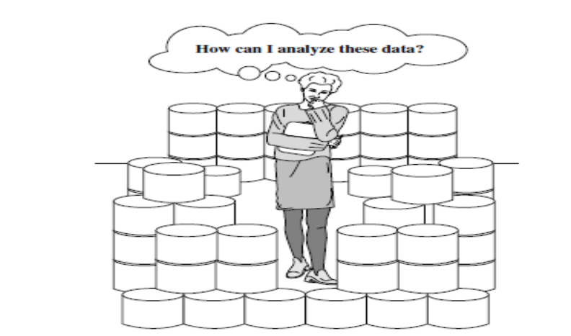

The world is data rich but information poor

We start with a description of some well-known applications that require new techniques for data analysis.
Business Point-of-sale data collection (bar code scanners, radio frequency identification (RFID), and smart card technology) have allowed retailers to collect up-to-the-minute data about customer purchases at the checkout counters of their stores. Retailers can utilize this information, along with other business-critical data such as Web logs from e-commerce Web sites and customer service records from call centers, to help them better understand the needs of their customers and make more informed business decisions. It can also help retailers answer important business questions such as "Who are the most profitable customers?" "What products can be cross-sold or up-sold?" and "What is the revenue outlook of the company for next year?"
Medicine, Science, and Engineering Researchers in medicine, science, and engineering are rapidly accumulating data that is a key to important new discoveries. For example, as an important step toward improving our understanding of the Earth's climate system, NASA has deployed a series of Earth orbiting satellites that continuously generate global observations of the land surface, oceans, and atmosphere.
As another example, researchers in molecular biology hope to use the large amounts of genomic data currently being gathered to better understand the structure and function of genes. In the past, traditional methods in molecular biology allowed scientists to study only a few genes at a time in a given experiment. Recent breakthroughs in microarray technology have enabled scientists to compare the behavior of thousands of genes under various situations.
Such comparisons can help determine the function of each gene and perhaps isolate the genes responsible for certain diseases.

What is Data Mining?
Data mining is the process of automatically discovering useful information in large data repositories.
(or)
Data mining is the process of discovering interesting patterns and knowledge from large amounts of data.
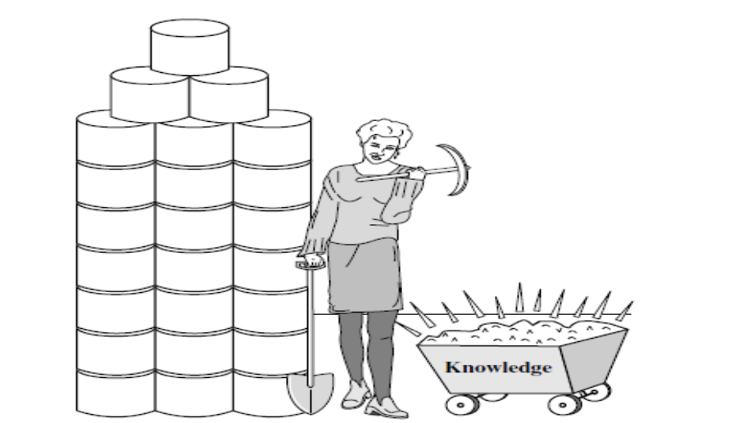

Data mining—searching for knowledge (interesting patterns) in data

They also provide capabilities to predict the outcome of a future observation, such as predicting whether a newly arrived customer will spend more than $100 at a department store.

Data mining refers to extracting or “mining" knowledge from large amounts of data. Data mining can be named as “knowledge mining from data". But the name is quite lang. The shorter name “Knowledge mining" may not reflect the emphasis on mining from large amounts of data. Thus, such a misnomer which carries both “data" and “mining" became a popular choice.
Many people treat data mining as a synonym for another popularly used term, “Knowledge Discovery in Databases", or KDD. Alternatively, others view data mining as simply an essential step in the process of knowledge discovery in databases. Knowledge discovery is a process which consists of an iterative sequence of steps. They are
Data cleaning and Preprocessing Stage: -Data cleaning is a process of removing unnecessary and inconsistent data from the databases. The main purpose of preprocessing is to improve the quality of the data by filling the missing values, configuring the data to make sure that it in consistent format.
Data Integration Stage: - In this stage multiple data sources may be combined (i.e integrated) to form a large database.
Data Selection Stage: - Data which is required for data mining process can be extracted from multiple and heterogeneous data sources such as databases, files etc., Data selection is a process where the appropriate data required for analysis is fetched from the databases.
Data Transformation and Reduction Stage: - In the transformation stage data extracted from multiple data sources are converted into an appropriate format for data mining process. Data reduction is used to decrease the number of possible values of data without affecting the integrity of data.
Data Mining Stage: -Data mining is an important process where expert techniques are applied to extract the hidden patterns from large volume of data stored in databases.
Pattern Evaluation: - In this stage, patterns generated during data mining stage are transformed into knowledge which is used in decision support system.

Knowledge presentation: - In this stage where visualization and knowledge representation techniques are used to present the mined knowledge to the user

Data warehouse is a repository of multiple heterogeneous data sources organized under a unified schema at a single site to facilitate management decision making
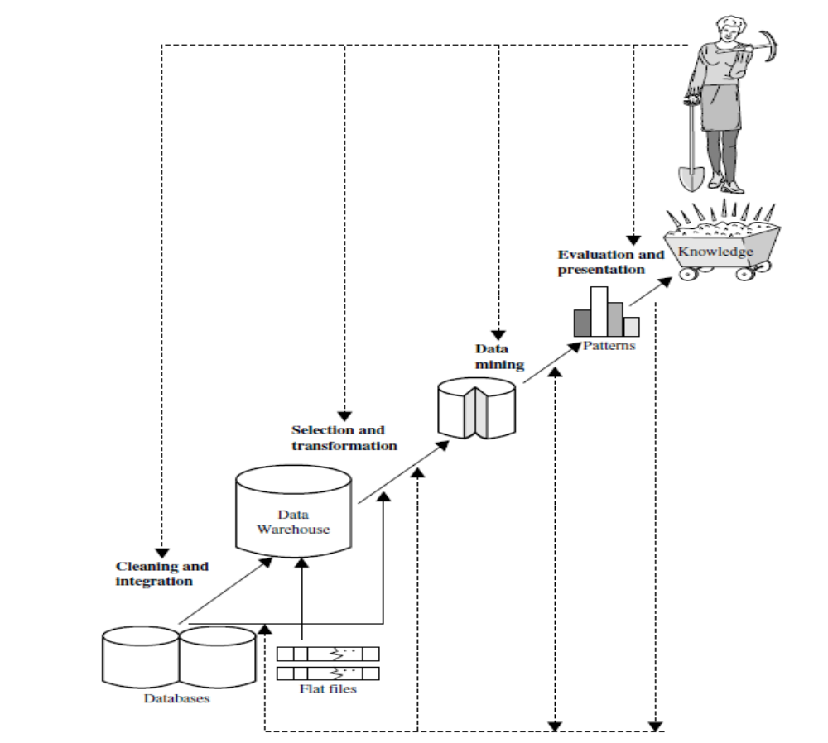
Data mining as a step in the process of knowledge discovery

Motivating Challenges

As mentioned earlier, traditional data analysis techniques have often encountered practical difficulties in meeting the challenges posed by new data sets. The following are some of the specific challenges that motivated the development of data mining.
Scalability Because of advances in data generation and collection, data sets with sizes of gigabytes, terabytes, or even petabytes are becoming common. If data mining algorithms are to handle these massive data sets, then they must be scalable. For instance, out-of-core algorithms may be necessary when processing data sets that cannot fit into main memory. Scalability can also be improved by using sampling or developing parallel and distributed algorithms.
High Dimensionality It is now common to encounter data sets with hundreds or thousands of attributes instead of the handful common a few decades ago. In bioinformatics, progress in microarray technology has produced gene expression data involving thousands of features. Data sets with temporal or spatial components also tend to have high dimensionality. For example, consider a data set that contains measurements of temperature at various locations. If the temperature measurements are taken repeatedly for an extended period, the number of dimensions (features) increases in proportion to the number of measurements taken. Traditional data analysis techniques that were developed for low-dimensional data often do not work well for such high dimensional data. Also, for some data analysis algorithms, the computational complexity increases rapidly as the dimensionality (the number of features) increases
Heterogeneous and Complex Data Traditional data analysis methods often deal with data sets containing attributes of the same type, either continuous or categorical. As the role of data mining in business, science, medicine, and other fields has grown, so has the need for techniques that can handle heterogeneous attributes. Recent years have also seen the emergence of more complex data objects. Examples of such non-traditional types of data include collections of Web pages containing semi-structured text and hyperlinks; DNA data with sequential and three-dimensional structure; and climate data that consist of time series measurements (temperature, pressure, etc.) at various locations on the Earth's surface. Techniques developed for mining such complex objects should take into consideration relationships in the data, such as temporal and spatial autocorrelation, graph connectivity, and parent-child relationships between the elements in semi-structured text and XML documents.
Data Ownership and Distribution Sometimes, the data needed for an analysis is not stored in one location or owned by one organization. Instead, the data is geographically distributed among resources belonging to multiple entities. This requires the development of distributed data mining techniques. Among the key challenges faced by distributed data mining algorithms include (1) how to reduce the amount of communication needed to perform the distributed computation, (2) how to effectively consolidate the data mining results obtained from multiple sources, and (3) how to address data security issues.

Non-traditional Analysis The traditional statistical approach is based on a hypothesize-and-test paradigm. In other words, a hypothesis is proposed, an experiment is designed to gather the data and then the data is analyzed with respect to the hypothesis. Unfortunately, this process is extremely labor intensive. Current data analysis tasks often require the generation and evaluation of thousands of hypotheses, and consequently. The development of some data mining techniques has been motivated by the desire to automate the process of hypothesis generation and evaluation. Furthermore, the data sets analyzed in data mining are typically not the result of a carefully designed experiment and often represent opportunistic samples of the data, rather than random samples.

Data mining tasks
Data mining tasks are generally divided into two major categories:
Predictive tasks the objective of these tasks is to predict the value of a particular attribute based on the values of other attributes. The attribute to be predicted is commonly known as the target or dependent variable, while the attributes used for making the prediction are known as the explanatory or independent variables.
Descriptive tasks here, the objective is to derive patterns (correlations, trends, clusters, trajectories, and anomalies) that summarize the underlying relationships in data. Descriptive data mining tasks are often exploratory in nature and frequently require post processing techniques to validate and explain the results. The following figure illustrates four of the core data mining tasks.
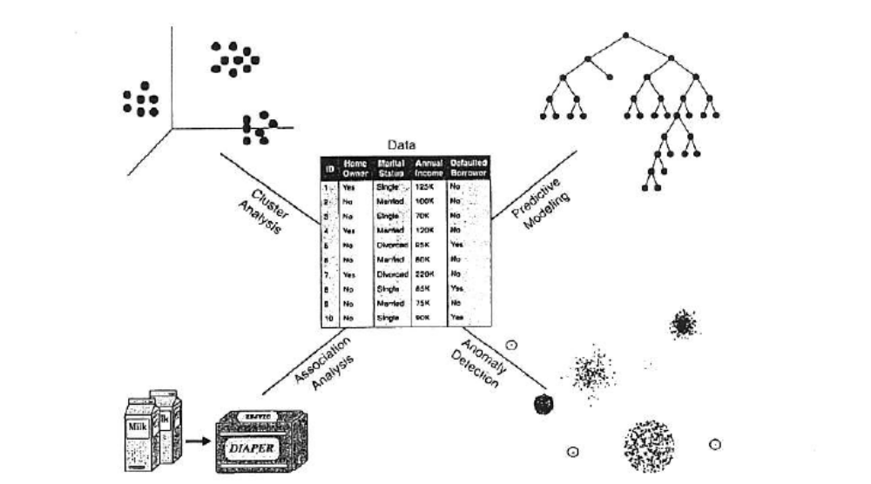
Figure four of the core data mining tasks.
Predictive modeling it refers to the task of building a model for the target variable as a function of the explanatory variables. There are two types of predictive modeling tasks:
Classification which is used for discrete target variables. For example, predicting whether a Web user will make a purchase at an online bookstore is a classification task because the target variable is binary-valued.
Regression which is used for continuous target variables. For example, forecasting the future price of a stock is a regression task because price is a continuous-valued attribute.
Predictive modeling can be used to identify customers that will respond to a marketing campaign, predict disturbances in the Earth's ecosystem, or judge whether a patient has a particular disease based on the results of medical tests.
Example (Predicting the type of a Flower). Consider the task of predicting a species of flower based on the characteristics of the flower. In particular, consider classifying an Iris flower as to whether it belongs to one of the following three Iris species: Setosa, Versicolour, or Virginica. To perform this task, we need a data set containing the characteristics of various flowers of these three species. In addition to the species of a flower, this data set contains four other attributes: sepal width, sepal length, petal length, and petal width. Petal width is broken into the categories low, medium, and high, which correspond to the intervals [0, 0.75),[0.75,1.75), [1.75,00), respectively. Also, petal length is broken into categories low, medium, and high, which correspond to the intervals [0, 2.5), [2.5, 5), [5, 00), respectively. Based on these categories of petal width and length, the following rules can be derived:
Petal width low and petal length low implies Setosa.
Petal width medium and petal length medium implies Versicolour.
Petal width high and petal length high implies Virginica
The following Figure shows a plot of petal width versus petal length for the 150 flowers in the Iris data set.
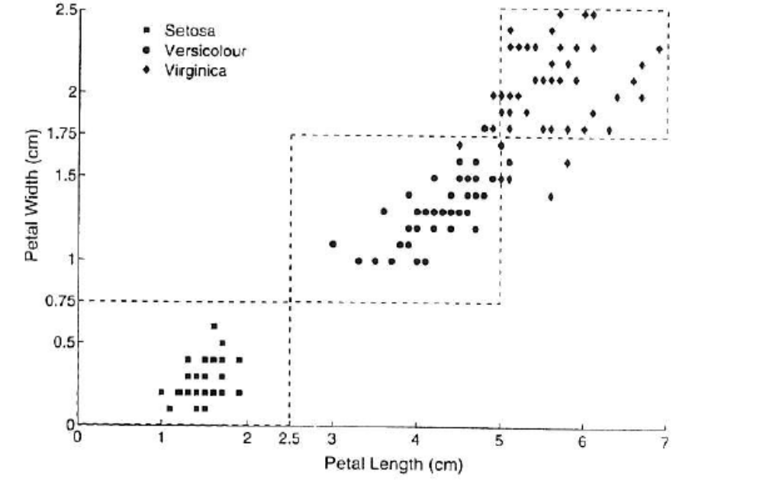
Figure Petal width versus petal length for 150 Iris flowers.
Association analysis is used to discover patterns that describe strongly associated features in the data. The discovered patterns are typically represented in the form of implication rules or feature subsets. Because of the exponential size of its search space, the goal of association analysis is to extract the most interesting patterns in an efficient manner. Useful applications of association analysis include finding groups of genes that have related functionality, identifying Web pages that are accessed together, or understanding the relationships between different elements of Earth's climate system.
Example (Market Basket Analysis). The transactions shown in the following Table illustrate point-of-sale data collected at the checkout counters of a grocery store. Association analysis can be applied to find items that are frequently bought together by customers. For example, we may discover the rule {Diapers} --+ {Milk}, which suggests that customers who buy diapers also tend to buy milk. This type of rule can be used to identify potential cross-selling opportunities among related items. 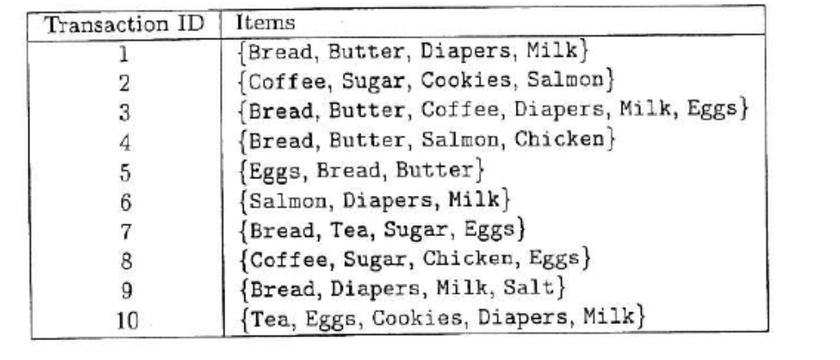
Table Markel basket data.
Ex:- The association rules may be specified as
age(X; “20…29") ^ income(X; “20K…30K") => buys(X, “CD player")
[support = 2%; confidence = 60%]
Cluster analysis seeks to find groups of closely related observations so that observations that belong to the same cluster are more similar to each other than observations that belong to other clusters. Clustering has been used to group sets of related customers, find areas of the ocean that have a significant impact on the Earth's climate, and compress data. The objects are clustered or grouped based on the principle of maximizing the intra class similarity and minimizing the interclass similarity.
Example (Document Clustering). The collection of news articles shown in the following Table can be grouped based on their respective topics. Each article is represented as a set of word-frequency pairs (w, c), where w is a word and c is the number of times the word appears in the article. There are two natural clusters in the data set. The first cluster consists of the first four articles, which correspond to news about the economy, while the second cluster contains the last four articles, which correspond to news about health care. A good clustering algorithm should be able to identify these two clusters based on the similarity between words that appear in the articles.
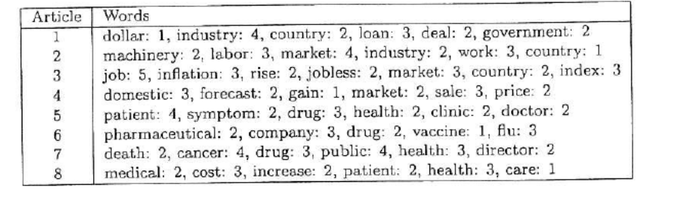
Table Collection of news articles.
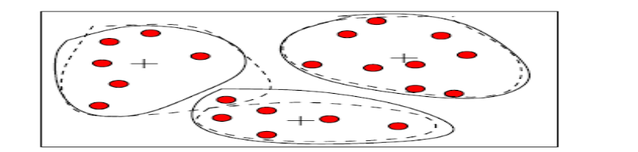
Fig. Sample clusters
Anomaly detection / outlier analysis is the task of identifying observations whose characteristics are significantly different from the rest of the data. Such observations are known as anomalies or outliers. Applications of anomaly detection include the detection of fraud, network intrusions, unusual patterns of disease, and ecosystem disturbances.
Example (Credit Card Fraud Detection). A credit card company records the transactions made by every credit card holder, along with personal information such as credit limit, age, annual income, and address. Since the number of fraudulent cases is relatively small compared to the number of legitimate transactions, anomaly detection techniques can be applied to build a profile of legitimate transactions for the users. When a new transaction arrives, it is compared against the profile of the user. If the characteristics of the transaction are very different from the previously created profile, then the transaction is flagged as potentially fraudulent.
For successful data mining operations we have to consider the following issues.
- The Type of Data
- The Quality of the Data
- Preprocessing Steps to Make the Data More Suitable for Data Mining
- Analyzing Data in Terms of Its Relationships

Data & Data Set

Data simply defined as raw facts and figures. A data set can often be viewed as a collection of data objects. Other names for a data object are record, point, vector, pattern, event, case, sample, observation, or entities). In turn, data objects are described by a number of attributes that capture the basic characteristics of an object, such as the mass of a physical object or the time at which an event occurred, Other names for an attribute are variable, characteristic, field, feature, or dimension.
Example (Student Information) Often, a data set is a file, in which the objects are records (or rows) in the file and each field (or column) corresponds to an attribute. For example, the following table shows a data set that consists of student information. Each row corresponds to a student and each column is an attribute that describes some aspect of a student, such as grade point average (GPA) or identification number (ID).
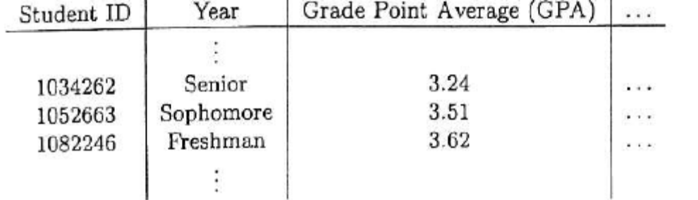
Table a sample data set containing student information

What is an attribute
An attribute is a property or characteristic of an object that may vary, either from one object to another or from one time to another. For example, eye color varies from person to person, while the temperature of an object varies over time. Note that eye color is a symbolic attribute with a small number of possible values {brown, black, blue, green, hazel, etc.}, while temperature is a numerical attribute with a potentially unlimited number of values.

Data Mining Issues:-

Researchers have been vigorously developing new data mining methodologies. This
involves the investigation of new kinds of knowledge, mining in multidimensional
space, integrating methods from other disciplines, and the consideration of semantic ties among data objects. In addition, mining methodologies should consider issues such as data uncertainty, noise, and incompleteness. Some mining methods explore how user specified measures can be used to assess the interestingness of discovered patterns as well as guide the discovery process. Let’s have a look at these various aspects of mining methodology.

1.Mining Methodology

Mining various and new kinds of knowledge
Data mining covers a wide spectrum of data analysis and knowledge discovery tasks, from data characterization and discrimination to association and correlation analysis, classification, regression, clustering, outlier analysis, sequence analysis, and trend and evolution analysis. These tasks may use the same database in different ways and require the development of numerous data mining techniques. Due to the diversity of applications, new mining tasks continue to emerge, making data mining a dynamic and fast-growing field. For example, for effective knowledge discovery in information networks, integrated clustering and ranking may lead to the discovery of high-quality clusters and object ranks in large networks

Mining knowledge in multidimensional space
When searching for knowledge in large data sets, we can explore the data in multidimensional space. That is, we can search for interesting patterns among combinations of dimensions (attributes) at varying levels of abstraction. Such mining is known as (exploratory) multidimensional data mining. In many cases, data can be aggregated or viewed as a multidimensional data cube. Mining knowledge in cube space can substantially enhance the power and flexibility of data mining.

Data mining—an interdisciplinary effort: The power of data mining can be substantially enhanced by integrating new methods from multiple disciplines. For example, to mine data with natural language text, it makes sense to fuse data mining methods with methods of information retrieval and natural language processing. As another example, consider the mining of software bugs in large programs. This form of mining, known as bug mining, benefits from the incorporation of software engineering knowledge into the data mining process.

Boosting the power of discovery in a networked environment: Most data objects reside in a linked or interconnected environment, whether it be the Web, database relations, files, or documents. Semantic links across multiple data objects can be used to advantage in data mining. Knowledge derived in one set of objects can be used to boost the discovery of knowledge in a “related” or semantically linked set of
objects.

Handling uncertainty, noise, or incompleteness of data:

Data often contain noise, errors, exceptions, or uncertainty, or are incomplete. Errors and noise may confuse the data mining process, leading to the derivation of erroneous patterns. Data cleaning, data preprocessing, outlier detection and removal, and uncertainty reasoning are examples of techniques that need to be integrated with the data mining process.

Pattern evaluation and pattern- or constraint-guided mining: Not all the patterns generated by data mining processes are interesting. What makes a pattern interesting? may vary from user to user. Therefore, techniques are needed to assess the interestingness of discovered patterns based on subjective measures. These estimate the value of patterns with respect to a given user class, based on user beliefs or expectations. Moreover, by using interestingness measures or user-specified constraints to guide the discovery process, we may generate more interesting patterns and reduce the search space.

2.User Interaction

The user plays an important role in the data mining process. Interesting areas of research include how to interact with a data mining system, how to incorporate a user’s background knowledge in mining, and how to visualize and comprehend data mining results. We introduce each of these here.

Interactive mining: The data mining process should be highly interactive. Thus, it is important to build flexible user interfaces and an exploratory mining environment,
facilitating the user’s interaction with the system. A user may like to first sample a
set of data, explore general characteristics of the data, and estimate potential mining
results. Interactive mining should allow users to dynamically change the focus
of a search, to refine mining requests based on returned results, and to drill, dice,
and pivot through the data and knowledge space interactively, dynamically exploring “cube space” while mining.

Incorporation of background knowledge: Background knowledge, constraints, rules, and other information regarding the domain under study should be incorporated into the knowledge discovery process. Such knowledge can be used for pattern evaluation as well as to guide the search toward interesting patterns.

Ad hoc data mining and data mining query languages: Query languages (e.g., SQL) have played an important role in flexible searching because they allow users to pose ad hoc queries. Similarly, high-level data mining query languages or other high-level flexible user interfaces will give users the freedom to define ad hoc data mining tasks. This should facilitate specification of the relevant sets of data for analysis, the domain knowledge, the kinds of knowledge to be mined, and the conditions and constraints to be enforced on the discovered patterns. Optimization of the processing of such flexible mining requests is another promising area of study.

Presentation and visualization of data mining results: How can a data mining system present data mining results, vividly and flexibly, so that the discovered knowledge can be easily understood and directly usable by humans? This is especially crucial if the data mining process is interactive. It requires the system to adopt expressive knowledge representations, user-friendly interfaces, and visualization techniques.

3.Efficiency and Scalability

Efficiency and scalability are always considered when comparing data mining algorithms. As data amounts continue to multiply, these two factors are especially critical.

Efficiency and scalability of data mining algorithms: Data mining algorithms must be efficient and scalable in order to effectively extract information from huge amounts of data in many data repositories or in dynamic data streams. In other words, the running time of a data mining algorithm must be predictable, short, and acceptable by applications. Efficiency, scalability, performance, optimization, and the ability to execute in real time are key criteria that drive the development of many new data mining algorithms.

Parallel, distributed, and incremental mining algorithms: The humongous size of many data sets, the wide distribution of data, and the computational complexity of some data mining methods are factors that motivate the development of parallel and distributed data-intensive mining algorithms. Such algorithms first partition the data
into “pieces.” Each piece is processed, in parallel, by searching for patterns. The parallel processes may interact with one another. The patterns from each partition are eventually merged.

4.Diversity of Database Types

The wide diversity of database types brings about challenges to data mining. These
Include

Handling complex types of data: Diverse applications generate a wide spectrum of
new data types, from structured data such as relational and data warehouse data to
semi-structured and unstructured data; from stable data repositories to dynamic data
streams; from simple data objects to temporal data, biological sequences, sensor data, spatial data, hypertext data, multimedia data, software program code, Web data, and social network data. It is unrealistic to expect one data mining system to mine all kinds of data, given the diversity of data types and the different goals of data mining. domain- or application-dedicated data mining systems are being constructed for in depth mining of specific kinds of data. The construction of effective and efficient data mining tools for diverse applications remains a challenging and active area of research.

Mining dynamic, networked, and global data repositories: Multiple sources of data are connected by the Internet and various kinds of networks, forming gigantic, distributed, and heterogeneous global information systems and networks. The discovery of knowledge from different sources of structured, semi-structured, or unstructured yet interconnected data with diverse data semantics poses great challenges to data mining. Mining such gigantic, interconnected information networks may help disclose many more patterns and knowledge in heterogeneous data sets than can be discovered from a small set of isolated data repositories. Web mining, multisource data mining, and information network mining have become challenging and fast-evolving data mining fields.

5. Data Mining and Society

Social impacts of data mining: With data mining penetrating our everyday lives, it is important to study the impact of data mining on society. How can we use data mining technology to benefit society? How can we guard against its misuse? The improper disclosure or use of data and the potential violation of individual privacy and data protection rights are areas of concern that need to be addressed.

Privacy-preserving data mining: Data mining will help scientific discovery, business management, economy recovery, and security protection (e.g., the real-time discovery of intruders and cyberattacks). However, it poses the risk of disclosing an
individual’s personal information. Studies on privacy-preserving data publishing and
data mining is ongoing. The philosophy is to observe data sensitivity and preserve
people’s privacy while performing successful data mining.

Data Mining Metrics:
Metrics are parameters or measures of quantitative assessment used for measurement, comparison, or to track performance.
Example:
Return on Investment (ROI) is used in business-oriented industries.
Time and space complexity is used in estimating the performance of algorithms
Accuracy can be used for the classification.
Metrics for Supervised Learning
A confusion matrix is a table that is often used to describe the performance of a classification model (or "classifier") on a set of test data.
- True positives (TP): These are cases in which we predicted yes (they have the disease), and they do have the disease.
- True negatives (TN): We predicted no, and they don't have the disease.
- False positives (FP): We predicted yes, but they don't actually have the disease. (Also known as a "Type I error.")
- False negatives (FN): We predicted no, but they actually do have the disease. (Also known as a "Type II error.")
Accuracy: Overall, how often is the classifier correct?
  - (TP+TN)/total
Error Rate: Misclassification Rate: Overall, how often is it wrong?
  - (FP+FN)/total
  - equivalent to 1 minus Accuracy
Recall: or True Positive Rate or Sensitivity
When it's actually yes, how often does it predict yes?
Recall =TP/actual yes
Precision: When it predicts yes, how often is it correct?
  - Precision=TP/predicted yes

Specificity: (True Negative Rate) When it's actually no, how often does it predict no?
  - Specificity=TN/actual no
ROC Curve: This is a commonly used graph that summarizes the performance of a classifier over all possible thresholds. It is generated by plotting the True Positive Rate (y-axis) against the False Positive Rate (x-axis)
Example:
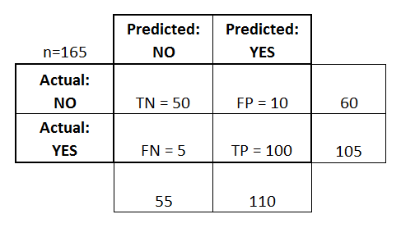

- Accuracy: Overall, how often is the classifier correct?
  - (TP+TN)/total = (100+50)/165 = 0.91
- Error Rate: Misclassification Rate: Overall, how often is it wrong?
  - (FP+FN)/total = (10+5)/165 = 0.09
  - equivalent to 1 minus Accuracy
  - also known as "Error Rate"
- Recall: True Positive Rate or sensitivity When it's actually yes, how often does it predict yes?
  - TP/actual yes = 100/105 = 0.95
- Specificity: True Negative Rate: When it's actually no, how often does it predict no?
  - TN/actual no = 50/60 = 0.83
  - equivalent to 1 minus False Positive Rate
- Precision: When it predicts yes, how often is it correct?
  - TP/predicted yes = 100/110 = 0.91
Metrics for Unsupervised Learning:
Squared Sum Error: SSE is typically used in clustering algorithms to measure the quality of clusters obtained.
If SSE is small when the points are close to their cluster center, indicating a good clustering. If it is high it indicates a poor clustering.
Data Mining From a Database Perspective:

The study of data mining from a database perspective involves looking at all types of data mining applications and techniques. We are concerned about the following implementation issues:
• Scalability: Algorithms that do not scale up to perform well with massive real-world datasets are of limited application. Related to this is the fact that techniques should work regardless of the amount of available main memory.
• Real-world data: Real-world data are noisy and have many missing attribute values. Algorithms should be able to work even in the presence of these problems.
• Update: Many data mining algorithms work with static datasets. This is not a realistic assumption.
• Ease of use: Although some algorithms may work well, they may not be well received by users if they are difficult to use or understand.

