**Languages Used:** AngularJS,JavaScript,JQuery,HTML.

**To get the screen :**

* Copy the files in a folder and place them in their respective inner folders.
* Open taskManager.Html with a browser (Chrome/Mozilla Preferred).

**Features :**

1.User can create a list by clicking on Create New List.

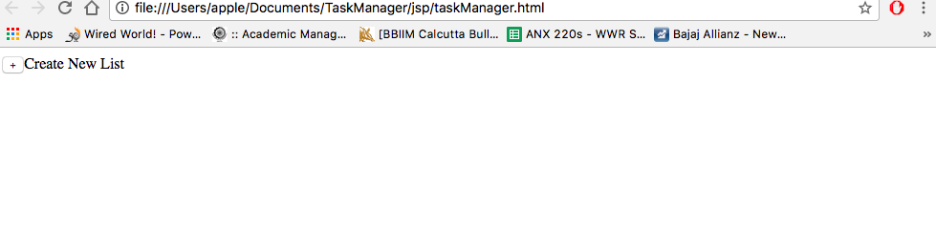

2.Enter the list Name and Press enter key to save

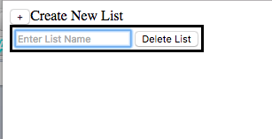

3.To add a new card click on add new card, Enter card status,username and cardName and press enter on each field to save

* + To add another card to the list click on Add new card and repeat above step
  + User can delete a card by clicking on Delete Card.
  + To delete a list click on Delete List
  + To rename list/card user/card status/card name click on the respective value .

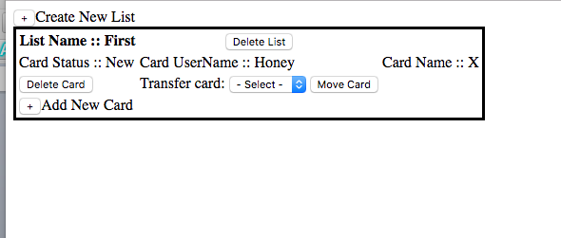

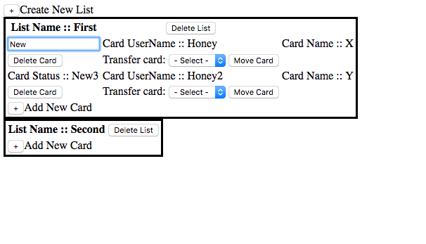

4.To Move a crad from one list to another ,select the new Card Name and click Move card

