Pattern Recognition HW4

M093781 趙宇涵

Part 1.

1. K-fold data partition:

In question 1, I implement the K-fold cross-validation function. Below is the steps:

1. Combine the a and y together.
2. Clone the array and random shuffle
3. Calculate the number of data in 1 fold by $n=\frac{total number}{k}$
4. Cut train and validation dataset.
5. Grid Search & Cross-validation

In this part I use the k-fold dataset to be training and valid dataset, and use grid search to train with SVC package. The C parameter are [0.01, 0.1, 1, 10, 100, 1000, 10000], and the gamma parameter are [0.0001, 0.001, 0.1, 1, 10, 100, 1000].

Finally I get the best accuracy is 0.8927, and the best parameters are (C=100, gamma=0.0001).

1. Plot the grid search results of your SVM.

Above is my grid search implement and result:

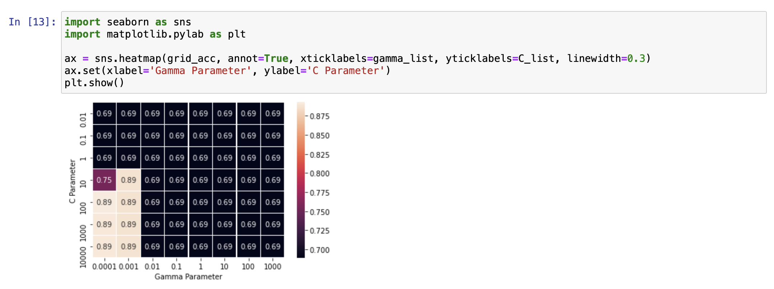

1. Train the SVM model and test with testing data.

I observed the testing result is depending in the shuffle random seed in question 1, so I try a few times, and set the best random seed in question 1.

Finally, I could get net best result is 0.9010.