WooCommerce Sales Analysis Report

This report brings together the data cleaning work, the dataset review and the Power BI dashboard built on the Jagadha by Padanjaly WooCommerce orders dataset. The dataset holds 690 orders placed between January 2023 and May 2026, spread over 72 columns. The original data was kept untouched and a cleaned copy was prepared for analysis.
Main findings from the dashboard:
- Revenue: total revenue is about ₹2.52M across 690 orders, an average of roughly ₹3,650 per order.
- Product concentration: Agnijith 90 gms alone brings in around half of all revenue, and the wider Agnijith range accounts for roughly four-fifths.
- Payments: Razorpay handles 99.48% of revenue and cash on delivery only 0.52%.
- International sales: orders placed in US dollars (about $13K) make up close to 46% of revenue, so overseas customers matter far more than their order count suggests.
- Guest checkout: 49% of orders are placed by guests who are not logged in.
- Seasonality: orders peak in May and June, while September and October are the quietest months for order count. October 2025 is the top month for revenue because of one very large order.

1. Dataset Overview
The dataset is an export of WooCommerce orders. Each row is one order. It has 690 rows and 72 columns, covering a period of over three years (January 2023 to May 2026). The columns fall into the groups below.
Field group | Columns | Data type
Order identity | order_id, order_number, order_key | Integer / text
Dates | order_date, paid_date,order_time,paid_time | Date-time
Financials | shipping_total, shipping_tax_total, fee_total, fee_tax_total, tax_total, cart_discount, order_discount, discount_total, order_total, order_subtotal | Numeric
Currency | order_currency | numeric
Payment | payment_method, payment_method_title, transaction_id | Text
Customer | customer_id, customer_user | Whole number
Shipping | shipping_method, shipping address fields | Text
Audit / operations | wt_import_key, tax_items, shipping_items, fee_items, coupon_items, refund_items, order_notes, download_permissions | Text
Products | line_item_1 to line_item_4, plus product name, ID, SKU, quantity, total and subtotal | Text
Location | Billing and shipping state, city, country (and postcode) | Text

2. Initial Data Quality Review
Before cleaning, the dataset was reviewed for missing and empty values. The main observations were:
- shipping_tax_total, fee_total, fee_tax_total, tax_total, cart_discount, order_discount and discount_total contain only zero values.
- Some values in billing state are missing.
- All Product Item 3 and Product Item 4 columns (name, id, SKU, quantity, total, subtotal) are empty,
- Some Product Item 2 columns (id, SKU, quantity, total, subtotal) contain blank cells, because many orders have only one product.
- Billing and shipping city, state, country and postcode columns are present and can support location analysis.

3. Data Cleaning Process

3.1 Objective and approach
The aim was to identify and handle missing values, duplicates, incorrect data types, inconsistent values and other data-quality problems. The source file was loaded into Power BI, the original dataset was kept as it is, and all cleaning was done in a duplicated copy. The work was done column by column in Power Query.

3.2 Data types applied
Columns | Data type applied
order_id, order_number, customer_id | Whole number
order_date, paid_date | Date
order_time, paid_time | Time
All amount columns (shipping, tax, fee, discount, order totals, item totals and subtotals) | Decimal number
subtotal_convertor, total_convertor | Decimal number
Product item quantities | Whole number
Product item ids, postcodes, shipping_phone | Text
status, payment, city, state, country and other descriptive columns | Text

3.3 Major issues identified and resolved
# | Issue / step | Action taken
1 | Date and time in one column | order_date and paid_date were split into separate date and time columns (order_date, order_time, paid_date, paid_time) and typed as Date and Time.
2 | zero values | Left as zero and not filled in. filling it with made-up values would create false data.
3 | Mixed currency (USD) | Orders were recorded in US dollars (order_currency). Amounts were converted to Indian rupees so that all sales can be compared on one scale.
4 | tax_total always 0 | Not an error: no tax was applied. Column left unchanged. Revenue needs no tax adjustment.
5 | Discount and coupon columns | cart_discount, order_discount and discount_total are 0 and coupon_items is empty in every order. The website offers no discounts or coupons, so the values are correct and were left unchanged.
6 | customer_id = 0 | Treated as guest customers. The values were not replaced or removed, which allows registered and guest customers to be compared.
7 | Location accuracy | Billing and shipping city, state and country were checked against the billing and shipping postcodes. Verified values were saved in new columns, so the originals remain available.
8 | Product details packed in line_item columns | line_item_1 to line_item_4 were split into separate columns: product name, product id, SKU, quantity, total and subtotal (Product Item 1 to 4).
9 | Duplicate orders | order_id was checked for duplicates. None were found.

4. Sales Performance Dashboard
The dashboard was built in Power BI from the cleaned dataset. It shows the key figures, the monthly trend of revenue and orders, the payment method split, revenue by product and the number of orders by month.
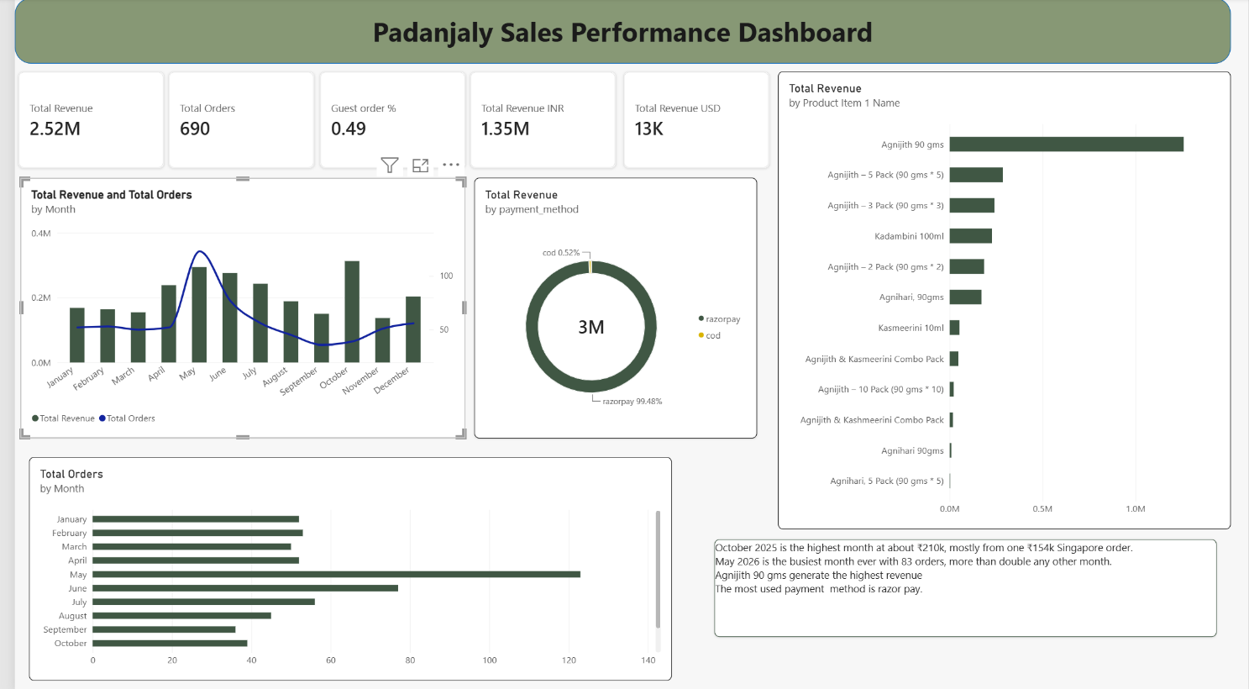

Figure 1: Padanjaly Sales Performance Dashboard

5.1 Key figures
Measure | Value | What it tells us
Total revenue | ₹2.52M | All orders after converting USD to INR
Total orders | 690 | Matches the dataset size, one row per order
Total revenue (INR orders) | ₹1.35M | About 54% of revenue
Total revenue (USD orders) | $13K | About 46% of revenue after conversion (₹2.52M − ₹1.35M ≈ ₹1.17M)

6. Dashboard Insights

6.1 Revenue and orders over time
- Order volume is steady at around 50 orders per month from January to April, then jumps to about 120 in May, the clear peak, and stays high in June (about 77) before falling to its lowest levels in August, September and October (about 36 to 45).
- Revenue and orders do not always move together. October has only about 39 orders but one of the highest revenue figures (about ₹0.31M). The dashboard note explains this: October 2025 reached about ₹210k, mostly from a single ₹154k Singapore order.
- May 2026 is the busiest single month on record with 83 orders, more than double any other month. This suggests recent demand is growing, and is worth checking against any campaign, launch or festival activity in that month.
- Revenue is also strong in April, May, June, July and December, so the first half of the year and the year-end are the commercial high points.

6.2 Product performance
- Agnijith 90 gms is the top product by a wide margin, at roughly ₹1.28M, about half of total revenue.
- The multi-pack versions of Agnijith (5 pack, 3 pack, 2 pack) come next, at roughly ₹0.18M to ₹0.28M each. Together with the single 90 gms they show that the Agnijith range makes up around 80% of revenue.
- Kadambini 100ml (about ₹0.22M) and Agnihari 90gms (about ₹0.17M) are the next strongest products.
- Kasmeerini 10ml, the combo packs and the 10 pack contribute very little. These are the low-selling products that need attention.
- The 5 pack sells better than the 3 pack and the 2 pack, which shows that some customers are willing to buy in bulk.

6.3 Payments
- Razorpay accounts for 99.48% of revenue and cash on delivery for only 0.52%. Customers are very comfortable paying online.
- Because the business depends almost completely on one payment gateway, any Razorpay outage or fee change would affect nearly all sales.

6.4 Customers and markets
- 0.49 of orders are guest orders. Many buyers do not create an account, which means the business loses the chance to track repeat purchases and build loyalty.
- International (USD) orders are a small share of the order count but close to 46% of revenue. Overseas customers place larger orders, so they are a valuable segment.
- The business charges no tax and offers no discounts or coupons, so revenue reflects full-price sales. The strong sales show that demand does not rely on discounting.

7. Business Recommendations
- Promote bulk buying. Identify customers who frequently buy in large quantities and offer bulk or multi-pack options. The 5 pack results show that this works.
- Fix low-selling products. Look at Kasmeerini 10ml, the combo packs and the 10 pack. Review pricing, bundling and visibility to find ways to increase their sales.
- Protect the best seller. Since Agnijith 90 gms drives about half of revenue, keep stock levels high, especially ahead of May and June.
- Plan around seasonality. Schedule marketing and inventory for the April to July peak. Use campaigns to lift the weak months of August to October.
- Grow the overseas market. Study which countries the USD orders come from and invest in shipping, pricing and marketing for those regions.
- Convert guests to registered customers. Offer easy account creation or order tracking after checkout so repeat buyers can be identified.
- Location-wise analysis. Analyse billing_city, billing_state, billing_country and billing_postcode to find the regions generating the highest sales and orders.

